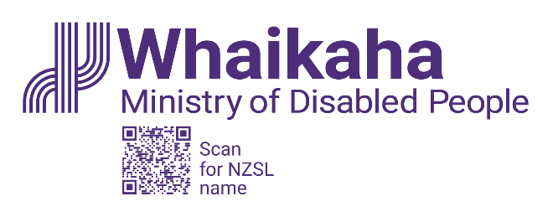
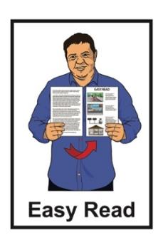

Purchasing Guidance:

How to spend your

disability support funding

Updated: 18 March 2024

What you will find in here

Page number:

About the Purchasing Guidance 3
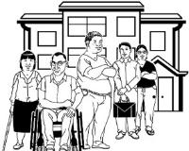

What disability funding is for 7

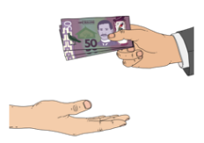
How Government disability
funding works 10

Rules for spending disability
funding 18

Making a plan 26

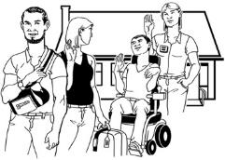
Examples of how the funding
can be used 28
Page number:

What you cannot use the
funding for 34

Employing support workers 38

Where to find more information 39

How to get in touch with
Whaikaha 42

About the Purchasing Guidance

This Easy Read information is from Whaikaha – Ministry of Disabled People.

In this Easy Read guide:
Whaikaha – Ministry of Disabled People is called Whaikaha
when you see the words we / us it means Whaikaha
disability community means:

- disabled people

- tāngata whaikaha Māori

- whānau / family

- carers.
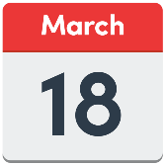
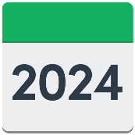
From 18 March 2024 we are making changes to the Purchasing Guidance.

Purchasing Guidance is about the rules on what people can buy with disability support funding.

Purchase means to buy something.

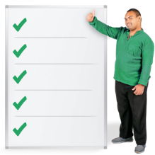
We are making these changes so that the rules about how people can use their disability support funding are clearer.

There are 4 rules that must be followed when purchasing / using disability support funding.

The 4 rules are for the following disability support funding:

          - Carer Support

          - Individualised Funding / IF

          - Enhanced Individualised Funding / EIF
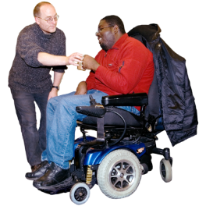
          - Choice in Community Living or Enabling Good Lives / EGL

          - Personal Budgets.

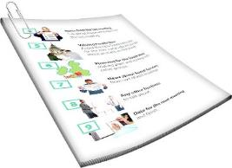
We will look at these 4 rules on pages 18 to 25.

We needed to change the rules to make sure that funding is being spent where it is needed most.

The rule changes will be in place until after we have talked to the disability community.

The rule changes are needed so that we can:

- work with the disability community

- work out some rules for using the funding going forward.

What disability funding is for

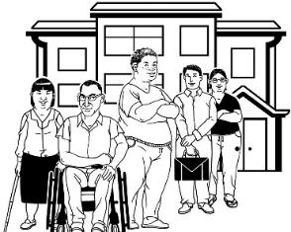
Disability funding is for some:
disabled people
tāngata whaikaha / Māori disabled people.
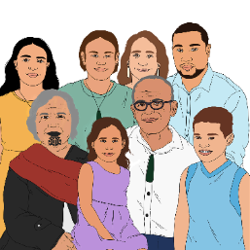

Disability funding can also be used to support the families / whānau of disabled people.

The funding can be used to:

give you more chances to live a good life
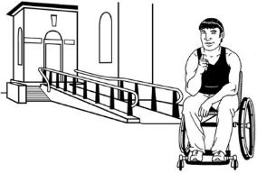
take away barriers that stop you from being able to do the things you want.
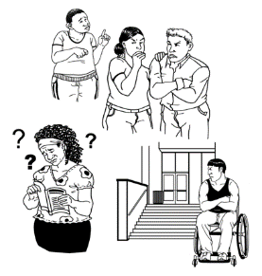
Barriers are things that make it harder for disabled people to live a good life like:
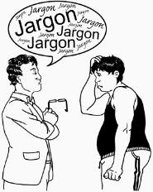
buildings that they cannot use / get into
information that is hard to understand
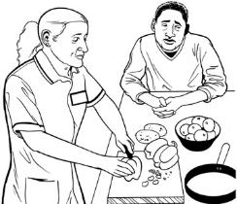
not being able to get the things / support they need to have a good life.

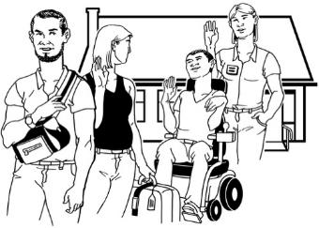
Disability funding can also be used for respite.

Respite is a way to give whānau / family a break from caring for someone.

You can find out more about respite on our website:

https://tinyurl.com/2vku3vpc

This information is not in Easy Read.

How Government disability support funding works

The Government disability support funding pays only for costs that are about your disability.

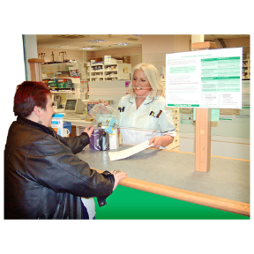
Disability support funding does not:
- replace other ways of paying for things that support your life
- pay for other types of support that are not part of your disability.
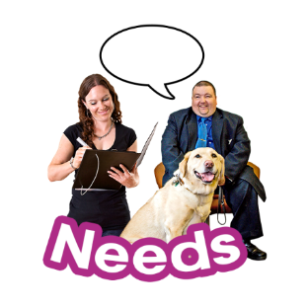

Your disability support funding has been given to you to manage / use to meet your disability support needs only.

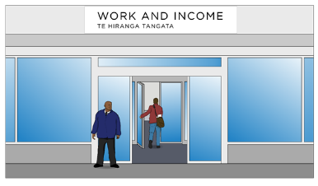
This is different to getting a benefit or allowance from the Government.

A benefit or allowance is money you may be able to get to pay for some of your living costs.
m

Disability support funding cannot be used to pay for day to day costs like:
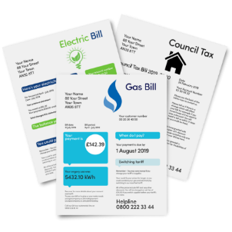
- recreational costs
- living costs / expenses.

Recreational costs means the cost of doing things you enjoy like:
- exercising
- gaming like Xbox or PlayStation
- entertainment like movies / shows.
Living expenses are things like:
food
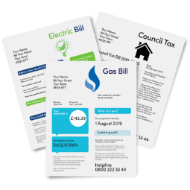
rent / housing costs
power / electricity bills.

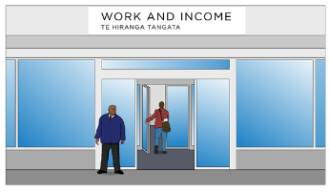
You can talk to Work and Income at the Ministry of Social Development if you need money for living expenses.

When you talk to Work and Income you can find out if there are any benefits or allowances that you can get.

You can find more information about support from Work and Income at this website:

www.workandincome.govt.nz
You can ask for assistance from Work and Income:
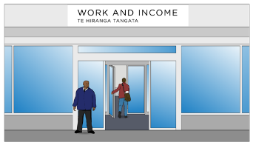
online using My MSD
in person
by phone.

Online using My MSD

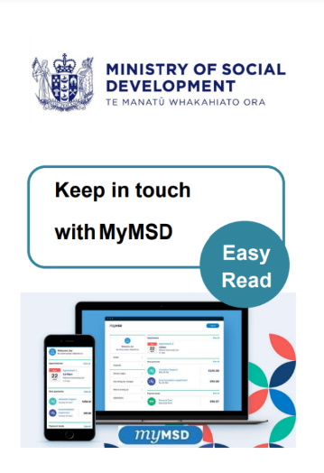
You can find Easy Read information about using My MSD in a document called:

Keep in touch with MyMSD

You can find this document here:

shorturl.at/kuFMR

In person
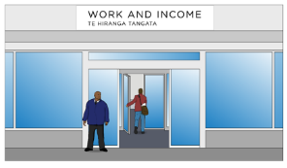
You can visit the Work and Income centre which is closest to where you live.

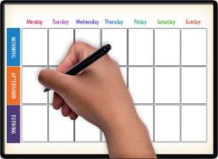
It is best to make an appointment before you go.

You can find the Work and Income centre closest to you on this website:

www.workandincome.govt.nz/findus

By phone

You can apply / ask for assistance over the phone.

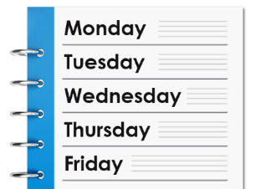
You can call Work and Income at these times:
- Monday to Friday from:
- 7 am in the morning
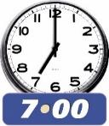
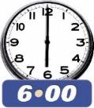
to
- 6 pm in the evening
- Saturday from:
- 8 am in the morning
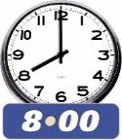
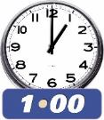
to
- 1 pm in the afternoon.

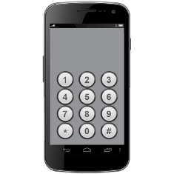
If you are working age phone:

0800 559 009

Working age means you are a person aged between:
18 years
and
65 years.

If you are a student phone:

0800 88 99 00

If you are a senior citizen phone:

0800 552 002

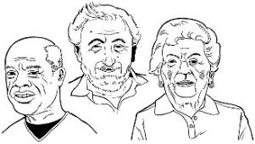
A senior citizen is a person aged 65 or over.
If you find it hard to use the phone the New Zealand Relay service is for people who are:

- Deaf / hard of hearing
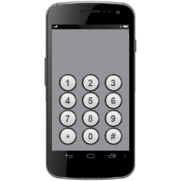
- deafblind

- speech impaired / find it hard to talk.

You can find out more about the New Zealand Relay service at:

www.nzrelay.co.nz

Rules for spending

disability support funding

There are 4 rules that tell you how you can spend disability support funding.

The 4 rules are the same for:

          - Carer Support

          - Individualised Funding / IF

          - Enhanced Individualised Funding / EIF

          - Choice in Community Living or Enabling Good Lives

          - Personal Budgets.

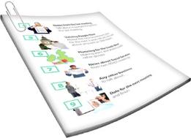
You must make sure the thing you want to buy fits the Purchasing Guidance before you buy it.

The changes to the Purchasing Guidance do not change the rules about other disability government funding.

Rule 1: The funding / purchase:
helps you live a good life
makes your life better.
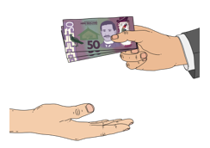
The funding has been given to you to use in a specific way.

You will have discussed the way you use your funding / purchase with your:
- Needs Assessment Service Coordinator / NASC Coordinator
- Individualised Funding Host
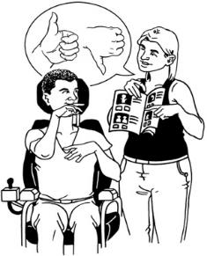
- Choice in Community Living provider
- Flexible Disability Funding providers
- Enabling Good Lives Team / EGL Team.
Question: Does this purchase fit with the way the funding is to be used?

Rule 2: The purchase is a disability support

The purchase is being used for something that you need because of your disability.

You cannot use the funding for something that you would still need if you were not disabled.

Question: Is this purchase needed for my disability?

Rule 3: The purchase must be:
reasonable
cost effective.

Reasonable means that:
the cost is what you would expect
the item is a good use of the money.

Cost effective means:
- it is a good use of the funding / money
- the purchase will mean good outcomes / support for you.

Cost effective does not mean that the thing you buy must be cheap.

Sometimes it is better to buy something that will last a long time even if it costs more.

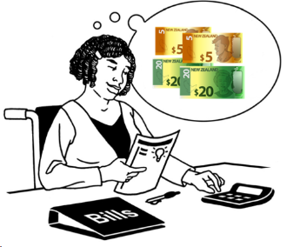
The purchase must fit your budget.

A budget tells you how much funding you have to spend on purchases.

Question: Does this purchase make good use of your funding on something that will make a lasting impact?

Lasting impact means something will have good outcomes for a good amount of time.

Rule 4: The purchase is not subject to a limit or exclusion

This rule means that your purchase:
- is something you are allowed to buy
- is not against the law like drugs
is something you have enough funding to buy
is something you cannot get other funding to pay for
follows the way you are supposed to do things like paying people to support you.

Question: Is this the best way to fund your purchase?

You can find more information about the purchasing rules on our website:

www.whaikaha.govt.nz/rules

Making a plan

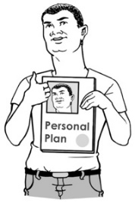
Having a plan will support you to:

- make good purchases

- have good conversations / talks with your Host or Connector about how to use the funding.

If you get IF or EIF funding your Host is the organisation that:

- works with you to look after your funding

- checks that your funding is spent in a way that meets the purchasing rules

- works with you to write an Individual Service Plan / ISP.
Your Host will also:

- support you to relook at your plan when your needs change

- give you advice / support.

If you manage your EGL personal budget your Connector will work with you to write a plan.

If you do not already have a plan then discuss this with your Connector.

You can find more information on our website about working with a Connector to write a plan:

https://tinyurl.com/5cmfud9y

Examples of how the funding can be used

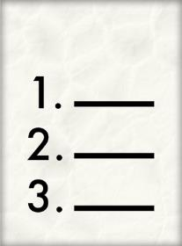
A good way to understand the rules is to read some examples of how the funding might be used.

Example 1:

Example 1 talks about a disabled person called Joelene.

Joelene has funding for:
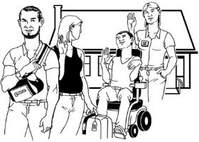
personal care
respite.

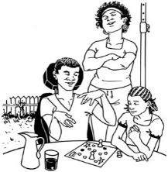
Joelene lives with her whānau / family.

Joelene has a support team which she pays for using her funding.

Joelene purchased technology to manage the booking of her support team.

Joelene has a plan that she has worked out with her Host.

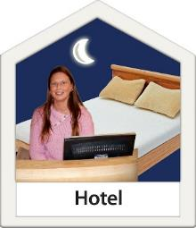
In her plan Joelene says she wants to spend 1 weekend in every month away at an Airbnb / hotel.

Joelene plans to use her respite funding to pay for the cost of her support worker to stay with her.

Joelene will have to use her own money to pay for other costs of going away like paying for:
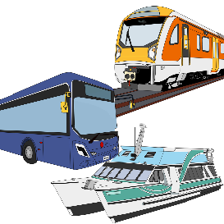
- accommodation costs – the cost of the Airbnb / hotel where they stay
- her own travel costs between the Airbnb and home.

Joelene can use her funding to pay for the paid support workers travel costs.

This way of using her funding fits with the rules because it:
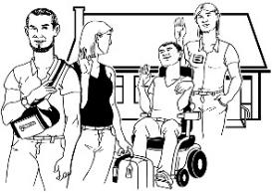
is individual which means it fits with what Joelene wants to do
means Joelene can spend time away from her family.

This way of using her funding also fits with the rules because it:
is included in her plan
fits with why she has funding.

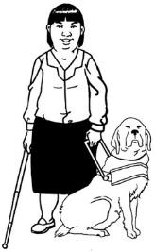
Example 2:

Billie has a sight disability.

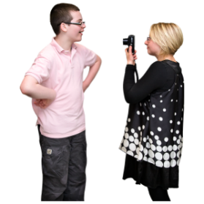
Billie has a goal in her plan about becoming a photographer.

Billie goes to photography classes.

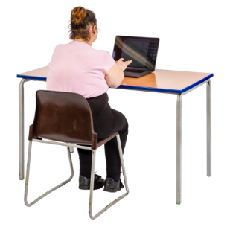
Billie needs to buy some computer software to support her to take part in the photography class.

Billie uses her EGL Personal Budget – Community Participation funding to purchase the software.

Billie can use Rule 2 to purchase the software because it makes it possible for her to take part in a recreational activity she enjoys independently.

Independently means Billie can do the class without the need for a support person.

This way of using the funding fits with the rules because:
the software will make it possible for Billie to access information she needs
it makes it possible for Billie to take part in the class like everyone else
the software is an extra cost because of her disability.

What you cannot use the funding for

You cannot use the funding for:
anything that is against the law
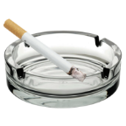
alcohol like beer or wine
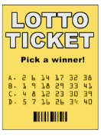
tobacco / smoking products / vaping
gambling like buying a lottery ticket
things that are not a cost of disability
money for yourself
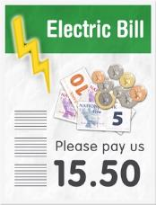
things that everyone else has to pay for like bills unless they are related to your disability.

What you cannot buy with your funding depends on the funding stream your money comes from.

To know what you can use your funding for you should talk to your:
- IF Host
- Service Coordinator at the NASC
- Connector.

You cannot use the IF Respite or Carer Support funding to pay for respite related costs such as:
- accommodation like hotel or Airbnb costs
- domestic travel which is travel to:
  - different parts of New Zealand to another
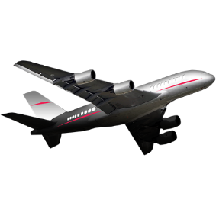
  - different towns or cities in New Zealand
- overseas travel
- food
- costs that come from respite but are not part of supporting the disabled person like entertainment costs.

These rules about how funding for respite can be used apply to:
- disabled people
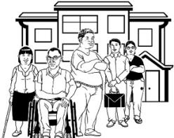
- whānau / family
- the person / people providing respite.

You also cannot use the funding to buy a support:
- when funding for that support has been turned down by another government agency
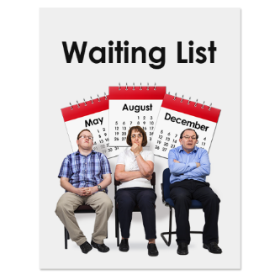
or
- where you may have to wait to be able to access / get a service – for example if there is a waiting list.

Employing support workers

If you use the funding to employ support workers you must:
follow the laws about employment
be a good employer.
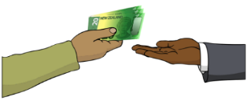
Employ means you pay someone for work they do.

You can talk to your Host about how to do this properly.

Where to find more information

If you have any questions about disability funding you can ask your:
IF Host
EGL team
Service coordinator at the NASC.

They will be able to support you by:
understanding your needs
working with you to decide what is best for you
changing your plan with you
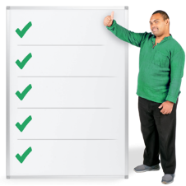
checking that the choices you make fit with the Purchasing Guidiance.
A full list of Hosts can be found at the bottom of this website page:

https://tinyurl.com/mxzbtksa

Carers New Zealand can also answer any questions you have about disability funding.

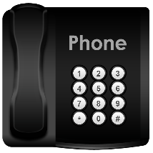
You can contact Carers New Zealand by:
phone on:

0800 777 797
going to their website at:

https://carers.net.nz

Enable NZ has a website called Firstport that has lots of information about disability funding.

You can find the Firstport website at:
https://firstport.co.nz

The phone number for Firstport is:

0800 171 981

You can find information about the
New Zealand Relay service on
page 17.

How to get in touch with Whaikaha

You can get in touch with Whaikaha on this website:

www.whaikaha.govt.nz/contact-us/

You can also contact Whaikaha by:
- phone on:

0800 566 601
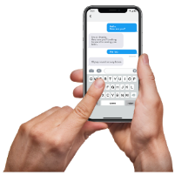
- text message on:

4206

You can call us on the phone:
- from 8 am to 5 pm on:
- Monday
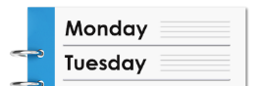
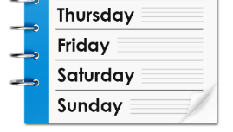
- Tuesday
- Thursday
- Friday
- from 9.30 am to 5 pm on:
- Wednesday.

You can information about the
New Zealand Relay service on
page 17.

This information has been written by Whaikaha – Ministry of Disabled People.

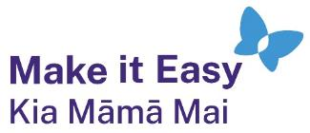
It has been translated into Easy Read by the Make it Easy Kia Māmā Mai service of People First New Zealand Ngā Tāngata Tuatahi.
The ideas in this document are not the ideas of People First New Zealand Ngā Tāngata Tuatahi.
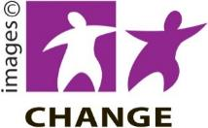
Make it Easy uses images from:

- Changepeople.org

            - Photosymbols.com

- SGC Image Works
- Huriana Kopeke-Te Aho
- T. Wood.
All images used in this Easy Read document are subject to copyright rules and cannot be used without permission.

