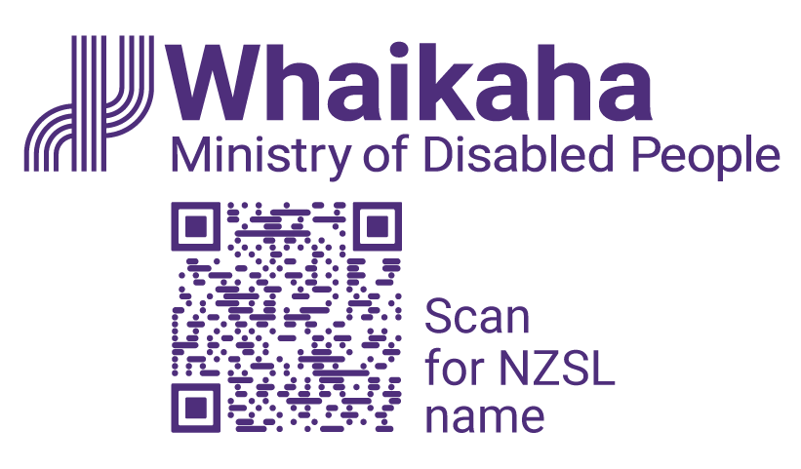Finance Business Partner
Adapted in 2024 by Accessible Formats Service,
Blind Low Vision NZ, Auckland

TN: The logo on the top of the page is Whaikaha Ministry of Disabled People.

Finance Business Partner
- Work in an organisation committed to accessibility
- Growth and development opportunities
- Flexible working arrangements available
Support engagement with managers to implement the financial strategy, embed best-practice financial processes and grow the financial management capability across the Ministry, to support quality decision-making about the services we fund.

Ko wai mātou | About Us:
Whaikaha – Ministry of Disabled People has a unique mandate of having responsibility to steward change across Government, while commissioning disability support services; as well as transforming how these services are commissioned and delivered.
Disabled people expect to have greater choice and control over the supports and services they receive to lead their best life. We are committed to this by strengthening relationships and working in partnership with disabled people, tāngata whaikaha Māori, Pacific disabled people and their whānau.
Whaikaha presents an exciting opportunity to make a real difference. The call for "Nothing about us, without us" is an integral part of our operation.

Mō tēnei tūranga mahi | About the Role:
As the Finance Business Partner, you will work with the Principal Financial Business Partner to ensure that financial information is captured and recorded accurately, to create robust financial datasets that allow for in-depth analysis and data interpretation.
You will use your experience in the development of reports and presentations for managers, to communicate insights gleaned from complex financial data.
You will partner with the business to provide advice that will help inform senior and executive business leaders with their decision-making on the large number of services we fund.
Alternate formats of this advertisement and PDs can be found here www.whaikaha.govt.nz/fin-ana

Ko wai koe | About You:
You will have solid demonstrable experience in Management Accounting and/or Business Partnering, preferably in the Government sector, and a deep understanding of the accounting discipline. This will be paired with a Chartered Accountant full membership of CAANZ or CPA.
Your proven experience working with large complex datasets, collating information and monitoring results effectively will see you use your advanced Microsoft Excel skills to produce reporting that effectively communicates insights to support senior leaders' decision-making.
Your excellent attention to detail and ability to gather, arrange and communicate information effectively, will be the keys to success in this role.
You will have sound judgement and problem-solving skills with the ability to analyse information and provide multiple solutions as well as influence decisions for the best outcome.
You will have strong relationship building and interpersonal skills to connect with colleagues in Whaikaha and across our 3 partner agencies.
To undertake this role successfully, you will be a disabled person or be able to establish credibility and trust with the disability community, as well as having empathy and an understanding of the unique and diverse experiences of disabled people.

Mō Te Tono, Mō Te Tirotiro Tātai Tūranga Apply or View the Position Description:
www.whaikaha.govt.nz/fin-ana
Salary Range: $116,827–$141,873

Tono Mai | We encourage you to apply:
Joining Whaikaha means being part of a whānau that celebrates the diversity each individual brings. Currently, just over 40% of our people identify as disabled people and we want this number to grow. We care about the wellbeing and success of our people and provide a supportive and inclusive working environment where people can thrive and be who they really are. We are committed to the application of Te Tiriti o Waitangi in all levels of our work.

Me He Pātai Anō | Further Enquiries:
We encourage you to talk to us about any support you need. We want you to present this information in a way that plays to your strengths. For example, you may prefer to use video instead of a traditional CV and cover letter. You might want whānau or a friend to tell us about you or use social media or a PowerPoint presentation. Let's kōrero about what you need to feel supported in your application.
Contact us about the best way for you to apply by emailing us at: PeopleandCulture@whaikaha.govt.nz

Te Tono | Application:
Please click the 'Apply' button to submit your application.
If you work for Whaikaha or MSD already – Please apply through the myHR portal. You can do this by clicking the 'Apply' button to complete the online application form and upload your CV and cover letter. This will ensure that your employee profile is visible as an internal candidate.

Ka Kati Ngā Tono | Applications Close:
For closing dates, please refer to this job position on www.whaikaha.govt.nz/fin-ana
Whaikaha has adopted the Ministry of Social Development's (host agency) COVID-19 vaccination policy. This policy applies to all Whaikaha employees and encourages, but does not require, employees to be fully vaccinated for COVID-19 and its variants, unless the role is identified as requiring vaccination at the time.
End of Finance Business Partner

