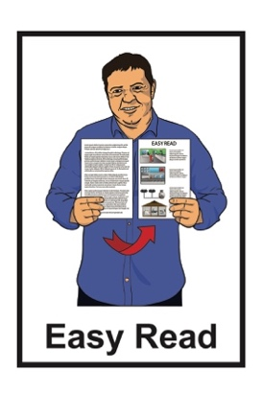
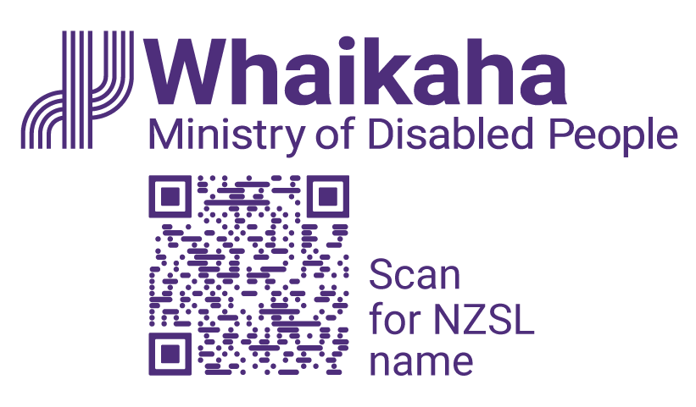

United Nations Convention on the Rights of Persons with Disabilities: What the New Zealand Government wants to do
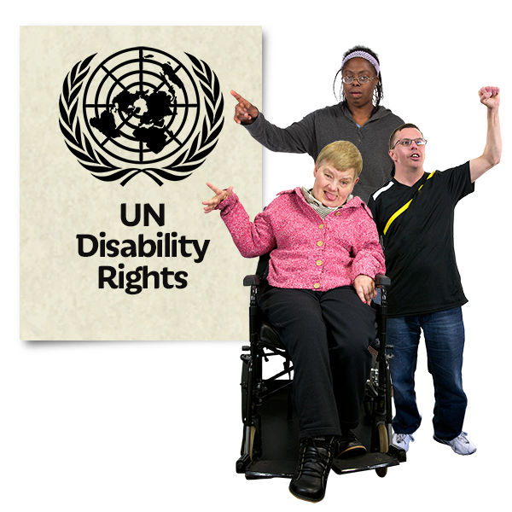

Published: August 2023

What you will find in here

Page number:

What is this document about? 2
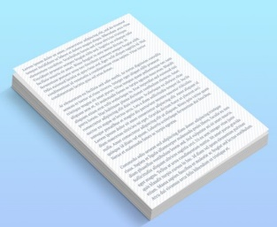

What is the Cabinet paper about? 4

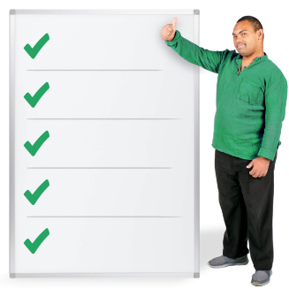
What are the main recommendations in the Cabinet paper? 10
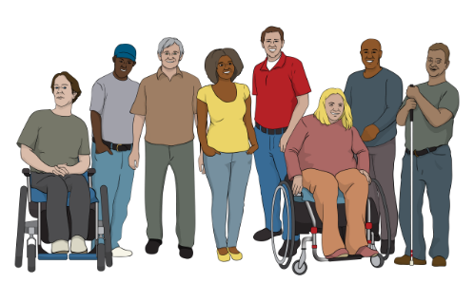

How does the Cabinet paper fit
with other Government work? 15

Where to find more information 17

What is this document about?

This Easy Read document is a summary of a Cabinet paper that went to the Cabinet Social Wellbeing Committee.

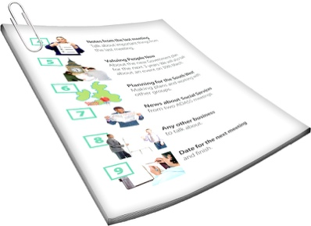
A summary:

- is shorter than the full document

- tells you the main ideas.

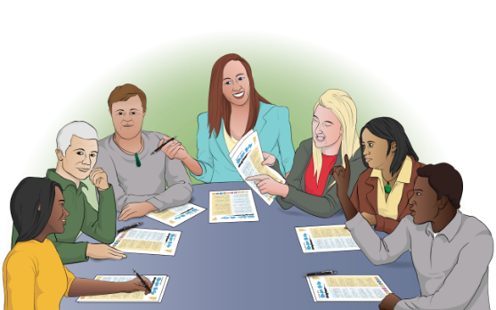
Cabinet:
- is a group of senior government ministers
- meets to make important decisions.

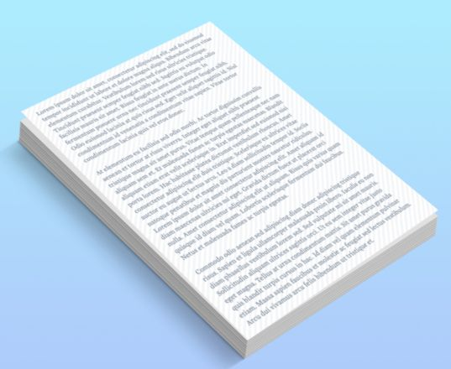
A Cabinet paper has information in it that Cabinet needs to:
- know about
- make a decision about.
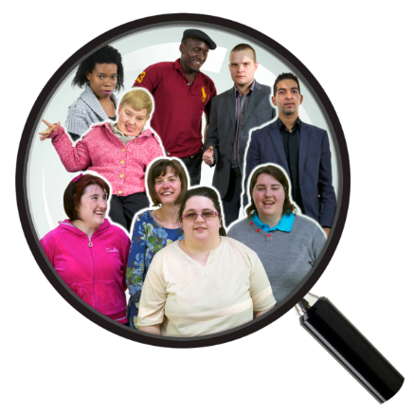

The Cabinet Social Wellbeing Committee is a group of government ministers who work on things to do with social wellbeing.

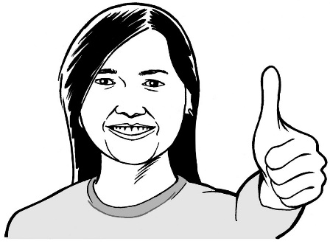
Social wellbeing is about making sure everyone has a good quality of life.

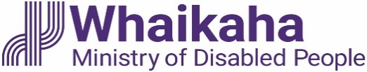
The summary of the Cabinet paper has been written by Whaikaha – Ministry of Disabled People.

What is the Cabinet paper about?

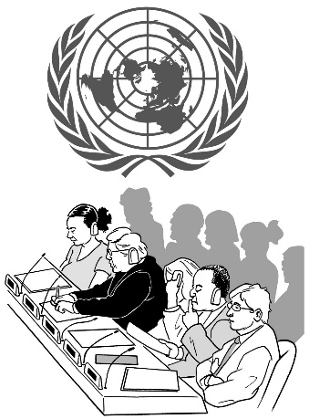
In 2008 the New Zealand Government said they agree with the United Nations Convention on the Rights of Persons with Disabilities.

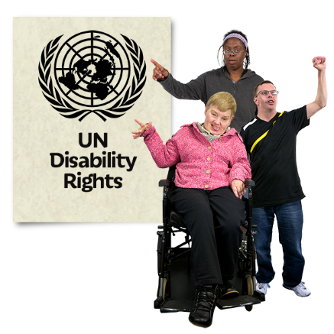
The United Nations Convention on the Rights of Persons with Disabilities is a group of rules that lots of countries have agreed to.

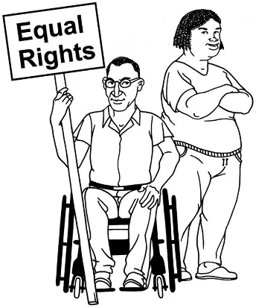
The United Nations Convention on the Rights of Persons with Disabilities is also called the UNCRPD.

It says what governments must do to make sure disabled people get the same rights as everybody else.

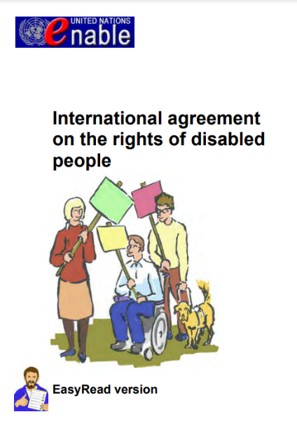
You can find more Easy Read information about the UNCRPD on this website:

https://tinyurl.com/bddwdxue

The United Nations Committee is an independent group of 18 experts on disability rights from around the world.
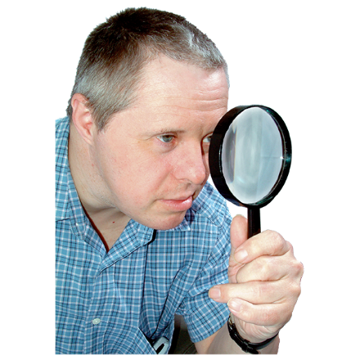

The United Nations Committee looks closely at how governments are doing with making sure disabled people get the same rights as everybody else.
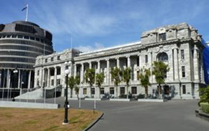

Independent means the experts are not part of any governments.
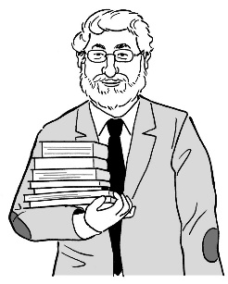

Experts are people who know a lot about something.
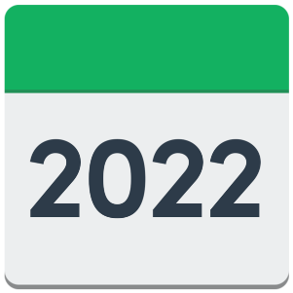
The United Nations Committee met with the New Zealand Government in 2022 to look at how they were doing.

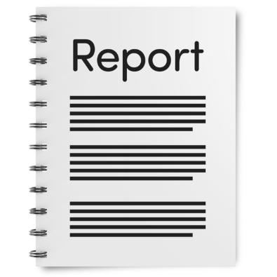
The United Nations Committee wrote a report that listed 60 concluding observations for the New Zealand Government to work on.

Concluding observations are the things that New Zealand needs to do better at.

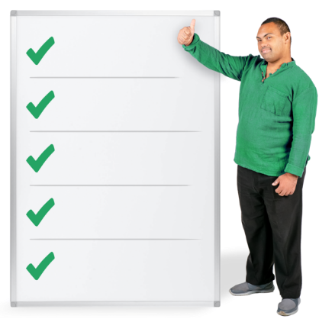
The concluding observations are recommendations for things that New Zealand could do.

Recommendations are things that could be done to make things better.

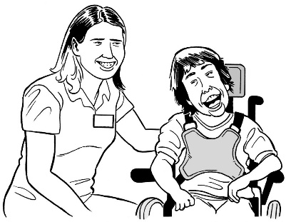
These concluding observations were about things like:
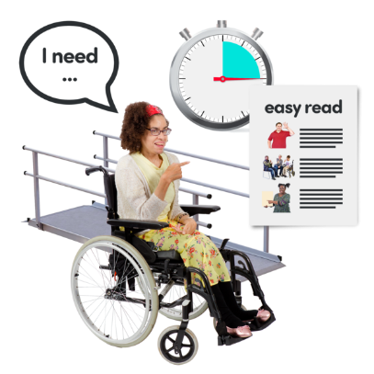
- disability support services
- accessibility
- welfare
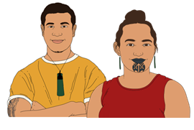
- the health system
- support for tāngata whaikaha Māori / disabled Māori.

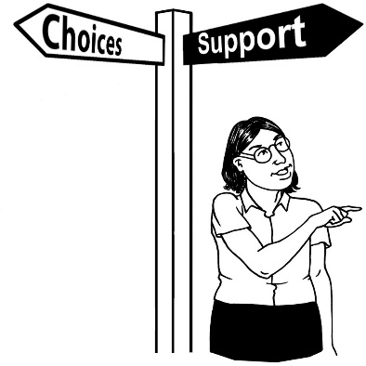
Disability support services include many services such as:
- Enabling Good Lives
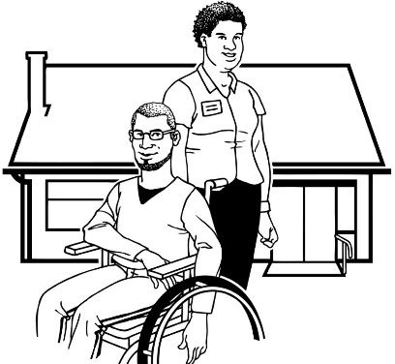
- residential care support
- carer support.

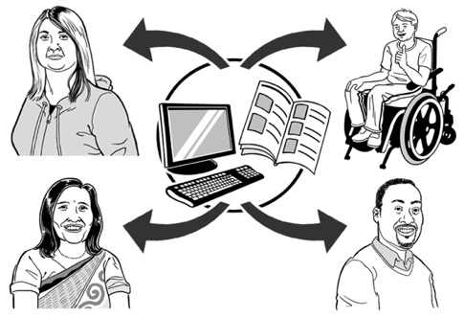
Accessibility means making it easy for everyone to:
- find the things / information they need
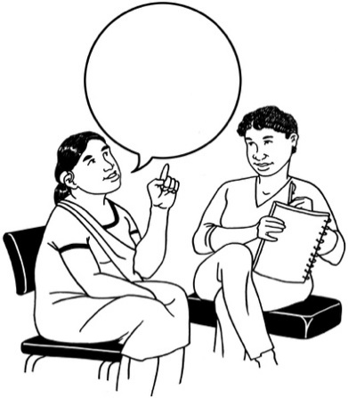
- use the things / information they need
- get around in ways they want to
- communicate with other people.
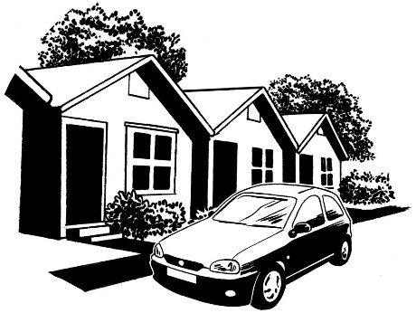
Welfare is about things like:
- a good place to live
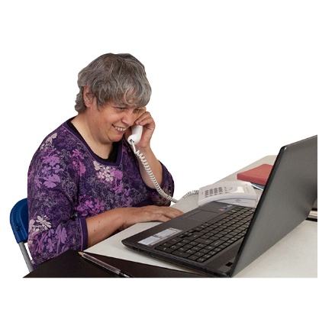
- support with money / costs
- having a job / work.

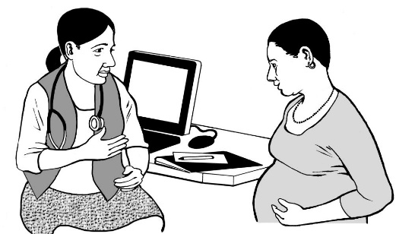
The health system is about getting good healthcare from places like:
- hospitals
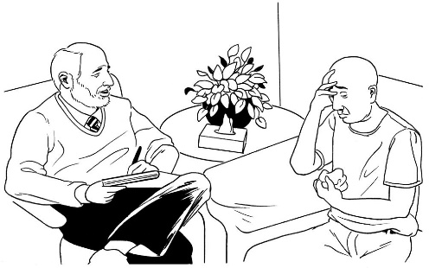
- community health centres
- dentists
- mental health services.

What are the main recommendations

in the Cabinet paper?

The Cabinet paper asks the Social Wellbeing Committee to agree to work on all 60 observations.

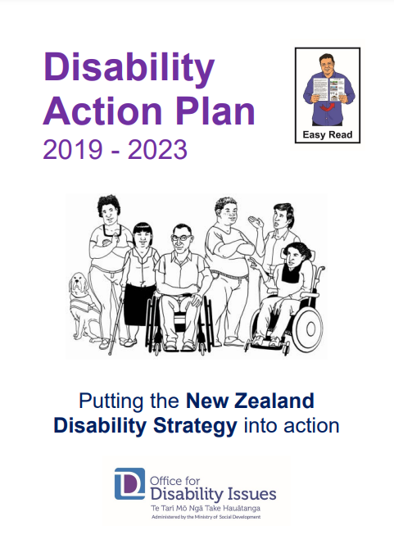
1 of the ways of doing this is to keep working on the things outlined in the Disability Action Plan 2019 – 2023.

You can find Easy Read information about the Disability Action Plan 2019 – 2023 on this website:

https://tinyurl.com/2pfpxtj2

The Cabinet paper also asks that a domestic forum is held by December 2027.

A domestic forum is a:
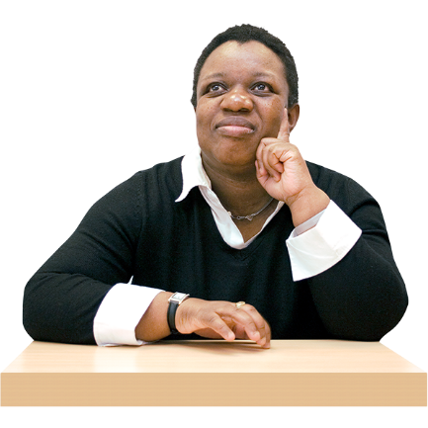
- meeting where lots of people can take part
- way of checking with disabled people about how they think New Zealand is doing with meeting the things in the UNCRPD.
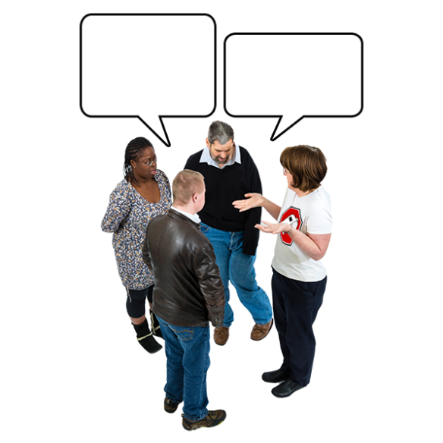

Disabled people would be able to say:
- what is working
- what is not working.

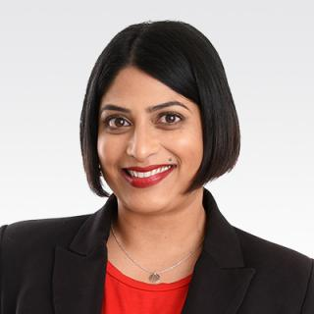
The Minister for Disability Issues is Priyanca Radhakrishnan.

The Minister says that doing these things will show that New Zealand:
- is a leader in working to make sure that disabled people get their rights
- understands it is important for people to have their say including:
- tāngata whaikaha Māori / disabled Māori
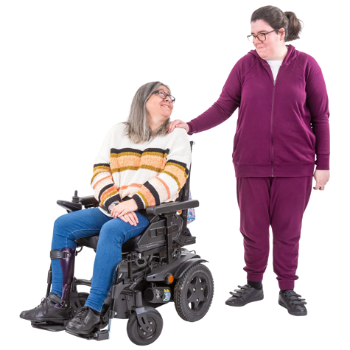
- disabled people
- whānau / families
- the wider community.
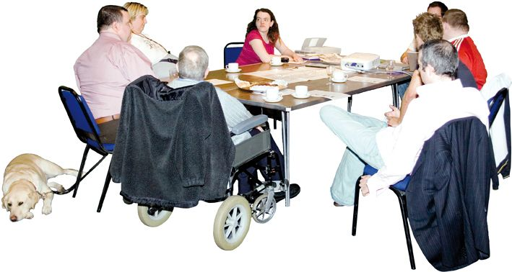
It also shows the importance of the Independent Monitoring Mechanism group.

The Independent Monitoring Mechanism group looks at what the Government is doing to make sure disabled people are getting their rights in New Zealand.

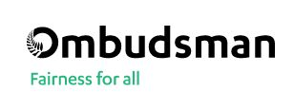
There are 3 groups that make up the Independent Monitoring Mechanism:
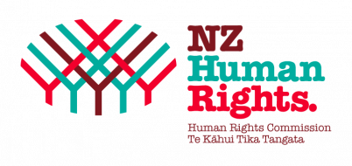
- Office of the Ombudsman
- New Zealand Human Rights Commission
- Disabled People’s Organisations Coalition / DPO Coalition.

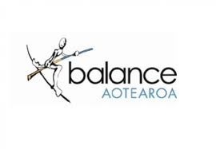
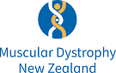
The Disabled People’s Organisations that belong to the DPO Coalition are:
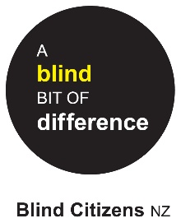
- Balance Aotearoa
- Blind Citizens New Zealand
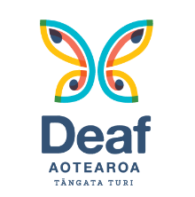
- Deaf Aotearoa
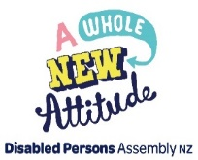
- Disabled Persons Assembly New Zealand
- Muscular Dystrophy Association of New Zealand
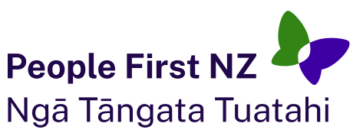
- People First New Zealand Ngā Tāngata Tuatahi.

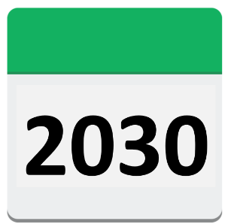
The United Nations Committee will next meet with the New Zealand Government no later than October 2030.

How does this Cabinet paper fit with

other Government work?

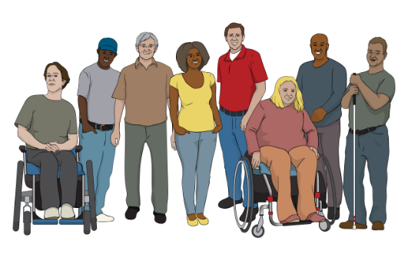
The recommendations in this Cabinet paper fit with the things that are said in the:

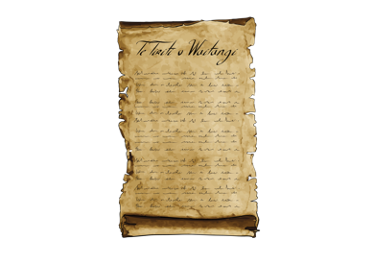
- New Zealand Disability Strategy 2016 – 2026

          - Te Tiriti o Waitangi / The Treaty of Waitangi.

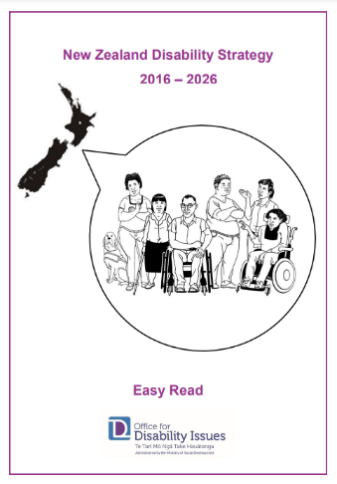
The New Zealand Disability Strategy outlines what the Government will do to make sure disabled people get their rights.

You can find the New Zealand Disability Strategy in Easy Read at this website:

https://tinyurl.com/cuecp5tf
Te Tiriti o Waitangi / The Treaty of Waitangi is an important agreement between Māori and the British Crown.

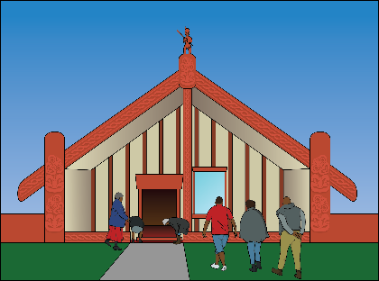
It is about Māori and the New Zealand Government:
- making decisions together
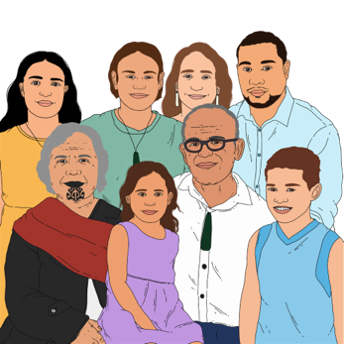
- protecting things that are important to Māori.

Where to find more information

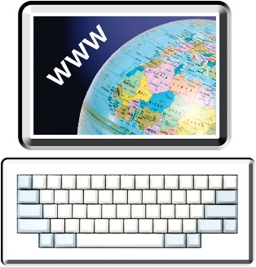
You can find more information about the recommendations made in the Cabinet paper on the Whaikaha – Ministry of Disabled People website:

www.whaikaha.govt.nz/UNCRPD-paper

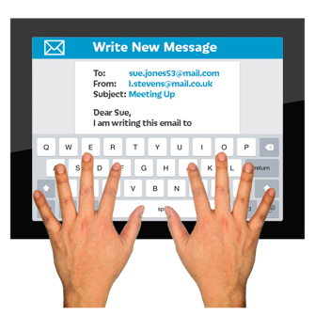
You can contact Whaikaha – Ministry of Disabled People by:
email at:
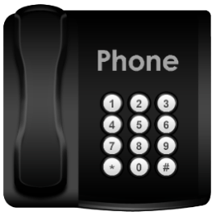
contact@whaikaha.govt.nz
phone on:
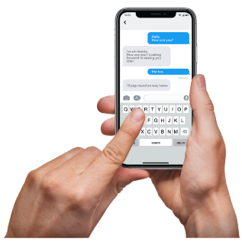
0800 566 601
          - text on: 4206

This information has been written by Whaikaha – Ministry of Disabled People.

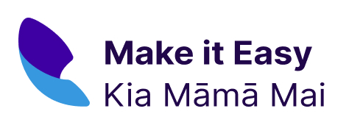
It has been translated into Easy Read by the Make it Easy Kia Māmā Mai service of People First New Zealand Ngā Tāngata Tuatahi.

The ideas in this document are not the ideas of People First New Zealand Ngā Tāngata Tuatahi.

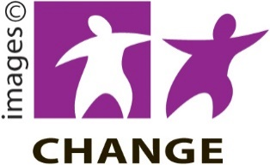
Make it Easy uses images from:

- Changepeople.org

- Photosymbols.com

- SGC Image Works

- Huriana Kopeke-Te Aho.
All images used in this Easy Read document are subject to copyright rules and cannot be used without permission.

