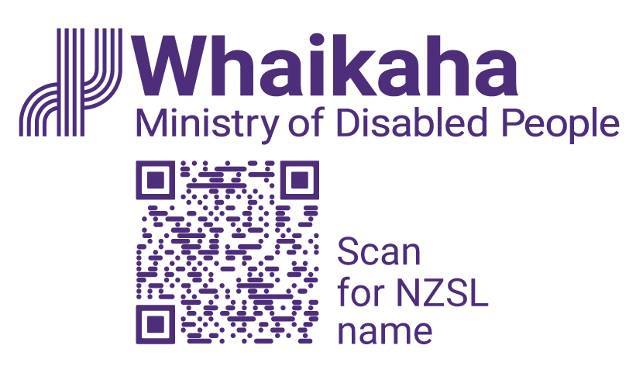
Summary of the Ministry of Disabled People - Whaikaha 2024/25 Annual Report
Adapted in 2025 by Accessible Formats Service,
Blind Low Vision NZ, Auckland
Transcriber's Notes: The logo on the top of the page is Whaikaha - Ministry of Disabled People.

Notes for the Large Print Reader
Main text is in Arial typeface, 18 point.
Headings are indicated as:

Heading 1

Heading 2

Heading 3

Our context
About one in six New Zealanders—approximately 851,000 people—are disabled, and the Ministry of Disabled People—Whaikaha serves all people with impairments, recognising that not everyone identifies with the term 'disabled', including Deaf communities and Turi Māori.
You can find the full document in PDF and Word version here: https://tinyurl.com/whaikaha-reports
The full document is not available in Alternate Formats online but is available upon request.

Our values
- Mana taurite | Equity drives us
- Mana kaha | We strengthen and support
- Mana tīhura | We explore and learn

Our leaders are:
- Paula Tesoriero, Chief Executive
- Ginny Baddeley, Deputy Chief Executive, Strategy and Enablement
- Ben O'Meara, Deputy Chief Executive, Policy and Insights
- Rebecca Elvy, Deputy Chief Executive, Outreach and Innovation
- Ronelle Baker, Kauhautū—Chief Advisor Māori

Our establishment as a standalone public service department
The Ministry was established in July 2022 and became a standalone public service department in December 2024, following a government review of Disability Support Services, with a mission to partner with disabled people, tāngata whaikaha Māori, their whānau, Māori, and government to improve independence and outcomes.

How we drive for impact
The Ministry's work is guided by the vision of disabled people thriving in New Zealand, with a purpose of driving meaningful change alongside disabled people, tāngata whaikaha Māori and their whānau, through a stewardship role that builds relationships across government and embeds disability expertise and lived experience into public services and policy.

Initial performance framework
The Ministry has begun developing a performance framework to monitor its activities as a standalone department, with progress and operations assessed against key components outlined in the report.

Our vision
Disabled people thriving in New Zealand

Our purpose
Driving real and meaningful change with disabled people, tāngata whaikaha Māori and their whānau

Our strategic outcomes
- Accessibility
- Education
- Employment
- Health
- Housing
- Justice
Our strategic outcomes are the high-level areas we want to influence, because they will help achieve our vision of disabled people thriving in New Zealand.
We are establishing system-level measures to understand whether we are influencing our strategic outcomes.

Our stewardship functions
- System leadership and societal change
- Strategic policy
- System-level monitoring
- Disability information and advice
- Building relationships between government and disabled people

Our work programmes
- The New Zealand Disability Strategy refresh
- The New Zealand Sign Language (NZSL) Strategy refresh
- United Nations Convention on the Rights of Persons with Disabilities (UNCRPD) response
- Royal Commission of Inquiry into Abuse in Care response
- Accessibility Work Programme
- Creating employment opportunities for disabled people
- Reshaping our Ministry

Progress on our strategic intentions
Link to our Strategic Intentions that has all alternate formats is: https://tinyurl.com/MoDP-Strategy
Whaikaha's strategic outcomes aim to reduce barriers and improve equity for disabled people across six key areas:
Accessibility: We are working to remove barriers that prevent disabled people from participating fully in society, with a focus on improving access to buildings, transport, services, and information. Progress in this area will enable greater independence and dignity.
Education: Our efforts target reducing disparities in attendance, participation, and achievement for disabled learners. Improved education outcomes will support lifelong learning, confidence, and social inclusion.
Employment: We are addressing systemic and societal barriers to employment, aiming to increase workforce participation and income equity for disabled people. Better employment outcomes will enhance financial independence and wellbeing.
Health: We are focused on improving access to health services and reducing unmet needs, with the goal of closing the gap in physical, mental, and social health outcomes between disabled and non-disabled people.
Housing: Our work supports access to safe, suitable, and accessible housing, which is essential for health, independence, and community participation. Reducing housing deprivation will improve overall quality of life.
Justice: We are working to ensure disabled people are treated fairly and safely within the justice system, with improved protections, legal support, and responsiveness. This will reduce victimisation and promote equitable justice outcomes.

Assessment of operations

Implementing the Government's priorities
The Government Targets are nine targets the Government has set to improve the results that public services are achieving. They are intended to be achieved by 2030.
There is strong alignment between the Government Targets and our six strategic outcomes, as well as the priority outcome areas for the New Zealand Disability Strategy refresh.
Information about the Government Targets can be found on the DPMC website (https://www.dpmc.govt.nz/our-programmes/government-targets).

Our education strategic outcome contributes to:
Target 6—Increased student attendance
Target 7—More students at expected curriculum levels.

Our employment strategic outcome contributes to:
Target 5—Fewer people on the Jobseeker Support
benefit.

Our health strategic outcome contributes to:
Target 1—Shorter stays in emergency departments
Target 2—Shorter wait times for treatments.

Our housing strategic outcome contributes to:
Target 8—Fewer people in emergency housing.

Our justice strategic outcome contributes to:
Target 3—Reduced child and youth offending
Target 4—Reduced violent crime.

Activity to fulfill Ministry stewardship functions
In August 2024, Cabinet confirmed Whaikaha's transition to a standalone public service department and agreed five stewardship functions—system leadership and societal change, strategic policy, system-level monitoring, disability information and advice, and building relationships between government and disabled people which guide the Ministry's work to improve outcomes for disabled people.

Ministry work programmes

The New Zealand Disability Strategy refresh
The Ministry led cross-agency work to refresh the New Zealand Disability Strategy, securing Cabinet agreement on five priority outcome areas and engaging with disability groups and working groups to support its development ahead of the December 2025 launch.

The New Zealand Sign Language Strategy refresh
We worked with the NZSL Board to refresh the New Zealand Sign Language Strategy, achieving key milestones including Cabinet approval and national engagement, to strengthen the use of NZSL and guide inclusive practices across government ahead of its late 2025 launch.

United Nations Convention on the Rights of Persons with Disabilities (UNCRPD) response
We coordinated cross-agency efforts to meet New Zealand's commitments under the UNCRPD, following the Government's acceptance of 30 recommendations and partial adoption of 17 others from the 2022 review, and supported transparency by publishing progress actions on the Ministry of Justice's Human Rights Monitor.

Royal Commission of Inquiry into Abuse in Care response
We contributed to the cross-agency response to the Royal Commission of Inquiry into Abuse in Care by leading work to develop options for improving the care safety system for disabled people, following the release of the final report in July 2024.

Accessibility Work Programme
We advanced accessibility by stabilising the Alternate Formats service, which was successfully transitioned from MSD. We also partnered with the Department of Internal Affairs to build inclusive communication capability across government, and progressing initiatives in digital inclusion, transport equity, emergency planning, and electoral accessibility—while also establishing an Accessibility Advisory Group and supporting awareness-raising projects and events to promote consistent, lived-experience-driven accessibility nationwide.

Creating employment opportunities for disabled people
We worked with the Public Service Commission to advance a 2024−2026 employment plan that promotes inclusive recruitment, builds disability confidence, and strengthens data practices—while expanding its focus to include private sector collaboration and supporting key milestones such as the development of inclusive recruitment guidance and participation in the 2025 Disability Inclusive Pathways Conference.

Reshaping our Ministry
We completed a major organisational transformation to support its role as a standalone public service department, including developing a new operating model, restructuring governance and leadership, recruiting for the new structure, and establishing corporate policies and processes, with structural changes finalised in May 2025.

Organisational health and capability

Systems and processes
Following its establishment as a standalone public service department, Whaikaha implemented a new organisational structure and operating model through its Reshaping our Ministry programme, adapting systems, processes, and policies to reflect its size and responsibilities, including operating with a smaller, more generalist workforce.

Long-term capability and people
Whaikaha's new organisational structure and operating model aim to strengthen core capabilities—including disability knowledge, policy, research, and enabling functions—and will be considered mature when the Ministry is recognised as a trusted, influential contributor across government, demonstrating inclusive engagement, systems thinking, and evidence-based impact aligned with Te Tiriti o Waitangi and public sector priorities.

Māori Crown relationships capability
Whaikaha is committed to strengthening Māori Crown relations by embedding te reo Māori and tikanga into its daily practices, supporting staff engagement with Māori perspectives, and demonstrating leadership commitment—reflected in strong staff agreement in the 2025 Te Taunaki Public Service Census.

Legislation that the Ministry administers
The Ministry administers the New Zealand Sign Language Act 2006.

Contact Whaikaha
- Call us on 0800 WHAIKAHA (0800 942452) between 9am and 5pm weekdays
- contact@whaikaha.govt.nz
- If you are Deaf, hard of hearing, deafblind, speech impaired or find it hard to talk, you can use the New Zealand Relay Service. www.nzrelay.co.nz
End of Summary of the Ministry of Disabled People—Whaikaha 2024/25 Annual Report

