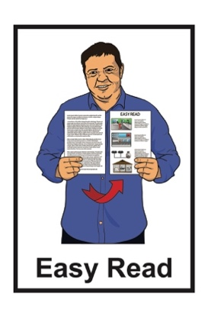
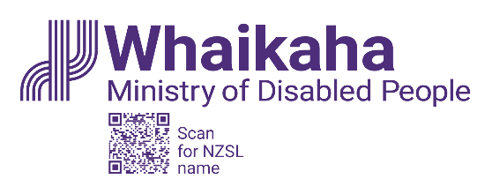

Summary: Pay gap report and diversity and inclusion plan
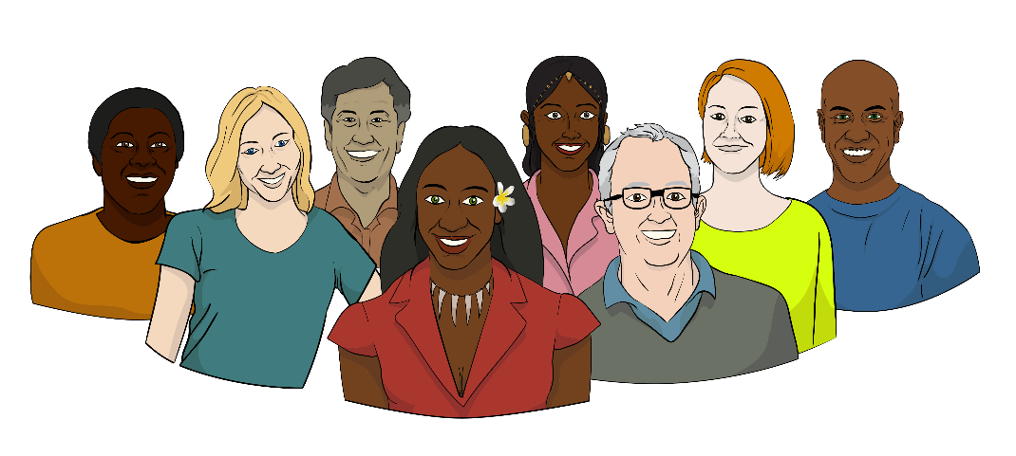

Published: November 2023

What you will find in this document

Page number:
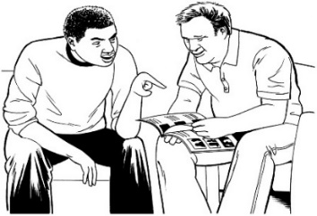
Before you start 3

What is this document about? 4

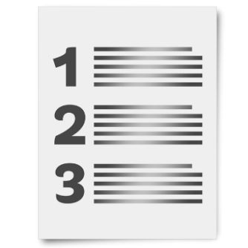
What are diversity and inclusion? 6

What is a pay gap? 7

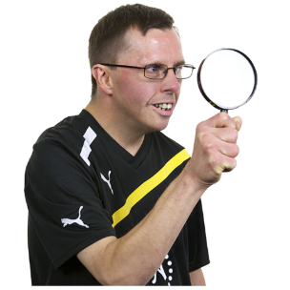
What did Whaikaha want to
know? 10

What rules did Whaikaha use? 11

Page number:
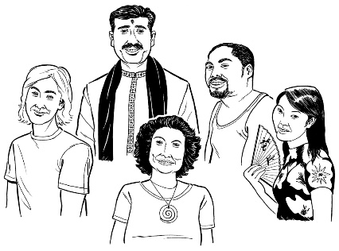

Who works for Whaikaha? 14

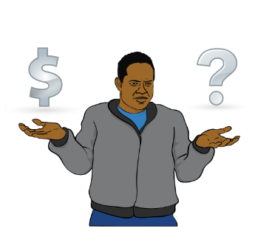
What are the pay gaps at
Whaikaha? 18

What will they do about the
pay gaps? 21
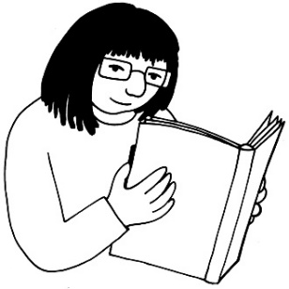

Who is working to fix the
pay gaps? 25
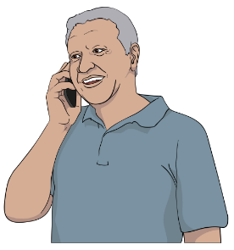

How to contact Whaikaha 28

Before you start

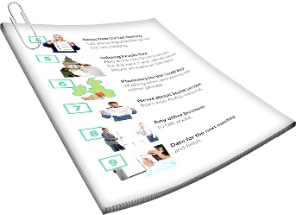
This is a long document.

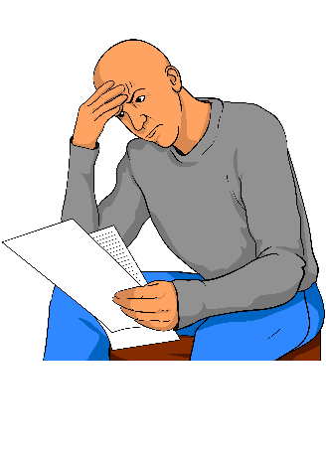
It can be hard to read a document this long.

Some things you can do to make it easier are:
read it a few pages at a time
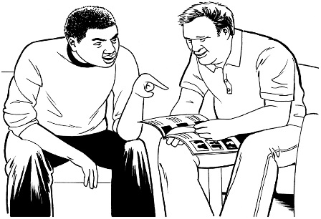
set aside some quiet time to look at it
have someone read it with you to support you to understand it.

What is this document about?

This Easy Read document is summary from Whaikaha – Ministry of Disabled People of:
their diversity and inclusion plan
their pay gap report.

You will find the information about diversity and inclusion on pages 14 to 17.
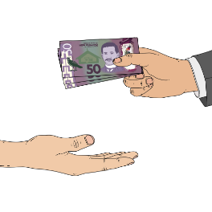

You will find the information about the pay gap report on pages 18 to 27.

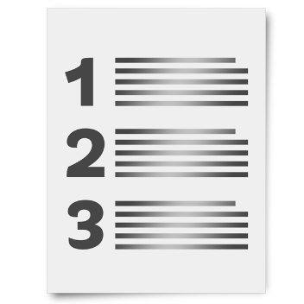
A summary:
is shorter than the main report
tells you the main ideas.

In this document Whaikaha – Ministry of Disabled People is called Whaikaha.

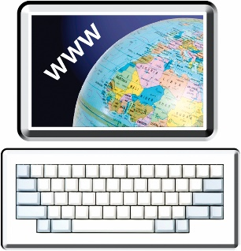
The full report / plan can be found at this website:

www.whaikaha.govt.nz

What are diversity and inclusion?

In the summary Whaikaha talks about their diversity and inclusion plan.

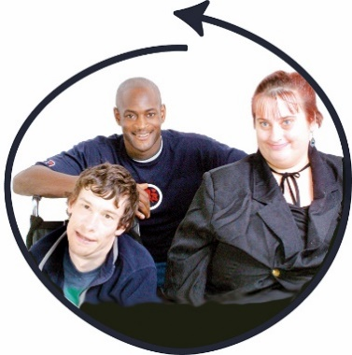
A diversity and inclusion plan is a plan to make sure a workplace has people of different:
genders
ethnicities
disabilities.

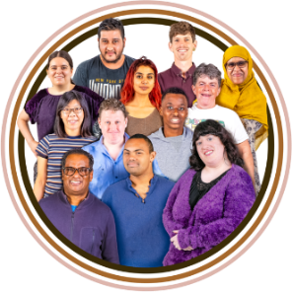
Diversity means people are not all the same.

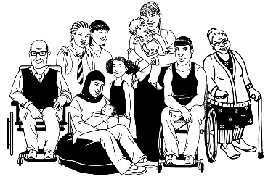
Inclusion means everyone can take part.

What is a pay gap?

In the summary Whaikaha talks about their pay gap report.

A pay gap is when people are paid different amounts of money for the same job because of differences like:
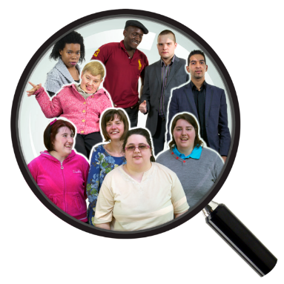
gender
ethnicity
disability.

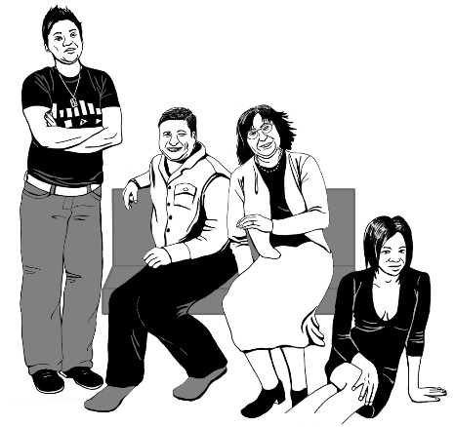
Gender is if you are a:
woman
man
gender diverse person like:
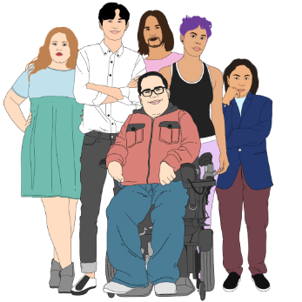
- non-binary
- agender
- takatāpui.

Ethnicity means your:
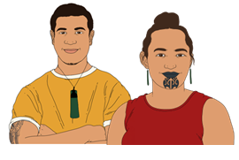
race like:
- Māori
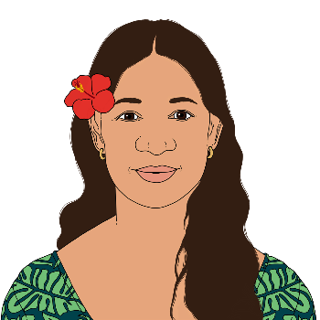
- Samoan
- New Zealand European
background like whether you:
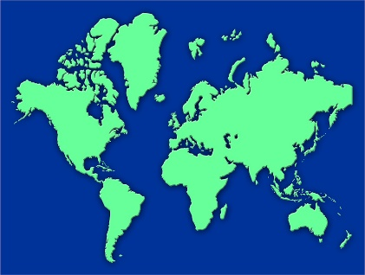
- were born in Aotearoa New Zealand
- moved to Aotearoa New Zealand from another country.
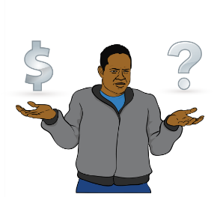

Pay gaps can show where a group of people may be treated in a different way at work.

What did Whaikaha want to know?

Whaikaha wanted to know if:
they had lots of different kinds of people working for them
they were paying their workers fairly.

This was the first time Whaikaha looked for this information.

They wanted to know this information so they could:
get better at including different people.
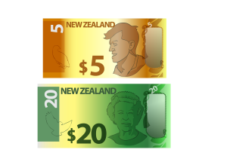
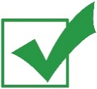
pay people a fair amount for their work.

What rules did Whaikaha use?

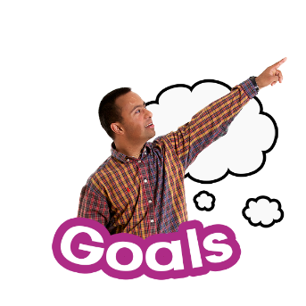
To figure out what Whaikaha needed to know they used the goals from
Te Kawa Mataaho – Public Service Commission.

In this document Te Kawa Mataaho – Public Service Commission will be called the Public Service Commission.
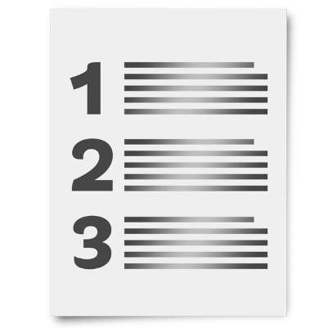
The Public Service Commission supports the Government to:
carry out:
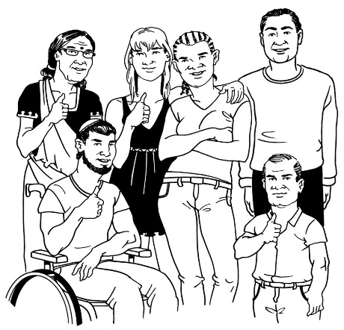
- plans
- rules
make sure everybody in Aotearoa New Zealand can get the services they need.

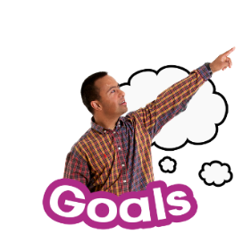
Whaikaha used the Public Service Commission goals of:
Kia Toipoto
Papa Pounamu.

Kia Toipoto is things that can be done to close pay gaps for people working in the public service / government services.
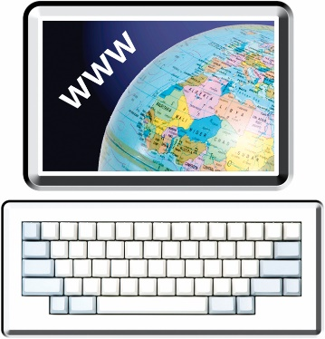
You can find out more about Kia Toipoto on the Public Service Commission website:

tinyurl.com/2hcmrrnc

Papa Pounamu is the programme used to make sure lots of different kinds of people work in the public service.

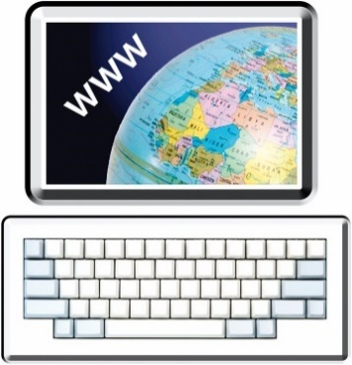
You can find out more about Papa Pounamu on the Public Service Commission website:

tinyurl.com/3y6t2xz5

Who works for Whaikaha?

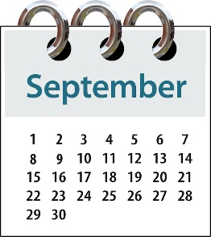
Whaikaha got the data for the report about their workers on
1 September 2023.

Data is sets of:
information
numbers.

Whaikaha have 1 hundred and 94 people working for them.

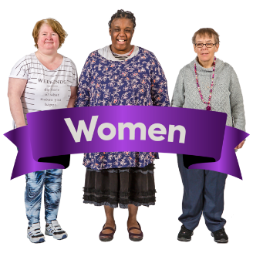
Out of every 1 hundred people who work for Whaikaha 70 of them are women.

Out of every 1 hundred people working for Whaikaha:
about 78 are European
19 are Māori
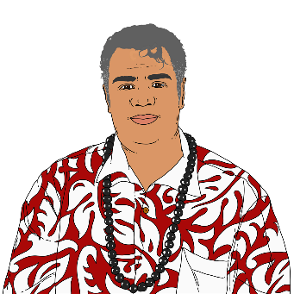
about 8 are Asian
about 7 are Pacific
about 3 are:
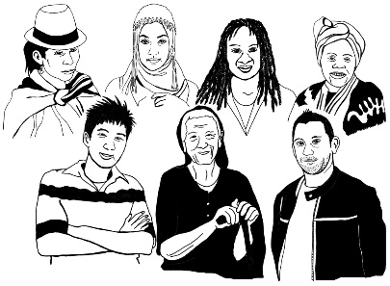
- Middle Eastern
- Latin American
- African.

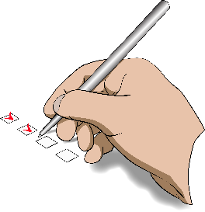
Some people might say they are more than 1 ethnicity.

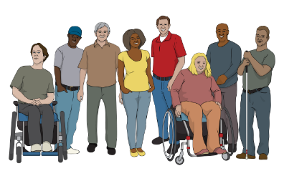
68 people who work for Whaikaha self-identify as disabled.

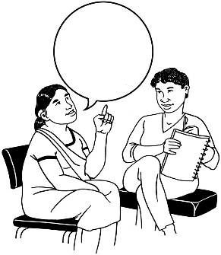
Self-identify means saying you belong to a group of people.

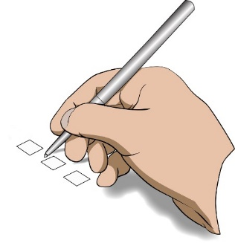
31 people chose not to say if they were disabled.

Whaikaha left out the information of these 31 people.

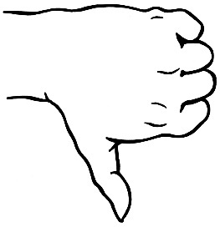
They did this because it is not right to guess if people are disabled.

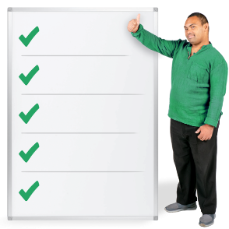
This is a rule Kia Toipoto says is important.

Whaikaha will ask people about their information again in the future just in case anything has changed.

The future is a time that has not happened yet.

This is so Whaikaha can make sure they have the right information.

What are the pay gaps at Whaikaha?

Kia Toipoto rules say Whaikaha need to compare groups of 20 people or more.

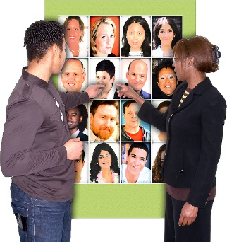
Compare means to look at things in different groups that are the:
same
different.

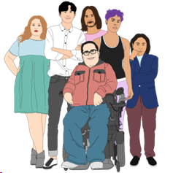
Using the Kia Toipoto rules Whaikaha were able to report on pay gaps for:
gender
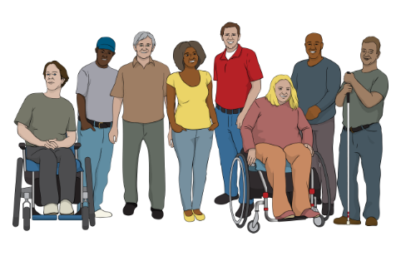
Māori
disabled people.
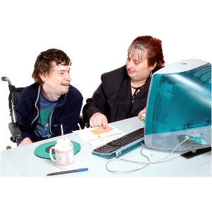
For every 1 hundred people working at Whaikaha about 10 people may have been paid differently because of their gender.

For every 1 hundred people working for the public service in 2022 about 8 may have been paid differently because of their gender.

For every 1 hundred people working at Whaikaha about 5 may have been paid differently because they were Māori.

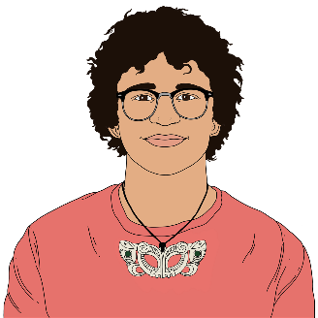
For every 1 hundred people working in the Public Service about 7 may have been paid differently because they were Māori.

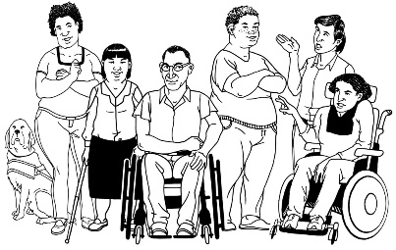
For every 1 hundred people working for Whaikaha about 8 may have been paid differently because they were disabled.
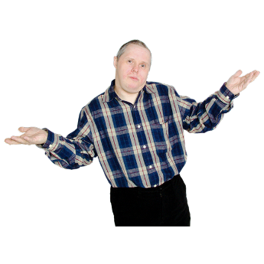

The Public Service Commission does not know what the pay gap is for disabled people.

Whaikaha will have to do more work to figure out if these pay gaps are because of:
gender
ethnicity
disability.

What will they do about the pay gaps?

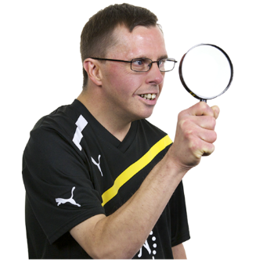
Whaikaha knows they need to find out why these pay gaps are happening.

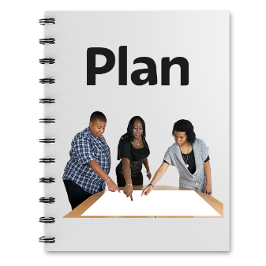
Whaikaha will make a pay gap action plan.

A pay gap action plan is the things Whaikaha will do to make their pay gaps smaller.

Whaikaha knows they have different pay problems because:
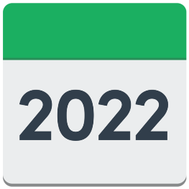
Whaikaha was created in 2022
their workers came from different places in the Government
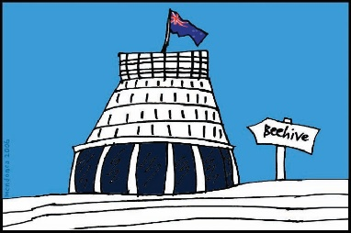
their workers have different pay agreements.

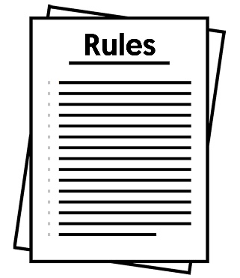
Here pay agreements means the rules workers have for:
how much they get paid
how they do their work.

Whaikaha thinks the old agreements may make pay gaps look different to what they really are.

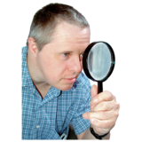
Whaikaha will look at these differences more.

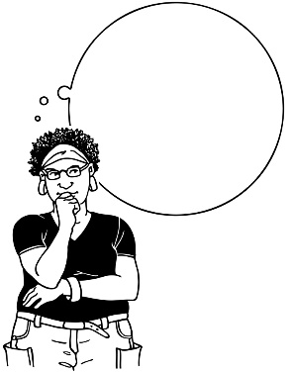
Whaikaha will think hard about rules for fair pay that work for everyone.

Whaikaha knows that when making the rules to fix pay gaps it is important to think about:
fairness
equity.

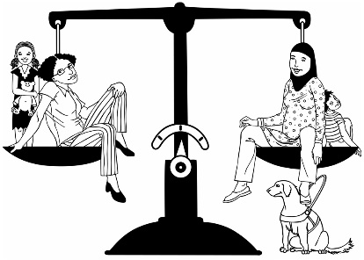
Equity means everyone gets what they need to live a good life.

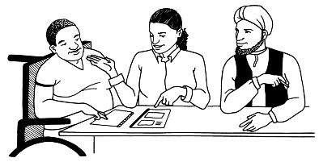
Whaikaha will also talk to their workers about what they think is fair pay.

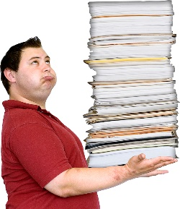
All this work is hard.

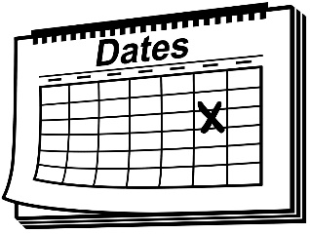
Whaikaha thinks all this work may take up to 2 years to do.

Who is working to fix the pay gaps?

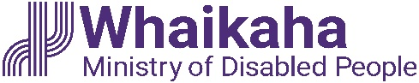
The people at Whaikaha working on the pay gap action plan are the Remuneration Working Group.

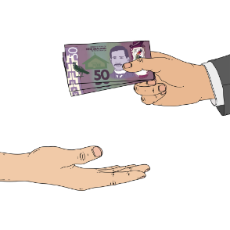
Remuneration means the pay you get for work.

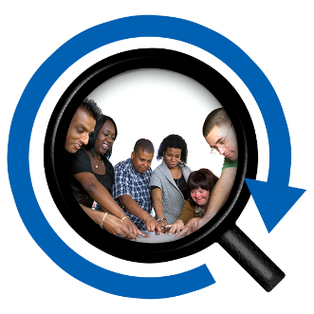
A Remuneration Working Group is a group of people researching things to do with pay.

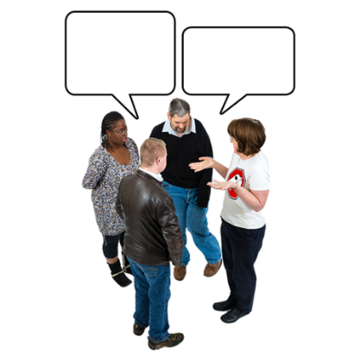
The Remuneration Working Group will talk to people about:
making the rules for fair pay
the fair pay action plan.

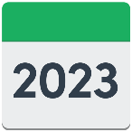
The Remuneration Working Group will do this during:
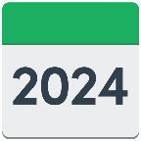
2023
2024.

The Remuneration Working Group think it is important to talk with:
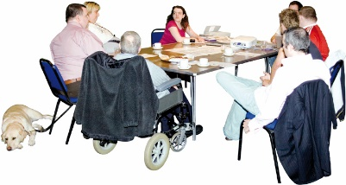
the workers at Whaikaha
the Public Service Association.

The Public Service Association is the union that supports public service workers in Aotearoa New Zealand.

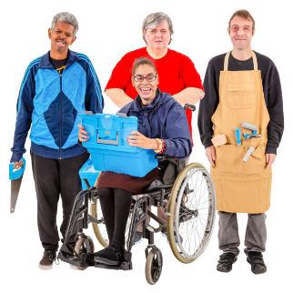
A union is a group workers can join that supports them to be treated fairly at work.
The Deputy Chief Executive People and Culture at Whaikaha is the person who is making sure the fair pay action plan happens.

The Deputy Chief Executive People and Culture is:
1 of a team in charge
the person in charge of People and Culture at Whaikaha.
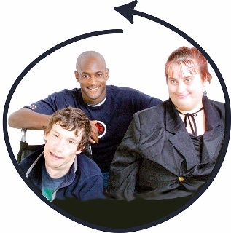

People and Culture is a group at Whaikaha that makes sure all kinds of people get to work with them.

How to contact Whaikaha

You can contact Whaikaha by:
email at:
contact@whaikaha.govt.nz

phone on:
0800 566 601

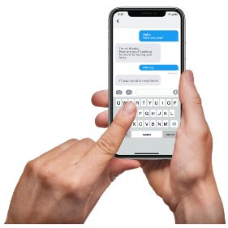
text on:
4206

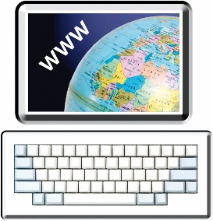
You can find more about how to contact Whaikaha on their website at:

www.whaikaha.govt.nz/contact-us

If you find it hard to use the phone the New Zealand Relay service is for people who are:

- Deaf / hard of hearing
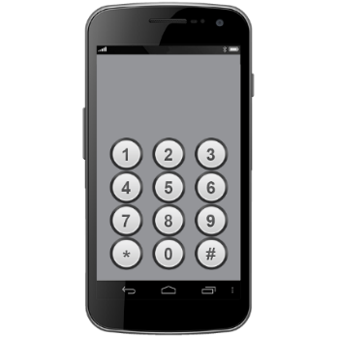
- deafblind

- speech impaired / find it hard to talk.

You can find out more about the New Zealand Relay service at:

www.nzrelay.co.nz

This information has been written by Whaikaha – Ministry of Disabled People.

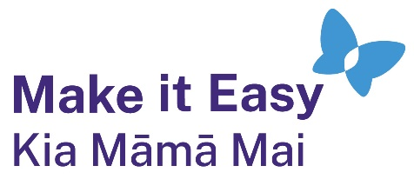
It has been translated into Easy Read by the Make it Easy Kia Māmā Mai service of People First New Zealand Ngā Tāngata Tuatahi.
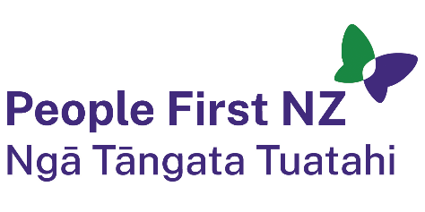
The ideas in this document are not the ideas of People First New Zealand Ngā Tāngata Tuatahi.
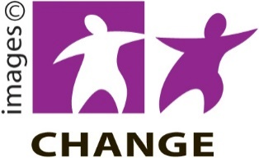
Make it Easy uses images from:

- Changepeople.org

            - Photosymbols.com

- SGC Image Works
- Huriana Kopeke-Te Aho
- T. Wood.
All images used in this Easy Read document are subject to copyright rules and cannot be used without permission.

