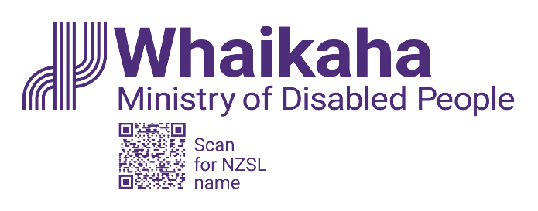

Combined Kia Toipoto (pay gap) and Diversity and Inclusion plan
Whaikaha – Ministry of Disabled People
November 2023

Executive Summary of the pay gap report
This is the first diversity and inclusion action plan for Whaikaha – Ministry of Disabled People.
It combines our pay gap report for Whaikaha, with our diversity and inclusion action plan, mapped to Te Kawa Mataaho - Public Service Commission’s Kia Toipoto and Papa Pounamu public service goals for this period.
Given we are a new organisation participating for the first time, our action plan outlines our planned activities to establish good pay and diversity and inclusion practices.

Our current pay gaps
To report on our pay gaps in a statistically robust way, Kia Toipoto guidance requires comparator groups of twenty people or more. This means that this year we can report our gender, Māori and disability pay gaps.
- Our gender pay gap is 10.2%, compared to a public service pay gap in 2022 of 7.7%.
- For our Māori employees, our average pay gap of 4.9% is lower than the 6.5% public service average.
- Our pay gap for disabled people is 8.1%. There is no public service comparison information available this year.

Our pay gaps tell us that we have work to do, to analyse, understand and correct any pay gaps that cannot be reasonably explained.
Whaikaha has some unique remuneration issues to work through given how the Ministry was established in 2022, when teams from different agencies were brought together. We expect that the current legacy arrangements may, in some instances, be distorting our view of pay gaps, with further, detailed analysis required to establish all causes.
Core principles for the Remuneration Working Group will include creating a fair and equitable approach to remuneration at Whaikaha.

Our action plan for 2024 includes:
- Working with our people and the PSA to develop future action plans and consider how to create a remuneration framework for Whaikaha (noting that this work is complex and may take up to 24 months).
- Refining our recruitment approach to ensure it is accessible and inclusive.
- Implementing updated starting salary guidelines.
- Supporting the establishment of employee-led networks at Whaikaha.
- Reviewing our accessibility, reasonable accommodations and flexibility practices.
- Developing a cultural capability plan.
- Setting the foundations for career pathways.
- Developing an internship programme that promotes pathways to employment for disabled people.
- Co-designing our Whaikaha values and behaviours to identify and enable positive workplace behaviours.

End of information: Combined Kia Toipoto (pay gap) and Diversity and Inclusion plan

This Large Print document is adapted by Blind Citizens NZ from the standard document provided by Whaikaha Ministry of Disabled People

