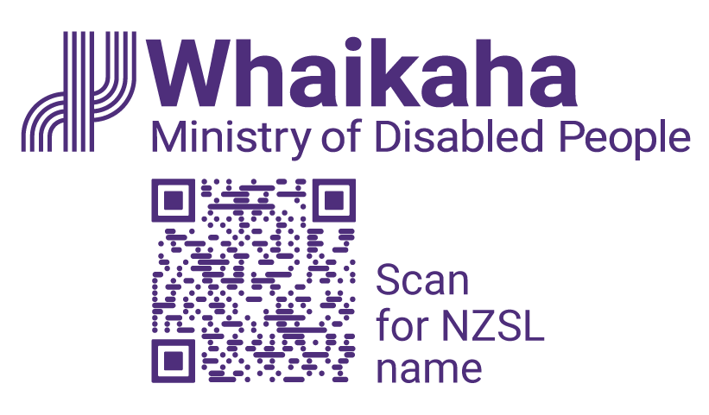
Introduction of the Insights Alliance and its members
Adapted in 2024 by Accessible Formats Service, Blind Low Vision NZ, Auckland

TN: The logo on the top of the page is Whaikaha Ministry of Disabled People.

Introduction of the Insights Alliance and its members
The Insights Alliance is a collaborative leadership group.
Alternate formats are available at Insights Alliance | Whaikaha - Ministry of Disabled People (tinyurl.com/bdhp76yd).
The Insights Alliance provides oversight of the monitoring and evaluation of key areas of work. These areas are:
- Enabling Good Lives (EGL) and the transformation of the disability support system based on the EGL Vision and Principles.
- The implementation of the Monitoring, Evaluation, Analysis and Learning (MEAL) Strategic Framework.
More information on Enabling Good Lives (EGL) and System Transformation is available on the System Transformation and Enabling Good Lives page (tinyurl.com/3xhsnztk) on the Whaikaha website.
More information on the MEAL Strategic Framework can be found on the MEAL Strategic Framework page (tinyurl.com/3kmba4kd) on the Whaikaha website.
We will inform the community through a range of channels, including publishing the insights from the meetings on our website twice per year, inviting people to attend Insights Alliance meetings and give them the opportunity to talk to our members. We will also hold an online hui to hear from the community.

Current membership of the Insights Alliance
The Insights Alliance is led by disabled people and tāngata whaikaha Māori members from the community and Whaikaha – Ministry of Disabled People. The group also includes Pacific disabled people, whānau/family members of disabled people, and a representative from a disability support provider.
The current members of the Insights Alliance were appointed in October 2023 for a three-year term.
The members are:

Mark Benjamin (Co-Chair)
Mark is currently a Director of Catalyst Aotearoa and Executive Officer for the Enabling Good Lives National Leadership Group. Mark has been involved in various youth/community work and adult education roles, including several in the disability sector, since the early 1980s.
Mark previously worked with the Standards and Monitoring Services (SAMS), which leads international approaches to having disabled people and their families playing a key role in the development of monitoring and evaluation services.
Since 1994, Mark has had an interest in developmental evaluation approaches. Mark contributed to the original Enabling Good Lives report in 2011 and was involved in the Christchurch, Waikato and Midcentral Enabling Good Lives demonstrations as well as growing regional leadership initiatives.

Fran Kewene (member)
"Tena koutou katoa. Ko Tainui te waka. Ko Karioi to maunga. Ko Waikato me Ngati Maniapoto ngā Iwi. Ko Ngāti Whakamarurangi, Ngāti Hikairo, Ngāti Mahuta, Ngāti Haua ōku hapū. Ko Francis Kewene tōku ingoa"
Fran identifies herself as a mum, sister, aunty, creative wāhine Māori, whānau haua. She is the mother of two young adults and her youngest is autistic and non-verbal.
In 2016 she helped establish a disability support whānau roopu (group) in Dunedin called Aspire Kids Tamariki Matanā. She is also a founding and current Board member of Te Ao Mārama Trust (TAMA) and was a TAMA representative in the establishment of the Transitional Insights Alliance.
Currently Fran is a member of the governance board for the Porirua Localities Prototype as a representative voice for tāngata whaikaha Māori. She is also a trainee Māori evaluator of providers with Whakanui and studying for her PhD which explores kaupapa Māori theatre-based research to explore what a "Good life" means for Māori mothers with autistic children.

Dr Diane Lystette Mara MNZM (member)
Diane is currently an independent Pacific consultant following a long career in Pacific educational policy, research, evaluation and teacher education.
Diane's consultancy work has included Pacific community development, consumer and disability health, the Pacific Panel for Oranga Tamariki, Education Review Office, Universities of Auckland, Victoria University and Canterbury University.
She is a mother and advocate for her autistic non-verbal son, and she completed her doctorate in 2007 on The Social Construction of Ethnic Identity: Pacific Women Graduates.

Bernadette Jones (Co-Chair)
Bernadette Jones (Ngā Wairiki, Ngāti Apa) is a senior research fellow at the University of Otago, director of the Foundation for Equity and Research New Zealand, and chair of the tāngata whaikaha Māori Central Region Rōpū (Group).
Bernadette has lived experience of disability, and she is passionate about creating mechanisms for community voices to be included, especially for tāngata whaikaha Māori.
As a researcher, she has developed kaupapa Māori methodologies that support community partnership approaches. Bernadette also consults across various government sectors to promote the rights of tāngata whaikaha Māori, their whānau and communities to be supported to monitor and co-design improved health and disability services/policies that will achieve equitable outcomes for Māori.

Mel Rice (member)
Melissa (Mel) Rice is of Ngā Puhi, Te Rarawa and Te Aupouri descent. Mel has worked for Access Community Health – Uru Ātea for 19 years in various roles and has gained extensive knowledge and experience in delivering disability support services.
As the Tumuaki mō Whakamana Tāngata, Mel currently leads Access Community Health's disability portfolio and Māori health strategy, striving to address the existing inequities and enhance the mana of tāngata whaikaha Māori and their whānau.

Helena Tuteao (member)
"Tēnā koutou katoa, ko Taupiri te maunga, ko Waikato te awa, ko Ngāti Mahuta te hapuu, ko Poihakena te marae, ko Tainui te iwi."
Helena has lived experience of disability and 20 years' experience in a variety of roles in the disability sector. This includes, supported living coordination, policy analysis and research and evaluation.
She is passionate about achieving social justice and equity by, and with disabled people and tāngata whaikaha Māori. She is also passionate about prioritising investments in communities.
Since 2013 Helena has been on the Waikato Leadership Group of Enabling Good lives as a disabled person and tangata whenua. She currently works for My Life My Voice as a Community Capacity Builder Lead, prioritising investing in disabled people and communities.

Latoa Halatau (member)
Latoa has lived experience of disability being legally Blind. He has extensive experience in the disability sector, with over 30 years of governance and leadership experience, engaging with diverse communities and marginalised groups.
Latoa has been on the National Enabling Good Lives Leadership Group since 2013 and is currently co-chair of the International Pacific Disability Forum. He is also the Pacific Disability representative on the Health and Disability Commission's Consumer Advisory Group.

Trish Davis (Crown member)
Trish Davis (Ngāti Maniapoto) has worked in the health and disability sector for over 25 years in commissioning and service delivery roles.
Trish returned to the Disability Directorate, Ministry of Health in 2020 and most recently has been Acting Chief Advisor, Commissioning Design and Delivery at Whaikaha before moving into the new Group Manager Quality and Insights role.

Dr Pauline Boyles (Co-Chair, Crown member)
Dr Pauline Boyles is co-chair of the Insights Alliance on behalf of Whaikaha. She is currently a Principal Advisor within the Policy Strategy and Partnership Group and is leading the work on the MEAL Strategic Framework.
She has worked in the disability sector for more than 40 years. She has a PhD in social work and social policy and since then has replicated her research on partnership for transformation in three different settings. Pauline, has been pivotal in the development of important partnerships with disabled people, led by disabled people and tāngata whaikaha Māori in all her roles.

How were the Insights Alliance members selected?
Members of the Insights Alliance were appointed in November 2023 following a rigorous selection process by Whaikaha and a panel of independent community leaders. This new group replaces the former interim Insights Alliance group that was set up in 2021.
The selection panel sought advice and support from relevant community, partnership, and nominating groups before finalising the group membership.
Other nominees were invited to form a community of practice, to work with the Insights Alliance periodically during 2024.
Nominations for membership closed on 11 September 2023.

How to contact the Insights Alliance
If you want to ask any questions or want to contact a member of the Insights Alliance, please email community_admin@whaikaha.govt.nz

How to contact Whaikaha
If you want to get in touch, please visit our website at www.whaikaha.govt.nz/contact-us/
You can also call us on:
Phone: 0800 566 601
Text: 4206
Monday, Tuesday, Thursday, Friday: 8am - 5pm.
Wednesday: 9:30am - 5pm
New Zealand Relay is a telecommunications service for people who are Deaf, Deaf-blind, experiencing hearing loss or have a speech condition: www.nzrelay.co.nz
End of Introduction of the Insights Alliance and its members

