Whanau Ora outcome goals | Enabling Good Lives principles | United Nations Declaration on the rights of Indigenous Peoples (UNDRIP) Standards | United Nations Convention on the Rights of Persons  with Disabilities Articles
Whānau are self-managing | Self-determination | Self-determination 3, 4, 5 | Self-direction, Clauses N and O in the Preamble
Whānau are living healthy lifestyles | Beginning Early | Health 24 | Health, Article 25  Habitation, Article 26
Whānau are participating fully in society | Person Centred | Equality 2 | Awareness raising, Article 8  Living independently and being involved in the community, Article 19  General obligations – human rights and fundamental freedoms  Accessibility, Article 9
Whānau are confidently participating in Te Ao Māori | Ordinary life outcomes | Indigeneity, culture; language 9, 11, 13 | Participation in cultural life, recreation, leisure and sport, Article 30
Whānau are economically secure and successfully involved in wealth creation | Mainstream first | Economic activities; special measures 20, 21 | Work and employment Article 27  Adequate standard of living and social protection, Article 28
Whānau are cohesive, resilient and nurturing | Mana enhancing | Life, liberty and security; dignity and diversity; specific groups 7, 15, 22 | Article 17, Liberty of movement and nationality  Article 18, Respect for home and family  Article 23, Protecting the integrity of the person
Whānau are responsible stewards of their living and natural environment | Easy to use | Environment 25 | Accessibility, Article 9
 | Relationship building |  | Living independently and being involved in the community, Article 19
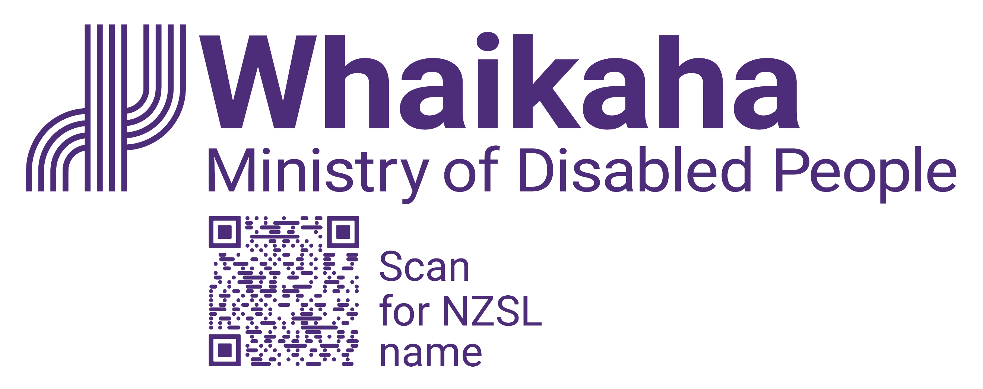
Relevant frameworks mapped to
Enabling Good Lives principles
Published July 2023

