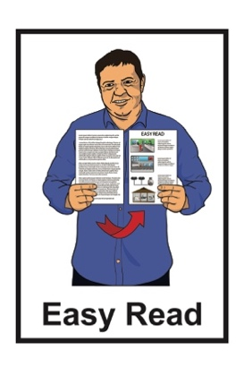
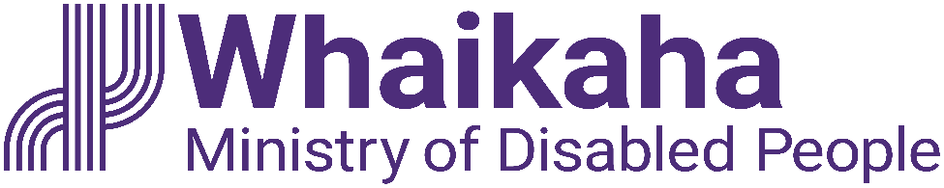

The MEAL Strategic Framework

Published: May 2023

About this document

This document is from Whaikaha – Ministry of Disabled People.

Whaikaha is a new part of the
New Zealand Government that is:
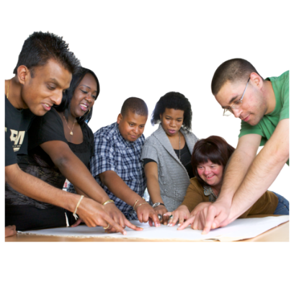
- using an Enabling Good Lives way of doing things
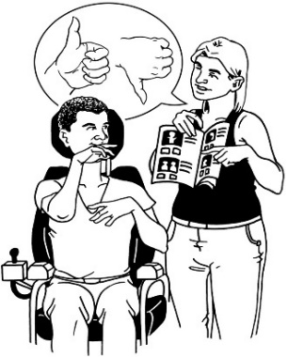
- working with other government agencies to better support disabled people
- making disability support services better.

Enabling Good Lives is about disabled people having:
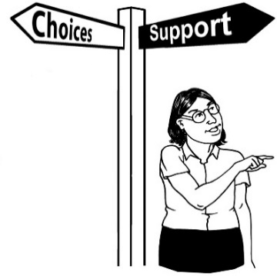
- choice and control in their life
- the support they need and want
- a good life.

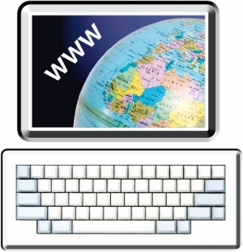
You can read more about the Enabling Good Lives ideas at this website:

www.enablinggoodlives.co.nz/
about-egl/egl-approach/principles/

In this document we will also call Enabling Good Lives EGL.

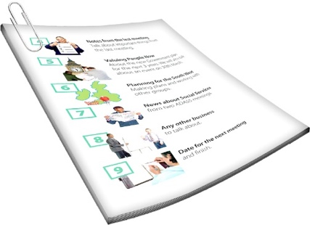
This document is about something called the MEAL Strategic Framework.
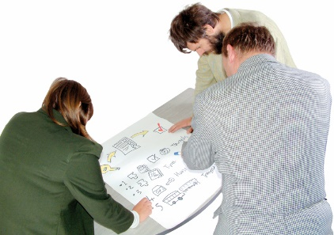
A Strategic Framework is a document that sets out a plan for how an agency will work on things.

The letters in MEAL stand for the work that will be done including:
Monitoring
Evaluation
Analysis
Learning.
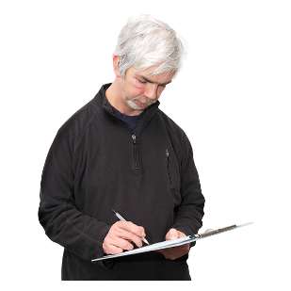

Monitoring means checking how things are going.

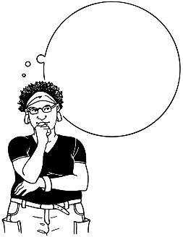
Evaluation and Analysis are ways of:
- understanding the information we get from monitoring
- finding out more about:
- what is happening
- why things are happening the way they are.
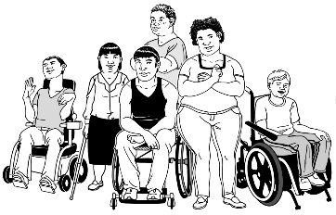
The MEAL Strategic Framework was made together by:
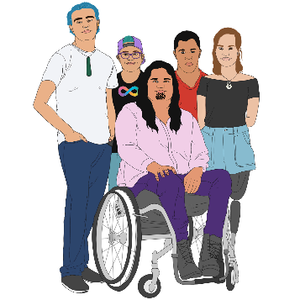
disabled people
tāngata whaikaha Māori / Māori disabled people
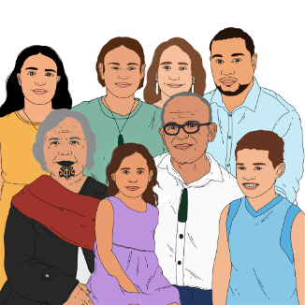
whānau / family
the Crown.
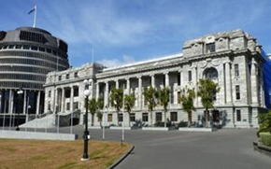
The Crown means:
the Government
the people who work in government departments.
The MEAL Strategic Framework is based on the Enabling Good Lives ideas.

The MEAL Strategic Framework uses ideas from Enabling Good Lives to:
check how things are going
understand what is happening
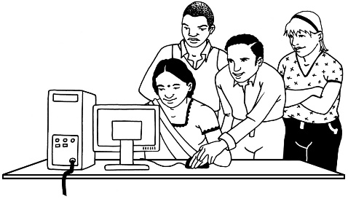
learn from what we find out.

Why are things changing?

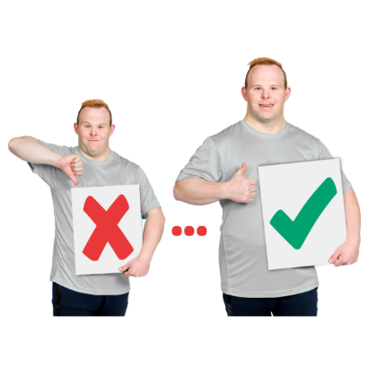
People have been saying for a long time that the way disability support works needs to change.

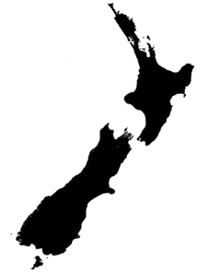
Some different ways of doing things have been tried out.

The Government has now agreed to use Enabling Good Lives for disability support in all of New Zealand.

It is not just disability support that needs to work in an Enabling Good Lives way.

MEAL work also needs to be changed to fit with Enabling Good lives.

Some of the ways MEAL is done now do not work to give disabled people / tāngata whaikaha Māori control over their lives.

How should we do things differently?

Working in an Enabling Good Lives way means moving things over to:
disabled people
tāngata whaikaha Māori / Māori disabled people
whānau / family.

Moving things over means changing things like:
- who makes decisions
- resources.

Resources are things you need to do a job well like:
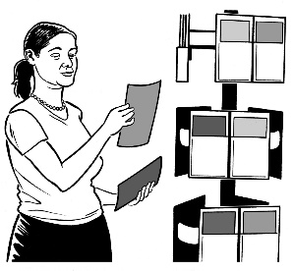
- money
- information
- people to do the work.

Disabled people / tāngata whaikaha Māori need to be part of all parts of MEAL including leadership.

Leadership means:
making decisions
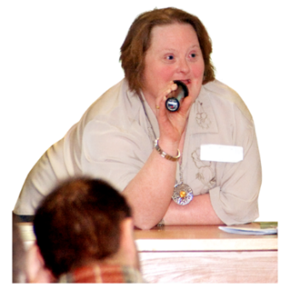
showing people good ways to do things.

MEAL that is a good fit with Enabling Good Lives needs:
- resources
- leadership by and for:
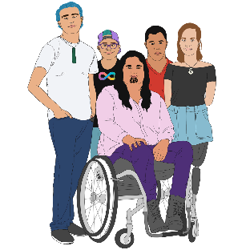
- disabled people
- tāngata whaikaha Māori / Māori disabled people
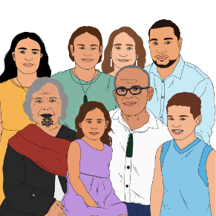
- whānau / family
- people working together following the principles of Te Tiriti o Waitangi.
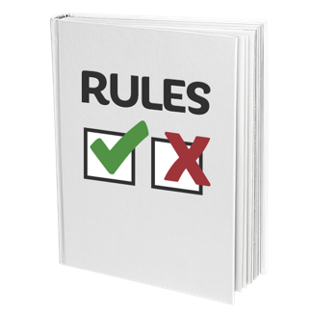

Principles are rules that tell people how to act / behave.

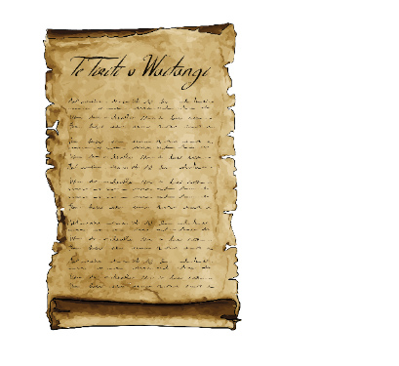
Te Tiriti o Waitangi / Treaty of Waitangi is an important agreement between Māori and the British Crown.
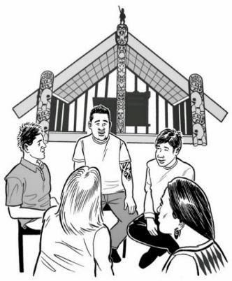
Te Tiriti o Waitangi / Treaty of Waitangi is about Māori and the New Zealand Government:
- making decisions together
- protecting things that are important to Māori.

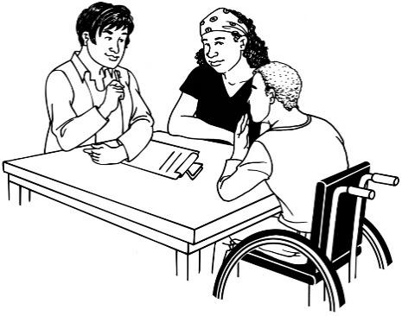
MEAL that is a good fit with Enabling Good Lives also needs a tripartite approach.

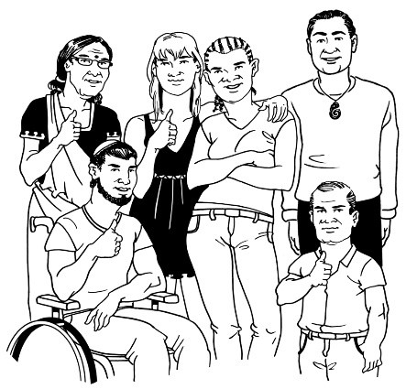
A tripartite approach means 3 different groups share duties / goals to:
make sure things happen
sort things out if they go wrong.

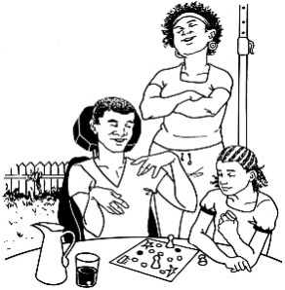
The 3 groups that are part of the tripartite approach are:
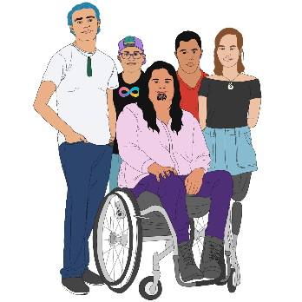
disabled people and the whānau / family of disabled people
tāngata whaikaha Māori / Māori disabled people
the Crown.

Other important parts of making MEAL work in an EGL way are:
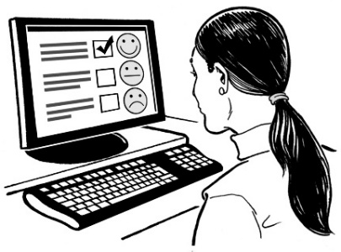
MEAL work playing a part in making the disability support system fairer for Māori
having independent voice mechanisms.

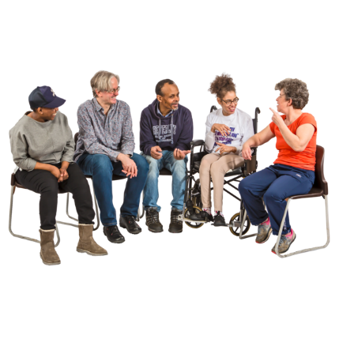
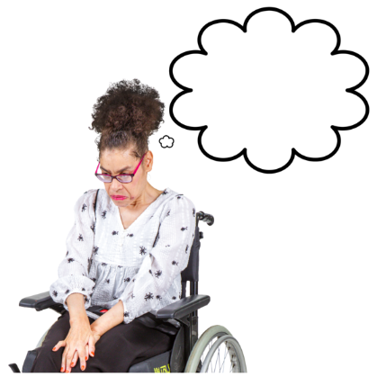
Independent voice mechanisms are a way of finding out what people in the disability community think.

These ways support disabled people to say what they think without being scared that their disability support / services might be taken away.

What are the MEAL strategic shifts?
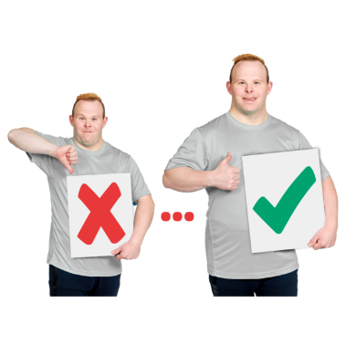

The MEAL strategic shifts are changes in how MEAL work in the disability system is done.

These changes are to support MEAL work being led by:
disabled people
tāngata whaikaha Māori / Māori disabled people
whānau of disabled people.

This means that things found out by MEAL work in the disability system can be used as part of:
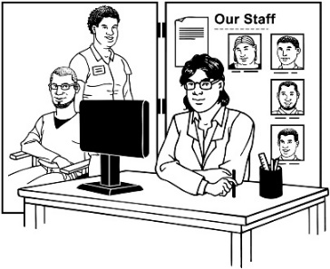
making policy
changing how disability services work.
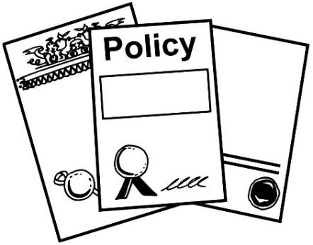
Policy is like a set of rules about how an organisation / the Government does things.

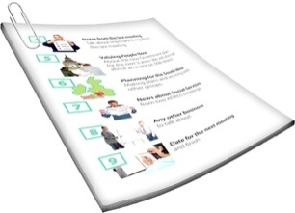
There are 4 strategic shifts.

Shift 1 is about:

MEAL work in the disability system being done by / with people all working together with the Crown including:
- disabled people
- tāngata whaikaha Māori
- whānau.

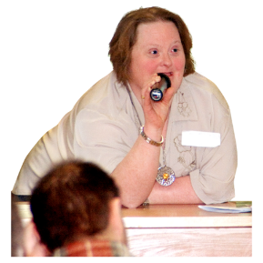
This means people in these groups will:
lead the work
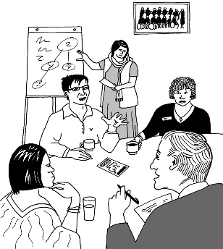
work out how the work will be done
do the work.

Shift 2 is about:

MEAL work in the disability system following the principles of Te Tiriti o Waitangi.

Shift 3 is about:

MEAL work in the disability system being used to make things better for:
- disabled people
- tāngata whaikaha Māori
- whānau / family.

Shift 4 is about:
MEAL work in the disability system using the right:
- tools which are what you use to do things
- systems which are how things work together.

What happens next?

The Strategic Plan has a list of things that are likely to happen.

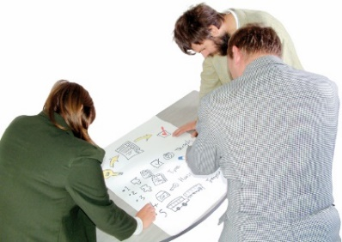
We are working on a plan with lots more information about how things will be done.

These things will happen at the same time as the changes to make disability support work in an Enabling Good Lives way.

We think it is a good idea for a group called the Insights Alliance to work on making the MEAL way of doing things happen.

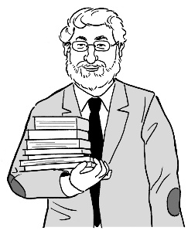
The Insights Alliance includes people who know a lot about the kinds of work MEAL is all about.

The people in the Insights Alliance include:
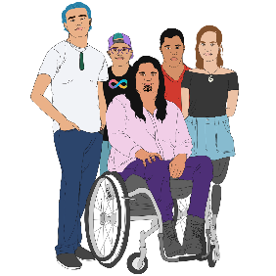
disabled people
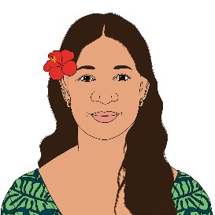
tāngata whaikaha Māori / Māori disabled people
Pacific disabled people
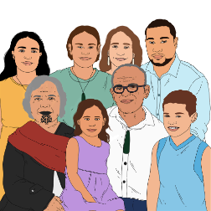
whānau
people who work for the Government.

How do we know we have done
a good job?

We will know we have done a good job with making MEAL happen when:
the leaders in doing MEAL are:
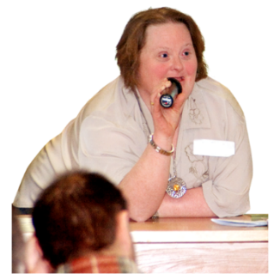
- disabled people
- tāngata whaikaha Māori
- whānau / family
independent voice mechanisms are linked to things being made better in:
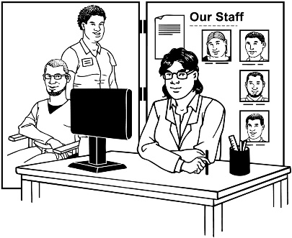
- Whaikaha – Ministry of Disabled People
- the disability support system.

We will also know we have done a good job with making MEAL happen when:
monitoring and evaluation that is already done better fits with the EGL ideas
MEAL systems are accountable to:
- disabled people
- tāngata whaikaha Māori
- whānau.

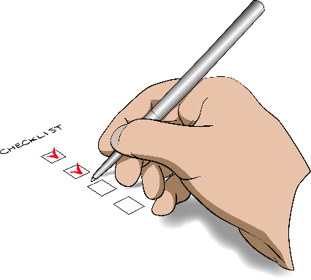
Accountable to means that the people the MEAL systems work for get to:
check things are going well
have things sorted out if they go wrong.
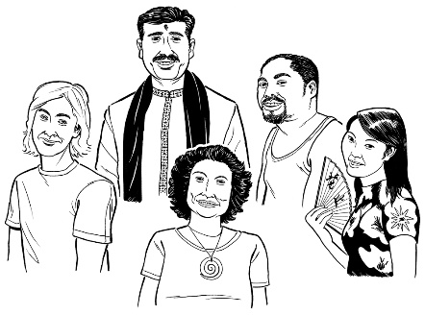
We will also know we have done a good job with making MEAL happen when the ways MEAL are done are a better fit for different cultures.

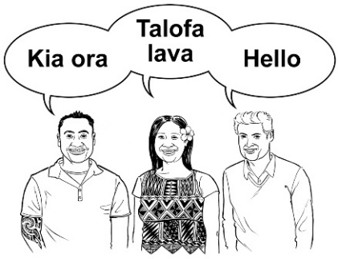
Culture is a way of:
thinking that a group shares
doing things as a group.
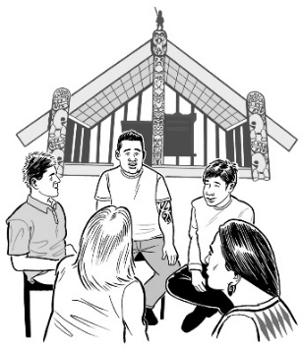

There are many different cultures in
Aotearoa New Zealand like:
Māori culture
Pacific culture
Deaf culture.

Where to find more information

You can find more information about the MEAL Strategic Framework on the Whaikaha website:

www.whaikaha.govt.nz/about-us/policy-strategies-and-action-plans/meal-strategic-framework

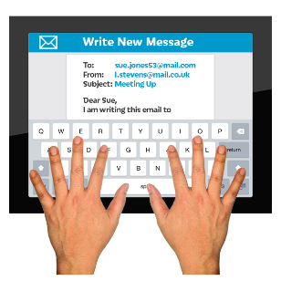
You can also contact Whaikaha by:
          - Email: contact@whaikaha.govt.nz
- Phone: 0800 566 601

- Text: 4206
          - Website: www.whaikaha.govt.nz
          - Facebook: www.facebook.com/whaikaha.govt
This information has been written by Whaikaha – Ministry of Disabled People.

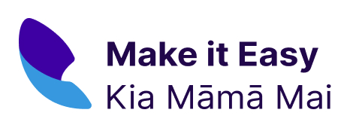
It has been translated into Easy Read by the Make it Easy Kia Māmā Mai service of People First New Zealand Ngā Tāngata Tuatahi.

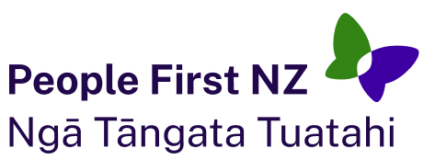
The ideas in this document are not the ideas of People First New Zealand
Ngā Tāngata Tuatahi.

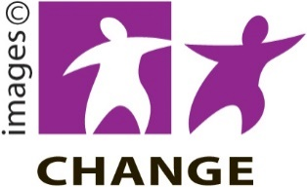
Make it Easy uses images from:

- Changepeople.org

- Photosymbols.com

- SGC Image Works

- Huriana Kopeke-Te Aho.
All images used in this Easy Read document are subject to copyright rules and cannot be used without permission.

