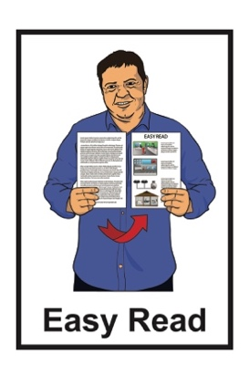

How to be part of the
My Home, My Choice
steering group

Published: May 2023

What is this document about?
This Easy Read document is from Whaikaha – Ministry of Disabled People.
Whaikaha is working on a programme called My Home,
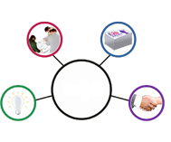
My Choice.
A programme is work that looks to make something better.

The My Home, My Choice programme looks at what changes are needed so that people in residential services have more:
choice in their lives
control in their lives.
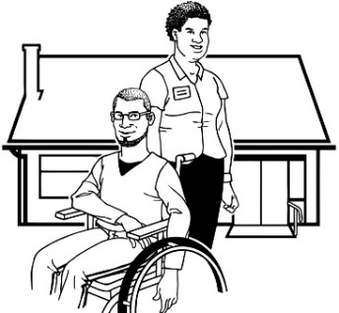
Residential services are when disabled people:
live in a house in the community
- get support all through the
day / night.

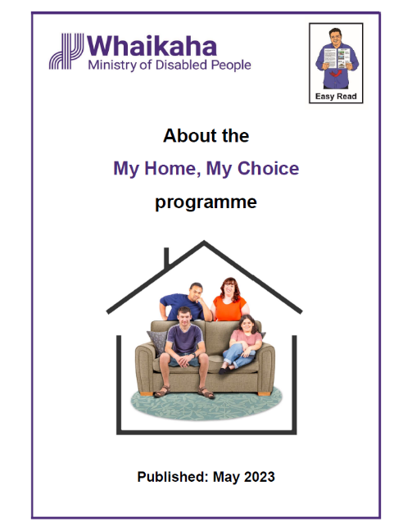

You can find out more about the programme in the Easy Read document called:

About the My Home, My Choice programme.

You can find this document on the Whaikaha website at:
www.whaikaha.govt.nz/about-us/policy-strategies-and-action-plans/my-home-my-choice

The My Home, My Choice programme includes a steering group.

A steering group is a group of people who guide the work being done on the programme.

The people who are chosen to be part of the steering group will get money for the work they do.

Some of the people who are chosen to be part of the steering group might have accessibility needs like needing:
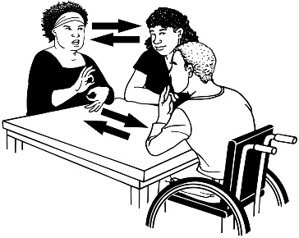
New Zealand Sign Language interpreters
support when taking part in meetings.

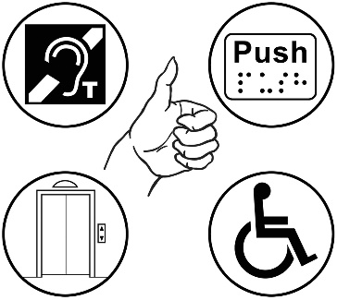
Accessibility needs are when a disabled person needs support to do the things / work they want to do in the same way as someone who is not disabled.

Whaikaha will make sure the accessibility needs of steering group members are taken care of / paid for.

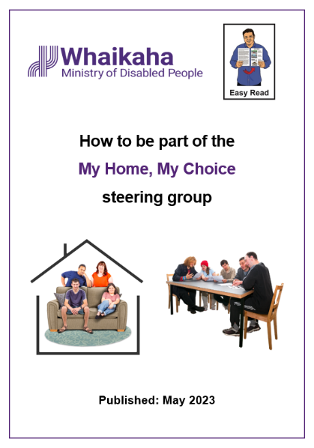
This Easy Read document will tell you:
who can be part of the steering group
how the steering group will work
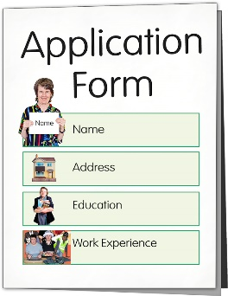
how to apply to be part of the steering group
how members of the steering group will be chosen.

Who can be part of the steering group

Whaikaha want to put together a My Home, My Choice steering group that has:
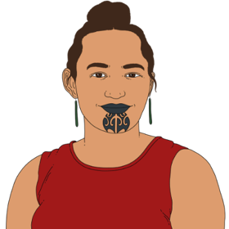
- a disabled leader

- a tāngata whaikaha Māori / disabled Māori leader
- a leader from the Pacific disability community
- a whānau / family leader
- a leader from an organisation that has residential services
- a leader who knows a lot about working in an Enabling Good Lives way.

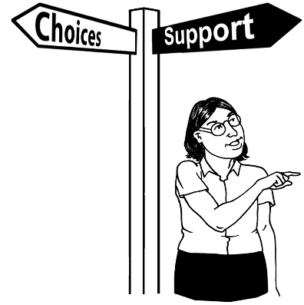
Enabling Good lives is a different way of thinking about disability support.

Enabling Good Lives in about having:
- choice and control in your life
- the support you need and want
- a good life.

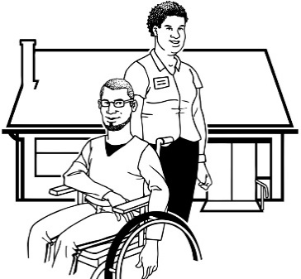
All the people in the steering group will:
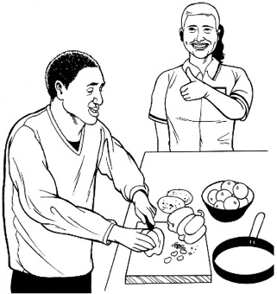
- have lived in or know a lot about residential services
- know what a good home / living situation would look like for them / their community
- know about alternatives to residential care.
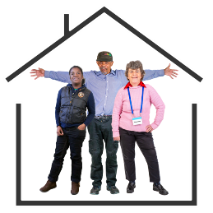
Alternatives to residential care is about people having more choice / control about where they live in the community while still getting support to live well.

Whaikaha also want people on the steering group who:
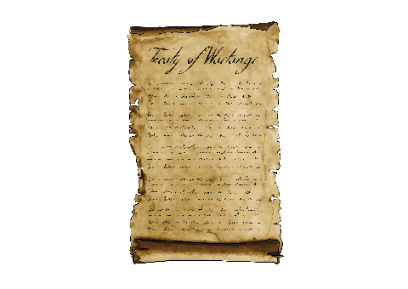
- know how Enabling Good Lives works
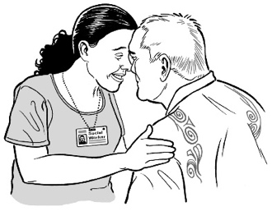
- know about Te Tiriti o Waitangi / The Treaty of Waitangi
- understand Te Ao Māori / the Māori world
- have good connections with the disabled community.

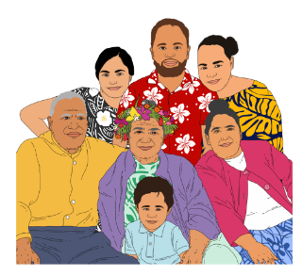
It will also be good if the people on the My Home, My Choice steering group know about:
- Pacific communities
- migrant / refugee communities
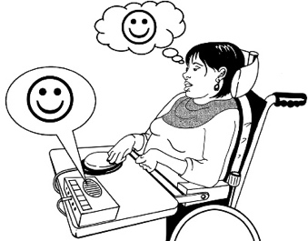
- augmentative communication or an understanding of communicating with people who are not able to speak
- LGBTQIA+ community
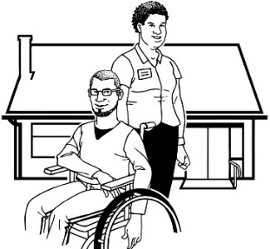
- different ways that residential services can work
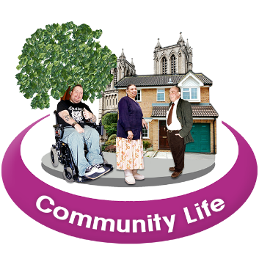
- safeguarding so disabled people can make their own decisions
- ways to build stronger communities.

Migrant communities are made up of people who have left their home countries looking for a better life somewhere else.

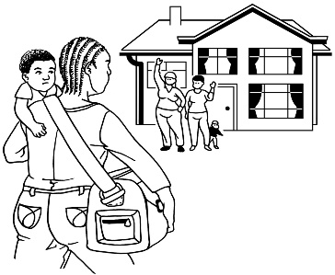
Refugee communities are made up of people who have had to leave their home countries as they were no longer safe.

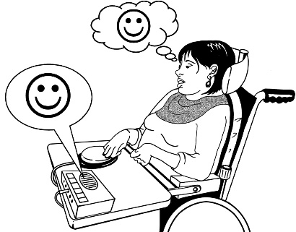
Augmentative communication is about the tools that support someone who has difficulty talking to communicate.

LGBTTQIA+ stands for people who are:
- Lesbian
- Gay
- Bisexual
- Transgender
- Takatāpui
- Queer
- Intersex
- Asexual
- + is for other people who fit in similar groups.

Safeguarding means making sure that disabled people:

- get their human rights

- keep safe from harm and abuse.

How the steering group will work

Steering group members will spend
4 hours a month doing work for the steering group.

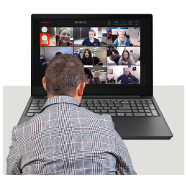
Of these 4 hours:
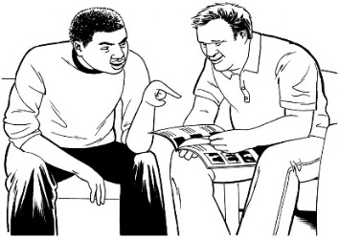
- 2 hours a month will be for online meetings
- 2 hours a month will be reading / getting ready for meetings.

Online meetings means you will need to have:
- your own device like a computer or tablet
- access to the internet.
Online meetings will happen once a month.

Each meeting with be 2 hours long.

There will be a short break during the meeting.

The steering group will get Terms of Reference at their first meeting.

Terms of Reference is a document that sets out:
- what the steering group will do

- how the steering group will get the work done.
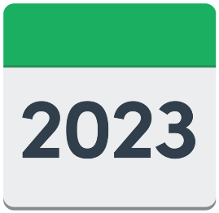

The first steering group meeting will be in July 2023.
Between each meeting members will need to spend 2 hours:
- reading information from the My Home, My Choice programme / steering group
- getting ready for steering group meetings
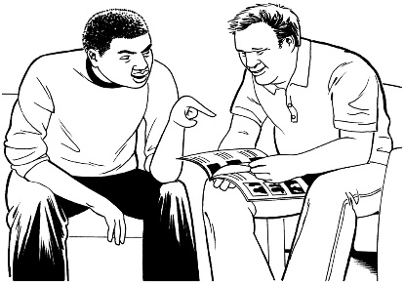
- talking to people to get ideas of what to take to the steering group meetings.
The steering group may also be asked for information / advice between meetings.

How to apply to be part of the

steering group

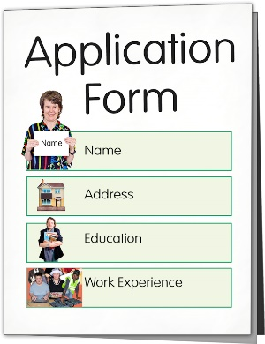
If you would like to be part of the My Home, My Choice steering group you will need to fill in an application form.

You can find the full application form on our website at:
https://bit.ly/3M06fRm

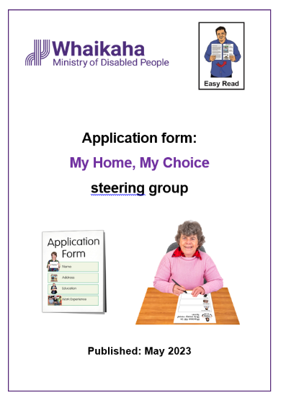
You can find the application form in Easy Read on our website at:

www.whaikaha.govt.nz/assets/About-us/My-Home-My-Choice/My-Home-My-Choice-steering-group-nomination-form.docx

You can send your application form by email to:

nominations@whaikaha.govt.nz

You can also send any questions you have about your application to this email address.

You can also send your application in an accessible format like:
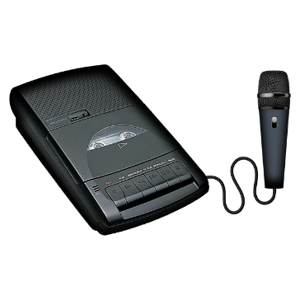
- a video of you using sign language to answer the questions
- an audio recording of you saying your answers to the questions.

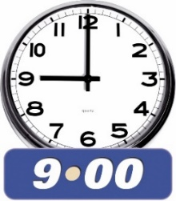
You must make sure we get your application before 9 am on
Monday 26 June 2023.

How steering group members

will be chosen

The My Home, My Choice programme team at Whaikaha:
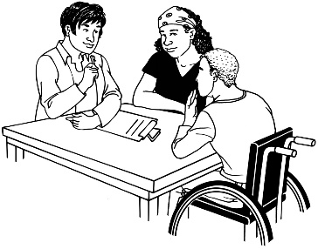
- will look at all the application forms
- pick some people to have an interview.

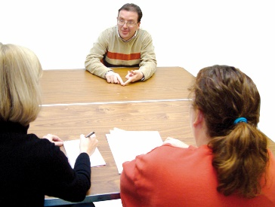
An interview is when you talk to someone from Whaikaha about why you should be on the steering group.

After the interview you will be told if you are chosen to be part of the steering group.

Where to find more information

You can find updates about the
My Home, My Choice programme on the Whaikaha website:
www.whaikaha.govt.nz/about-us/policy-strategies-and-action-plans/my-home-my-choice

Updates about the My Home, My Choice programme will be available in alternate formats like:
- Easy Read
- New Zealand Sign Language
- Braille
- large print
- audio.
You can also contact the My Home, My Choice programme leads:

- Gordon Boxall

- Kelly Woolston.

You can contact Gordon or Kelly by:
- email:

My_home_my_choice@whaikaha.govt.nz
- phone: 0800 566 601

- text: 4206

You can contact Gordon or Kelly:

on Monday to Friday
from 8:30 am to 5 pm.

You can send Gordon or Kelly a text at any time.

They will get back to you as soon as they can.

This information has been written by Whaikaha – Ministry of Disabled People.
It has been translated into Easy Read by the Make it Easy Kia Māmā Mai service of People First New Zealand Ngā Tāngata Tuatahi.

The ideas in this document are not the ideas of People First New Zealand Ngā Tāngata Tuatahi.

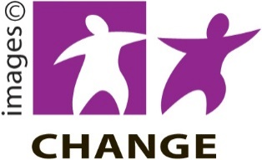
Make it Easy uses images from:

- Changepeople.org

- Photosymbols.com

- SGC Image Works

- Huriana Kopeke-Te Aho.
All images used in this Easy Read document are subject to copyright rules and cannot be used without permission.

