Application form:

My Home, My Choice

steering group

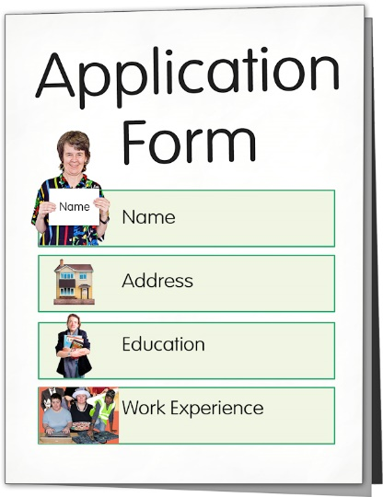

Published: May 2023

# About this application form

This is the Easy Read **application form** to be part of the steering group for the Whaikaha **My Home,**

**My Choice** programme.

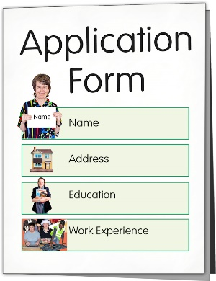An **application form** is a document you fill in to tell people about things like:

* who you are
* your contact details
* what things you know.

The **My Home, My Choice** programme looks at what changes are needed so that people in **residential services** have more:



choice in their lives

control in their lives.

You can find more Easy Read information about the My Home,

****My Choice programme on the Whaikaha website at:

[**www.whaikaha.govt.nz/about-us/policy-strategies-and-action-plans/my-home-my-choice**](http://www.whaikaha.govt.nz/about-us/policy-strategies-and-action-plans/my-home-my-choice)

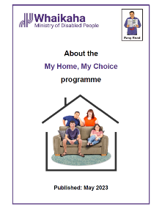

There are 2 documents on the website called:

About the My Home, My Choice programme

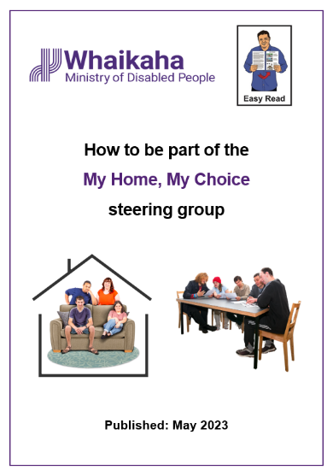How to be part of the My Home, My choice steering group.

# How to fill in the form

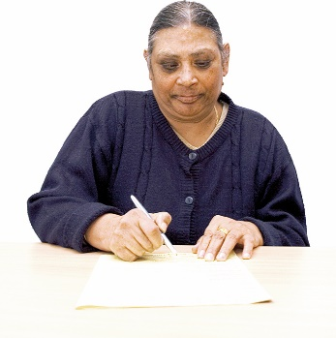You can fill in this form yourself.

Someone can fill in this form on your **behalf**.

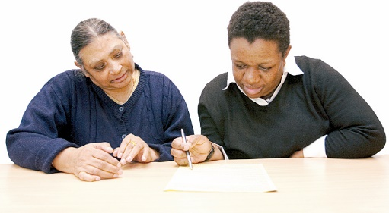

**Behalf** means doing something for someone who is unable to do it.

Is it okay to ask someone you know for support with filling in this form.

You can send your application form by email to:

[**nominations@whaikaha.govt.nz**](mailto:nominations@whaikaha.govt.nz)

You must make sure we get your application form before **9 am** on **Monday 26 June 2023.**



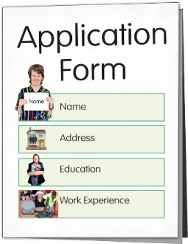

This form is in **3 parts**.

The first 2 parts are for you to answer:

1. personal information like your name / phone number
2. what you think a good home / living a good life looks like.

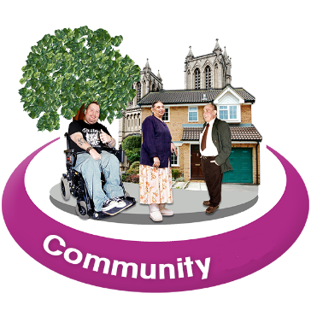Part 3 is for someone in your **network** to answer.

Your **network** is the connections you have with other people in your community.

The person in your network can be anyone that you know from:

organisations that support disabled people

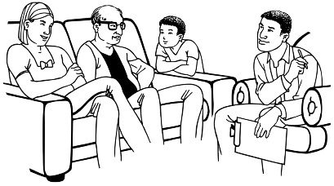support services providers

a family that you work with / support.

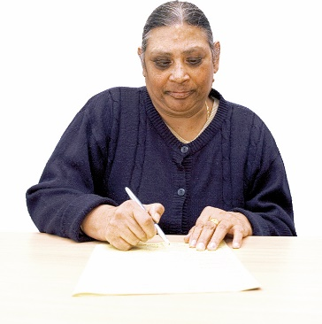

For each question you should:

* write your answer on the lines below
* tick the box that works best for you.

You can also send this form in a way that works best for you like:

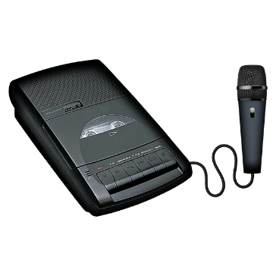a video of you using sign language to answer the questions

an audio recording of you saying your answers to the questions.



Remember to say your name at the start of your video / audio recording.

# Part 1: Personal information

**My name is:**

If someone is filling in this form for you ask them to write their name here:

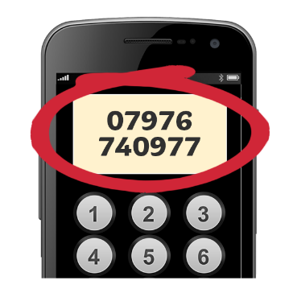**My phone number is:**



**My email address is:**

**You can contact me in another way like:**

**another phone number**

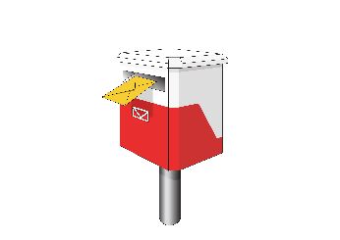**my address / where I live.**

**The organisation I work for is:**

You do not need to write anything if you do not work for an organisation.

You can get in touch with this organisation by:

phone number

email.

**Write Yes on the line below if you have a disability.**

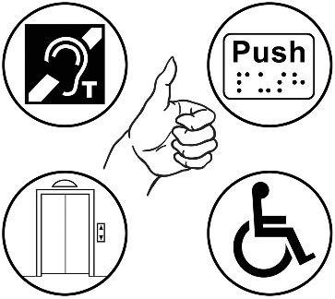

**Write Yes on the line below if you have access / support needs that will have to be met during the steering group meetings.**

**I would like to be contacted by**:



✓ Tick the box that is best for you:

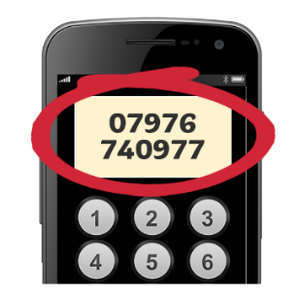email

phone call.

**Use this page and the next page to tell us why you think you would be a good member of the steering group.**

You can tell us about:

things that you are good at / know a lot about

things you have done

anything else you think we should know about you.

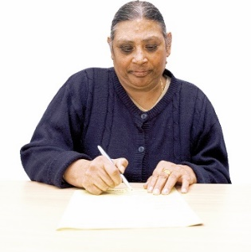There are more lines on this page if you need more space to answer the question on page 11.

# Part 2: What you think a good home /

# life looks like



**Tell us what you think about what kind of homes / support in the home should be available in Aotearoa New Zealand for all:**

**disabled people**

**tāngata whaikaha Māori / disabled Māori**

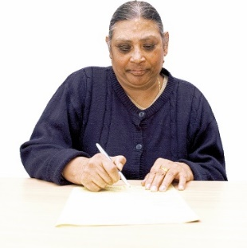There are more lines on this page if you need more space to answer Part 2.

# Part 3: Network

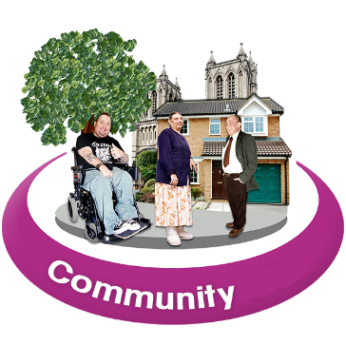

**This question is for someone from your network to answer.**

**My name is:**



**The organisation I work for is called:**

**I think the person named in   
Question 1 of this application form will be a good member of the steering group because:**

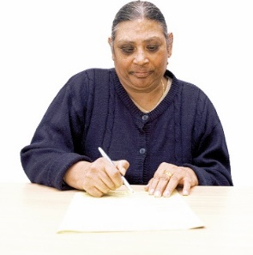There are more lines on this page if

you need more space to answer Part 3.

# Where to find more information

You can find updates about the

My Home, My Choice programme on the Whaikaha **website**:

[**www.whaikaha.govt.nz/about-us/policy-strategies-and-action-plans/my-home-my-choice**](http://www.whaikaha.govt.nz/about-us/policy-strategies-and-action-plans/my-home-my-choice)

Updates about the My Home, My Choice programme will be available in alternate formats like:

* Easy Read
* New Zealand Sign Language
* Braille
* large print
* audio.

You can also contact the My Home, My Choice programme leads:

* Gordon Boxall
* Kelly Woolston.

You can contact Gordon or Kelly by:

* **email**:

**My_home_my_choice@whaikaha.govt.nz**

* **phone**: **0800 566 601**
* **text**: **4206**



You can contact Gordon or Kelly:

on Monday to Friday



from 8:30 am to 5 pm.

This information has been written by Whaikaha – Ministry of Disabled People*.*

It has been translated into Easy Read by the Make it Easy Kia Māmā Mai service of People First New Zealand Ngā Tāngata Tuatahi.

The ideas in this document are not the ideas of People First New Zealand Ngā Tāngata Tuatahi.

Change logo.
Change is the name of the organisation.Make it Easy uses images from:

* Changepeople.org
* Photosymbols.com
* SGC Image Works
* Huriana Kopeke-Te Aho.

All images used in this Easy Read document are subject to copyright rules and cannot be used without permission.