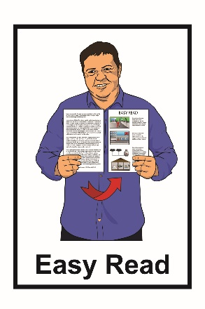
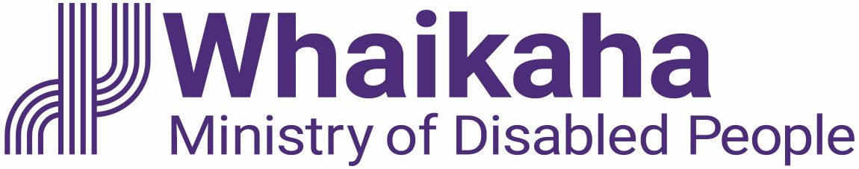

About the

My Home, My Choice

programme

Published: May 2023

What you will find in here

Page number:

What is this document
about? 2

Information about some of the
website links in this document 4

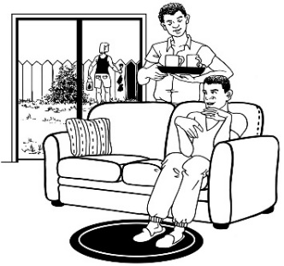
What is My Home, My Choice? 5

Who is working on My Home,
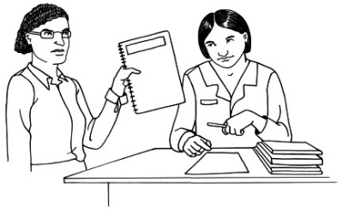
My Choice? 8

What documents
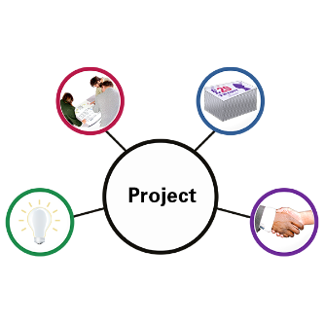
My Home, My Choice uses 11

How to stay updated and
get involved 20

What is this document about?

This Easy Read document is from Whaikaha – Ministry of Disabled People.

Whaikaha is working on a programme called My Home, My Choice.

A programme is work that looks to make something better.

The My Home, My Choice programme looks at what changes are needed so that people in residential services have more:
- choice in their lives
- control in their lives.
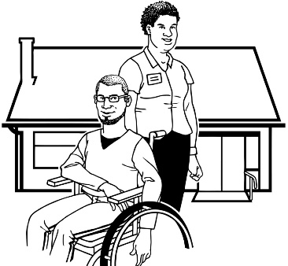
Residential services is when disabled people:

  - live in home / flat in the community
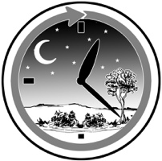
  - get support all through the day / night.

Information about some of the website links in this document

You will see website links in this document that start with:
https://bit.ly/3MPT9IA

https://bit.ly

bit.ly is a website that makes long website links:
shorter
easier to read
easier to share.

We use bit.ly so the links in our Easy Read documents are easy to use.

What is My Home, My Choice?

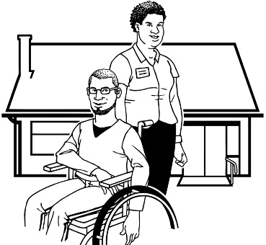
The My Home, My Choice programme looks at what changes are needed so that people in residential services have more:
- choice in their lives
- control in their lives.

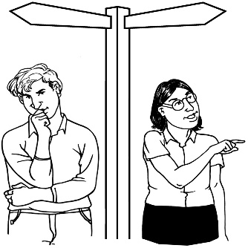
We are looking at changing how we:
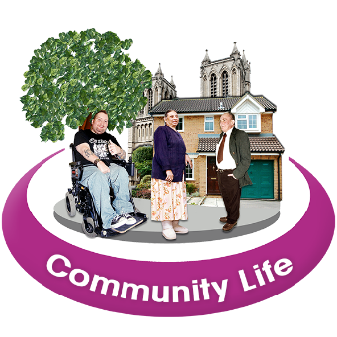
- support people to live their lives the way they want to
- support people to use everyday places like:

- libraries

- parks

- cafes.
The My Home, My Choice programme will also look at making things better so that tāngata whaikaha / disabled people have the same choices as
non-disabled people to live a good life.

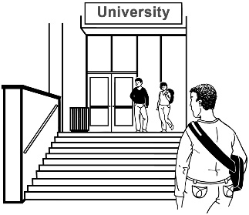
This includes:
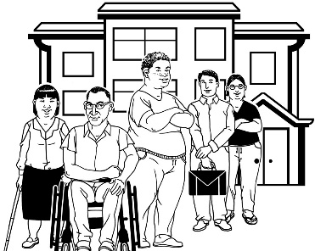
- the places they go to learn like college / university
- having a choice about the kinds of work they do
- having a home / safe place to live
- being part of their local community.

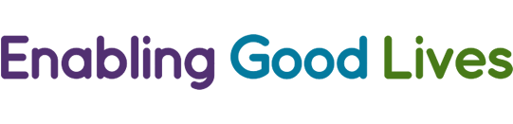
The My Home, My Choice programme is following the Enabling Good Lives way of doing things.

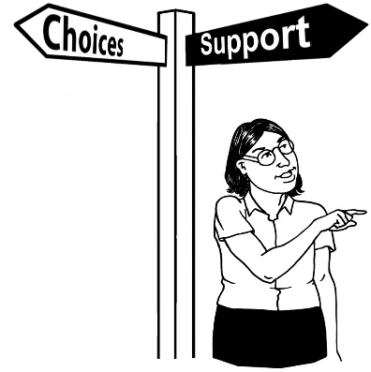
Enabling Good Lives is a different
way of thinking about disability
support.
Enabling Good Lives is about having:
- choice and control in your life
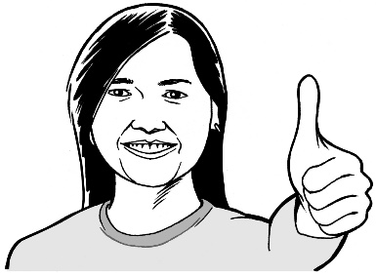
- the support you need and want
- a good life.

Who is working on My Home, My Choice?

The My Home, My Choice programme team at Whaikaha will work together with:
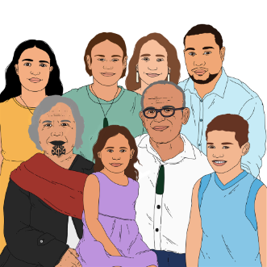
- disabled people
- tāngata whaikaha Māori
- whānau / family of disabled people
- the Government.

The My Home, My Choice programme team includes:
people who have important jobs at Whaikaha called senior members
- Amanda Bleckmann who is the:
  - Deputy Chief Executive Operational Design and Delivery at Whaikaha
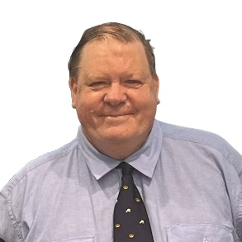
  - sponsor of My Home, My Choice programme
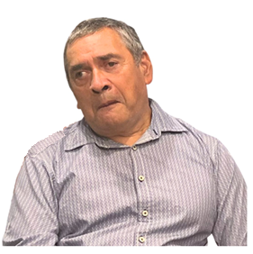
- the patrons of the My Home, My Choice programme:
- Sir Robert Martin KNZM
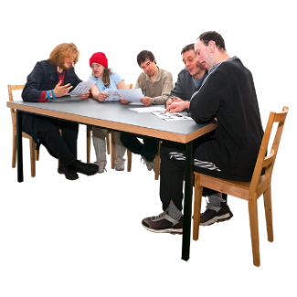
- Gary Williams MNZM
- a steering group.

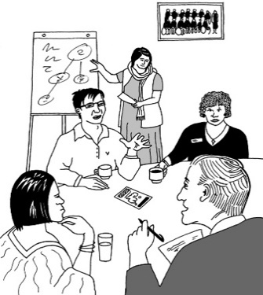
A sponsor / patron is someone who supports a programme in ways like:
leading a programme
offering the support needed to make sure the programme goes well.
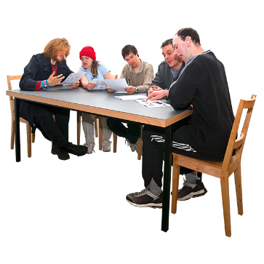

A steering group is a group of people who guide the work being done on the programme.

This steering group is made up of:
disabled people
tāngata whaikaha Māori
whānau / family of disabled people
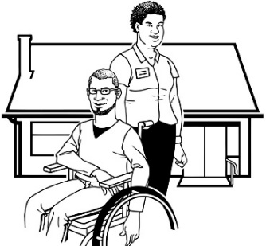
disabled Pacific people
disability service providers.

What documents

My Home, My Choice uses

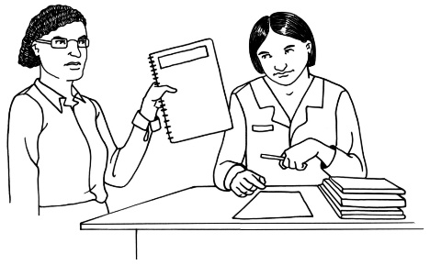
The Whaikaha programme team is using some important documents to guide how My Home, My Choice works

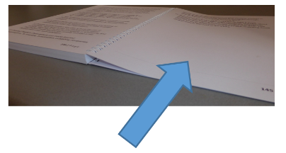
We talk about the documents we are using on pages 12 to 19 of this document.

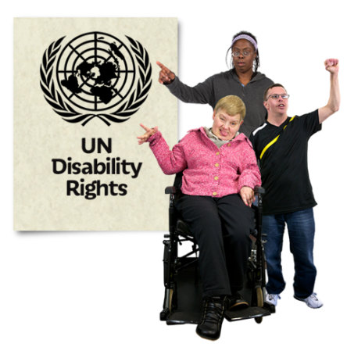
The United Nations Convention on the Rights of Persons with Disabilities

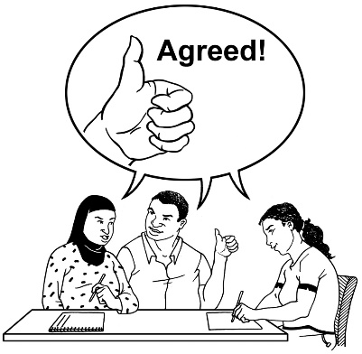
The United Nations Convention on the Rights of Persons with
Disabilities is a law lots of countries have agreed to.
The United Nations Convention on the Rights of Persons with Disabilities is also called the UNCRPD.

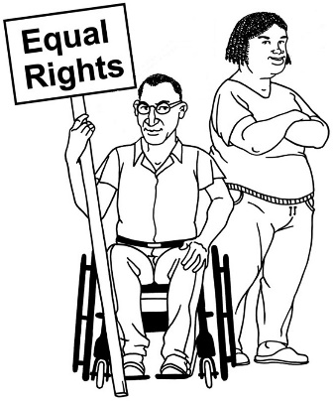
The UNCRPD says what governments must do to make sure disabled people get the same rights as everybody else.

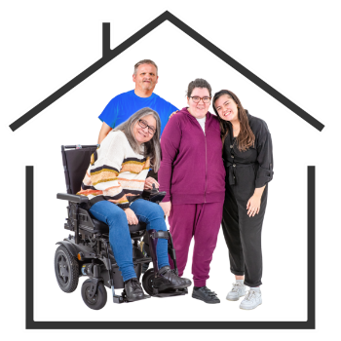
Rights are the things everyone should have to live a good life like:
- a safe place to live
- food to eat
- good medical care.
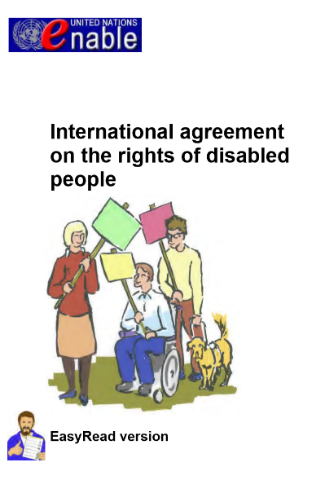
You can find out more about the UNCRPD in an Easy Read document called:

International agreement on the rights of disabled people.

You can find this document at:

https://bit.ly/3KNQgoR

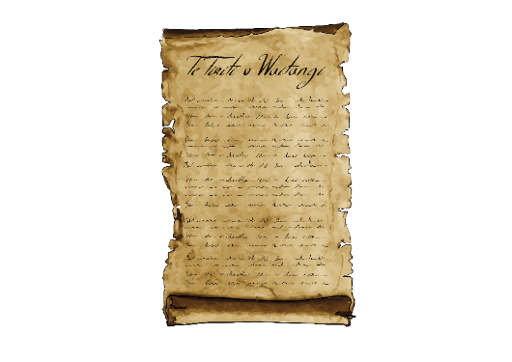
Te Tiriti o Waitangi / The Treaty of Waitangi

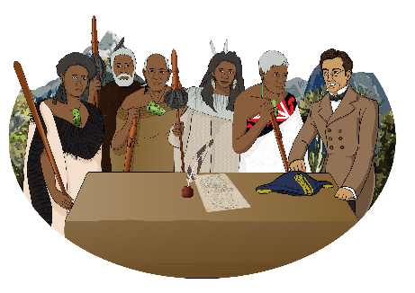
Te Tiriti o Waitangi / The Treaty of Waitangi is a legal document that was signed in 1840.

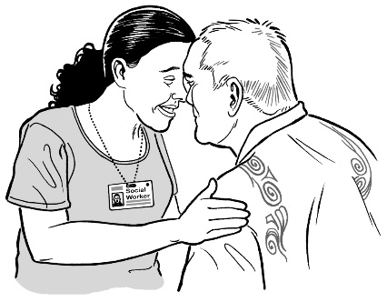
Te Tiriti / The Treaty is about Māori and the New Zealand Government:
making decisions together
protecting things that are
important to Māori.

You can find more Easy Read information about Te Tiriti / The Treaty at this website:
www.treatypeople.org/easyread

The Enabling Good Lives principles

Principles are rules that tell people how things should be done.

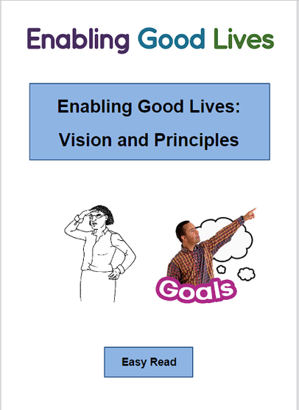
You can find out more about Enabling Good Lives in the Easy Read document called:
Enabling Good Lives: Vision and Principles.

You can find this document at this website:
https://bit.ly/41x8f9O

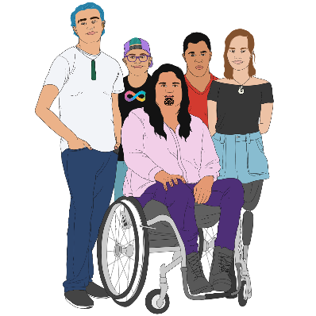
The Health Services and Outcomes Inquiry

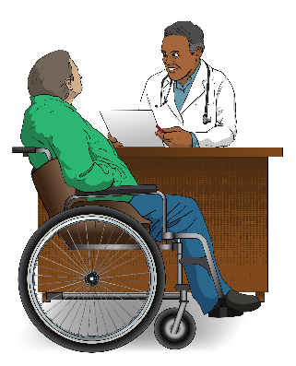
The Health Services and Outcomes Inquiry is about hearing complaints from Māori about:
- health services like doctors
- disability support services.

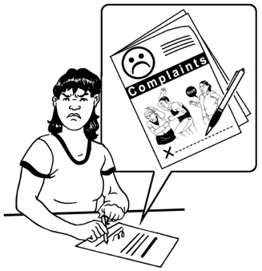
A complaint is when you tell someone you are not happy about something.

You can find more information on this website:

https://bit.ly/2Z3y8S3

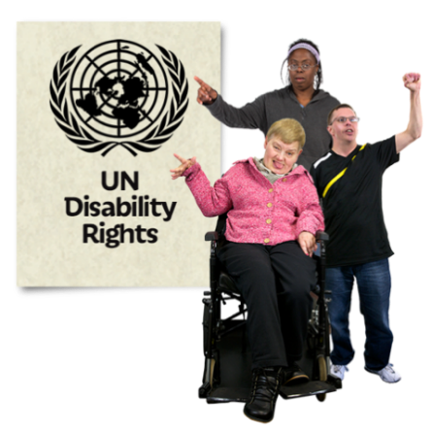
New Zealand Disability Strategy

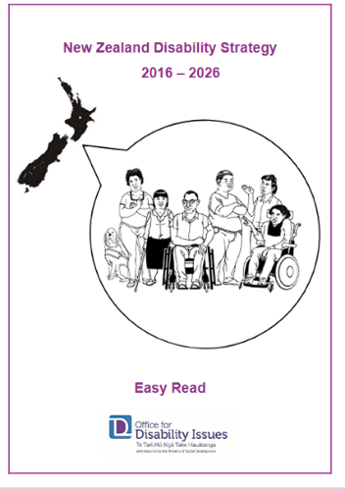
The New Zealand Disability Strategy makes sure that disabled people in New Zealand have the rights as set out by the UNCRPD.

You can find more Easy Read information in a document called:

New Zealand Disability Strategy 2016 – 2026.

You can find this Easy Read document at this website:

https://bit.ly/3opBflR

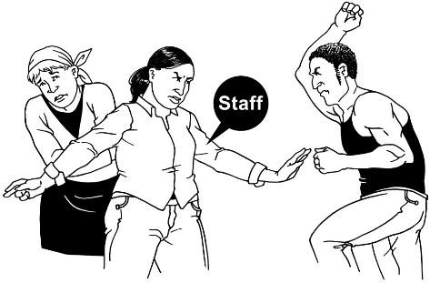
Te Aorerekura National Strategy to Eliminate Family Violence and Sexual Violence

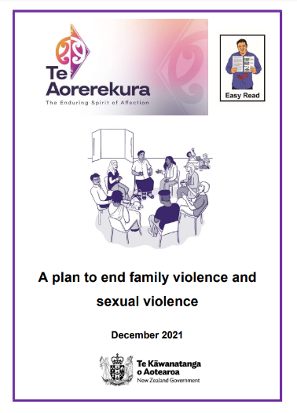
Te Aorerekura is a plan for how the Government will stop family violence and sexual violence in New Zealand.

You can find out more in the Easy Read document called:

A plan to end family violence and sexual violence.

You can find this Easy Read document on this website:

https://bit.ly/3njLuru

What was learned from the Royal Commission of Inquiry into Abuse in Care

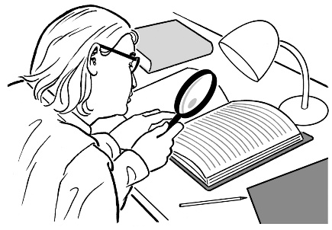
The Royal Commission of Inquiry into Abuse in Care is looking into abuse that happened to people in care.

You can find Easy Read documents about the Inquiry at this website:

https://bit.ly/3nhwSch

How to stay updated and get involved

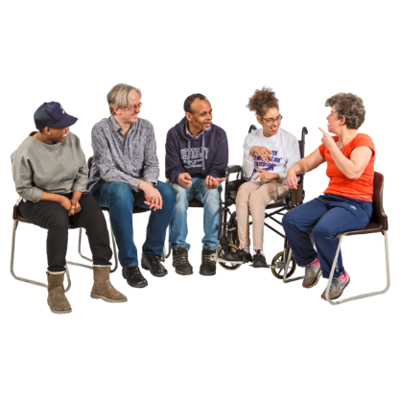
As we work on the My Home, My Choice programme you will be able to share your ideas / experiences about residential services.

The My Home, My Choice programme team will put updates on:
          - the Whaikaha website:
www.whaikaha.govt.nz/about-us/policy-strategies-and-action-plans/my-home-my-choice

- social media like the Whaikaha Facebook page:
www.facebook.com/whaikaha.govt

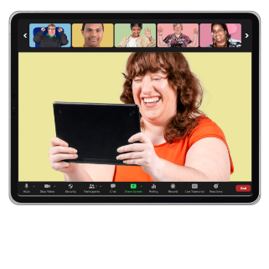
The My Home, My Choice programme team will:
- hold webinars / online meetings
- put out newsletters.

The updates on the website will be available in alternate formats like:
- Easy Read
- New Zealand Sign Language
- Braille
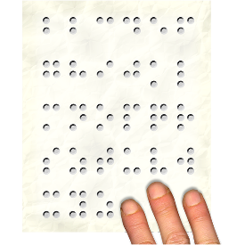
- large print
- audio.

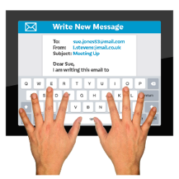
You can sign up to get the newsletter by emailing:

My_home_my_choice@whaikaha.govt.nz
You can also contact the My Home, My Choice programme leads:

- Gordon Boxall

- Kelly Woolston.

You can contact Gordon or Kelly by:
- email:

My_home_my_choice@whaikaha.govt.nz
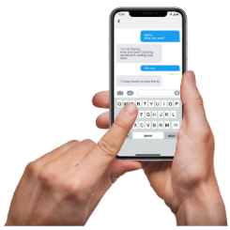
- phone: 0800 566 601

- text: 4206
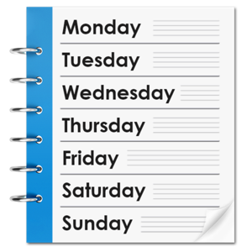

You can contact Gordon or Kelly:

on Monday to Friday
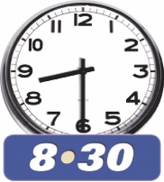
from 8:30 am to 5 pm.

You can send Gordon or Kelly a text at any time.

They will get back to you as soon as they can.

This information has been written by Whaikaha – Ministry of Disabled People.

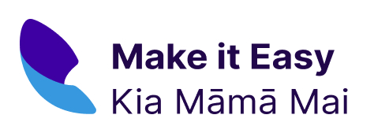
It has been translated into Easy Read by the Make it Easy Kia Māmā Mai service of People First New Zealand Ngā Tāngata Tuatahi.

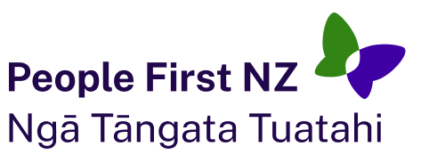
The ideas in this document are not the ideas of People First New Zealand Ngā Tāngata Tuatahi.

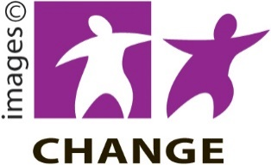
Make it Easy uses images from:

- Changepeople.org

- Photosymbols.com

- SGC Image Works

- Huriana Kopeke-Te Aho.
All images used in this Easy Read document are subject to copyright rules and cannot be used without permission.

