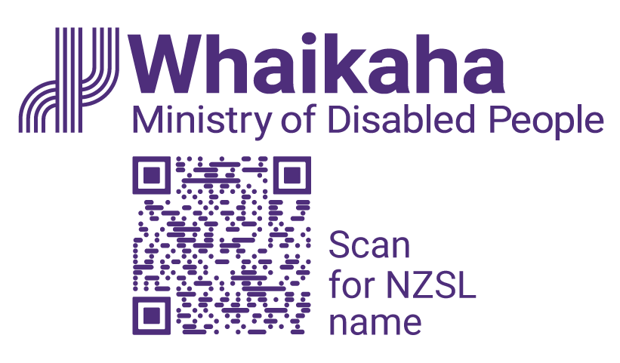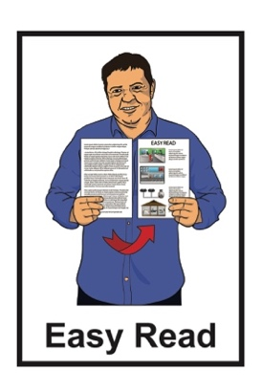

Looking for people to be on a Transformation Management Board

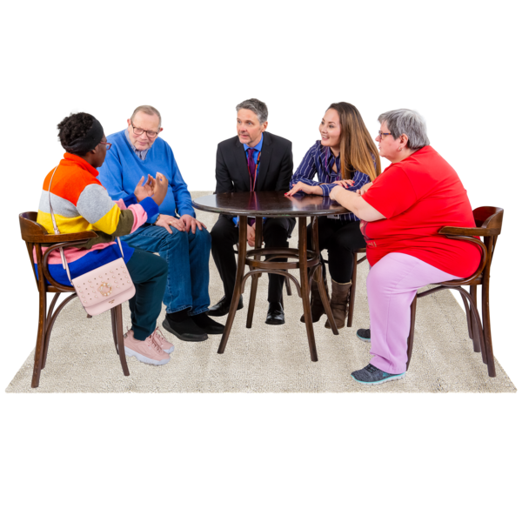

Published: October 2023

# About the Board

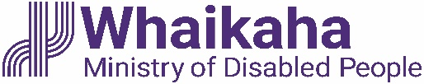This Easy Read document is from **Whaikaha – Ministry of Disabled People**.

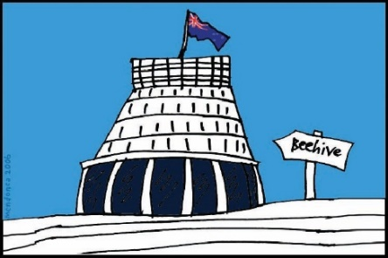

**Whaikaha – Ministry of Disabled People** is the part of the Government that works on things to do with disabled people.

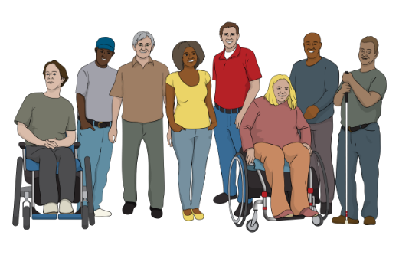

In this document we will just call it **Whaikaha**.

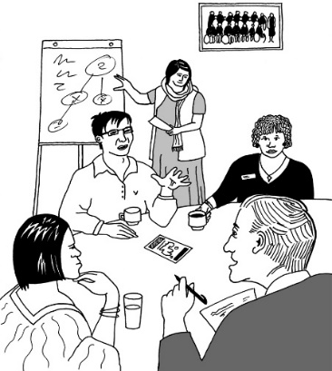

Whaikaha is working on **Disability System Transformation**.

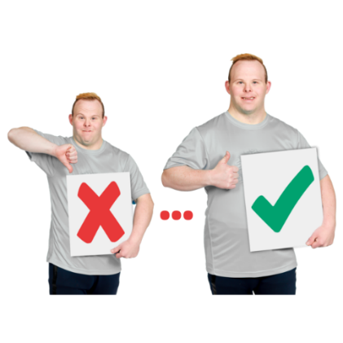**Disability System Transformation** is making big changes to disability support.

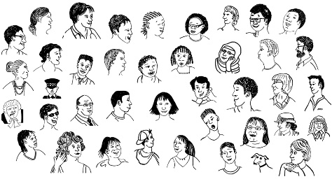

Part of the Disability System Transformation work is making sure more people can use **Enabling Good Lives**.

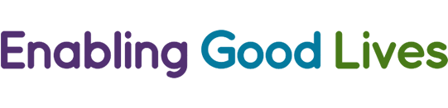

**Enabling Good Lives** is a different way of thinking about disability support.

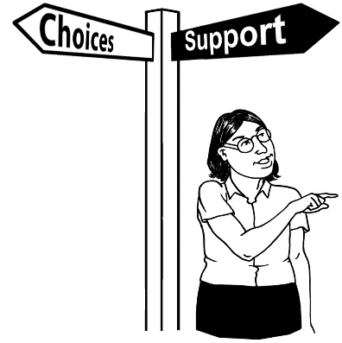

Enabling Good Lives is about having:

* 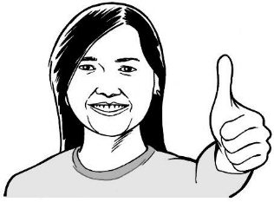choice and control in your life
* the support you need and want
* a good life.

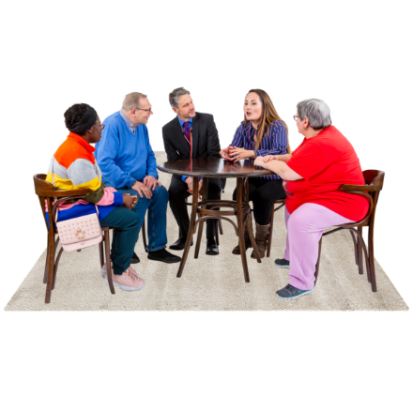As part of the Disability System Transformation work Whaikaha is setting up a Transformation Management **Board**.

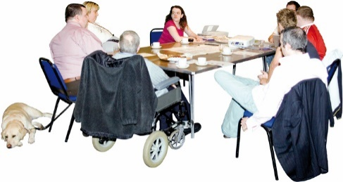A **board** is a group of people who:

look after how the main things are going

do not do the everyday work.

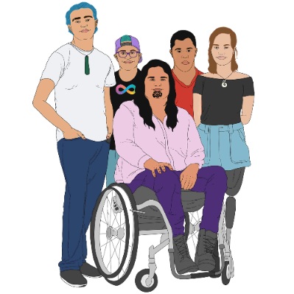

The Transformation Management Board will be one of the ways that Whaikaha works together with:

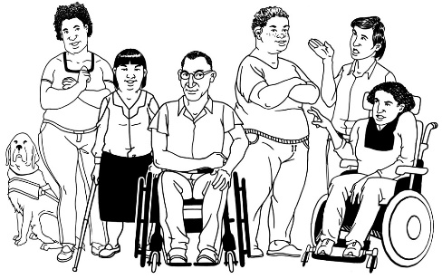tāngata whaikaha Māori / disabled Māori

disabled people.

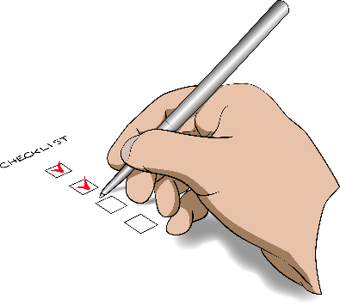The Transformation Management Board members will:

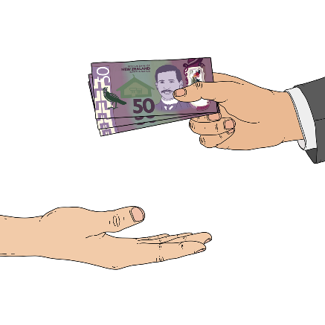check how the transformation is going

agree to money going to different things

look for where the order of things being done can be changed to make transformation go better

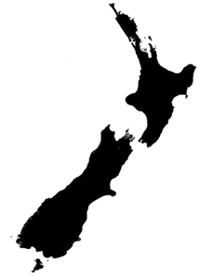agree what things should be managed:

* for the whole country
* in different parts of the country.

# Becoming a member of the Board

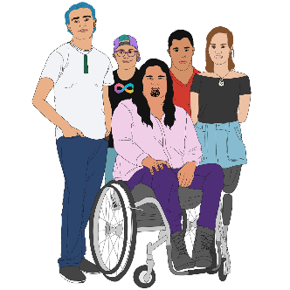

The Transformation Management Board will have 9 members including:

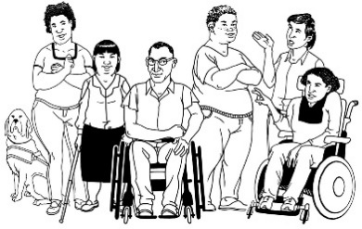3 tāngata whaikaha Māori / disabled Māori

3 disabled people

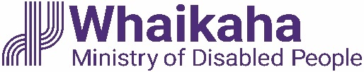3 senior leaders from Whaikaha with 1 of these being the Chief Executive.

If you think you would be a good fit for the Transformation Management Board please **email** us at:

[**transformation@whaikaha.govt.nz**](mailto:transformation@whaikaha.govt.nz)

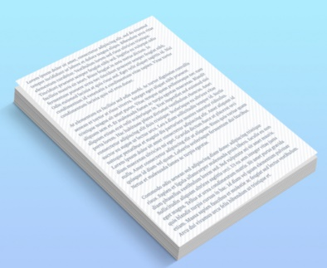You should attach to your email:

a **CV**

a letter about your

* **skills**
* **experience**.

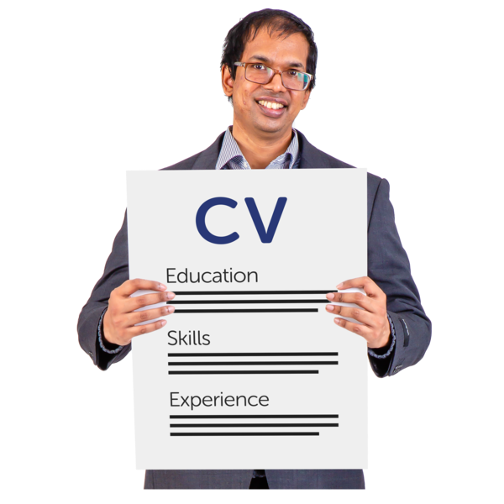

A **CV** is a document that includes things like:

work you have done

courses you have studied.



**Skills** are things you can do / know.

**Experience** means things you have done like jobs you have had.

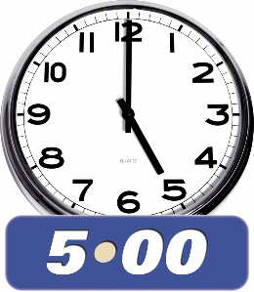You need to send the email by:

**5 pm**

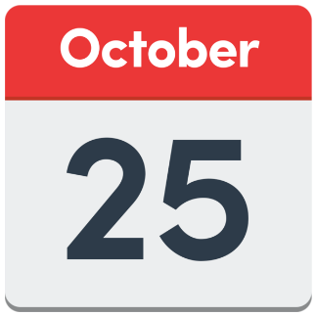

on

**Wednesday 25 October 2023**.

# Where to find more information



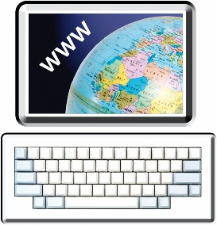You can find more information about being on the Transformation Management Board on the Whaikaha **website**:

**https://tinyurl.com/4zxpyu2b**



If you have questions you can contact Whaikaha:

by **email**:  
  
[**transformation@whaikaha.govt.nz**](mailto:transformation@whaikaha.govt.nz)

* by **phone**: **0800 566 601**
* by **text**: **4206**

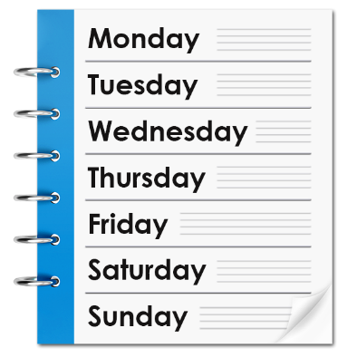The Whaikaha phone line is open:

* Monday – 8 am to 5 pm
* Tuesday – 8 am to 5 pm
* Wednesday – 9.30 am to 5 pm
* Thursday – 8 am to 5 pm
* Friday – 8 am to 5 pm.

If you find it hard to use the phone the **New Zealand Relay** service is for people who:

* 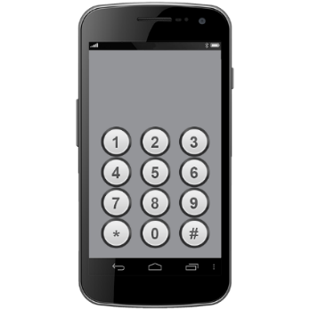are Deaf / hard of hearing
* are deafblind
* speech impaired / find it hard to talk.

You can find out more about the New Zealand Relay service at:

**www.nzrelay.co.nz**

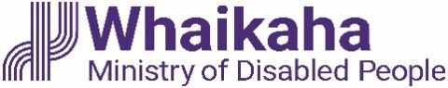This information has been written by Whaikaha – Ministry of Disabled People.

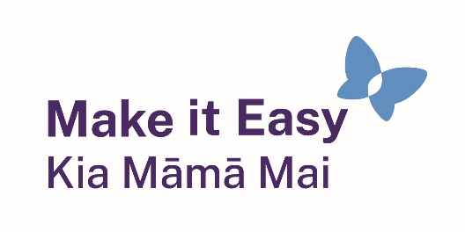It has been translated into Easy Read by the Make it Easy Kia Māmā Mai service of People First New Zealand Ngā Tāngata Tuatahi.

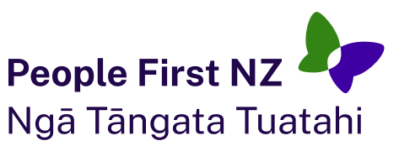The ideas in this document are not the ideas of People First New Zealand Ngā Tāngata Tuatahi.

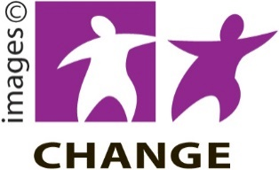

Make it Easy uses images from:

* Photo SymbolsChangepeople.org

Photosymbols.com

* 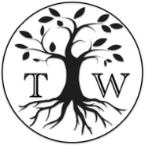SGC Image Works
* Huriana Kopeke-Te Aho
* T. Wood.

  
All images used in this Easy Read document are subject to copyright rules and cannot be used without permission.