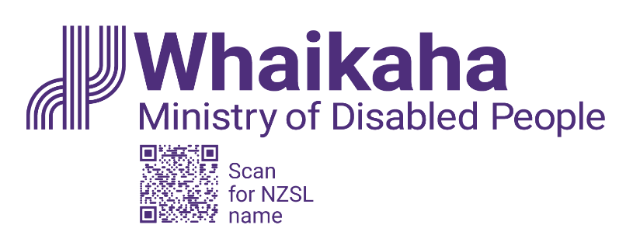

# Call for interest in membership of Whaikaha Transformation Management Board

Adapted in 2023 by Accessible Formats Service,  
Blind Low Vision NZ, Auckland

**TN**: Logo on the top of the page is: Whaikaha Ministry of Disabled People.

[Whaikaha – Ministry of Disabled People](https://www.whaikaha.govt.nz/about-us/) works in partnership with disabled people, tāngata whaikaha Māori and across government to transform the disability support system so disabled people and whānau can live the life they are seeking.

We are inviting expressions of interest from disabled people and tāngata whaikaha Māori to join our Transformation Management Board.

We want to ensure disabled people and Tāngata Whaikaha Māori are at the decision-making table.

## Purpose of the Transformation Management Board

Disability System Transformation is a Cabinet agreed programme of work under the Disability Action Plan 2019-2023. It involves fundamental changes to the entire disability support system.

In Budget 2022, Cabinet approved a tagged contingency “to extend Enabling Good Lives to more of the disabled population and their whānau, progressing towards a national rollout of the Enabling Good Lives approach”.

In September 2023, the Government announced that Whaikaha could access $73.7 million over the next four years and an additional $40.5 million each year in the following years to support our disability system transformation work. Cabinet noted that more funding would be needed to complete the full transformation.

The transformation funding supports the establishment of a tripartite Transformation Management Board and a Transformation Management Office.

The Transformation Management Board will be appointed until December 2025.

They will oversee the execution of plans to:

* support the disability community as they lead the growth of partnership groups and networks.
* support disabled people who are at risk of abuse through a mix of prevention (including safeguarding skills), early responses, greater community connections and intensive response and advocacy, when needed.
* improve equity of access to disability support services by extending Enabling Good Lives supports to historically underserved communities.
* Transform existing services, by intervening early and supporting transitions through changing what support is available.
* build the system infrastructure required to support and embed the Enabling Good Lives approach, including through IT, data and insights, and legislative and policy settings.

It is important to keep in mind that the funding's initial priority is creating the system architecture so that the foundations necessary for change are in place.

## The Management Board members will be responsible for:

* reviewing the progress of the transformation programme
* approving the allocation of funding to specific initiatives
* identifying potential areas for re-prioritisation to better support transformation
* agreeing responsibilities that need to be managed nationally, where consistency is required and where regional and local flexibility will lead to better outcomes.

## Part of the growing partnerships with disabled people and communities

The Management Board is one of the many partnerships to transform the disability support system so it improves the lives of disabled people and tāngata whaikaha Māori throughout Aotearoa New Zealand.

Management Board members will primarily provide advice to support the implementation of the transformation initiatives funded through the Budget 2022 contingency.

## What the Membership involves

Whaikaha has committed to having tripartite partnerships between disabled people, tāngata whaikaha Māori and the Crown.

The tripartite Management Board will have 9 members:

* three tāngata whaikaha Māori
* three disabled people
* three senior Whaikaha leaders including the Chief Executive.

The Management Board members will be appointed by the Chief Executive of Whaikaha, alongside a panel of disabled people and tāngata whaikaha Māori (who are not seeking Board appointment).

Transformation Management Board members will be appointed as individuals. They will not be appointed as representatives of Disabled Persons Organisations or community groups.

Management Board members will be required to abide by the code of conduct guiding public servants.

## Your time commitment and remuneration

The Transformation Board will meet five times each year with face-to-face meetings in Wellington preferred. Board meetings will be held over two days, generally, the afternoon of one day and the morning of the second day. Whaikaha will organise overnight accommodation and travel to meet the needs of members. Whaikaha will provide reasonable accommodations as necessary.

Preparation and post-meeting activity is expected. Members will be paid a daily fee of $600 for each meeting day ($1200 for a two-day meeting), which includes preparation time.

## Independent evaluation

An independent evaluation of the Management Board will help support continuous improvement of how the Board operates.

## Skills we are looking for

* **Disabled person | tāngata whaikaha Māori life experience**. Reflect and respect the wide diversity of experiences, needs and strengths among the disability community and bring these to the decision-making table.
* **Able to embed Te Tiriti o Waitangi principles**. Experienced in applying and embedding Te Tiriti o Waitangi principles into design and delivery of policy, supports, systems, monitoring and evaluation.
* **Strategic leadership**. Comprehends the big picture and maintains a strategic outlook; demonstrates the capacity to think holistically and strategically, balancing diverse needs of stakeholders. Examples could include guiding the strategic direction of organisations or groups.
* **Assurance leadership**. Brings a questioning mindset to the role; focuses on results; interest in challenging for success against goals; able to understand and assess risks that need managing. Examples include managing ongoing projects, services or investments, to ensure they are producing the desired results and taking corrective action when needed.
* **Transformation**. Understands the difference between transformational and ongoing improvement initiatives, and ideally with experience in working in a transformation environment. Examples could include developing innovative responses and changing how organisations or groups work.
* **Governance**. Understands the difference between governance and management, and ideally has experience in governance roles in a public sector context.
* **Programme/portfolio management**. Being able to relate to the work of the Transformation Management Office and hold it accountable for carrying out agreed-upon transformation programmes requires experience in programme and/or portfolio management disciplines.
* **Financial/investment management**. Fluency with a variety of financial and investment management principles is demonstrated, as well as knowledge of managing budgets and trade-offs. Planning and managing work schedules and budgets are some examples.
* **Experience in Enabling Good Lives initiatives**. Brings insights and experience including lessons learned from the Enabling Good Lives initiatives.
* **Whaikaha connection.** Brings insights and connection with the wider work of Whaikaha.
* **Network connections**. Brings connections and relationships that enable connection with the broader disabled person and whānau voice, including such groups as the Disabled Persons Organisations Coalition, Regional Leadership Groups, National Enabling Good Lives Leadership, Te Ao Marama o Aotearoa, Faiva Ora and Mana Pasifika leadership group and Insights Alliance.
* **Relationship management.** Capacity to build trusted and credible relationships with multiple stakeholders.

## Personal attributes we are looking for

* **Objective thinker**. Able to debate and demonstrate the benefit of independent thought.
* **Integrity and openness**. Truthful, trustworthy, demonstrates integrity and is fair-minded.
* **Positive, constructive attitude**. Open to considering new perspectives, encouraging, and supportive.
* **Culturally astute**. Emotionally intelligent and respectful of diversity.
* **Innovative thinking**. Is creative and original in addressing issues and assessing priorities.

## How to apply

If you are disabled or tāngata whaikaha Māori and believe your skills match some of the above requirements, we would like to hear from you.

Please send a cover letter outlining how your skills and experience match the types of skills and attributes being sought and outlined above, and an up to date CV to [transformation@whaikaha.govt.nz](mailto:transformation@whaikaha.govt.nz) by 5pm on   
**25 October 2023.**

**Please note that Whaikaha will accept applications in writing, audio format or NZSL.**

If you have any questions, please get in touch by:

* emailing [transformation@whaikaha.govt.nz](mailto:transformation@whaikaha.govt.nz)
* calling 0800 566 601 (Monday, Tuesday, Thursday and Friday 8am – 5pm, and Wednesday 9:30am – 5pm).

**End of Call for interest in membership of Whaikaha Transformation Management Board**