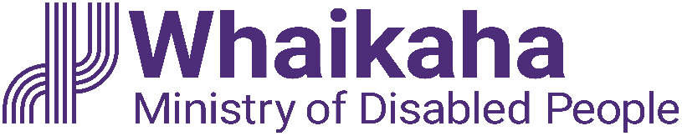
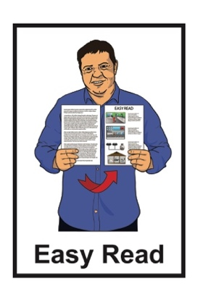

Summary:

High and Complex Framework -

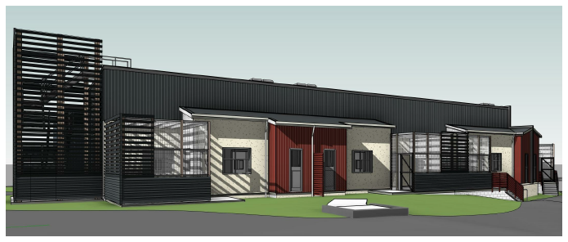
Strategic Statement

Published: June 2023

What you will find in here

Page number:

About this document 2
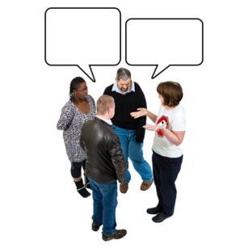

About the words used in the
High and Complex Framework 4

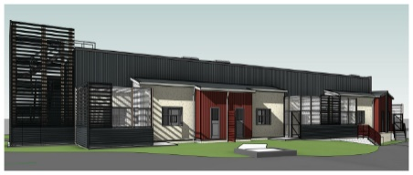
What is the High and Complex
Framework? 6

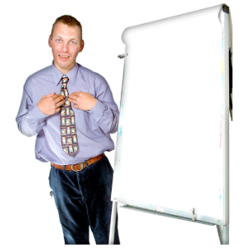
Why write a Strategic Statement? 8

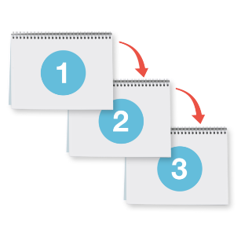
What is in the High and Complex Framework Strategic Statement? 11

What happens next? 19

Where to find more information 22

About this document

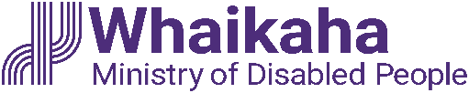
This is an Easy Read summary of a document written by Whaikaha – Ministry of Disabled People.

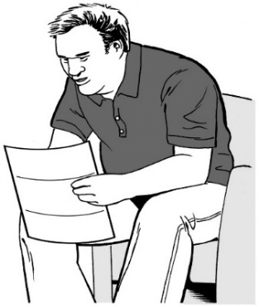
A summary:
is shorter than the full document
tells you the main ideas.

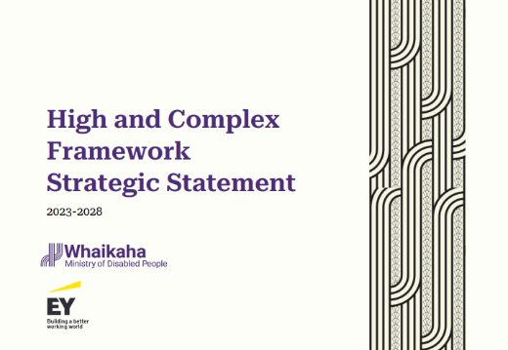
The document written by Ernst & Young is called:

High and Complex Framework Strategic Statement 2023 – 2028.

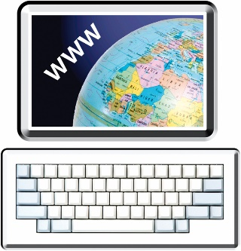
You can find the full document on the the Whaikaha website:

https://tinyurl.com/mr2aw46x

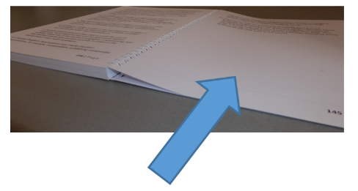
You can find more about what the High and Complex Framework is on page 6.
You can find more information about what a strategic statement is on page 8.

About the words used in the

High and Complex Framework

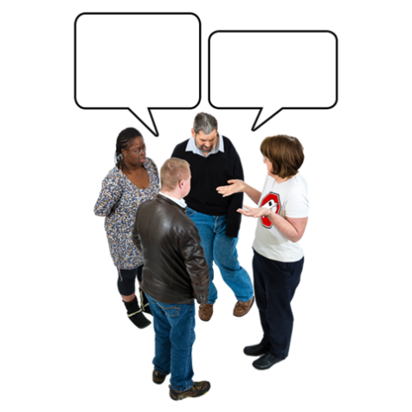
The words used to talk about disability are important.

Sometimes not everyone agrees on the words being used.

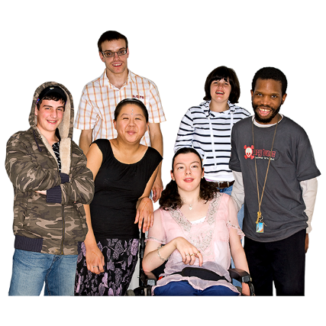
The High and Complex Framework uses the words care recipients.

Care recipients are the people who are supported by the High and Complex Framework.

Whaikaha is working with stakeholders to find words that better fit with what people want to use.

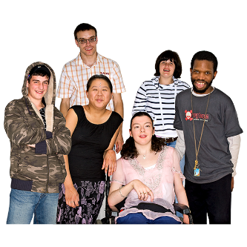
Stakeholders are people who have an interest in something.

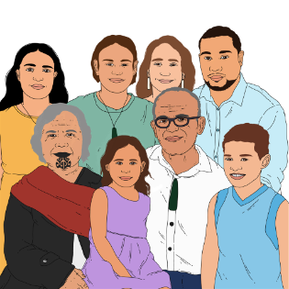
Stakeholders include:

- disabled people / care recipients

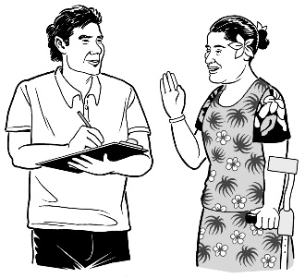
- tāngata whaikaha Māori / disabled Māori

- whānau / family

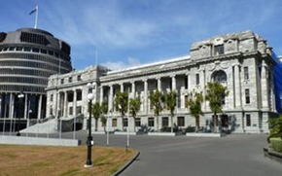
            - Māori and Pacific people from the disability community

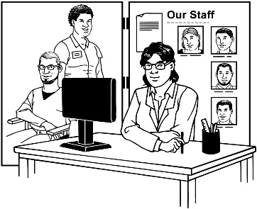
- people who work across different parts of the Government

- people who work in the disability sector like residential services.

What is the High and Complex Framework?

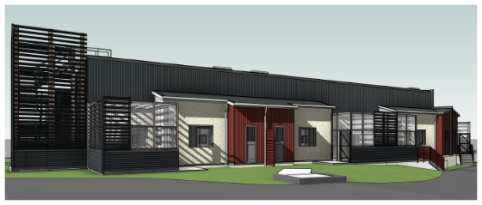
In this Easy Read document we call the High and Complex Framework the Framework.

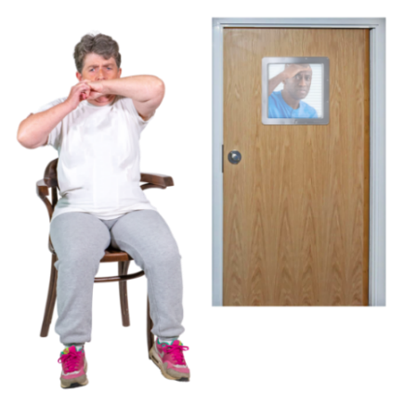
The Framework is a group of services that support people who:
- have an intellectual disability

- have very high support needs

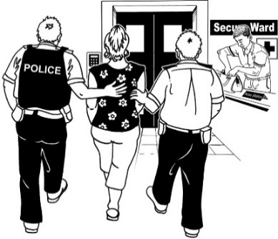
- have committed an imprisonable offence

- have support needs that regular services like prisons cannot meet
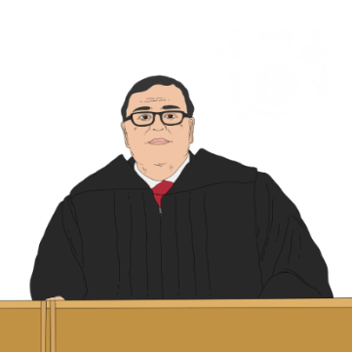
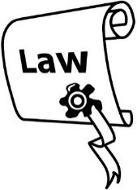
- come under a law called the Intellectual Disability (Compulsory Care and Rehabilitation) Act 2003.
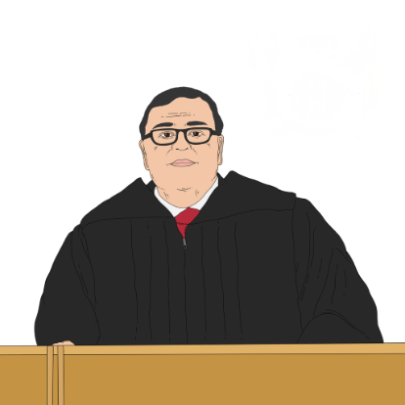
An imprisonable offence means:

- a person has broken the law

- a court judge has decided what should happen to that person.

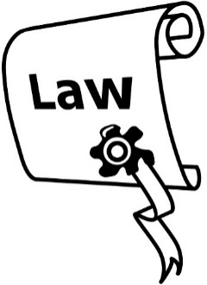
The Intellectual Disability (Compulsory Care and Rehabilitation) Act 2003 is a law that means a person with an intellectual disability can be placed in the care of Framework services when:

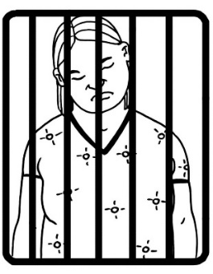
they have been charged with or convicted of an imprisonable offence

being in prison is not suitable for them.

Laws are rules made by the Government.

Why write a Strategic Statement?

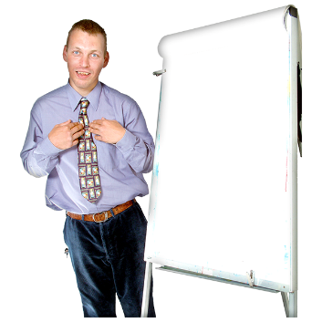
A Strategic Statement tells you:
- the things that may happen
- the work that will be done to make these things happen.

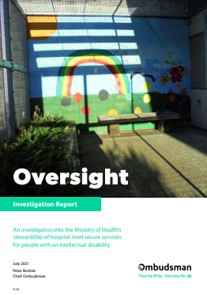
The work behind the Framework Strategic Statement started after a report written by the Chief Ombudsman called:

Oversight: An investigation into the Ministry of Health’s stewardship of hospital-level secure services for people with an intellectual disability.

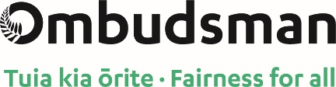
The Office of the Ombudsman looks into problems with government services.
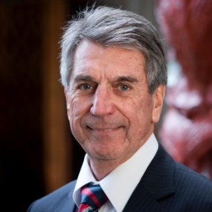

The Chief Ombudsman is Peter Boshier.

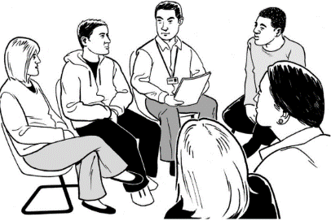
There are a lot of people who work with him at the Office of the Ombudsman.

The Chief Ombudsman can:
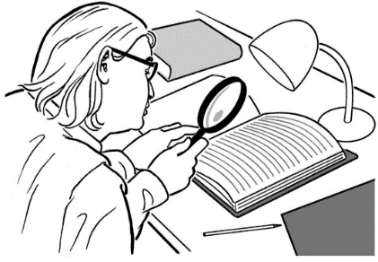
- do investigations

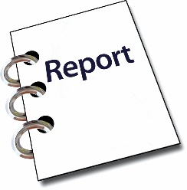
- write reports about what he has found out
- say what needs to be done to make things better.

An investigation means looking closely at something to find out what has been happening.

In the Oversight report the Chief Ombudsman said there were problems with:
- the Framework
- there not being enough services for the people who need them.

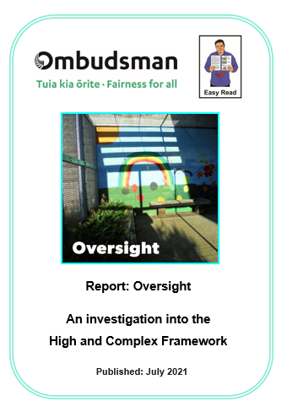
There is an Easy Read summary of the Oversight report.

You can find both these reports on the Ombudsman website:

https://tinyurl.com/3h8px4vc

What is in the High and Complex

Framework Strategic Statement?

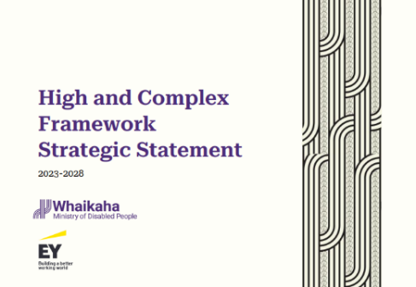
The Strategic Statement tells you what needs to change so the Framework works better to support the wellbeing of:
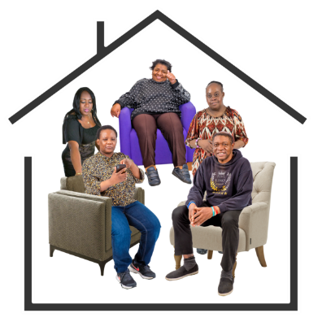
care recipients
staff / people who work in the Framework.

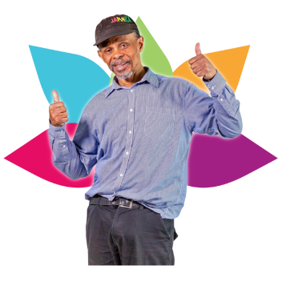
Wellbeing means many things like:
- how we feel about ourselves
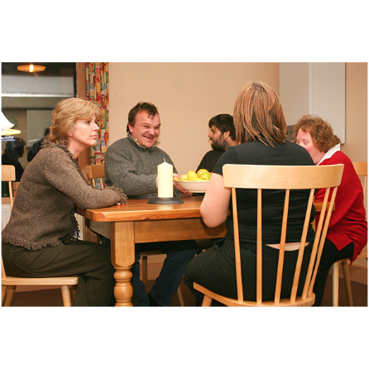
- feeling safe in the place we live / work
- getting support when we are feeling sad or worried.
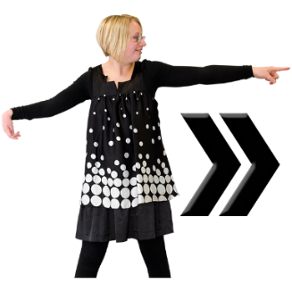
The Strategic Statement also outlines:
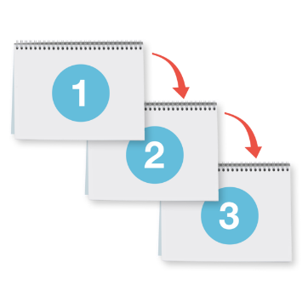
- the vision for the future of the Framework
- the steps that will be taken to meet this vision.

Vision means how things should be in the future / years to come.

The vision of the Framework is that for the next 20 years all care recipients:
- are supported to live safely
- have things happening in their lives that make them happy
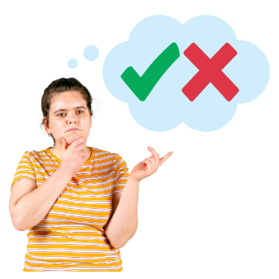
- are able to take part more in making decisions about their care / support
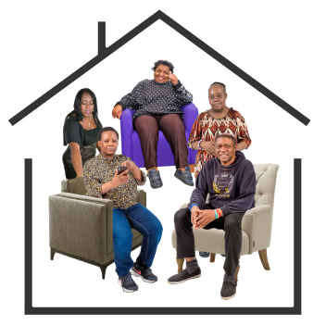
- are able to have a say about how the Framework system / services work.

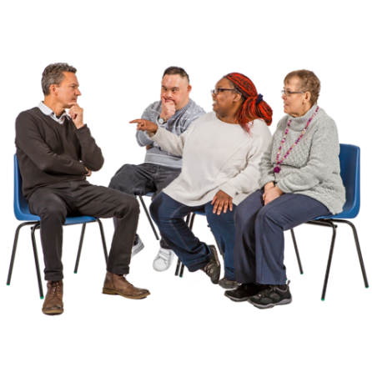
To write the Strategic Statement Ernst & Young and Whaikaha first listened to what stakeholders said about the Framework.

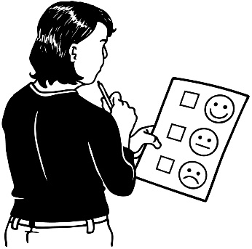
Ernst & Young and Whaikaha did this by:
- asking care recipients to answer questions in surveys
- meeting with care recipients 1 to 1 to do interviews / ask questions
- holding workshops / meetings with stakeholders.

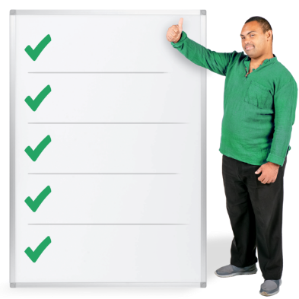
Whaikaha used what stakeholders said to write about 5 main things that need to change in the Framework.

Framework change 1:
Creating capacity in the system which means:
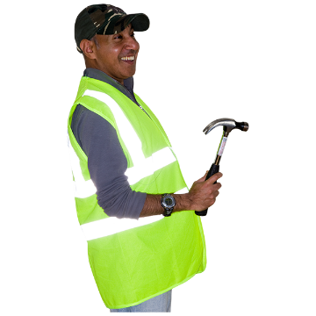
- taking away the things that make it hard for staff to work in the Framework
- making changes to buildings where care recipients live
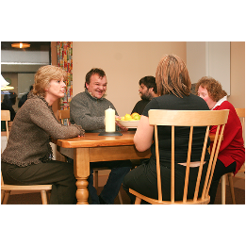
- building new places for care recipients to live
- having more places available for care recipients:

- now
and
- in the future / years to come.

Framework change 2:

Streamlining transitions which means that the support care recipients get is planned well when moving:

- between services

- out of services.

Framework change 3:
Improving visibility and transparency which means the ways things are run in the Framework:
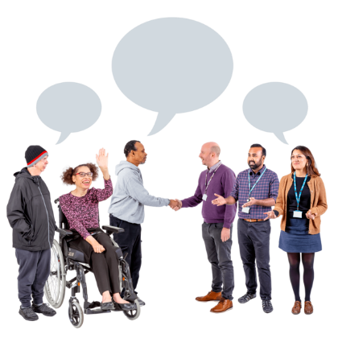
- are easy for everyone to see / follow
- support care recipients and staff working together.

Framework change 4:
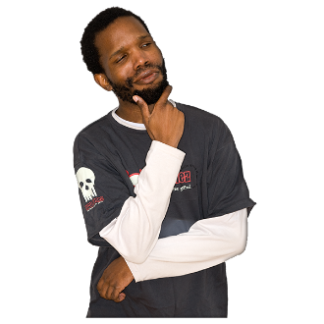
Supporting greater autonomy which means that the wellbeing of each care recipient is supported by:
- their whānau / family

- staff

- the wider community.

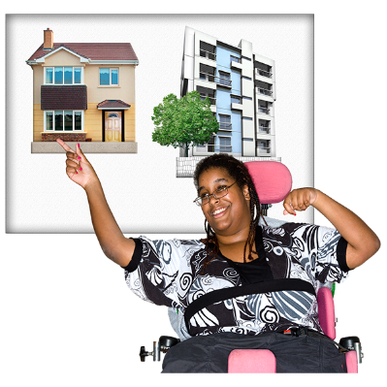
Autonomy means:

- having choices

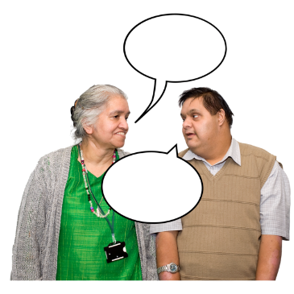
- having a say in what is happening
- taking part in making decisions.

Framework change 5:
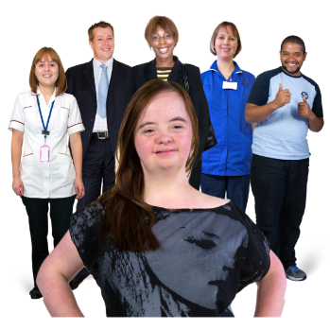
Having a safe effective practice which means that staff are supported to work in a way that:

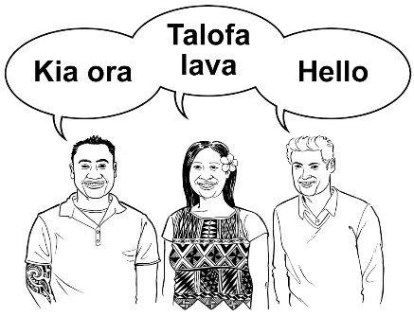
- is best practice / the best way of doing things safely

- matches the culture of each care recipient.

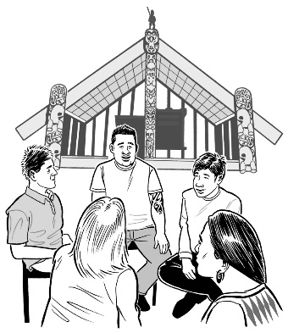
Culture:

          - is a way of thinking that a group of people share
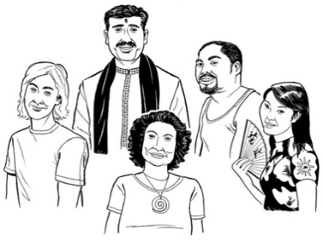
- is a way of doing things as a group.

What happens next?

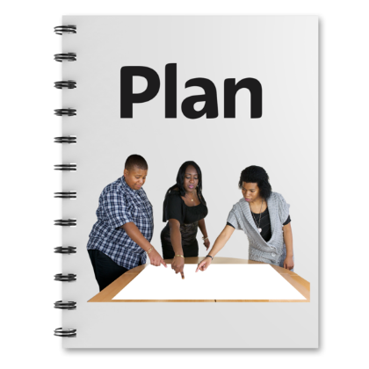
For each of the Framework changes there is a plan of things that need to be done:
- over the next 5 years
and
- in the years ahead.
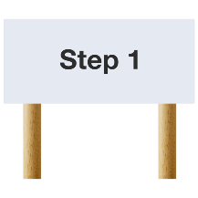
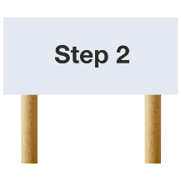
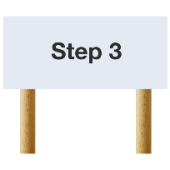
There are 3 steps that will be worked on first.

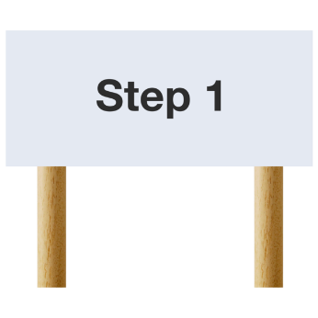
Step 1 to changing the Framework:
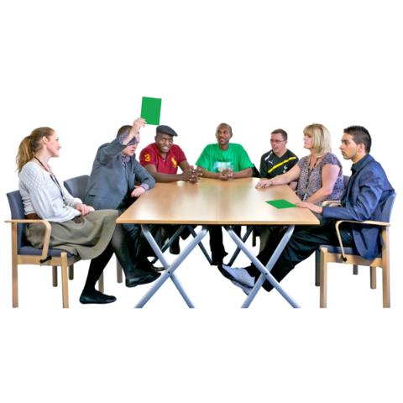
Working on roles and responsibilities which means:
- working out who does what
- making sure the changes fit with the way Whaikaha does things.

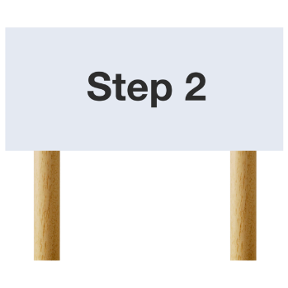
Step 2 to changing the Framework:
Implementation planning which means Whaikaha will plan for:
- how the changes to the Framework will happen
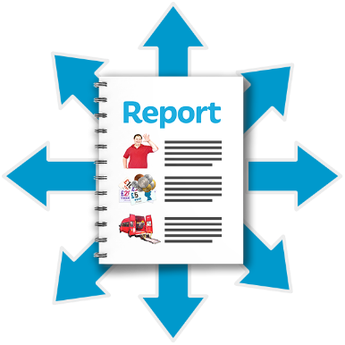
- who will work on making the changes happen
- how the changes will be tracked / reported.
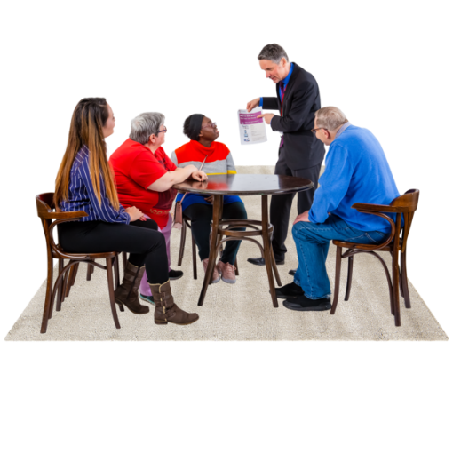
Stakeholders will be:
- able to have a say in the plan / how the changes will be made
- part of the changes as they happen.

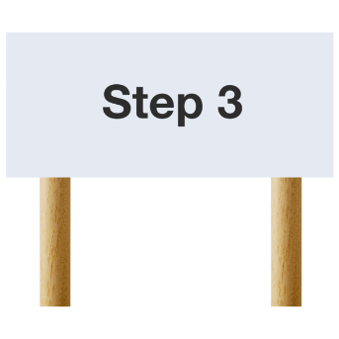
Step 3 to changing the Framework:
Uplifting the voices of tāngata whaikaha Māori / disabled Māori

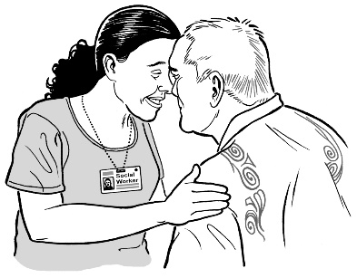
This is part of the important mahi / work that Whaikaha is doing in building a good relationship with Māori.
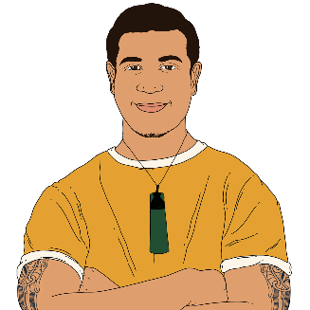

It also means looking at making sure the Framework works better for Māori.

Where to find more information

The full High and Complex Framework Strategic Statement 2023 – 2028 is on the Whaikaha website:

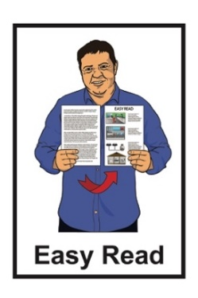
https://tinyurl.com/mr2aw46x

The full document is not in Easy Read.

The contact details for Whaikaha are:

- phone: 0800 566 601

- text: 4206
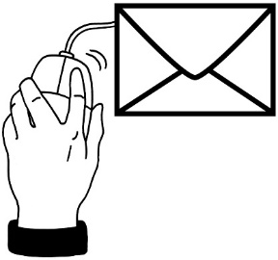
- email:

contact@whaikaha.govt.nz

This information has been written by Whaikaha – Ministry of Disabled People.

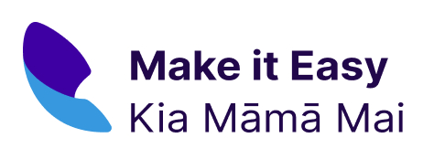
It has been translated into Easy Read by the Make it Easy Kia Māmā Mai service of People First New Zealand Ngā Tāngata Tuatahi.
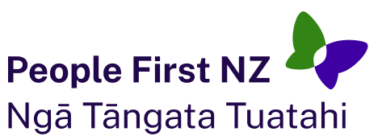
The ideas in this document are not the ideas of People First New Zealand Ngā Tāngata Tuatahi.
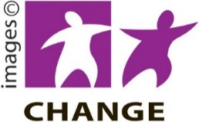
Make it Easy uses images from:

- Changepeople.org
- Photosymbols.com
- SGC Image Works

- Huriana Kopeke-Te Aho.

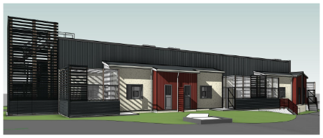
Thank you to McKenzie Higham Architects for permission to use cover image.
All images used in this Easy Read document are subject to copyright rules and cannot be used without permission.

