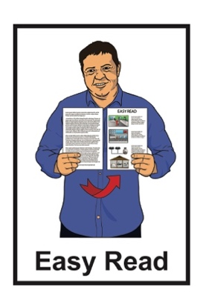
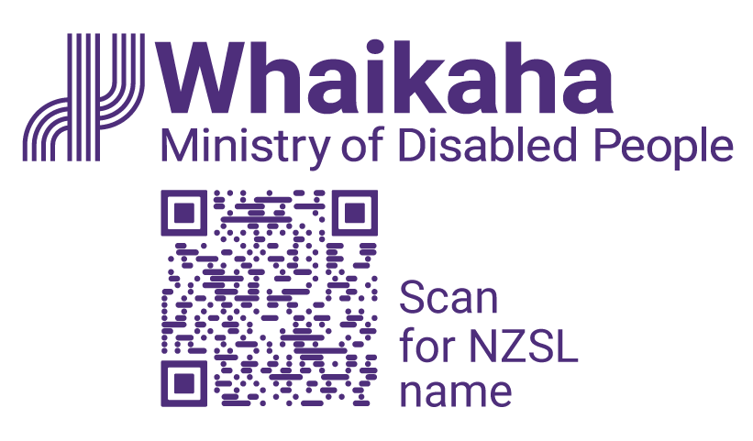

What the disabled community told us about the future
Disability Support Workforce
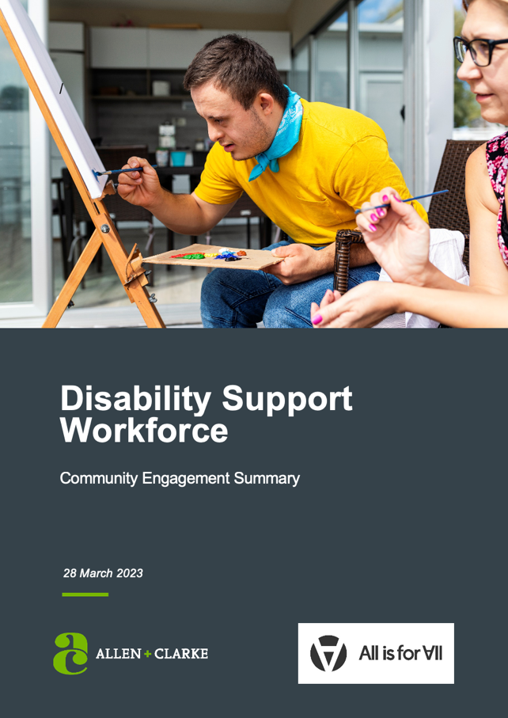

Published: August 2023

What you will find in here

Page number:

What is this document
about? 3
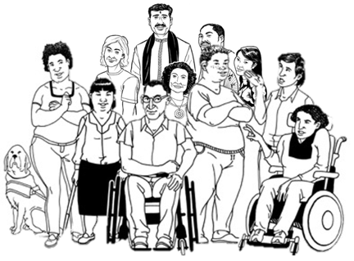

Who took part in community engagement? 6

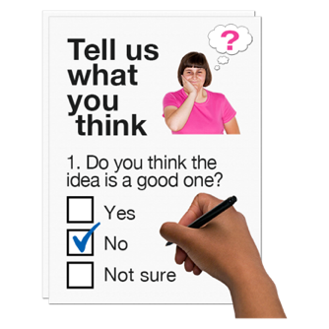
Why did we do
community engagement? 7

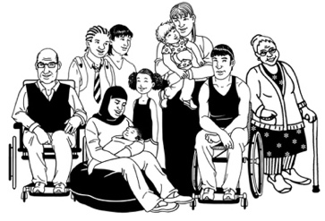
What disabled people
told us 9
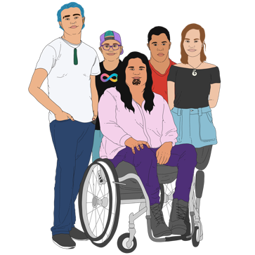

What tāngata whaikaha Māori
told us 11

Page number:

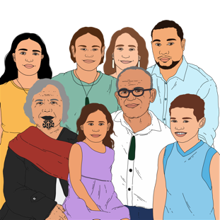
What whānau / family
told us 12

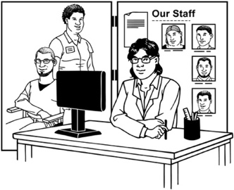
What service providers /
support workers told us 14

What are the priorities
for the future? 18

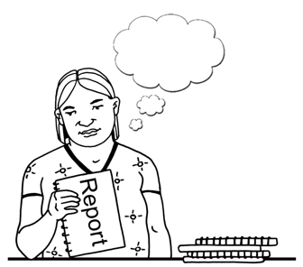
The main things we learned
from the report 28

Where to find more information 30

What is this document about?

This Easy Read document is from Whaikaha – Ministry of Disabled People.
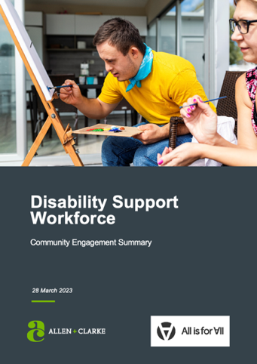

It is about the Disability Support Workforce Community Engagement Summary from March 2023.

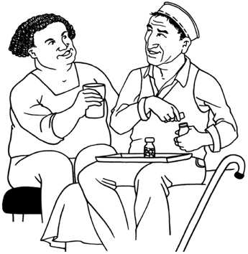
The disability support workforce means people like:
support workers
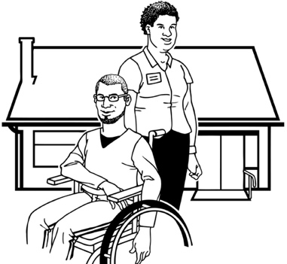
respite services
residential care workers.

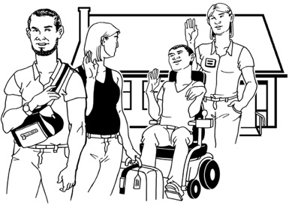
Respite is a way to give whānau / family a break from caring for someone.

Residential means the place where someone lives.

The disability support workforce also means people who work in other disability related support services like:
- speech language therapists
- physiotherapists
- wheelchair technicians
- nurses / doctors
- teacher aides.

Community engagement is when you ask lots of different people in a community what is important to them.

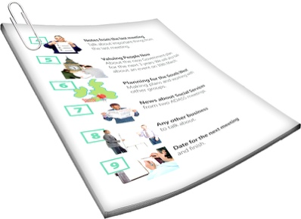
A summary:
is shorter than the full document
tells you the main ideas.

Who took part in community engagement?

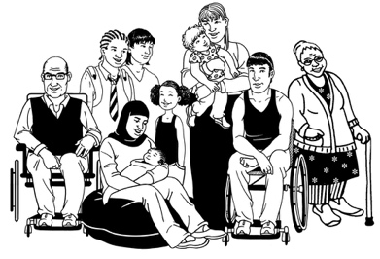
The people who took part in community engagement were:
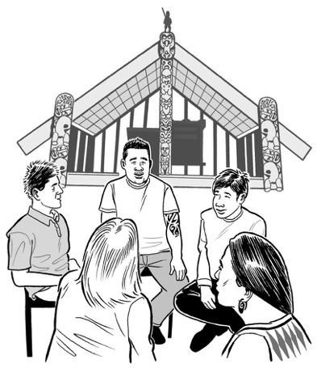
disabled people
tāngata whaikaha Māori / Māori disabled people
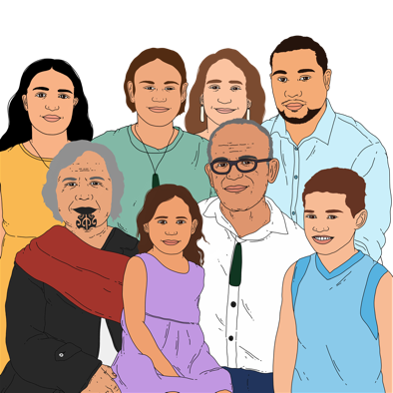
whānau / family of disabled people
members of the disability support workforce
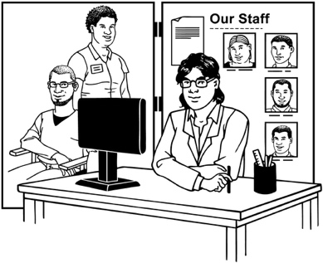
service providers / Māori service providers.

Why did we do community engagement?

Whaikaha decided to do community engagement to find out what the disabled community:
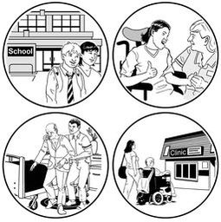
want from the future disability support workforce
think the future disability support workforce should be like.

Future means in the time / years to come.

We asked Allen and Clarke and
All is for All to:
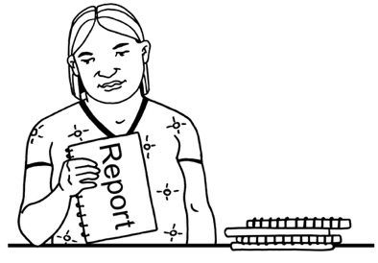
do the community engagement
write a report about what they found out.
Allen and Clarke is a business that supports the Government to do research.

All is for All:
is a business led by disabled people
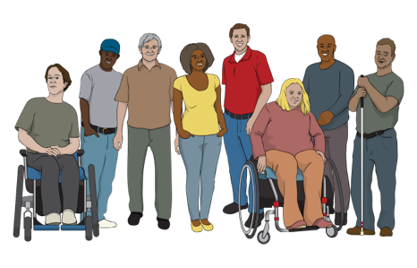
works to support disabled people to be fully included in society in the same ways as non-disabled people.

Research is when we:
look at what things have happened
try to find ways to do things better.

What disabled people told us

Disabled people told us they want disability support services to give them:
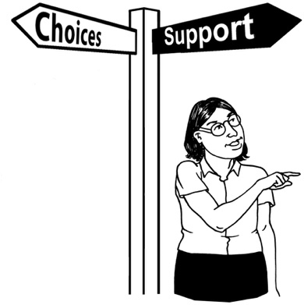
freedom
choice
control over their own lives.

They said it is important to have:
control over who provides their support
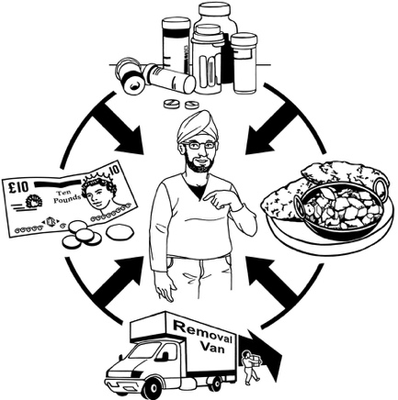
services provided in a way that fit their needs
services provided in ways that can change to meet their needs.

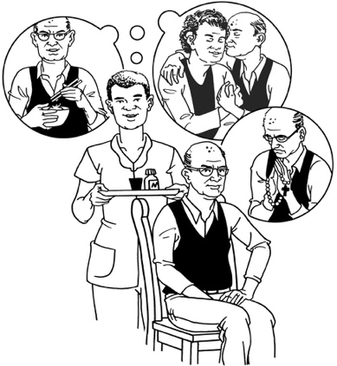
Disabled people told us it is important that the people who support them:
understand their needs / choices
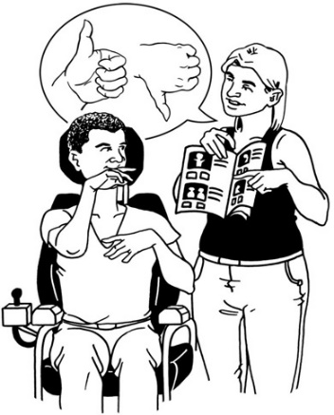
respond / answer to their needs / choices quickly
respect their choices for small things
respect their choices for big things.

Respect means you think about how someone else feels.

Disabled people also told us they would like more people like them to be their support workers.

What tāngata whaikaha Māori told us
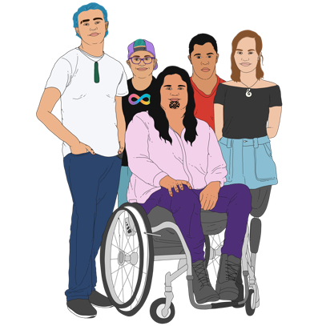

Tāngata whaikaha Māori told us it is very important to be able to choose:
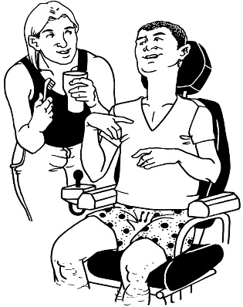
their support workers
how their support workers support them.

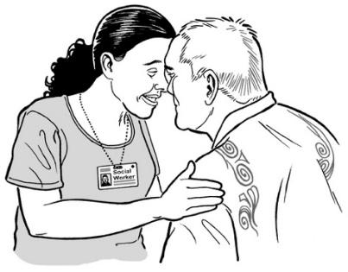
They also told us our plan for the future workforce must:
include / think about things that are important to Māori
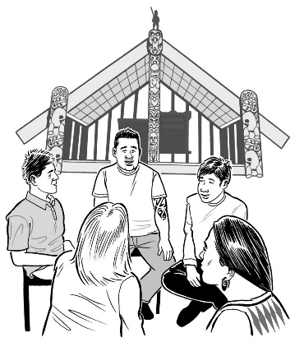
include tāngata whaikaha Māori from different backgrounds like people who live in places outside of cities.

What whānau / family told us

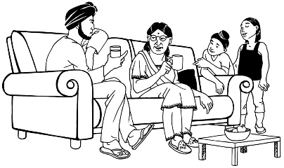
The whānau / family of disabled people told us carers must:
be well trained
work well together
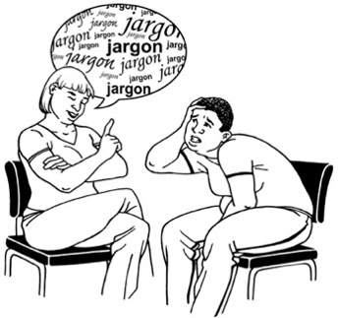
understand disability
communicate in a clear way.

They also want their own caregiving work to be:
noticed / given thanks for
paid.

Whānau / family of disabled people also asked for:
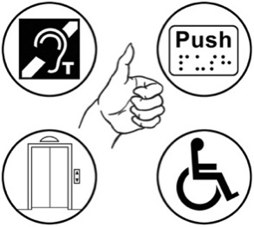
the same amount of money for family / non-family carers
accessible employment opportunities
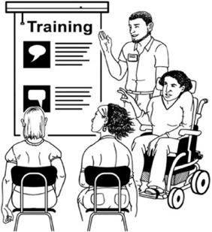
training for whānau / family to keep on learning more skills.

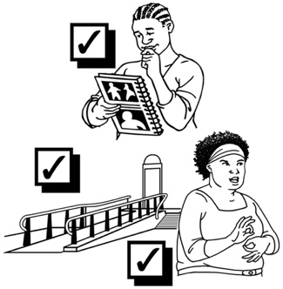
Accessible employment opportunities means things like:
- being able to do training while working
making the training affordable
having training information in ways that people can understand
having choices of online or face to face training.

What service providers /

support workers told us

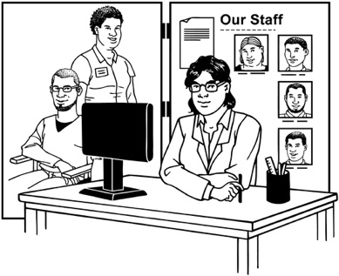
Service providers / support workers told us the disability support sector needs:
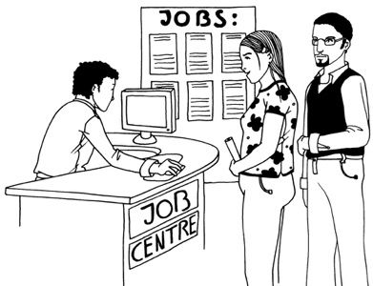
more new support workers starting out in the job more often
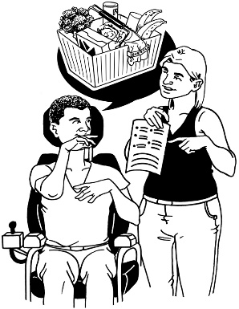
disability support work to be a good career choice
more support workers so that everyone has enough time to learn new ways of working.

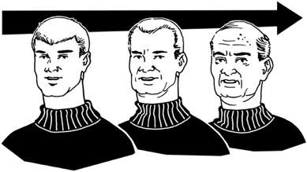
Career means the work you choose to do for a long time not just for a short time.

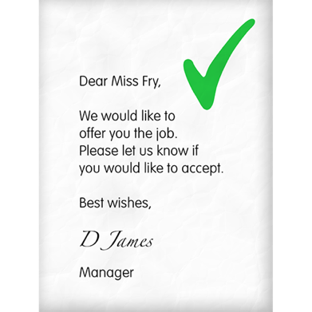
Service providers / support workers told us it is hard to:
find new workers
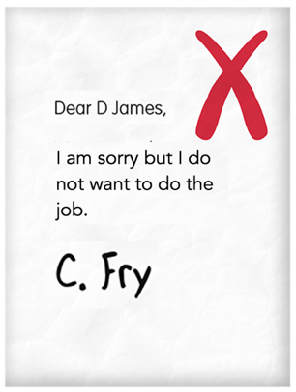
get workers to stay in the job.

It is especially hard to get technical workers because of:
different providers all trying to get the same workers
workers not being paid enough.

Technical workers are people such as:
- speech language therapists
- physiotherapists
- nurses / doctors.

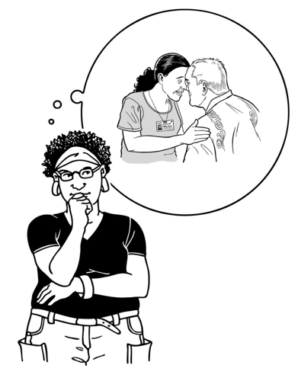
Māori service providers told us things that are important to Māori are also important for the future workforce.

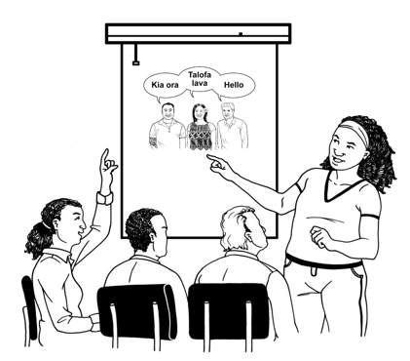
They would like finding new workers / training for disability support workers to include:
cultural competency
te ao Māori ways of doing things.

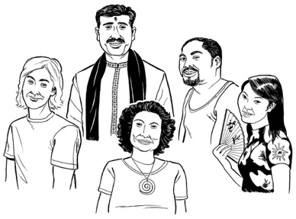
Cultural competency means knowing:
all about different cultures
how to support someone in the best way for their culture.

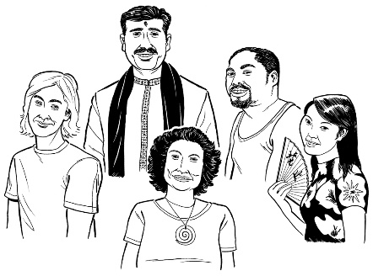
Culture is a way of:
thinking that a group shares
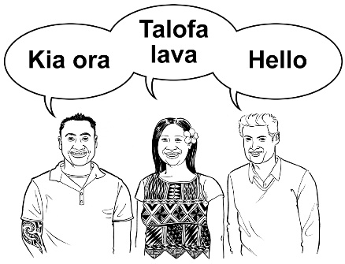
doing things as a group.

There are many different cultures in Aotearoa New Zealand.

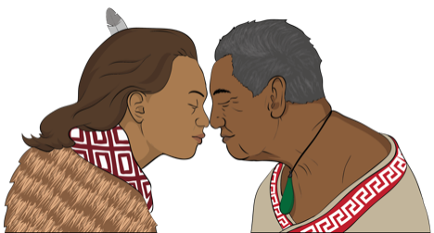
Some examples of the different cultures are:
Māori culture
Pacifica culture
Deaf culture.
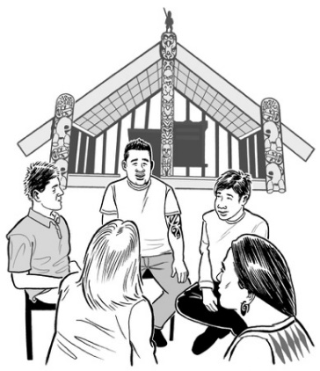

Te ao Māori means the way Māori think about the world.

What are the priorities for the future?

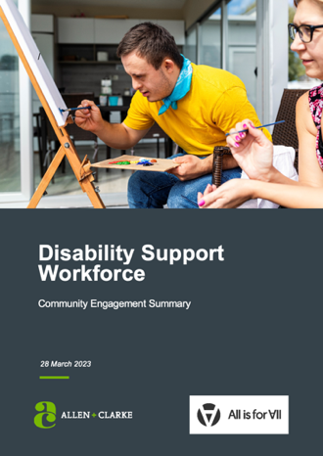
The report sets out 3 priorities for the future disability support workforce.

Priorities are the:
most important things to do something about
things to do first.

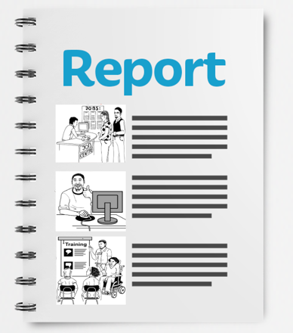
The priorities the report sets out are about:
- recruitment
- retention
- development.

Recruitment means doing things to get new people to join your workforce.

Retention means making sure everyone who is already in your workforce stays in your workforce.
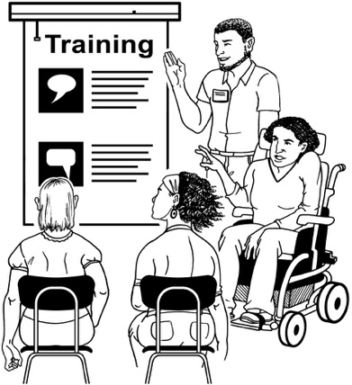

Development means doing training so your workforce can keep getting better skills.

Recruitment priority

It is hard to get new workers for the disability workforce because:
some people do not think the job is very nice
it is difficult for people to get a job using only skills they have got from their lived experience.

Lived experience is something you have done / had happen in your life.

The disability support workforce needs more people:
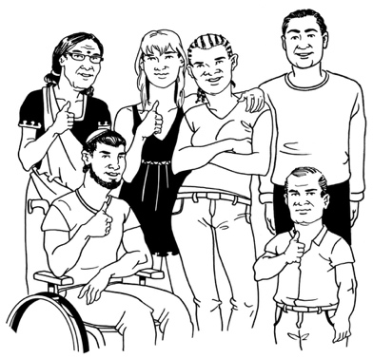
with the right values
from all sorts of ways of life / cultures.

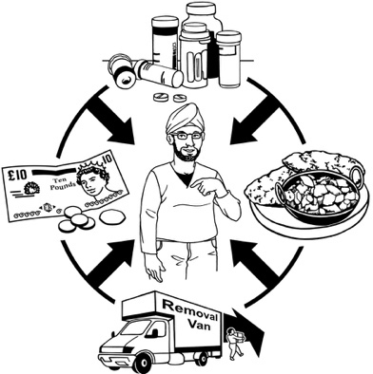
Support workers must be able to support a disabled person by:
understanding their choices
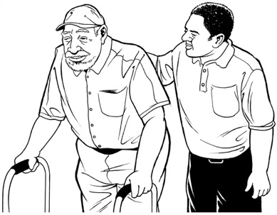
being kind
taking time to support them / meet their needs.

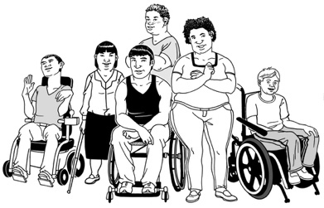
The disabled community want more support workers who are like them including more:
Māori / Pacifica
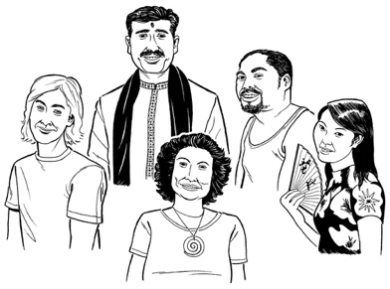
men
younger people
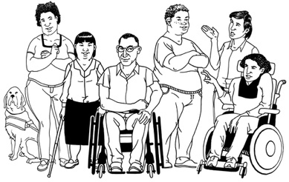
disabled people
people who have lived experience of disability.

Retention priority

Workforce wellbeing affects workers as well as the disabled community they work with.

Wellbeing means things like:
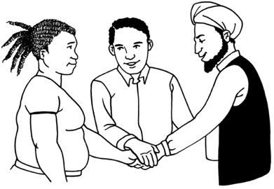
feeling good about your work
getting support from your team when things are difficult
getting paid enough to live a good life
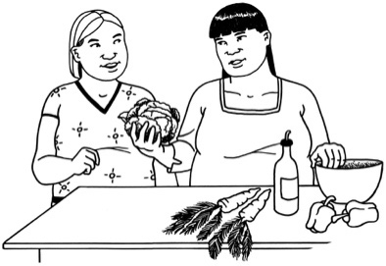
having time to look after yourself as well as do your work.

Many disability support workers leave the workforce because they do not have good wellbeing.

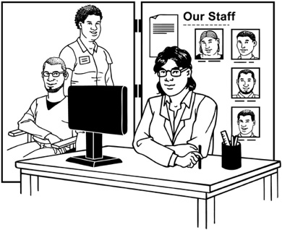
Some big employers provide wellbeing support for workers.

Disabled people / whānau who employ their own workers find it hard to provide wellbeing support for workers.

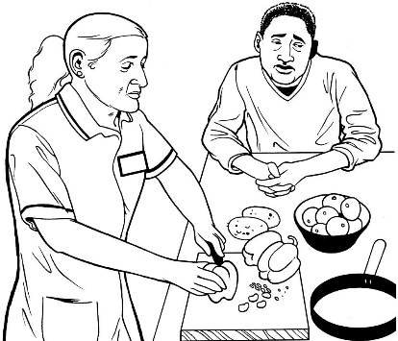
Disabled people / whānau told us:
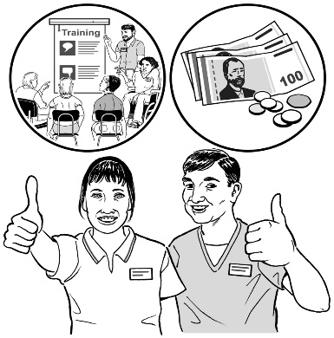
they do not always trust disability support service providers because of bad experiences in the past
they need better ways of supporting the wellbeing of workers that they choose for themselves.
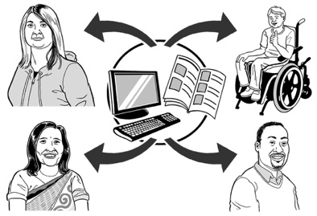
A good idea for the future would be to make:

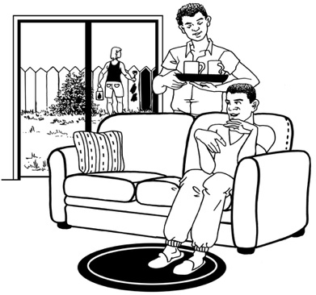
workforce wellbeing resources for all providers to share
better ways for family / whānau carers to get a rest.

Resources are things like booklets / videos to teach you how to look after your wellbeing.

Development priority

People had different ideas about whether official training is important for disability support workers.

Some people said other things were more important such as:
values / attitudes which are what people think about things
skills which are the things people can do.

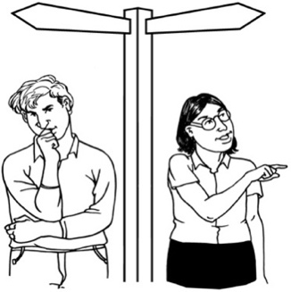
Other development problems for the disability support workforce include:
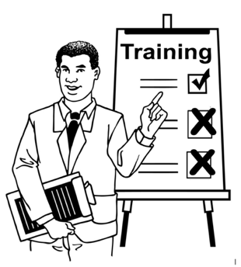
not enough career choices
not enough ways to train / get better skills
not enough training for certain skills that are needed
too many things that stop disabled people / family carers from joining the workforce
providers not having enough money for training.

The main things we learned

from the report

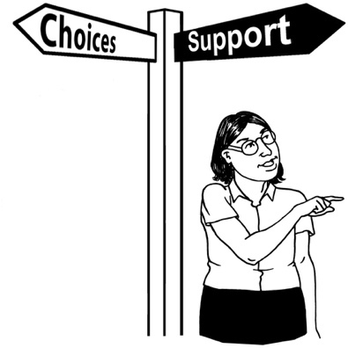
The disabled community told us they want the future disability support workforce to:
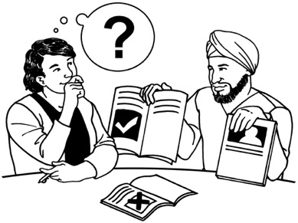
give disabled people more choice about their care
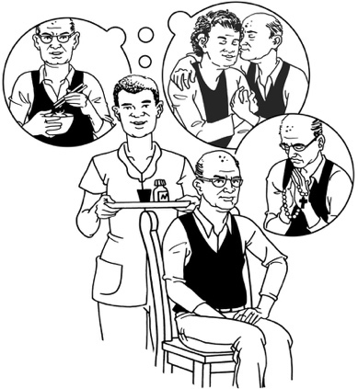
give disabled people power over their own care which gives them more say in what happens to them
respect the needs / choices of each disabled person.

The disabled community also told us it is important that the disability support workforce:
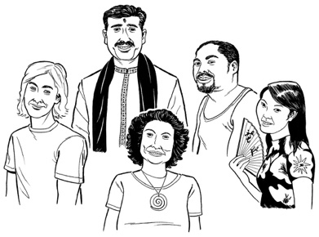
includes all types of people
is able to give the right support to people from different cultures
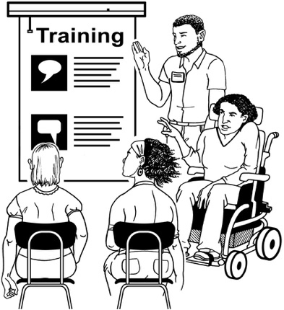
has good training opportunities.

The disabled community also told us it is important that the Government:
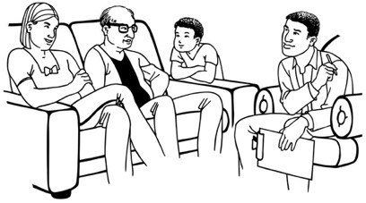
gives more support to family / whānau carers
gives more respect to family / whānau carers.

Where to find more information

You can contact Whaikaha – Ministry of Disabled People for more information about the Disability Support Workforce Community Engagement Summary by:
email at:
contact@whaikaha.govt.nz
phone on:
0800 566 601
It will not cost you any money to call this number.

This information has been written by Whaikaha – Ministry of Disabled People.

It has been translated into Easy Read by the Make it Easy Kia Māmā Mai service of People First New Zealand Ngā Tāngata Tuatahi.

The ideas in this document are not the ideas of People First New Zealand Ngā Tāngata Tuatahi.

Make it Easy uses images from:

- Changepeople.org

- Photosymbols.com

- SGC Image Works

- Huriana Kopeke-Te Aho.
All images used in this Easy Read document are subject to copyright rules and cannot be used without permission.

