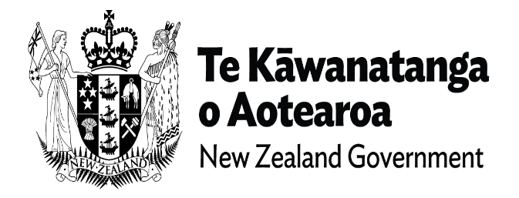

Your guide to what the new Ministry will do
The new Ministry for Disabled People [name TBC; the new Ministry] will do many things with and for the disability community. Government has asked that it does things differently to other Ministries. The disability community and Māori will partner with this new ministry and guide how it operates. The new Ministry’s responsibility in this partnership is to listen to the voice of the disability community and learn from the process of working together.
To do this, the new Ministry is also asked to use founding documents of: 1) Te Tiriti O Waitangi; 2) The United Nations Convention on the Rights of Persons with Disabilites (UNCRPD); 3) Enabling Good Lives and 4) Whānau Ora. Using these documents will create strong relationships between the disability community, Māori and the new Ministry.
All partners commit to equity for disabled people, tāngata whaikaha Māori, and the disability community (families/whānau; children and young people/tamariki, rangatahi; support people).

Two main responsibilities
From this, the new Ministry has two main responsibilities. This first is providing leadership/stewardship of disability across government. This is a responsibility to guide transformation of how government departments work with the disability community.
The second is enabling person-directed support by disabled adults, children, families and tāngata whaikaha Māori me o rātou whānau. This is a responsibility to transform how support services are provided for those in the disability community who need them.

When will things happen?
On July 1, the new Ministry will start operating (day one). A lot of what it does on day one will shift from the Ministry of Health and the Ministry of Social Development. The new Chief Executive (the person taking care of all operations) will make decisions about dates for the new work at the new Ministry. This is an outline of what the new Ministry will do on day one, and what it will start working on for the future.

What can you expect on day one?
The new Ministry will have everything needed for a Ministry to carry out its day-to-day operations. This includes things like IT services, legal services and administration of a ministry.
These will be supported by MSD and Health NZ, with the new Ministry taking on much of this independently over time as it becomes established.
Disability support services will transfer and continue to operate as they do now. This will include equity for Māori; Commissioning of services; policy about disability support; coordination of ministerial responses; monitoring of services; and the disability support workforce. People will also be able to give feedback and complaints.
The new Ministry takes on disability specific COVID response and support.
Enabling Good Lives (EGL) services which already exist will come to the new Ministry. This includes partnering for putting EGL into practice; carrying out EGL services; EGL practices which build capability and capacity for disabled people, tāngata whaikaha Māori and families; Services covering the three already existing EGL locations (Waikato, Christchurch and Mid-Central).
The new Ministry will be responsible for transforming the disability support system to one that is person-directed. This work has already started within Ministry of Health. This will transfer for day one and includes: already funded person-directed support and equity advice about all groups within the disability community; service development and improvements; quality related analysis, insights and learning.

The new work…
The new Chief Executive will set up the new work of this new Ministry. Ministry operations that are introduced after day one, across time, are the ones which create a different Ministry. There are 8 categories where the new ministry will guide change by, with, and for the disability community.
- Partnering: The new Ministry will create partnership relationships with disabled people, families and tāngata whaikaha Māori me o rātou whānau, Māori
- Voice: The new Ministry will seek and listen to views of the disability community. These will guide the new Ministry’s work.
- Te Tiriti: The new ministry will give effect to the articles of Te Tiriti in the work of the Ministry.
- Leadership/Stewardship of Disability across Government: The new Ministry will provide guidance, advice and strategic policy support related to disability, accessibility and equity for all disability population groups. The new Ministry has a specific responsibility for policy leadership for tāngata whaikaha Māori me o rātou whānau
- Enabling Person-Directed support: The new Ministry will plan and act on transformation of the disability support system. This includes using the Enabling Good Lives model across the country so disabled people direct their support.
- Performance and Governance: The new Ministry will provide administration for its partnership groups and keep track of how well it is doing its work
- Listening, Insights and Learning: The new Ministry will provide monitoring, evaluation, analysis and learning related to disability. It will also generate disability and Te Tiriti based research and learning, and take care of data related to disability.
- Building Capability and Capacity: The Ministry will grow capability and capacity of the disability community to engage with the whole government system. It will also have workforce development programmes for its own staff and the disability support workforce.

End of guide to what does the Ministry will do

