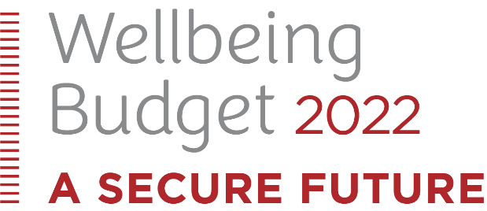

What the Minister for Disability Issues had to say about the
Wellbeing Budget 2022
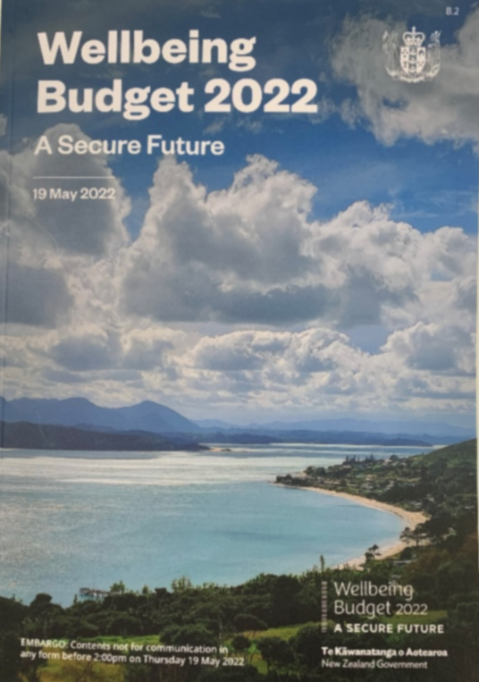
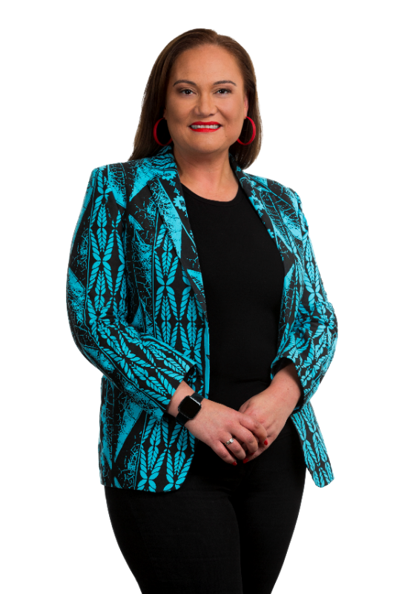

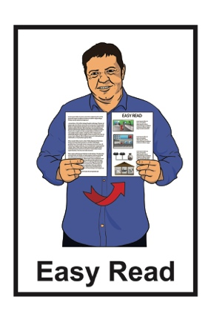

19 May 2022

Wellbeing Budget 2022

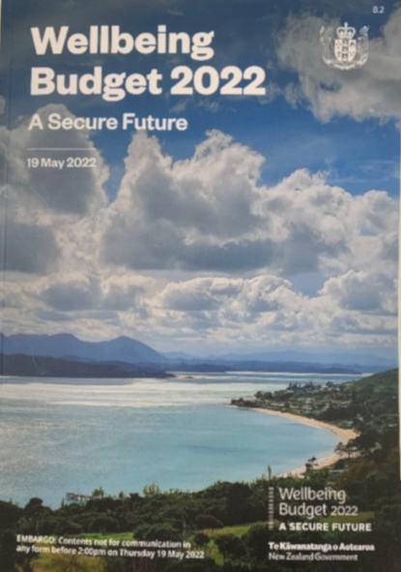
On 19 May 2022 the Government told us about what was in their Wellbeing Budget 2022.

A Budget is a plan of what:

- money the Government has

- the Government plans to spend the money on.

This Easy Read document looks at what the Minister for Disability Issues had to say about the Wellbeing Budget 2022.

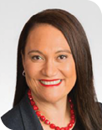
The Minister for Disability Issues is the Honourable Carmel Sepuloni.

In this Easy Read document we will call her Minister Sepuloni.

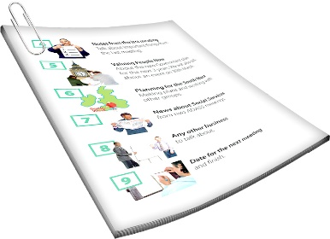
Minister Sepuloni put out a press release on 19 May 2022.

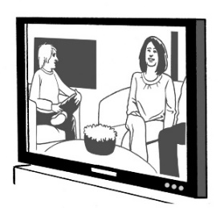
A press release is a document that is written for the media like TV / newspapers to use.

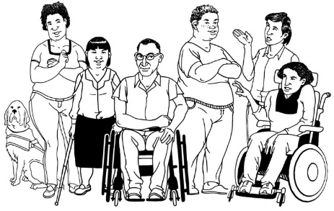
In the press release Minister Sepuloni said that:

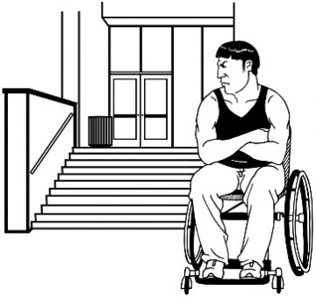
- about 1 in every 4 people in New Zealand say they have a disability

- many disabled people face barriers to living a good life.

Barriers are things that make it hard for disabled people to live their good lives.
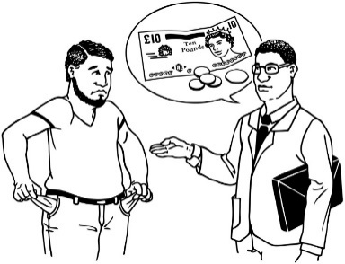
Some of these barriers are things like:

- not having enough money

- not being able to get the support they need
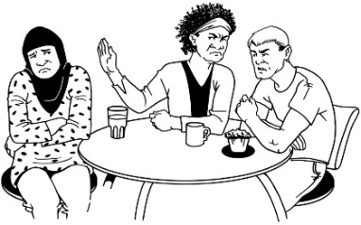
- not being treated fairly.

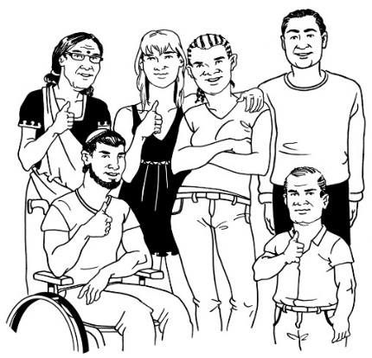
Minister Sepuloni said that the Wellbeing Budget 2022 shows that the Government wants better outcomes for:

- disabled people

- whānau / families.

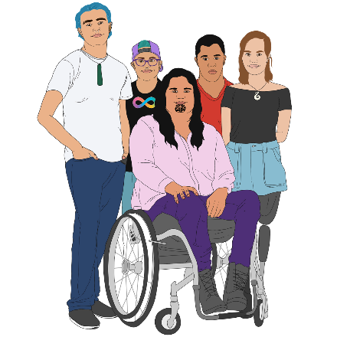
In the Budget the Government has money for:

- the setting up of the new Ministry for Disabled People
- rolling out Enabling Good Lives across New Zealand
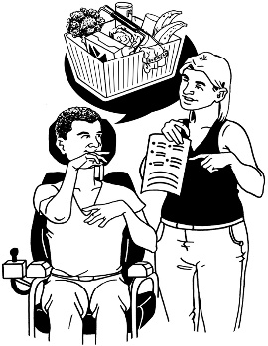
- funding more disability support services.

The new Ministry for Disabled People

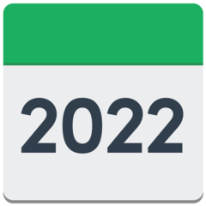
The new Ministry for Disabled People will start from 1 July 2022.

The new name for the Ministry for Disabled People has not yet been decided.

In this document we will call it the Ministry.

The Government has put 1 hundred million dollars into the new Ministry.

The Ministry will work to make disability support services better for disabled people and their whānau / families.
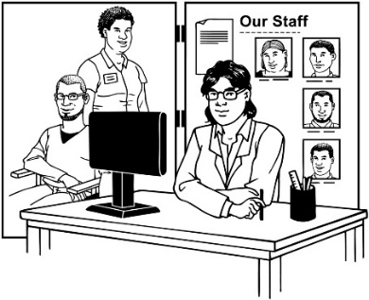
The disability support services that people get will be moved from the Ministry of Health to the new Ministry.

People will keep getting their disability support services.

The Ministry will also work with other government agencies to better support disabled people.

This will mean working with other government agencies that look after things like:

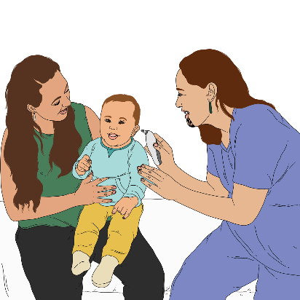
- work / employment

- education

- health.

Rolling out Enabling Good Lives across
all of New Zealand

Enabling Good Lives is a different way of thinking about disability support.

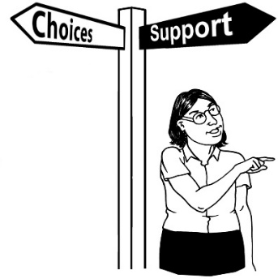
Enabling Good Lives is about having:
- choice and control in your life
- the support you need and want
- a good life.

The Ministry will also begin the work of having disability support services that follow the Enabling Good Lives principles.

Principles are the ways in which Enabling Good Lives works.

You can find more information about the principles of Enabling Good Lives at this website:

www.enablinggoodlives.co.nz

More funding for disability support services

In the Budget there is 11 million dollars so that disabled people can get the services they need.

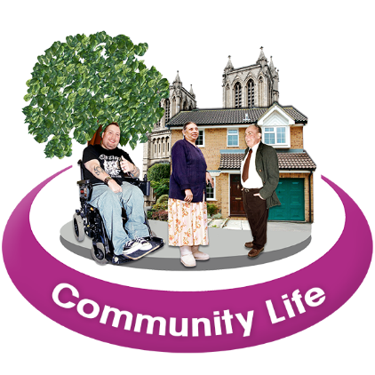
Some of this funding means that 370 more disabled people will be able to access Community Participation services.

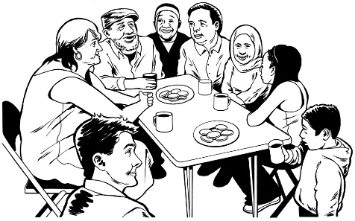
Community Participation services:

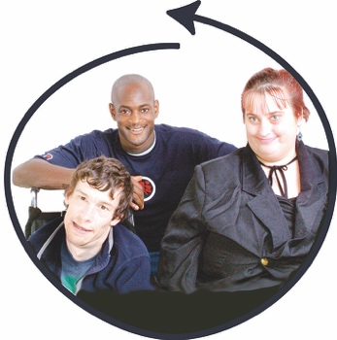
- support disabled people to take part in their community / the area they live

- work to improve the quality of life for disabled people.

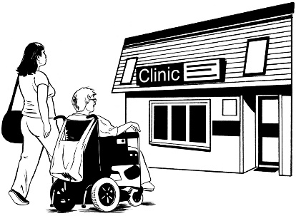
Community Participation services may be things like support to:

- go to the doctor
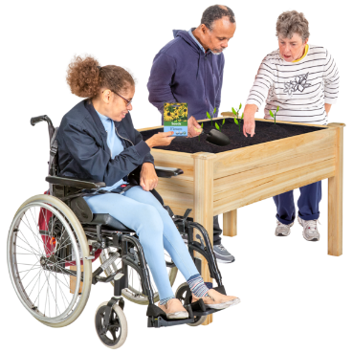
- go to the movies

- be a part of the things you enjoy doing.

Also in the budget is 7 hundred and thirty five million dollars that will be used to pay for the Government disability support services.

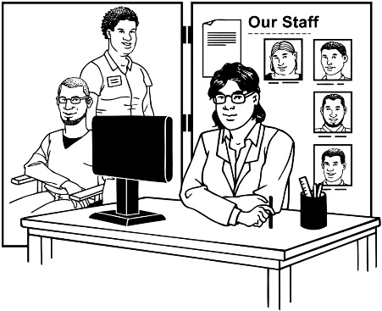
This funding is needed because of the increase in:

- the cost of running these services

- the number of people needing disability support services.

The Government also wants to make sure that family carers are paid for the support they give to their disabled family member.

A family carer might be:

- a parent

- husband / wife / partner

- someone that lives with their disabled family member.

This includes family carers who care for disabled people who have been assessed as having very low needs.

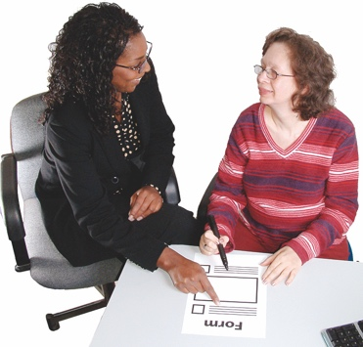
Assessed means someone from a Needs Assessment Service Coordination agency has looked at the level of support the disabled person needs.
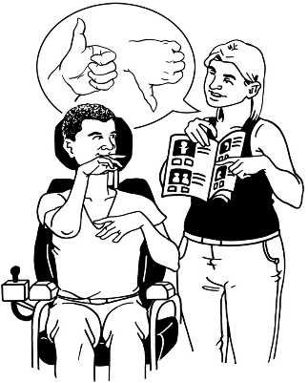
Paying family carers will mean that disabled people will get more choices about:

- the support they get
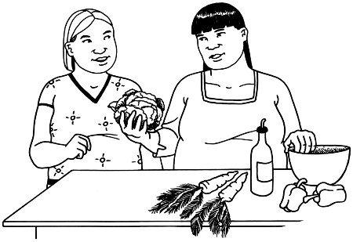
- the places where they want to get the support

- who does their care / support.

This also means that family carers will be better recognised for their work.

Recognised means being valued for the important work family carers do.

Where to find more information

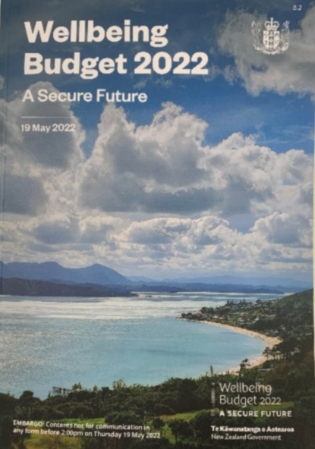
You can find the full Wellbeing Budget 2022 report on the Government Treasury website:

www.treasury.govt.nz/publications/budgets/budget-2022

You can also find more information about the budget on the Ministry of Social Development website:

www.msd.govt.nz

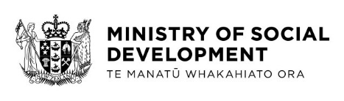
This information has been written by the Ministry of Social Development.
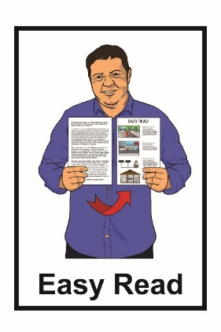
It has been translated into Easy Read by the Make It Easy service of People First New Zealand Inc. Ngā Tāngata Tuatahi.

The ideas in this document are not the ideas of People First New Zealand Inc. Ngā Tāngata Tuatahi.

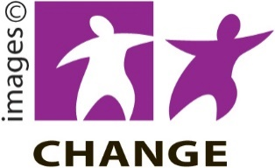
Make It Easy uses images from:

- Changepeople.org

- Photosymbols.com

- SGC Image Works

- Huriana Kopeke-Te Aho.

All images used in this Easy Read document are subject to copyright rules and cannot be used without

