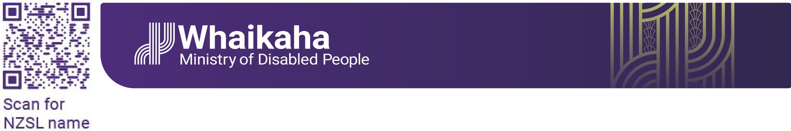

Visual description: A purple Ministry of Disabled People – Whaikaha logo. On the left is a QR code and underneath the words ‘scan for the NZSL name’.

# Expressions of Interest: Join the Accessibility Advisory Group

**Kia hiwa rā kia hiwa rā**

**Kia kōkiri ake, kia mataara.**

**He karanga atu ki te ao whānui, ki te ao whaikaha.**

**Mauria mai ōu whakaaro rangatira ki tēnei kaupapa whakahirahira nau mai e te iwi e.**

Be watchful, be alert. Rise up, come forward, be counted, be alert. A call going out to the world, to the disabled world. Bring your chiefly thoughts to this important discussion. We welcome all.

Ministry of Disabled People – Whaikaha is leading a programme of work to improve accessibility in Aotearoa New Zealand. We’re forming an Accessibility Advisory Group (rōpū) to help guide this work and are seeking solutions-oriented creative thinkers to join us.

This rōpū will bring together disabled people with fresh ideas, lived experience and a drive to explore new ways to achieve an accessible Aotearoa New Zealand.

This kaupapa is guided by our organisational values: Mana taurite - equity drives us, Mana kaha - we strengthen and support, and Mana tūhura - we explore and learn. Tāngata whaikaha Māori and Turi Māori voices are central to this mahi and together we will work to uphold Te Tiriti o Waitangi/the Treaty of Waitangi.

## What is the Accessibility Advisory Group?

This rōpū will bring together 10 creative, strategic thinkers from the disability community with a deep understanding of accessibility issues.

Members will provide advice on priorities, equity-focused outcomes, and practical solutions to improve accessibility in New Zealand.

The rōpū will work in ways that embed tikanga, create safe spaces for whakawhanaungatanga, and uphold cultural as well as technical aspects of accessibility.

## Who we’re looking for

We are seeking people who will bring enthusiasm, problem solving ability, open minds, and impact.

Expressions of interest are encouraged from tāngata whaikaha Māori, Turi Māori, Pacific peoples, neurodivergent people, carers, and people from diverse backgrounds, regions, age groups, genders and identities.

We need people who are committed to the Te Tiriti o Waitangi/The Treaty of Waitangi, United Nations Convention on the Rights of Persons with Disabilities, the Human Rights Act (1993) and the [Ministry’s Strategic Intentions](https://www.whaikaha.govt.nz/about-us/corporate-publications/strategic-intentions/strategic-intentions-tauaki).

## What’s involved?

The rōpū will meet online 4 to 6 times a year.

We are hoping to have the first meeting in person in Wellington.

Members will be paid for their time and preparation. Supports such as NZSL interpreters, captioning, meeting assistance, note-takers, and travel costs will be provided.

The members will elect a Co-Chair, and up to two members will also be part of the Whaikaha Steering Group for the Accessibility Work Programme.

## Payment

Members will be paid $61 per hour for each four-hour meeting, with up to two hours for preparation time.

The Co-Chair will be paid $77 per hour for each four-hour meeting, with up to two hours for preparation time.

Payment rates are based on the Cabinet Fees Framework. Members will invoice Whaikaha after each meeting.

## Skills and experience

We’re looking to bring together a group of entrepreneurial and creative thinkers who will collectively:

* understand accessibility and its barriers and be solutions focused.
* are committed to equity and inclusion, particularly for tāngata whaikaha Māori, Turi Māori, and Pacific peoples.
* understand Te Tiriti and kaupapa Māori approaches to social change.
* have worked on accessibility projects.
* understand disability advocacy and social change.
* have strong community, government, industry and/or business connections.
* understand the workings of government, the public sector and/or private enterprise.

## How to apply

* You can download the Expression of Interest form here: <https://www.whaikaha.govt.nz/about-us/our-work/accessibility-work-programme/accessibility-advisory-group> **or here** <https://whaikaha.govt.nz/aag>

You can send your completed form to:

* Email: [outreach@whaikaha.govt.nz](mailto:outreach@whaikaha.govt.nz)
  + If you prefer to apply with a video, please email us the link to your video.
* Post (Freepost):  
  Outreach and Innovation Group  
  Whaikaha – Ministry of Disabled People  
  Reply Paid: 262204  
  PO Box 1556  
  Wellington 6140

**Applications are due by 3 November 2025.**

## What happens next?

Expressions of Interest will be considered by a panel of community representatives, chaired by Whaikaha. The panel will ensure Te Tiriti principles are reflected in the selection process, with a focus on equitable outcomes for tāngata whaikaha Māori and Turi Māori.

We hope to notify people by Friday November 14 2025, with appointments confirmed by Friday November 28.

First meeting is planned for Friday 12 December 2025, in person, in Wellington.

**End of: Expressions of Interest: Join the Accessibility Advisory Group**

This Large Print document is adapted by Blind Citizens NZ from the standard document provided by Whaikaha, Ministry of Disabled People.