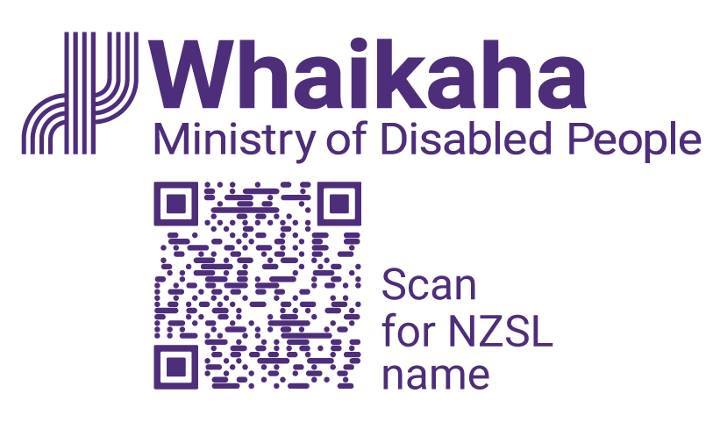
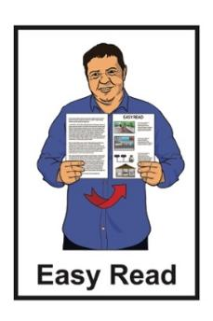

Accessibility Advisory Group Terms of Reference


Published: October 2025

Before you start

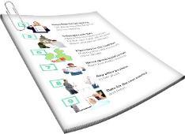
This is a long document.


It can be hard for some people to read a document this long.

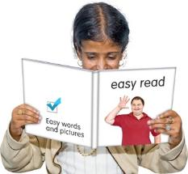
Some things you can do to make it easier are:
read it a few pages at a time
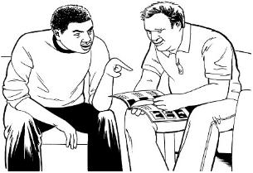
set aside some quiet time to look at it
have someone read it with you to support you to understand it.

What you will find in here

Page number:
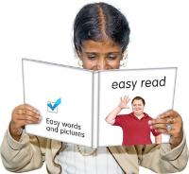

About this Easy Read 5


Background 8

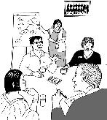
Work programme 13


Role of the rōpū / group 15


Scope / what the rōpū / group
will do 18


Membership 21

Page number:
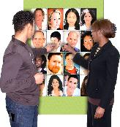

How members will be chosen 23


Job length and size 25

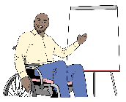
Member roles 27

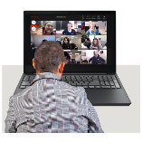
Meetings 29


Remuneration / pay 32


Support given by Whaikaha 33


Conduct / how people will
behave 35

Page number:


Confidentiality and conflict of
interest 37


Closing down the Accessibility
Advisory Group 39



Review of the terms of
reference 40

About this Easy Read

This Easy Read is the Terms of Reference for the Accessibility Advisory Group.

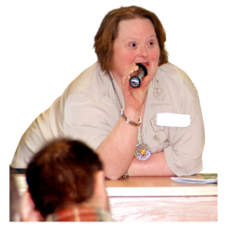
Terms of Reference means information about:
roles / jobs

responsibilities / duties
what the group will do.


The Accessibility Advisory
Group is a group which will give advice to Whaikaha about making accessibility better in Aotearoa New Zealand.


In this document the Accessibility Advisory Group will be
called the rōpū / group.


This Easy Read is from the Ministry of Disabled People – Whaikaha.


The Ministry of Disabled
People – Whaikaha works to make things better for disabled people by working with:

the Government
the community which includes:
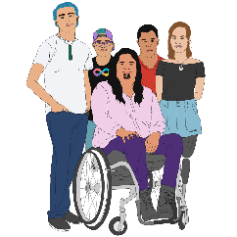
- disabled people
- tāngata whaikaha
Māori / Māori disabled
people
businesses.


In this Easy Read when we say Whaikaha this means the Ministry
of Disabled People – Whaikaha.

Where it says we / our this means Whaikaha.

Background
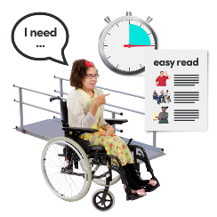

We are leading work to make accessibility better in Aotearoa New Zealand.

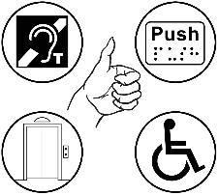
Accessibility means making sure disabled people can be part of something.

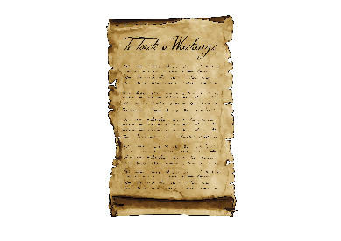
This work to make accessibility better fits in with:
Te Tiriti o Waitangi / The Treaty of Waitangi

the United Nations Convention on the Rights of Persons with Disabilities
The Human Rights Act 1993
our Strategic Intentions.
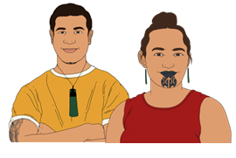
Te Tiriti o Waitangi / The Treaty of Waitangi is an important agreement between:
Māori
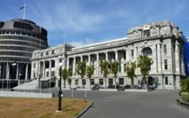
and
the Crown.


The purpose of Te Tiriti is to:
protect Māori:
- rights
- taonga / things that are very important to Māori
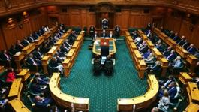
keep peace and order
set up government.


Rights are things that the
law says every person should:
have
be able to do.


Peace and order means following laws / rules.

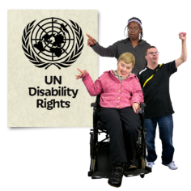
The United Nations Convention on the Rights of Persons with Disabilities / UNCRPD is a law lots of countries have agreed to.

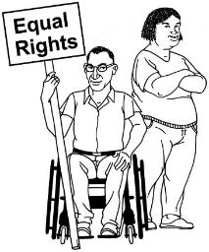
It says what governments must do to make sure disabled people get the same rights as everybody else.

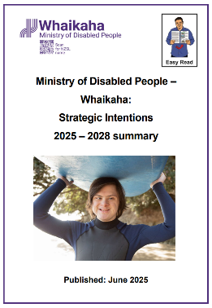
You can find the Easy Read version of our Strategic Intentions at this website:

https://tinyurl.com/58eb9fzc

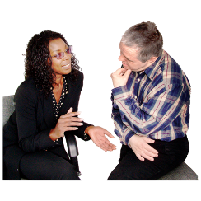
The rōpū / group will give us advice on how to make accessibility better by telling us:
the most important things to do
and
how to do them.

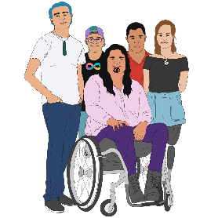
We want to make sure the
rōpū / group has members who are:
tāngata whaikaha Māori / Māori disabled people
Turi Māori / Māori deaf people.

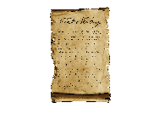
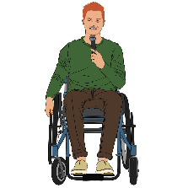
The rōpū / group will do their work using the ideas in Te Tiriti o
Waitangi / The Treaty of Waitangi.

Work programme

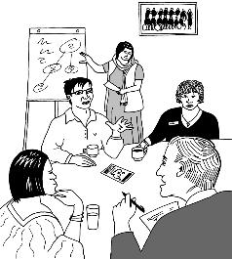
The rōpū / group will give us advice on what are the most important things to be done in the Accessibility Work Programme.

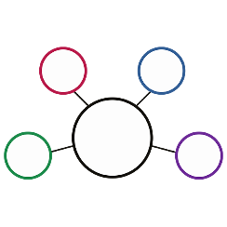
The Accessibility Work Programme is a list of the work that will be done to make accessibility in Aotearoa New Zealand better.


The rōpū / group will support us to:
come up with ideas

decide what ideas are important to do
make plans
get ready to do the work.
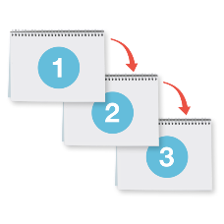
The advice from the rōpū / group will support us to:
work on a good number of plans
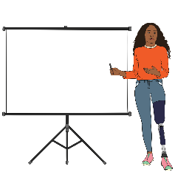
be open about the work we are doing
be accountable to the disability community.


Accountable means doing things in a responsible way including:
doing what was promised
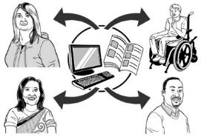
showing how decisions are made
making sure people know what is going on.

Role of the rōpū / group


The rōpū / group will work together:
to give us advice that:
- comes from lived experience

- comes from community connections
- uses ideas from Te Tiriti o Waitangi / The Treaty of Waitangi
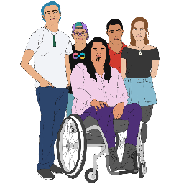
on equity for disabled people especially:
- tāngata whaikaha
Māori / Māori disabled people
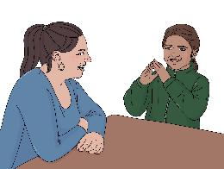
- Turi Māori / Māori deaf people.

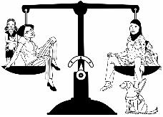
Equity means everyone gets what they need to live a good life.

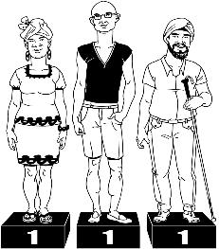
The rōpū /group will also work together:
using values like:
- mana taurite – equity drives us

- mana kaha – we strengthen and support
- mana tūhura – we explore and learn

by sharing:
- skills
- leadership.


Values are beliefs that people use to decide how to:
live

behave
work.

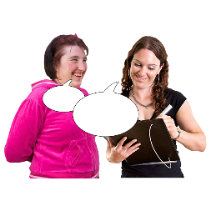
The rōpū / group:
only gives us advice
does not make decisions for us.


All final decisions will be made by Whaikaha.

Scope / what the rōpū / group will do

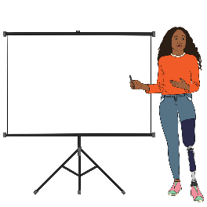
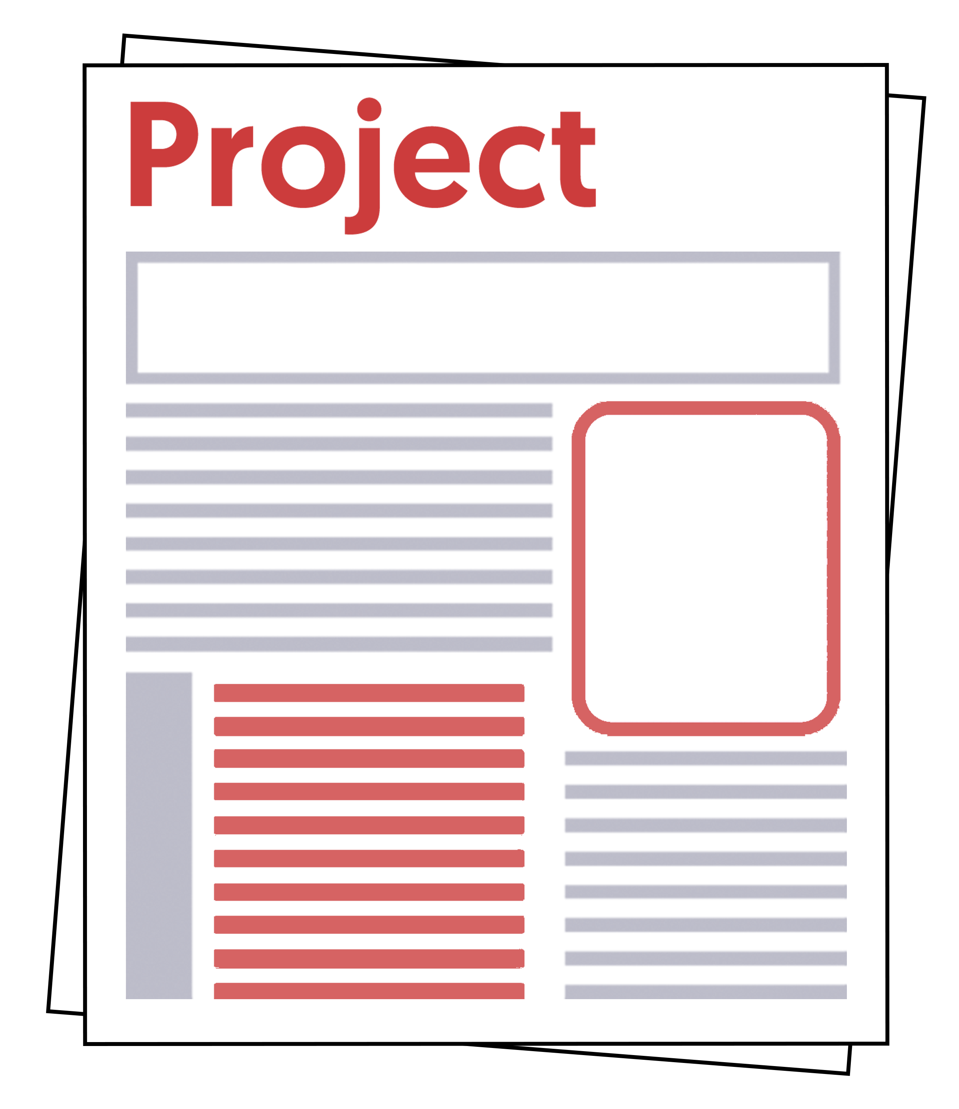
The rōpū / group will:
work together on priorities
support important projects
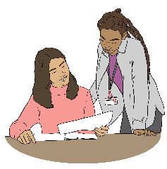
share what they know to support important decisions
connect / talk to people who know things about accessibility

look at plans
give advice about plans
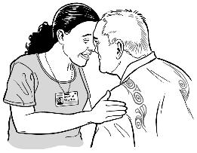
think about how accessibility outcomes can be made better using:
- kaupapa Māori
- mātauranga Māori
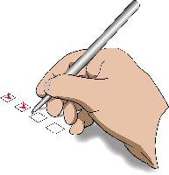
Priorities are very important things to do.


Outcomes means how things end up
for people.

For example better accessibility means disabled people will have better lives because they can:
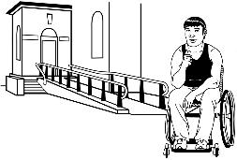
go to more places
do more things.

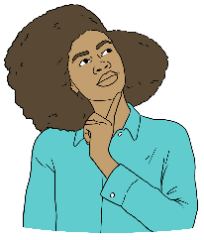
Kaupapa Māori means using all the parts of Māori:
knowledge
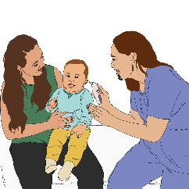
skills
attitudes
values.
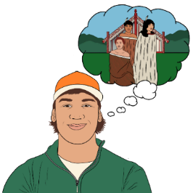
Mātauranga is:
Māori ways of knowing things
information Māori have known for a very long time.

Membership


The rōpū / group will have 10 people from the disability community in it.

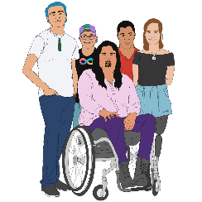
The rōpū / group will be made up of people who are:
disabled
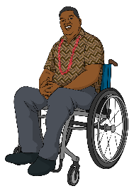
tāngata whaikaha Māori / Māori disabled people
Turi Māori / Māori deaf people
from the Deaf community
Pacific disabled peoples
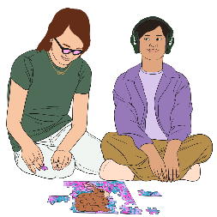
neurodivergent
whānau / families of disabled people.
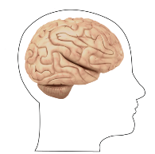
Neurodivergent people have brains that are different to:
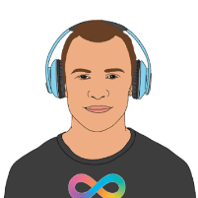
how most brains work
what some people think our brains should be like.

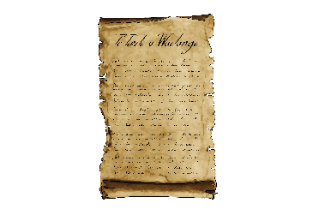
Rōpū / group members must understand:
Te Tiriti o Waitangi / The Treaty of Waitangi

how the Crown / Government and Māori get along
the United Nations Convention on the Rights of Persons with
Disabilities / UNCRPD.

How members will be chosen

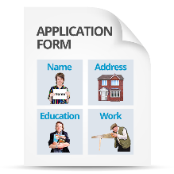
People can apply to join the
rōpū / group through an Expression of Interest / EoI.


An Expression of Interest means officially saying that you are interested in taking part in something.


A panel of people from the disability community will consider / think about all the people who apply to join the rōpū / group.


Whaikaha will lead the panel.

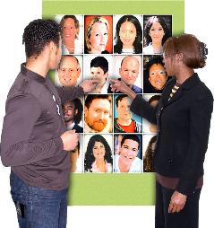
The panel will choose people who:
come from diverse / different backgrounds
know a lot about accessibility.

Job length and size


Most members will be part of the rōpū / group as an individual / 1 person.

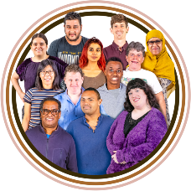
Up to 2 places on the rōpū / group might be filled by people from organisations so there are members from many different backgrounds.


In the first year of the rōpū / group:
5 members will be chosen to serve for 1 year
and

5 members will be chosen to serve for 2 years.


5 new members will be chosen every year after that by Expression of Interest / EoI.

Member roles

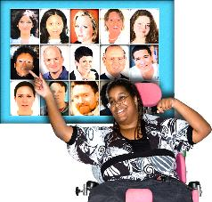
Rōpū / group members will choose a co-chair from their group who will work with the co-chair from Whaikaha.

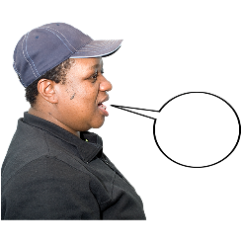
Rōpū / group members will share their:
skills
lived experience.
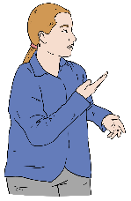


Rōpū / group members will:
talk about the Accessibility Work Programme

give advice and ideas on decisions for the Accessibility Work Programme.

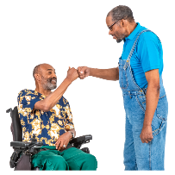
Rōpū /group members will:
support everyone working together

make sure what everyone says is thought about carefully.


Rōpū / group members will choose 2 members to take part in the Whaikaha Steering Group meetings for the Accessibility Work Programme.

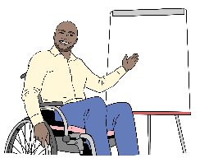
A steering group is a group of people who lead the work being
done on something.



People from outside the rōpū / group who know important things might be asked to give information sometimes.

Meetings


The rōpū / group will meet 4 to 6 times each government financial year.


A government financial year goes from:
1 July

to
30 June.

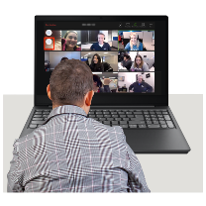
Most hui / meetings will be held online.


There might be 1 meeting a year that is:
in person
in Wellington.
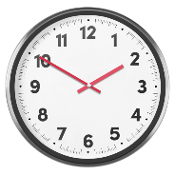
Each hui / meeting will go for up to 4 hours.

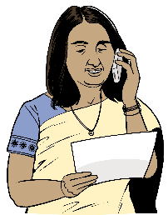
Members will also be paid for up to
2 hours for the work they do to:
get ready for the meeting
follow up after a meeting.

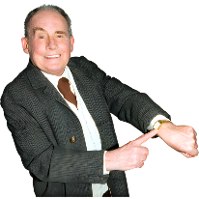
The members will decide:
meeting times
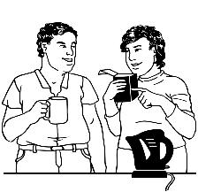
breaks
accessibility needs.


Hui / meetings will have
karakia / prayer at the:

start
and
end.

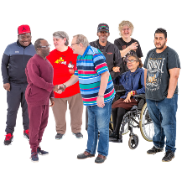
The karakia is for building:
relationships
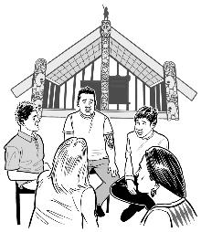
whakawhanaungatanga / Māori ways of getting along with people.

Remuneration / pay

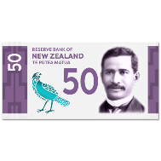
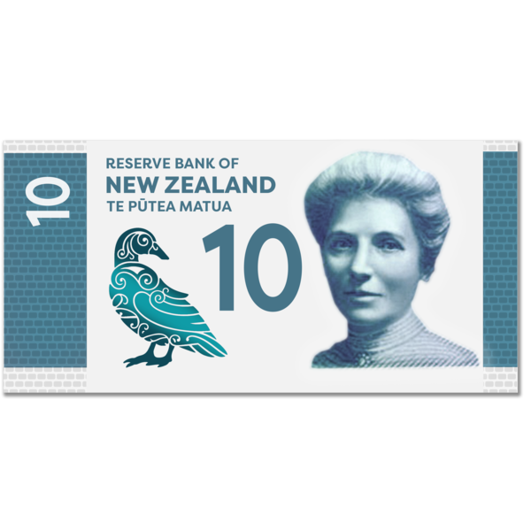

General rōpū / group members will be paid 61 dollars an hour.


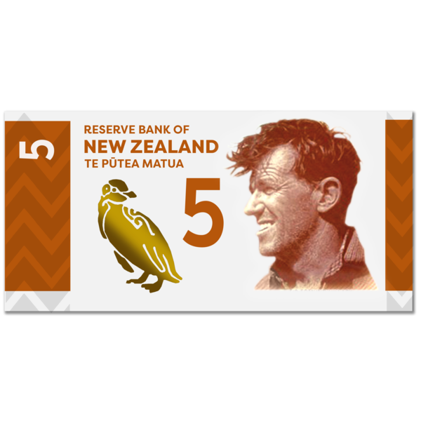

The co-chair will be paid 77 dollars an hour.

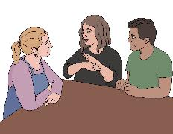
Whaikaha will cover reasonable costs for things like:
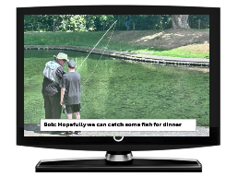
New Zealand Sign Language / NZSL interpreters
assistive technology like captioning

meeting assistance
travel.

Support given by Whaikaha

Whaikaha will support the
rōpū / group to use tikanga / Māori ways of doing things like:

karakia / prayer
waiata / song
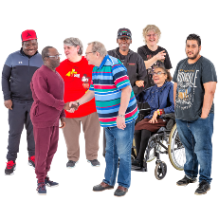
whakawhanaungatanga / Māori ways of getting along with people.

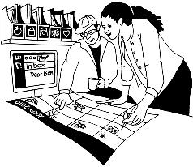
Whaikaha will support the
rōpū / group with:
organising the hui / meetings

taking notes during the
hui / meetings
technology like setting up the
hui / meetings online.

Whaikaha will also support the
rōpū /group with:
paying the members
accessibility like:
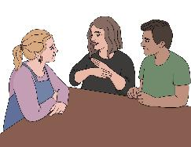
- interpreters
- Captions
meeting assistance.

Conduct / how people will behave

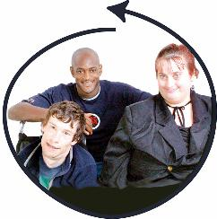
We will ask members to:
treat other people well
include everyone

be impartial
be people who can be trusted
use the values:
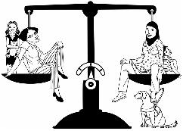
- mana taurite – equity drives us
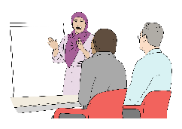
- mana kaha – we strengthen and support
- mana tūhura – we explore and learn.

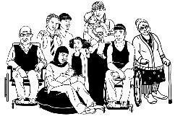
Impartial means to do things:
for the good of everyone

and
not just for yourself.


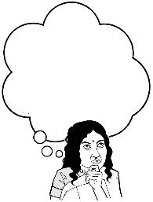
Members are expected to be part of the rōpū / group:
because of their knowledge of accessibility
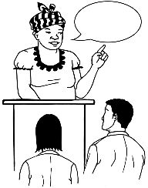
and

not because they
represent / speak for other organisations.

Confidentiality and conflict of interest

The rōpū / group members will be given:

an appointment letter
a confidentiality document
a conflict of interest document.

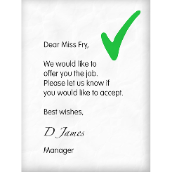
An appointment letter is an official letter that:
says you have been given a job
has information about the job.

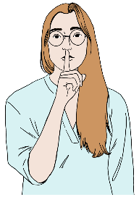
Confidentiality means not talking about something with people who should not know.
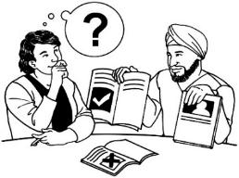
A conflict of interest is when someone has different things they need to do like:
their job
supporting a family member.


Doing different things at the same time can make it hard to make a fair decision.


It is important to tell people about a conflict of interest so things can be kept honest.


Rōpū / group members must behave by the rules in the:
Privacy Act 2020

and
Official Information Act 1982.

Closing down the Accessibility Advisory Group


Whaikaha may close down the Accessibility Advisory Group if things change in the Government.

Review of the terms of reference


These terms of reference will be reviewed / checked:
every year
or

earlier if agreed to by:
- Whaikaha
- the rōpū / group.


The reviews will check if the
rōpū / group is doing what it is supposed to.


This information has been written by the Ministry of Disabled People – Whaikaha.

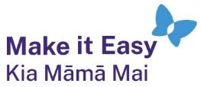
It has been translated into Easy Read by the Make it Easy Kia Māmā Mai service of People First New Zealand Ngā Tāngata Tuatahi.

The ideas in this document are not the ideas of People First New Zealand Ngā Tāngata Tuatahi.

All images used in this Easy Read document are subject to copyright rules and cannot be used without permission.


Make it Easy uses images from:

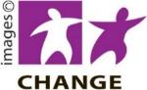
- Photosymbols

- Change Images


- Huriana Kopeke-Te Aho

- SGC Image Works

- T Wood

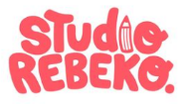
- Studio Rebeko

- Inga Kramer.

