# **Atoatoali’o**

# **National Pacific Disability Approach**

Image of the Whaikaha logo


## **The Cover Atoatoali’o**

Atoatoali’o is a Samoan word referring to a setting where everyone fits in or sits perfectly (atoatoa) in a circle (li’o)

This concept reflects the central values of inclusivity, connectedness, and balance that are foundational of Pacific cultures.

Our Aiga and communities know that despite life’s challenges and barriers when support and encouragement is available the circle (li’o) is connected.

The association of “Atoatoali’o” with life and community in its holistic reality forms the philosophical and cultural basis for this Pacific approach.

The name Atoatoali’o was thoughtfully gifted from the Wairarapa Pacific community, during the talanoa held in 2024 to inform this approach.

We all have an important part to play in creating a society where disabled people feel truly included and valued. This gesture highlights their deep commitment to the process, emphasising the importance of collaboration and cultural respect in our shared efforts.

### **Acknowledgments**

Whaikaha – Ministry of Disabled People (Whaikaha) wish to acknowledge the invaluable contributions of all those who provided input into the development of the Atoatoali’o National Pacific Disability Approach. We extend our sincere appreciation to the Pacific disability community for their significant contributions to this work, offering their voices, personal stories, and thoughtful insights.

We also acknowledge the valuable support of Faiva Ora Leadership Group, the Komiti, government agencies, Pacific providers, and non-government organisations whose collaboration was instrumental in shaping this work. We were deeply inspired by the overwhelming response from Pacific communities and their genuine commitment to improving outcomes, both now and for generations to come.

This work is licensed under the Creative Commons Attribution 4.0. In essence, you are free to copy, distribute and adapt the work, as long as you attribute the work to the Crown and abide by the other licence terms. To view a copy of this licence, visit: CC BY 4.0 Legal Code | Attribution 4.0 International | Creative Commons.

Please note that no departmental or governmental emblem, logo or Coat of Arms may be used in any way which infringes any provision of the Flags, Emblems, and Names Protection Act 1981. Attribution to the Crown should be in written form and not by reproduction of any such emblem, logo or Coat of Arms.

ISSN 3021-128X (Print)

ISSN 3021-1298 (Online)

## **Contents**

The Cover Atoatoali’o 2

Executive summary 6

Introduction 7

How Atoatoali’o – the National Pacific Disability Approach was created 8

Strategic context 9

What the community told us 10

The Roadmap 11

Strategic priorities and measuring progress 12

Priority areas 15

Priority One – Growing Pacific disabled leadership 16

Priority Two – Strengthening Pacific Health & Disability workforce 20

Priority Three – Disability awareness within Pacific communities 24

Priority Four – Supporting Access and Equity for Pacific disabled people 28

Priority Five – Stakeholder Data & Insights collaboration 32

Priority Six – Enabling Good Lives and its Principles 36

Appendix 40

References 42

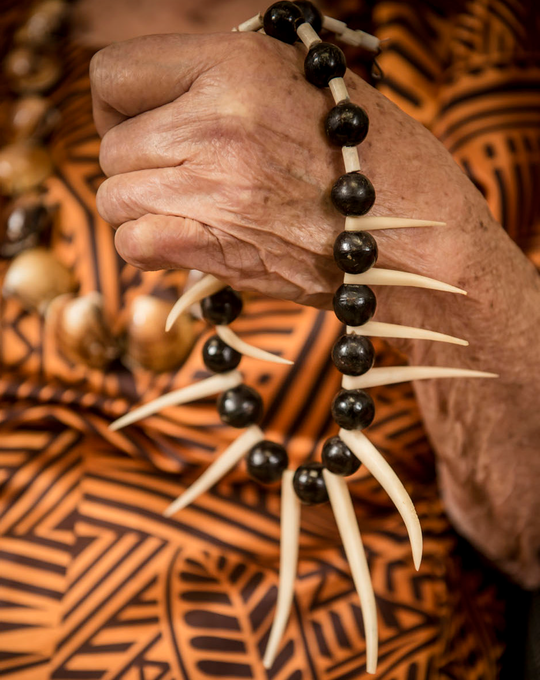

"As a grandfather who cares for my two autistic grandchildren, I have relied on traditional concepts of caring by always acknowledging and encouraging the role of my family, extended family, church, and my community to support us."

This quote highlights the critical role of family and community in supporting Pacific disabled individuals, which is deeply rooted in Pacific cultural values. It reflects the importance of collective care, where responsibility is shared among family members, extended networks, and faith-based groups.

In this Pacific approach, this perspective is woven into several strategic priorities, including:

* Priority 3: Disability Awareness within Communities, which seeks to strengthen community networks and promote disability literacy among Pacific families and churches.
* Priority 4: Supporting Access and Equity, which emphasises co-designing support services that consider the integral role of families in Pacific caregiving models.
* Priority 6: Enabling Good Lives, which prioritises family-centered approaches that empower caregivers and provide them with resources, training, and access to services.

The inclusion of this personal story reinforces the plan’s commitment to solutions that respect and build upon the collective strengths of Pacific communities.

## **Executive summary**

Atoatoali’o – the National Pacific Disability approach is built on the voices and feedback from the Pacific disabled people and their Aiga reflecting our commitment to “Nothing about us without us”.

Building on Previous work, including Faiva Ora National Pasifika Disability Action Plan (2016-2021) and the New Zealand Disability Strategy 2016-2026, the development of Atoatoali’o and the actions set out in this Pacific approach will feed into the refresh of the New Zealand Disability Strategy.

Aligned to the Ministry of Disabled People – Whaikaha (the Ministry), Atoatoali’o serves as both a metaphor and a guiding principle for achieving the following priorities. It reinforces the importance of:

* Strengthening leadership and workforce capabilities to create a more connected and inclusive service environment (Priority 1 and Priority 2: Leadership and Workforce)
* Disability Awareness within Communities, which seeks to strengthen community networks and promote disability literacy among Pacific families and churches (Priority 3: Disability awareness within Pacific communities)
* Ensuring every Pacific disabled person and their families feel supported and valued (Priority 4: Access and Equity)
* Increase the visibility of Pacific disabled people in cross-government data and research through systematic collection and disaggregation of service usage information (Priority 5: Stakeholder Data and insights collaboration)
* Promoting a holistic, family-centered approach to support that reflects the interdependence of Pacific communities (Priority 6: Enabling Good Lives).

The priorities as stated will guide the immediate and short- term approaches to supporting the wellbeing goals and aspirations of Pacific disabled people.

Atoatoali’o, the Pacific approach has been co-developed with the Pacific communities and the wider sector input. Whaikaha acknowledges the Pacific disability community for sharing your stories of strength, challenges, resilience, and success throughout the talanoa series. The gift of your voice has brought this Pacific approach to life and now we need to ensure the New Zealand Disability Strategy reflects the thoughts of our Pacific disability community.

## **Introduction**

Pacific People in Aotearoa New Zealand are vibrant, diverse and a youthful population, representing 17 distinct ethnic groups. They make up 9 percent of New Zealand’s population, with a median age of 25 years, significantly younger than the national median age of 38.3 years. The demographic not only highlights the cultural diversity within Pacific communities but also points to the growing potential and influence in shaping the future of New Zealand.

In New Zealand, approximately 851,000 people, representing approximately 17 percent of the population[1], identify as having a disability. Disability prevalence is also disproportionately higher among Māori and Pacific peoples. The reported disability prevalence among Pacific people is 16 percent; however, after adjusting for the younger age distribution of the population, the age-standardised prevalence increases to 21 percent.

The adjustments highlight the underrepresentation of disability rates when only raw percentages are considered. The age adjusted percentage shows the importance of providing disability support and services in ways that are responsive to the specifics of Pacific communities. It also shows the importance of inclusive policies and practices that address the immediate support needs and long-term opportunities for socio-economic, cultural inclusion, enabling all disabled New Zealanders to lead fulfilling lives and to contribute meaningfully to their communities.

In this context, Whaikaha has initiated a series of initiatives designed to drive the transformation of disability supports, processes, and policies. These initiatives aimed to enhance the effectiveness and responsiveness of the support provided to disabled people and ensure the timely delivery of its system stewardship function.

This Pacific approach incorporates the voices and perspectives gathered through our talanoa series with Pacific disabled people and their āiga. It will align with the New Zealand Disability Strategy and employs an outcome framework to connect its actions to broader Ministry objectives. Over the next five years, Whaikaha, in collaboration with government agencies, service providers, non-government organisations, and Pacific disability community will drive initiatives to improve health and social outcomes for Pacific communities that we serve.

## **How Atoatoali’o – the National Pacific Disability Approach was created**

As a part of preparing for the upcoming refresh of the New Zealand Disability Strategy in 2025, the Ministry of Disabled People – Whaikaha (the Ministry), in its commitment to Pacific disabled people, their āiga, and carers, has worked in partnership with the community to develop this National Pacific Disability Approach (Atoatoali’o). The actions set out in this Pacific approach will feed into the refresh of the New Zealand Disability Strategy.

Atoatoali’o captures the aspirations of the Pacific disabled community. It details strategic initiatives the community would like to see, designed to:

* Improve disability support and services, ensuring they are inclusive and culturally responsive.
* Ensure equitable access to information, making resources accessible in languages and formats that meet the needs of Pacific people.
* Enhance cultural responsiveness across the health, education, employment, and social service sectors to ensure these systems serve the needs of Pacific disabled people and their families effectively.

It reflects the community’s dedication to work towards an inclusive society, one that respects and upholds the cultural values of Pacific peoples.

Over the past year, our efforts have been dedicated to developing this approach. Throughout this process, we have engaged community leaders to ensure that the perspectives and voices of each Island group were integral to the planning process and valued throughout. A series of 20 talanoa facilitated by regional leadership and respective Island groups were held across New Zealand. These talanoa brought together over 1,000 Pacific disabled people, their aiga/whānau, carers, community leaders, Pacific providers, non-government organisations.

The community talanoa process highlighted a crucial need to place greater emphasis and value on families who, driven by deep cultural values, love, and a strong sense of duty, often serve as primary caregivers for many Pacific disabled people. By improving access to essential resources, information and support, we can empower both individuals and families, ensuring that they can thrive and lead fulfilling lives. This approach provides a foundational framework from a Pacific disability perspective, aiming to promote community-led initiatives and solutions that are effectively integrated and supported by government. This includes improving disability literacy in communities to reduce stigma and promote inclusive attitudes, addressing workforce gaps through cultural competence and targeted recruitment, and strengthening support for families by improving access to resources and services.

The approach also proposes a comprehensive monitoring and evaluation framework be developed to track progress and assess impact. This should incorporate a flexible Pacific model with culturally relevant practices and values.

## **Strategic context**

In Aotearoa New Zealand, disparities in health and social outcomes reflect differences that are both preventable and inequitable.

Achieving equity requires a strategic approach that addresses the distinct needs of individuals and groups, recognising that individuals and groups experience varying levels of advantage, tailored resources, and support to achieve equitable outcomes. By addressing these challenges and providing appropriate solutions, we can ensure that everyone, regardless of their circumstances, can achieve the same level of wellbeing.

Pacific disabled people, like other groups, encounter challenges in achieving equitable outcomes across various sectors, including health, education, employment, and social services. These challenges often stem from systemic barriers in access and support. Atoatoali’o focuses on addressing these challenges and contributing to a shift towards a more inclusive society, where the focus is on creating environments that are less disabling for all.

The Atoatoali’o Pacific disability approach is informed by:

* Te Tiriti o Waitangi.
* The United Nations Convention on the Rights of Persons with Disabilities (UNCRPD).
* The New Zealand Disability Strategy 2016-2026.
* Faiva Ora National Pasifika Disability Action Plan (2016-2021).
* The Enabling Good Lives (EGL) principles and approach.

## **What the community told us**

Pacific people’s perspectives on disability highlight the holistic integration of health, spirituality, and social connections, offering a unique viewpoint that contrasts a different understanding from non-Pacific perspectives.

The priorities of Pacific communities and Pacific disabled people continue to evolve, with a growing commitment to not only identify but also actively design and lead their own solutions that address the key challenges and opportunities they encounter. This shift recognises their expertise, lived experience, and cultural knowledge, which positions them as leaders within their own communities.

This leadership is essential for developing solutions that reflect their collective aspirations, promotes inclusion, and lead to better well-being outcomes for all members of the community.

The aspirations of young Pacific disabled people are also growing. Pacific young people aspire to learn and actively contribute to tackling the challenges facing their communities in New Zealand.

“I want Whaikaha to be the champion in the government space to help us continue to be the champions that we are, motivating and enriching lives.”

* Youth and Autism Talanoa

Inspired by the voices of Pacific disabled people and their families, āiga, kaiga, magafaoa, vuvale, whanaau across the country, we envision a future where Pacific disabled people and their āiga experience equity and cultural safety in all aspects of life.

To guide this endeavour, four key principles shared across Pacific communities are important when considering how we can work towards improving outcomes for Pacific disabled people and their aiga.

These principles are:

* Alofa – Love and compassion
* Fa’aaloalo – Respect
* Tautua – Service
* Va fealoa’i – Value of relations and space

The community wants to strive with government to create a system of care and support that embodies these principles.

## **The Roadmap**

The community proposes future initiatives that will be guided by the needs and aspirations of our Pacific disability.

This section outlines what the community believes is the roadmap for addressing the key issues faced by the Pacific disability community.

It also highlights significant service gaps at both mainstream and Pacific provider levels, as well as the main constraints impacting both Pacific and mainstream providers. There are six priority areas that the community have put forward to guide the planning and prioritisation of actions to improve the lives of Pacific disabled people.

Under each priority are statements describing what difference could be achieved for our Pacific disabled people and their āiga. Each priority has two or three objectives, alongside which are the areas we could focus on and the intended impact this would have.

### **The implementation of the Roadmap**

The community would like to work with government to create an implementation plan that details the deliverables and initiatives necessary to realise the strategic priorities outlined in this document.

This will need to occur as a part of developing the next New Zealand Disability Strategy, which is where the Government’s medium-term work to improve the lives of disabled people will be set out.

Taking forward the next steps in this work through the New Zealand Disability Strategy will enable prioritisation of the actions set out in this document, and translate strategic priorities into actionable steps, with long-term outcomes that meet the needs and aspirations of all disabled people.

## **Strategic priorities and measuring progress**

This section sets out priorities, initiatives, and actions over the next five years that could improve outcomes for Pacific disabled people and their families.

It provides a framework for change that will create improvements for Pacific disability communities over time.

“Services should go beyond just ticking boxes, they require the right attitude to make a real impact. It’s about actively learning and applying skills like correct pronunciation, while also understanding and respecting established protocols”

* Waikato Community talanoa

To effectively address inequalities and disparities, government will need to build on established relationships with the Pacific disability communities, collaborating not only with the wider group but also individual island groups. This approach will ensure that the specific needs of the smaller island groups are recognised and addressed.

The key benefit, of this approach would be a commitment to improving the capacity and capability of mainstream services to support Pacific disabled people and their Aiga.

“Fairer funding for services more suitable for Pacific peoples. For example, better funding for family-based support options for our disabled family member, as many Pacific communities prefer family to be responsible for providing care, for their loved ones, however, residential care services can be better funded to ensure the quality of services is consistently provided”

* Wairarapa Community talanoa

The six priority areas identify where improvements can be made within the disability ecosystem, while also empowering Pacific disabled people to take the initiative to meet their needs and aspirations. For each of the priority areas, several action items have been identified. Quotes from stakeholders involved in the community talanoa process reflect the voices of the community and highlight the necessary changes.

## **Priority areas**

1. Growing Pacific disabled leadership across regions
2. Strengthening the Pacific workforce: capability and capacity
3. Pacific awareness and Disability responsiveness in Pacific communities
4. Supporting Access and Equity for Pacific disabled people
5. Stakeholder Data & Insights collaboration
6. Enabling Good Lives and its principles

Through talanoa with Pacific disabled people and their families, we heard powerful stories of resilience. Despite challenges, their core values and beliefs drive them to strive for “equity in disability”.

Leadership thrives within communities. Whether in families, churches, or workplaces – empowering families is important to strengthen this leadership and increase awareness of disability and disability related issues. Pacific disabled people and their families embody the qualities of leaders, much like seeds waiting for the right conditions to grow into mighty trees that can shelter and uplift their communities.

Investing in the next generation of leaders is crucial, as they possess a deep understanding of the challenges their communities face, as well as the opportunities for improvement, enabling them to advocate for their communities, champion their strength, and break down barriers.

To make progress in the six priority areas, we need to establish a data governance framework that embraces Pacific values, ensuring all agencies consistently collect and analyse data that reflects the lived experiences of Pacific disabled people. Building strong relationships with key Pacific stakeholders will be crucial to ensure data is culturally relevant and aligned with Pacific worldviews.

Through its stewardship role, the Ministry plays a key role in improving outcomes for disabled people. The stewardship role enables the Ministry to collaborate with and guide other agencies on embedding disability perspectives into their policies and services. The aim is to remove barriers that prevent disabled people from fully participating in society by supporting Pacific disabled people to grow, lead, and thrive across all aspects of their lives.

## **Priority One – Growing Pacific disabled leadership**

**Ka Tupu Ruperupe Teia Tumu Rakau**

* Let this tree grow well (Cook Island Proverb)

### **What the community wants to achieve**

Over the next 5 years, the community would like to see focus on achieving the following

outcomes:

* Strengthen Pacific leadership to effectively engage their communities, thereby securing the necessary support for families.
* Empowering community leadership among Pacific disabled people is key to success - ‘Grow our own’.
* Prioritise the inclusion of Pacific leadership in the design and development of disability services as appropriate.

### Actions the community would like to see

**Outcomes could be progressed by:**

* Co-develop a leadership programme with the community that focuses on advancing leadership skills within the disability sector.
* Encourage regional representatives to participate in leadership training when offered and support them in attending.
* Creating opportunities for leadership and collaboration among government agencies to reduce duplication and fragmentation in efforts to improve Pacific disability wellbeing.

### **How we will measure progress**

This section describes indicators that can be used to measure the progress of the actions outlined on the previous page. Each indicator has a desired trend, and a sentence or two on what it will contribute to.

Indicator 1: Pacific disability leadership is increased, and youth be encouraged into leadership roles to advocate for our Pacific disabled people.

* The desired trend for this indicator is to increase.
* This will contribute to:
  + Increased participation of Pacific disabled people in decision making forums.
  + Ensuring youth representation in key decision-making processes to amplify their voices and perspectives.
  + Enabling Pacific disabled people to provide input into relevant policy and design work across government agencies.

Indicator 2: Increasing investment in the Pacific provider sector to develop a leadership and mentoring programme and invite community to participate.

* The desired trend for this indicator is to increase.
* This will contribute to empowering Pacific disability community to co-design a leadership and mentoring programme to support the capacity and capability of Pacific disabled people by developing leadership skills.

Indicator 3: Facilitation of the establishment of new Pacific community support networks, while also supporting the capacity of existing groups to advance leadership in strategically geographic regions.

* The desired trend for this indicator is to maintain.
* This will contribute to an increased number of leaders in regions outside the four main regions who can advocate for the issues affecting their disability communities.

Indicator 4: Support for youth leadership programmes at national and regional levels.

* The desired trend for this indicator is to increase.
* This will contribute to increased opportunities for intergenerational dialogue to facilitate the transfer of knowledge and skills to young people.

## **Priority Two – Strengthening Pacific Health & Disability workforce**

**Ia soso’o le fau ma le fau**

* Allow two of equal strength, follow each other. (Samoan proverb)

### **What the community wants to achieve**

Over the next 5 years, the community would like to see focus on achieving the following

outcomes:

* Increase the cultural competence of service providers to improve their effectiveness in serving Pacific disabled people.
* Investing in workforce capacity and capability for Pacific disabled people within government ministries, NGOs, and providers.
* Ensuring the workforce are competent to deliver “culturally inclusive support for Pacific disabled people and their families.
* Promoting the recruitment and development of Pacific-trained staff to enhance cultural understanding and effectiveness.

### **Actions the community would like to see**

Outcomes could be progressed by:

* Investing in workforce planning within ministries, providers, NGO’s.
* Engage with cultural experts and pacific community leaders to ensure training programs are both relevant and effective.
* Involve disabled people in the development and design of government agencies workforce plans, so it is responsive to the needs of disabled people.
* Targeting training programs and professional development opportunities for Pacific disabled people.

### **How we will measure progress**

This section describes indicators that can be used to measure the progress of the actions outlined on the previous page. Each indicator has a desired trend, and a sentence or two on what it will contribute to.

Indicator 1: Increase cultural competency uptake by service providers, NGOs, government agencies.

* The desired trend for this indicator is to increase.
* This will contribute to inclusion of cultures in national development plans of organisations that deliver disability services to communities.

Indicator 2: Inclusive and accessible recruitment and retention processes, while recognising the diverse disability sector workforce.

* The desired trend for this indicator is to increase.
* This will contribute to increased Pacific workforce will strengthen cultural competencies, improve access and utilisation of culturally appropriate disability services in the Pacific communities.

Indicator 3: Increase the public sector capability to apply Pacific perspectives, evidence, and intelligence, and to engage effectively with Pacific disabled people in designing and delivering policies and interventions that affect their lives.

* The desired trend for this indicator is to maintain.
* This will contribute to increased Pacific disabled people in policy settings in the public sector who can lead, support, and advise on Pacific matters.

Indicator 4: Maintain a disability literate workforce who understand disability, share knowledge, and continuously improve.

* The desired trend for this indicator is to maintain.
* This will contribute to an increase in the health and disability workforce who have completed cultural safety training.

## **Priority Three – Disability awareness within Pacific Communities**

Aloalo tou vaka, alo tonu ki mua. Sa kilo ki peau i ou tafa.

* Remain focussed on your goals and dreams, pay no attention to the waves around you. (Tuvaluan proverb)

### **What the community wants to achieve**

Over the next 5 years, the community would like to see focus on achieving the following outcomes:

* Improve the awareness of Pacific communities about disability information, services, and support.
* Pacific disabled people are better supported to navigate government systems and to access relevant services through the availability of information.
* Improve literacy and advocacy skills among Pacific disabled people, their families, and carers.
* Encourage the establishment of networks for Pacific disabled people to spearhead a disability awareness campaign.

### **Actions the community would like to see**

Outcomes could be progressed by:

* Promoting awareness and increasing the visibility of disability within the wider Pacific community.
* Develop options for improving access to disability and health advocacy services for people with disability, their families and carers, with a particular focus for people with limited capacity and skills to advocate in relation to health, justice, housing, and education.
* Explore options for promoting Pacific disability awareness programmes to where Pacific Peoples naturally gathers for example, churches.
* Develop and promote resources that are co-designed by Pacific disabled people.

### **How we will measure progress**

This section describes indicators that can be used to measure the progress of the actions outlined on the previous page. Each indicator has a desired trend, and a sentence or two on what it will contribute to.

Indicator 1: Facilitate the establishment of more Pacific community support networks across all regions.

* The desired trend for this indicator is to increase.
* This will contribute to wider availability of disability information that can be shared by the networks across to its own regions.

Indicator 2: Acknowledge and empower the role of family and community in raising awareness about the contribution that Pacific communities make to Aotearoa, New Zealand.

* The desired trend for this indicator is to increase.
* This will contribute to:
  + Our Pacific disability community confidently knowing options for services that are accessible, inclusive, and equitable.
  + Increased actions to advocate for women and youth with disability in the wider community.

Indicator 3: Develop disability information that is easy to read, easy to understand and in appropriate alternate formats.

* The desired trend for this indicator is to increase.
* This will contribute to new products and services developed with and by disabled people.

Indicator 4: Facilitate options and work with Pacific organisations to deliver disability information, awareness programmes in Pacific churches, where most Pacific disability community gathers.

* The desired trend for this indicator is to increase.
* This will contribute to Pacific churches and organisations demonstrate their leadership in disability advocacy to their wider community in supporting families with disability.

## **Priority Four – Supporting Access and Equity for Pacific disabled people**

Vivili fa’amanu o matagi.

* We strive after our goals despite difficulties (Samoan Proverb).

### **What the community wants to achieve**

Over the next 5 years, the community would like to see focus on achieving the following outcomes:

* Design support services with Pacific disabled people, ensuring agencies tailor models to their needs, and improve accessibility across all government platforms.
* Improve educational outcomes for Pacific disabled students, by promoting social inclusion and robust transition programs, higher education, and vocational training post-secondary pathways.
* Collaborate with relevant agencies to develop and provide accessible, Pacific specific resources that address the needs of the Pacific community.
* More affordable housing options are available that allows for improved access to essential services.

### **Actions the community would like to see**

Outcomes could be progressed by:

* Supporting the capacity of mainstream organisations to implement culturally competent practices in the design and delivery of programs that prioritise accessibility for Pacific disability community.
* Equip teachers with the skills, training, and resources necessary to implement inclusive teachings strategies that effectively meet the diverse needs of all students, ensuring that students with disabilities are fully supported in achieving academic success.
* Collaborating with Ministry of Pacific Peoples & Ministry of Social Development to co-design an information hub that provides accessible information in Pacific languages.
* Advocate to promote accessible, affordable housing and the sharing of data on disability needs to influence changes in housing policies.

### **How we will measure progress**

This section describes indicators that can be used to measure the progress of the actions outlined on the previous page. Each indicator has a desired trend, and a sentence or two on what it will contribute to.

Indicator 1: Monitor the engagement of service users with mainstream services and assess the representation of Pacific disabled people in committees and advisory groups.

* The desired trend for this indicator is to increase.
* This will contribute to:
  + Improves representation in decision making processes that leads to improved services and policies that are more culturally relevant and responsive to the specific needs.
  + Improves the effectiveness of service delivery.

Indicator 2: Monitor Pacific-specific resources developed and made accessible that meets community needs.

* The desired trend for this indicator is to increase.
* This will contribute to:
  + empowering individuals with relevant resources,
  + increasing community participation and engagement,
  + improving access to services,
  + and strengthening the collective voice in advocating for the community needs and priorities.

Indicator 3: Monitor disabled students who progress through key stages of education (primary, secondary, and post-secondary) with recognised qualification, ensuring success through their educational life.

* The desired trend for this indicator is to increase.
* This will contribute to more equitable access to education, improving long term academic outcomes and successful transition into adulthood.

Indicator 4: Monitor our advocacy by tracking policy changes, data utilisation in housing discussion, stakeholder engagement, community feedback, and the availability of accessible and affordable housing.

* The desired trend for this indicator is to increase.
* This will contribute to more accessible and affordable fit-for purpose housing options.

## **Priority Five – Stakeholder Data & Insights collaboration**

**Takanga ‘etau fohe**.

* mobilising and working together towards a common purpose (Tongan Proverb).

### **What the community wants to achieve**

Over the next 5 years, the community would like to see focus on achieving the following outcomes:

* Establish a coordinated data governance framework to ensure consistent collection, and analysis of disability data across agencies to ensure culturally relevant insights that reflect the unique needs and enabling evidence-based decision making.
* Increase the visibility of Pacific disabled people in cross-government data and research through systematic collection and disaggregation of service usage information by key demographic factors.
* Strengthen cross government relationship with the Ministry of Pacific Peoples to enhance culturally relevant data collection and sharing.
* Increase capacity building initiatives for government staff and stakeholders on culturally sensitive and inclusive data collection methodologies to ensure that data accurately represents the experiences of Pacific disabled people.

### **Actions the community would like to see**

Outcomes could be progressed by:

* Champion and advocate for a unified data governance framework for disability data collection and analysis across agencies.
* Encourage service providers and NGOs to incorporate the disaggregation of service usage data for Pacific disabled people by key demographic factors.
* Facilitate regular joint strategy sessions between the Ministry, Ministry of Pacific Peoples and the Ministry of Health to align efforts for culturally relevant data sharing and collection.
* Collaborate with relevant data-focused agencies to develop and implement strategic training initiatives on culturally sensitive methodologies for data collection aimed at enhancing the capabilities of government staff and stakeholders.

### **How we will measure progress**

This section describes indicators that can be used to measure the progress of the actions outlined on the previous page. Each indicator has a desired trend, and a sentence or two on what it will contribute to.

Indicator 1: Monitor inter-agency collaboration to improve disability data collection across government and community-level organisations, ensuring it informs the design and delivery of services, policies, and strategies, with a focus on transparent and comprehensive reporting.

* The desired trend for this indicator is to increase.
* This will contribute to more comprehensive understanding of disability related issues within Pacific communities and the intersectionality of cultural and social information, enabling more tailored and effective supports.

Indicator 2: Monitor proportion of contracted service providers and NGOs that implement disaggregated data collection for Pacific disabled people, and the quality and use of this data to guide decision-making policy development.

* The desired trend for this indicator is to increase.
* This will contribute to more targeted, data-driven services and policies that address the specific needs of Pacific disabled people for equitable and culturally relevant support.

Indicator 3: Investing in capacity building programs for Pacific researchers to enhance their leadership and expertise in disability-related research.

* The desired trend for this indicator is to increase.
* This will contribute to culturally relevant studies that address the unique challenges faced by Pacific disabled people and their families. Enhance policy development, produce culturally relevant insights, and improve community engagements.

Indicator 4: Monitor and track training session completion, participant engagement and improvements in data collection practices.

* The desired trend for this indicator is to maintain.
* This will contribute to:
  + Increased cultural competence among government staff and inform more effective policy development.
  + Strengthen interagency collaboration that improves comprehensive data collection.

## **Priority Six – Enabling Good Lives and its Principles**

**Ua tuhituhi mai kae omai ke gahua auloa.**

* Our collective work as a community will achieve great things (Niuean proverb).

### **What the community wants to achieve**

Over the next 5 years, the community would like to see focus on achieving the following outcomes:

* Embed Enabling Good Lives (EGL) principles in all services and systems set up for Pacific disabled people and their families, ensuring culturally relevant, family-centered, and Pacific-driven support systems.
* Prioritise early intervention and long-term investment in Pacific children and youth, reducing the risk of preventable conditions to ensure their empowerment, self-sufficiency, and full participation in society.
* Implement support systems that extend to families, recognising the collective approach for Pacific cultures, as to ensure the entire family benefits from resources.
* Provide the Pacific disability community with accessible, culturally relevant information that empowers them to actively contribute to the Enabling Good Lives (EGL) discussion, and increase participation in EGL site initiatives, ensuring their voices shape long term solutions tailored to their needs and aspirations.

### **Actions the community would like to see**

Outcomes could be progressed by:

* Collaborate with Disability support services to ensure contracts for Disability support and services adhere with Enabling Good Lives principles, with performance indicators that measure cultural relevance and family centered care.
* Collaborate with key government agencies and stakeholders to strengthen advocacy efforts for early intervention and support services tailored to the needs of Pacific children and youth, grounded in evidence-based practices.
* Engage with key agencies that provide support for disabled people to advocate for the integration of family centered approaches in funding and service delivery models.
* Collaborate with community leaders and advocates in hosting community workshops and forums that empower Pacific disabled people and their families to increase their knowledge and understanding of Enabling Good Lives and its principles.

### **How we will measure progress**

This section describes indicators that can be used to measure the progress of the actions outlined on the previous page. Each indicator has a desired trend, and a sentence or two on what it will contribute to.

Indicator 1: Monitor adherence of contracts for disability support services to Enabling Good Lives principles through performance indicators that measure cultural relevance and family-centered care in alignment with the needs and aspirations of Pacific communities.

* The desired trend for this indicator is to increase.
* This will contribute to increasing the responsiveness of service provision to the needs and aspirations of Pacific Disabled People.

Indicator 2: Monitor the number of policies for funding programs that incorporate evidence-based practices specifically tailored to the needs for Pacific children and youth. Monitor the availability and utilisation rates of early intervention and support services for Pacific children and youth.

* The desired trend for this indicator is to maintain.
* This will contribute to:
  + Increases evidence-based practices that enhances quality and relevance of services that overall improves wellbeing outcomes for Pacific disabled children and youth.
  + Help identify access gaps, enabling stakeholders to allocate resources more effectively and implement strategies that improve health outcomes and overall well-being.

Indicator 3: Track the number services that explicitly incorporate family centered approaches. Conduct surveys with families and service providers to gather feedback on their experiences with their services, and whether the services meet their needs.

* The desired trend for this indicator is to maintain.
* This will contribute to:
  + Prioritises family centered practices and more engagement in decision-making.
  + Identify gaps and unmet needs to tailor services to better align with circumstances for families.

Indicator 4: Monitor the number of Pacific disabled people and their families attending community workshops and forums on Enabling Good Lives.

* The desired trend for this indicator is to increase.
* This will contribute to increased knowledge about EGL principles and how they can benefit Pacific Disabled People.

## **Appendix**

### Appendix: 2023 Disability Support Services data

There are six tables included in the Dashboard.

The first table to the right is a pie graph titled “Active people by gender”. There are a total 2704 females to 1407 males receiving disability support services.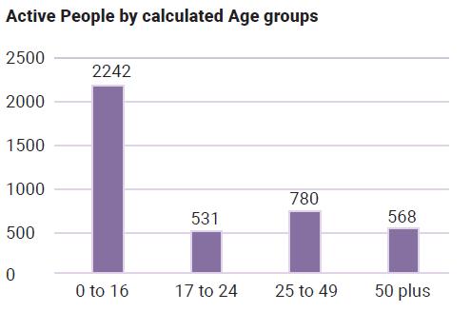

Table two, which is to the right, is a pie graph titled “Percentage of Pacific disabled people people. Pacific disabled people account for eight percent of the population in receipt of disability support services.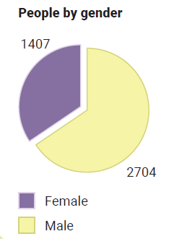

Table three, which is below, is a column graph titled “Active people by Disability” with five columns, Intellectual disability

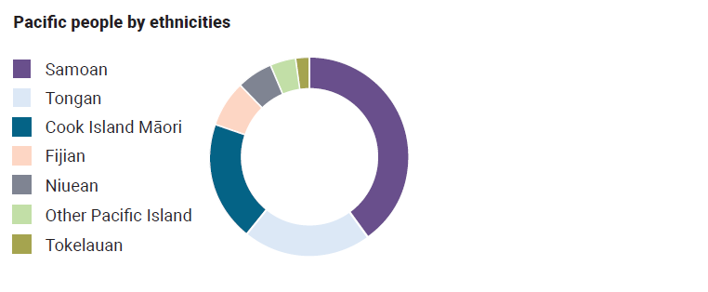

Table four, which is to the right, is a column graph titled “Active people by calculated age groups”. Age group 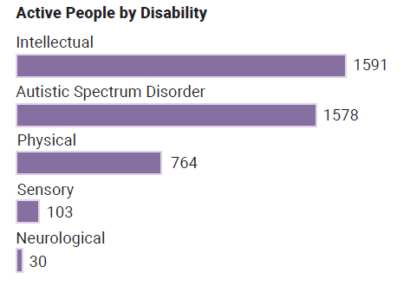0 to 16 - 2242, 17 to 24 - 531, 25 to 49 - 780 and 50 plus - 568.

Table five, which is to the right, is a pie graph titled “Pacific people by ethnicities”, illustrating the 3 leading ethnicities receiving Disability support services being Samoan, Tongan and Cook Island.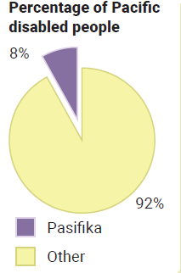

Table six, which is below, is the NASC (Needs assessment service coordination) for the year 2022/23. The image highlights New Zealand, depicted in shades in light blue to dark blue. The image illustrates that the Auckland region has the highest concentration of Pacific disabled people receiving disability support services.

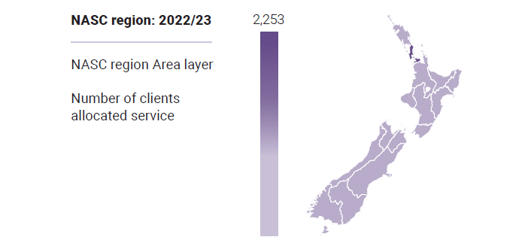

## **References**

(1) Ministry of Health. 2018. ’Ala Mo’ui Progress Report: Pacific health care utilisation. Wellington: Ministry of Health.

(2) Ministry for Pacific Peoples. (2022). All-of-Government Pacific Wellbeing Strategy 2022. <https://www.mpp.govt.nz/assets/Reports/Pacific-Wellbeing-Strategy-2022/All-of-Government-Pacific-Wellbeing-Strategy.pdf>

(3) Ministry of Health. 2019d. Annual Report for the Year Ended 30 June 2019: Ministry of Health. Wellington: Ministry of Health

(4) Ministry of Health 2024. Health National Adaptation Plan 2024 – 2027. Wellington: Ministry of Health

(5) Minister of Health. 2023. Te Mana Ola: The Pacific Health Strategy. Wellington: Ministry of Health

(6) Office for Disability Issues. 2016. New Zealand Disability Strategy 2016-2026.

(7) Office for Disability Issues. Disability Action Plan 2019-2023

(8) Ministry of Health. 2019a. Achieving Equity in Health and Wellness: A fair health system prioritises equity. Poster. Wellington: Ministry of Health. URL: [www.health.govt.nz/system/files/documents/pages/hp7168-equity-poster-v5.pdf](https://www.health.govt.nz/system/files/documents/pages/hp7168-equity-poster-v5.pdf) (accessed 15 September 2019)

(9) Ministry of Social Development. (2024). Annual Report 2024. [Annual Report 2024 (msd.govt.nz)](https://www.msd.govt.nz/about-msd-and-our-work/publications-resources/corporate/annual-report/2024/index.html)

(10) Department of the Prime Minister and Cabinet (DPMC). (2023). DPMC Strategic Intentions 2023/24 to 2026/27. Office of the Chief Executive (OCE). Presented to the House of Representatives pursuant to section 39 of the Public Finance Act 1989. Published on February 17, 2023

1. Disability-Survey-2013.pdf (stats.govt.nz)