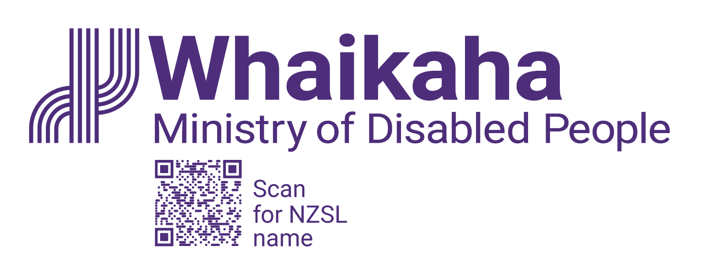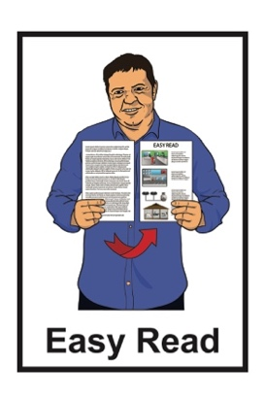

Summary of   
Atoatoali’o – National Pacific Disability Approach

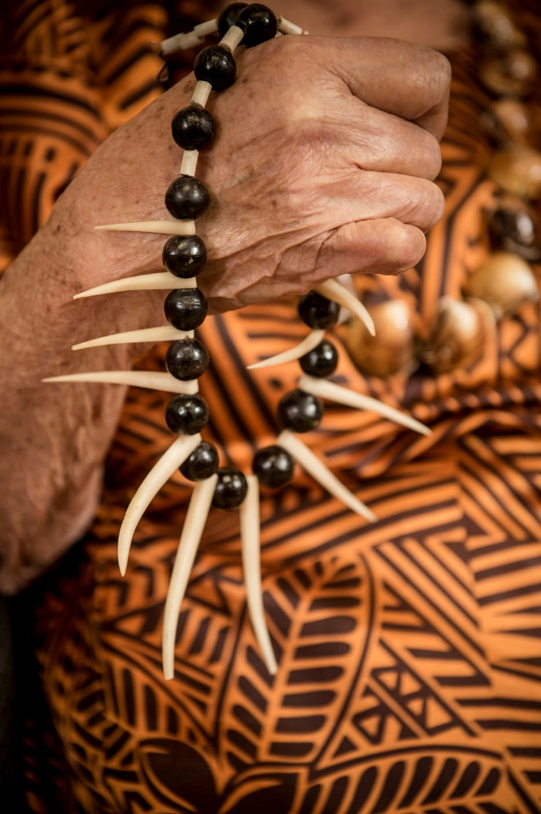

Published: April 2025

# What this Easy Read is about

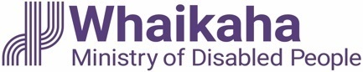This Easy Read is from **Whaikaha –Ministry of Disabled People.**

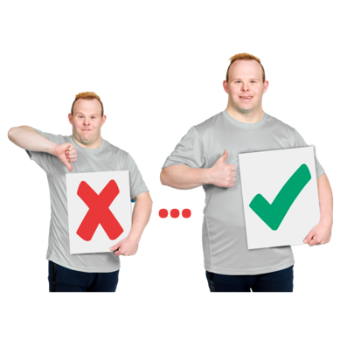

**Whaikaha – Ministry of Disabled People** works to make change for disabled people to make their lives better.

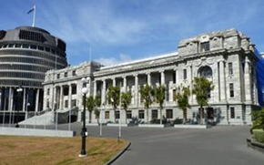Whaikaha –Ministry of Disabled People makes things better for disabled people by working with:

the Government

the community

businesses.

When you see **we** / **our** / **us** in this Easy Read it means **Whaikaha –Ministry of Disabled People**.

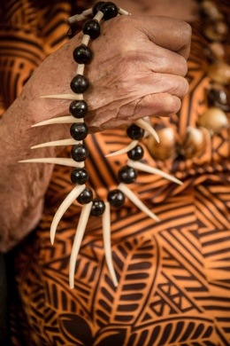

This Easy Read is about

**Atoatoali’o – the National Pacific Disability Approach**.

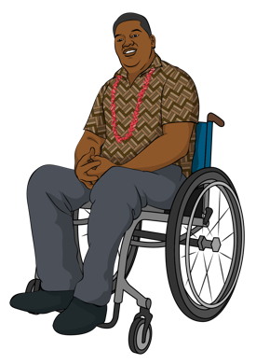

**Atoatoali’o – the National Pacific Disability Approach** says what we can do to make support and services better for Pacific disabled people.

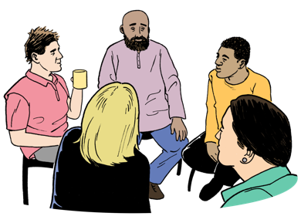

**Atoatoali’o** is a Samoan word about people sitting in a circle where everyone:

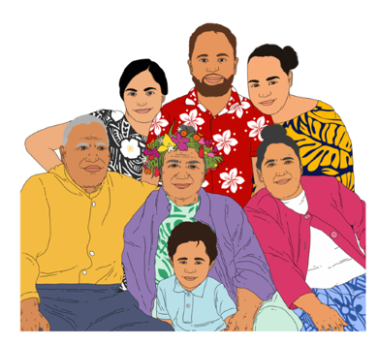fits

belongs.

In this Easy Read we will call Atoatoali’o the National Pacific Disability Approach **Atoatoali’o**.

This Easy Read is a **summary** of the full document.

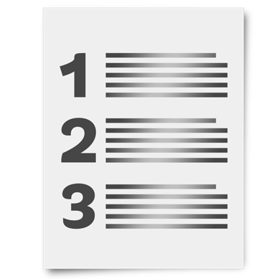

A **summary**:

is shorter than the full document

tells the main ideas.

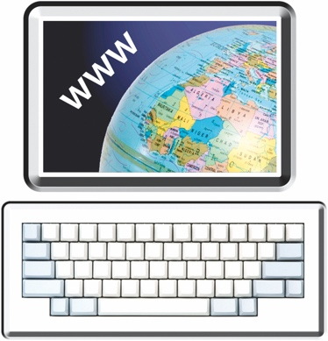

You can find the full document at:

[**https://tinyurl.com/3mczckx9**](https://aus01.safelinks.protection.outlook.com/?url=https%3A%2F%2Ftinyurl.com%2F3mczckx9&data=05%7C02%7Ckathparrish%40peoplefirst.org.nz%7Ca7fd201b36e84be88e1508dd7263fd20%7Ca4aa0d2ee24549a4bc5a7cd4f3f010e3%7C0%7C0%7C638792495979623471%7CUnknown%7CTWFpbGZsb3d8eyJFbXB0eU1hcGkiOnRydWUsIlYiOiIwLjAuMDAwMCIsIlAiOiJXaW4zMiIsIkFOIjoiTWFpbCIsIldUIjoyfQ%3D%3D%7C0%7C%7C%7C&sdata=xQWBMfPzlQuuqOePVuO0mKyBwV4hvAvIzKbPocjGwI4%3D&reserved=0)

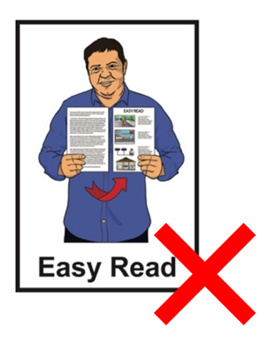

The full document is **not** in   
Easy Read.

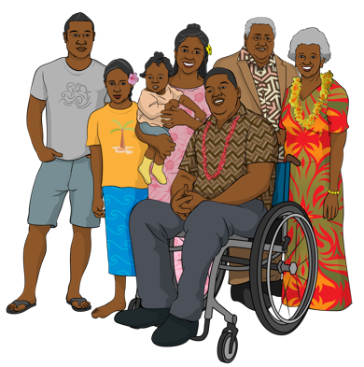Atoatoali’o uses ideas from:

Pacific disabled people

the aiga / families of Pacific disabled people.

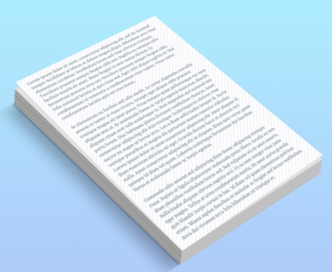

We will use Atoatoali’o when we update the **New Zealand Disability Strategy**.

The **New Zealand Disability Strategy** supports the Government to know how to make life better for disabled people.

# What Atoatoali’o says



Atoatoali’o talks about our **priorities** for Pacific disabled people.

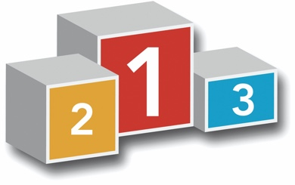

Here **priorities** means the things that are the most important to do.

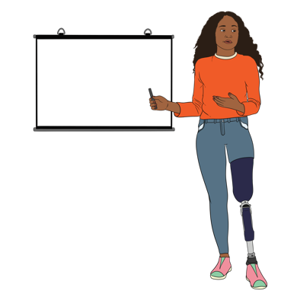

We want to support Pacific disabled people to be leaders in their communities.

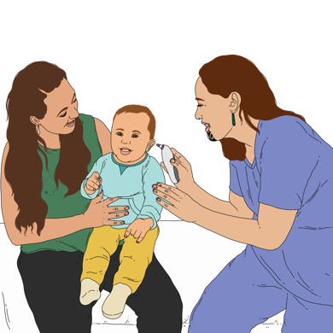We want to make sure people who work in health / disability services understand:

about Pacific **cultures**

what Pacific disabled people need.

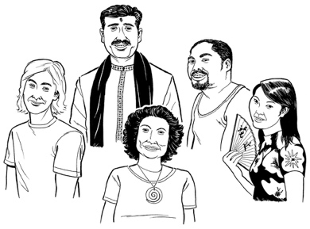**Culture** is a way of:

thinking that a group shares

doing things as a group.

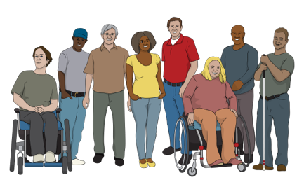

We want to support Pacific communities to understand about disability.



This will make it easier for Pacific disabled people to get support from their:

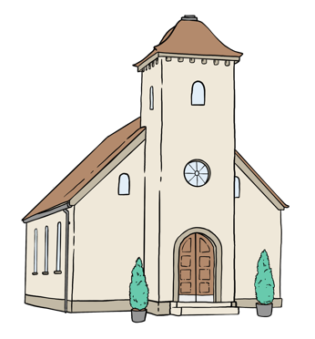aiga / family

church

community.

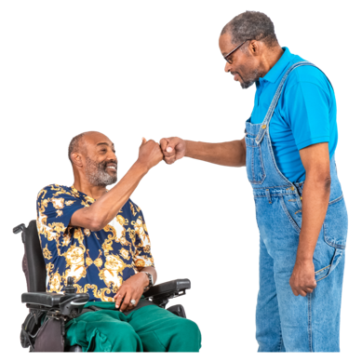We want to make sure   
Pacific disabled people feel:

supported

**valued**.



Here **valued** means being treated like:

you are important

people care about you.

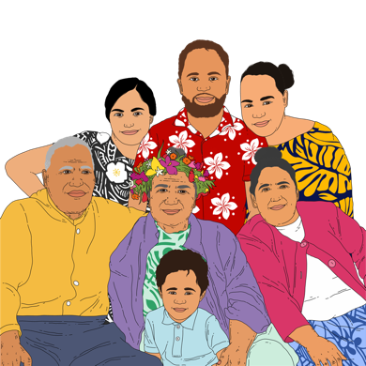

We want the aiga / families of Pacific disabled people to feel this way too.

We want to make sure any **research** the Government does includes Pacific disabled people.

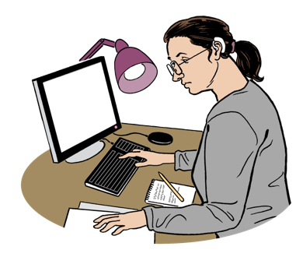**Research** is when someone:

looks at what is happening

tries to find ways to do things better.

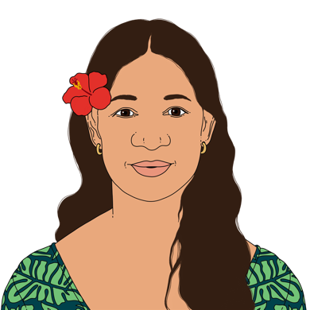

We want to work in ways that are good for:

Pacific disabled people

the aiga / families of Pacific disabled people

the whole community.

# Thank you



We wrote Atoatoali’o with a lot of support from:

Pacific disabled people

Pacific communities.

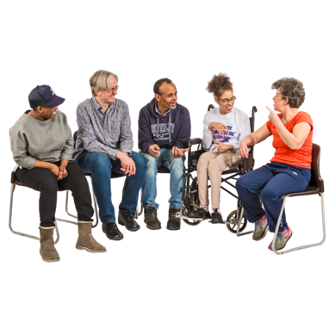

We want to thank everyone who:

came to talanoa / meetings

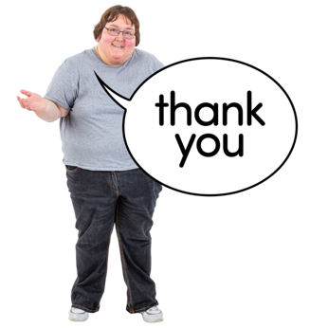told us their stories / ideas.

We could not have written Atoatoali’o without those people.



We need to make sure the New Zealand Disability Strategy shows that we have listened to the things everyone told us.

# Where to find more information



You can find out more about how we wrote Atoatoali’o here:

[**https://tinyurl.com/3mczckx9**](https://aus01.safelinks.protection.outlook.com/?url=https%3A%2F%2Ftinyurl.com%2F3mczckx9&data=05%7C02%7Ckathparrish%40peoplefirst.org.nz%7Ca7fd201b36e84be88e1508dd7263fd20%7Ca4aa0d2ee24549a4bc5a7cd4f3f010e3%7C0%7C0%7C638792495979623471%7CUnknown%7CTWFpbGZsb3d8eyJFbXB0eU1hcGkiOnRydWUsIlYiOiIwLjAuMDAwMCIsIlAiOiJXaW4zMiIsIkFOIjoiTWFpbCIsIldUIjoyfQ%3D%3D%7C0%7C%7C%7C&sdata=xQWBMfPzlQuuqOePVuO0mKyBwV4hvAvIzKbPocjGwI4%3D&reserved=0)

This information has been written by Whaikaha -Ministry of Disabled People.

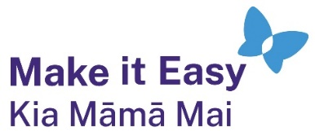It has been translated into Easy Read by the Make it Easy Kia Māmā Mai service of People First New Zealand Ngā Tāngata Tuatahi.

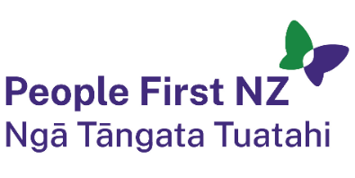

The ideas in this document are not the ideas of People First New Zealand Ngā Tāngata Tuatahi.



All images used in this Easy Read document are subject to copyright rules and cannot be used without permission.

Make it Easy uses images from:

* Photosymbols
* Change Images
* Huriana Kopeke-Te Aho



* SGC Image Works
* T Wood
* A logo for a school

  Description automatically generatedStudio Rebeko
* Inga Kramer.