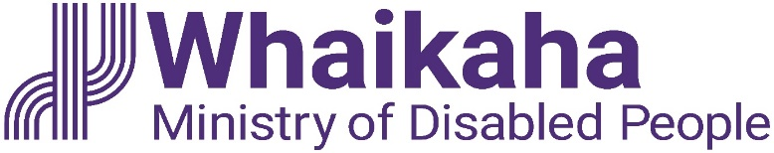

Information – Auckland Flooding and State of Emergency

We hope you are keeping safe.

Whaikaha has a team working to ensure disabled people and whānau have access to support during this time.

If you are in danger, please contact emergency services. Please call 111. If you are registered you can do this via the 111 text line.

If you need help you should first contact Auckland Emergency Management:
- Email to: aeminfo@aucklandcouncil.govt.nz or
- Phone: 0800 22 22 00

Deaf and disabled people and whānau can contact Whakarongorau Aotearoa, New Zealand Telehealth Services if you need support you can:
- Text 8988; or
- Phone: 0800 111 213

If you are accessing disability support services and need extra support, in first instance contact your provider.
You can also contact Whaikaha – Ministry of Disabled People at:
- Email: contact@whaikaha.govt.nz or
- Phone: 0800 566 601

If you are affected by the Auckland floods and on a benefit or low income, Work and Income may be able to help.

For people impacted by the flooding, there is financial support available, please contact Work and Income Auckland Welfare Flood Line. Details are:
- Freephone: 0800 400 100;
- Email to: MSD_Deaf_Services@msd.govt.nz. Open Saturday, Sunday and Monday 8am - 5pm

End of information about Auckland Flooding and State of Emergency

