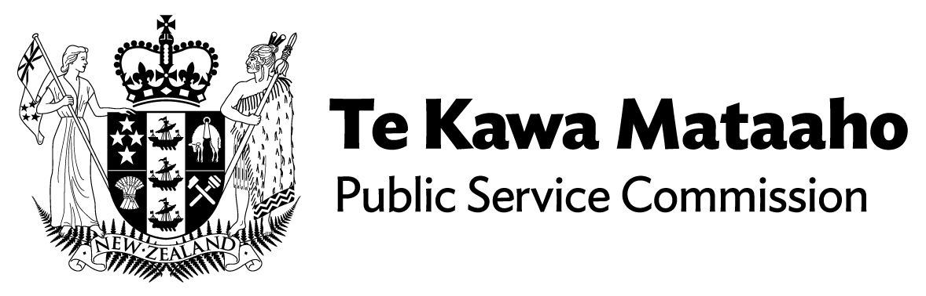

Acting Chief Executive Ministry for Disabled People appointed until permanent role is filled
Te Kawa Mataaho Public Service Commission is today announcing the appointment of Ms Geraldine Woods as Acting Chief Executive, Ministry for Disabled People.
An independent recruitment process took place to find a permanent person for the role. Due to the personal circumstances of the preferred candidate, who is a disabled person, the process has not yet been able to be finalised.
The Acting Chief Executive, Geraldine Woods is currently Co-Chair of the Ministry for Disabled People Establishment Governance Group and a respected leader with experience delivering services to disabled people.
Ms Woods said, “I’ve had the privilege of being involved in setting up the new Ministry and look forward to continuing to work closely with the disability community in this role.

I understand the importance of the job ahead and doing things right from the beginning until a permanent appointment is made.”
The role of the Chief Executive of the Ministry is to provide leadership to the Ministry and across the system to achieve better outcomes for disabled people in New Zealand.
End of information

