How to make a complaint and give feedback about your disability support services

February 2023
What you will find in this booklet

Page number:

What is this document about? 3

What are disability support services? 5

Making a complaint and giving feedback 8

What can you complain about? 13

How to make a complaint 15

Complaining to Whaikaha with a form 16

Page number:

How to contact Whaikaha when you
cannot use the form 21

Complaining to your service provider 23

How to get support with making a complaint 27

What will happen when you make a complaint? 31

Other languages and alternative
formats 36

What is this document about?

This Easy Read document is from Whaikaha - Ministry of Disabled People.

In this document we will call the Ministry Whaikaha.

This document is about how you can:

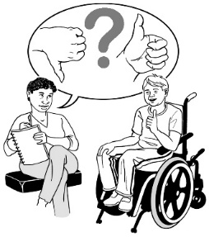
- make a complaint to Whaikaha about your disability support service

- give feedback to Whaikaha about your disability support service.

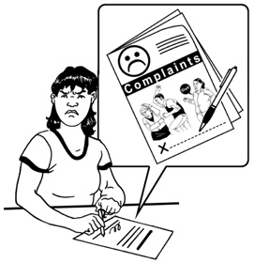
A complaint is when you tell someone that you are not happy about something.
Feedback is when you tell someone what you think about something.

We will tell you more about these things on page 8 of this document.

In this document we will tell you how you can:
- make complaints

- give feedback.

We will also tell you what will happen after you have done these things.

What are disability support services?

Whaikaha looks after the funding for disability support services.

Funding is money from the Government that is used to pay for things like disability support services.

Disability support services are things like home and community support services which is support for disabled people:
- with things they need around their home

- in the community.

Disability support services are also things like:

- respite which is when someone takes care of a disabled person so the person who usually cares for them can have a break / rest

- support for autistic people
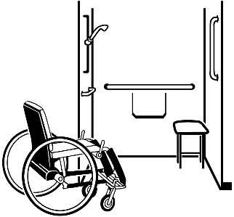
- equipment for disabled people

- individualised funding which is when disabled people manage their own disability supports.

Managing your own supports might also include things like choosing your own support workers.

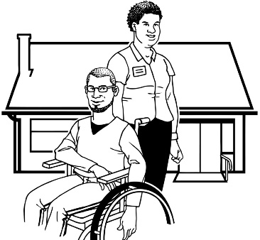
Disability support services are also things like community residential support services which is when disabled people:

  - live with other disabled people

  - get support all through the day.

You can find out more about all the disability support services on the Whaikaha website:

www.whaikaha.govt.nz/types-of-support

Making a complaint and giving feedback

Feedback can be things like:

- compliments

- suggestions

- concerns.

Compliments are when you tell someone something nice.

Suggestions are ideas about how to:

- do something differently

- make something better.

Concerns are things that you might not be happy about.

Whaikaha uses the feedback people give them to make disability support services better.

We want to know what you think about our services.

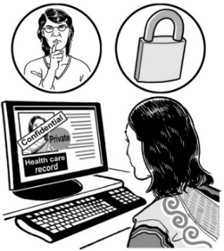
Any feedback or complaints you send us will be kept confidential.

Confidential means we will not share what you tell us with anyone who does not need to know about it.

When you give us your feedback you do not have to tell us your name.

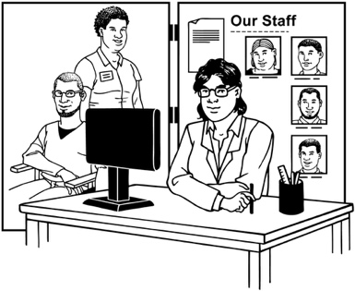
You can make a complaint about any disability support services you get.

You can also send us feedback about any disability support services you get.

We know that sometimes our disability support services:

- do not meet the expectations of some people

- may disappoint some people.

Expectations are what you think something should be like.
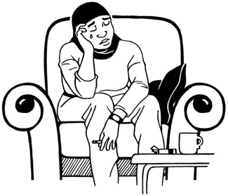

Disappoint means that you feel upset about something.

We want you to always feel:

- safe
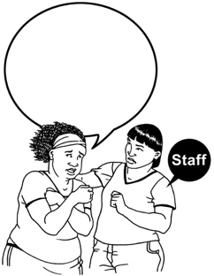
- supported by our staff

- supported by our services.

Your feedback can show us how we can make our services better.

Making our services better means we can support people better.

Complaints can be made by:

- the person who gets the services
- their whānau / family

- a friend of the person.

Complaints can also be made by an advocate.

An advocate is someone who can speak for you / support you if you need them to.

If you are making a complaint for someone else who gets disability support services we may ask that person if they are okay with you doing so.

What can you complain about?

Some things people have complained to us about before are:

- how good / bad the care they get is
- the support they got did not think about te Ao Māori
- the kinds of activities that can be done at home
- things to do with how they look after themselves / keep themselves clean

- things to do with food choices

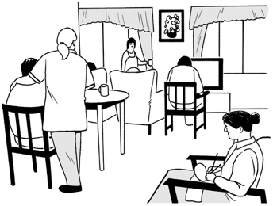
- how someone has been treated by a support worker

- the place where the support happens such as your home.

Te Ao Māori is how Māori think about:
- the world
- their place in the world.

You can complain about any of these things.

You can also complain about anything else that you do not like about our services.

How to make a complaint

It is a good idea to make your complaint as soon as you can.

You can make a complaint by:

- using a form
- contacting Whaikaha if you cannot use the form
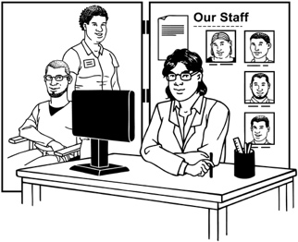
- complaining to your service provider.

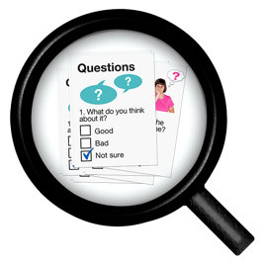
We will tell you how to do all of these things on pages 16 to 26.
Complaining to Whaikaha with a form

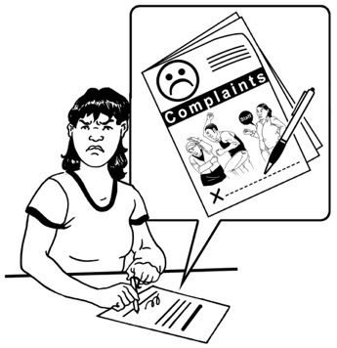
Whaikaha has 2 forms you can use.

The forms are:

- a complaint form for support / services which you can use to make a complaint

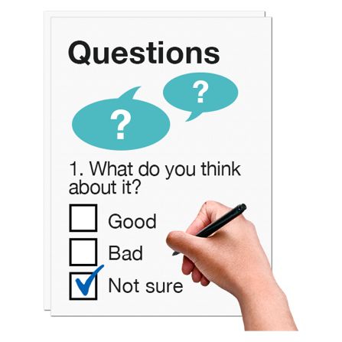
- a feedback form for support / services which you can use to give us:

- general feedback

- compliments

- suggestions.

These forms are not in Easy Read.

You can download these forms from the Whaikaha website.

You can find the complaints form at:

www.whaikaha.govt.nz/assets/Forms/
Complaints-Form.pdf

You can find the feedback form at:

www.whaikaha.govt.nz/assets/Forms/
Feedback-Form.pdf

Some of the forms might have information from the Ministry of Health on them.

This is because Whaikaha is a new Ministry that used to be a part of the Ministry of Health.

We are now making more accessible forms for Whaikaha.

Accessible means that:
- everyone can use them
- they are easy to use.

For now it is okay to use the old forms.

When you send us the Ministry of Health forms you should make sure that you:

- use the contact details on pages 19 to 20 to send them to us
- do not use the contact details that are on the forms.

You should fill in the form you want to send to us.

You can have someone assist you to fill out the form like:

- a family member / whānau

- a friend

- an advocate.

There are 2 ways you can send us the completed form.

If you fill out the form on a computer you can send it by email to:

complaints@whaikaha.govt.nz

If you print the form you can post it to us at:

Complaints / Feedback
Whaikaha — Ministry of Disabled People
Reply Paid: 262204
PO BOX 1556
Wellington 6140

It will not cost you any money to post us the form.
How to contact Whaikaha when you cannot use the form

Some people might not be able to use the form to get in touch with us.

This might be because you:

- cannot download the form
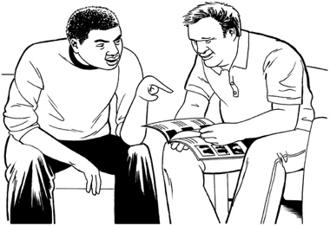
- you need assistance filling out the form

- you want to talk to a person.

There are other ways you can get in touch with us if you cannot use the form.

You can phone us on:

0800 566 601

You can phone us:

- from Monday to Friday
- from 8.30 am to 5 pm.

You can send us a text message on:

4206

You can also email us at:

complaints@whaikaha.govt.nz

We look to all the complaints that come in to us.

Complaining to your service provider

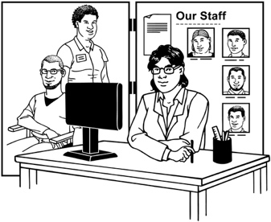
You may want to complain to your service provider without talking to us first.

This might be a good idea because it is often:

- quicker

- easier.

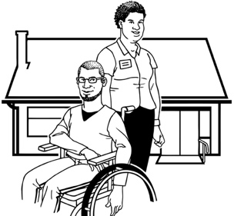
Your service provider is there to support you.

Your service provider should:

- listen to your thoughts

- talk with you about the problem you are having
- deal with the problem quickly.

You can have someone with you when you talk to your support provider like:

- a family member / whānau
- a friend

- an advocate.

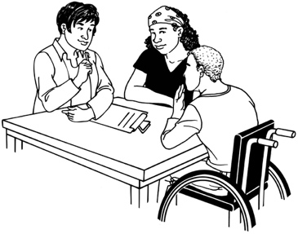
We will keep your complaint confidential however you send it to us whether it be:

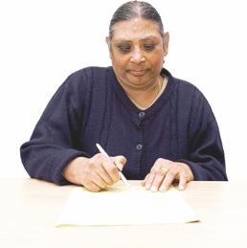
- in person

- in writing
- anonymously

- to your service provider
- to Whaikaha.

Anonymously means you do not tell us
your name.

We will reply to all of these kinds of complaints.

Your disability service provider must:

- give you information in writing about how to make a complaint
- tell you what the complaints process is like:
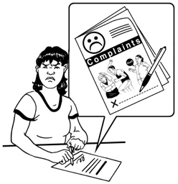
- who you can complain to
- what happens when you make a complaint
- tell you what is happening with your complaint

- let you know what else you can do.

How to get support with
making a complaint

You can ask someone to support you when you make a complaint like:

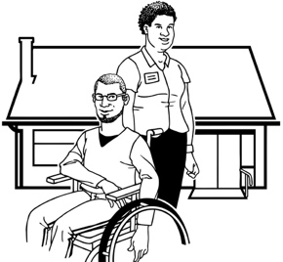
- an advocate

- a friend

- a support worker

- a family member / whānau.

There are some services that can support you too.

- New Zealand Relay Service

The New Zealand Relay Service is for people who:

- are Deaf / hearing impaired

- are Deafblind

- find it hard to talk.

You can use the New Zealand Relay Service to support you to make a complaint.

You can find more about the New Zealand Relay Service at the website:

www.nzrelay.co.nz

- Nationwide Health and Disability Advocacy Service

The Nationwide Health and Disability Advocacy Service is a service that:
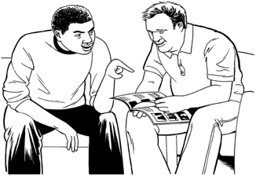
- gives advice / support
- can support people to make complaints
- does not cost any money
- is independent.

Independent means it does not work with / for Whaikaha.

You can contact the Nationwide Health and Disability Advocacy Service:

- by phone on:

0800 555 050

- by email at:

advocacy@advocacy.org.nz

What will happen when you
make a complaint?

When you make a complaint:

- there will be someone you can talk to about your complaint
- we will listen to you / your complaint

- we will treat you in a way that supports you

- we will keep your complaint confidential
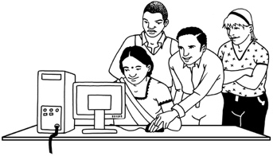
- we will work with you to fix the problem as fast as we can
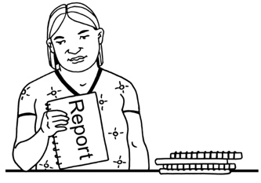
- we will tell you the outcome of your complaint.

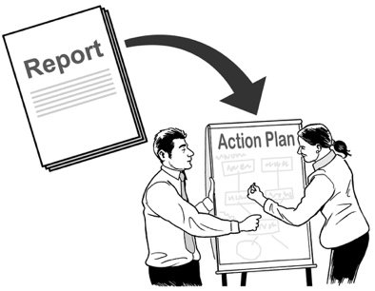
Outcome means:

- what things were done about your complaint

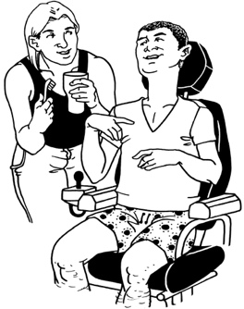
- what changes were made.

Making a complaint will not change the kind of care / support you get.
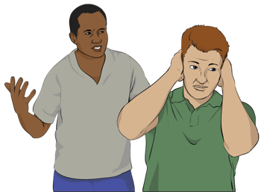

You will not get in trouble for making a complaint.

We will only talk about your complaint with people:

- who are a part of your complaint

- who we need any advice from.

We will contact you in 5 working days / fewer than 5 working days:
5

- after you make a complaint

- after you give us feedback.

Working days are the days in a week that people usually go to work.

The days are Monday to Friday.

We may need to talk to other people about your complaint.

Sometimes the other people might be a part of the problem you are complaining about.

If we need to talk to someone else about your complaint we will:

- ask you if it is okay for us to talk to them
- send you an email with more information about what we will do next.

After we have looked into your complaint we will:

- let you know the outcome of your complaint

- tell you about how we got to this outcome.

20
We will try our best to sort out any complaints in 20 working days.

20 working days means about 4 weeks.
We will tell you who else you can talk to if you are:

- not happy with the outcome
- need more information about the outcome.

Other languages and accessible formats

Whaikaha wants to make sure the information about how to make a complaint is accessible to as many people as possible.

You can read our complaints and feedback information in:
- te reo Māori

- accessible formats like:
- Braille

- audio
- large print

- New Zealand Sign Language.

You can find these on our website at:

https://www.whaikaha.govt.nz/contact-us/complaints-feedback/

If you have any questions about this document you can email us at:

contact@whaikaha.govt.nz

This information has been written by Whaikaha – Ministry of Disabled People.

It has been translated into Easy Read by the Make it Easy Kia Māmā Mai service of People First New Zealand Ngā Tāngata Tuatahi.

The ideas in this document are not the ideas of People First New Zealand Ngā Tāngata Tuatahi.

Make it Easy uses images from:

- Changepeople.org

- Photosymbols.com

- SGC Image Works

- Huriana Kopeke-Te Aho.

All images used in this Easy Read document are subject to copyright rules and cannot be used without permission.

