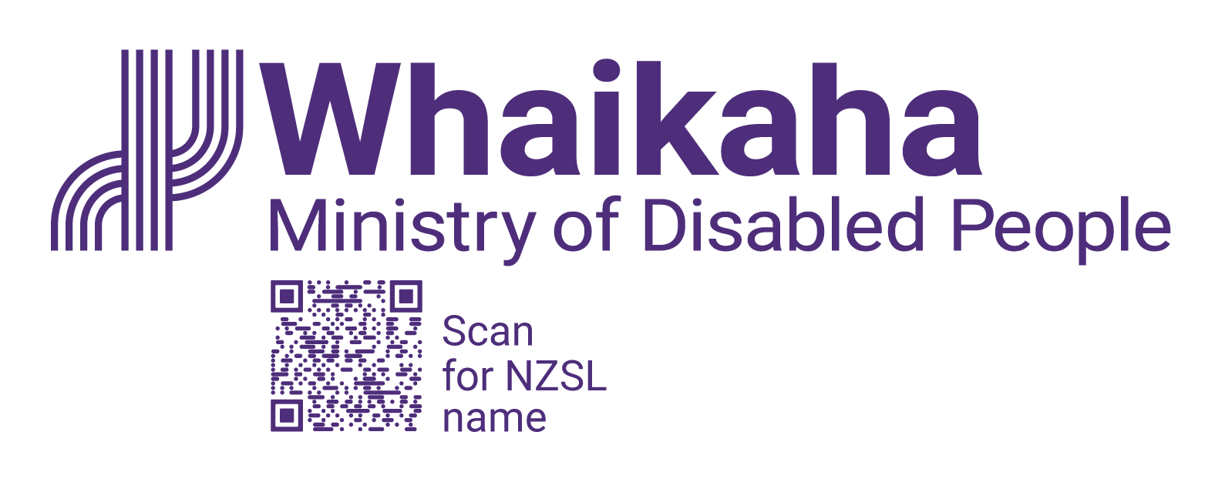
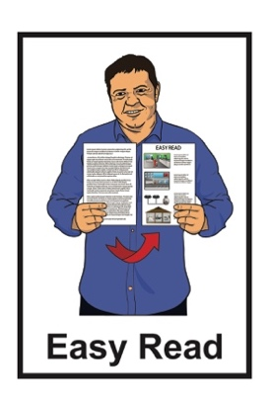

How the Government is getting on with the
Disability Action Plan
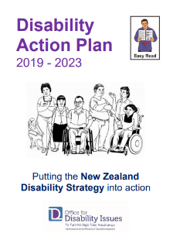
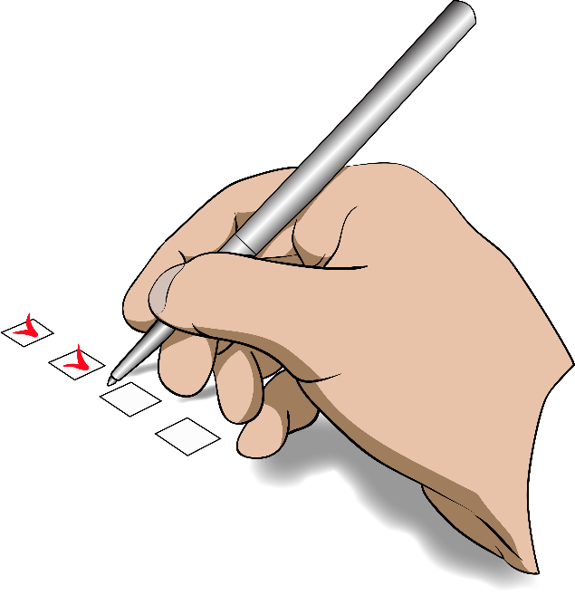

Review of July – December 2023

Before you start

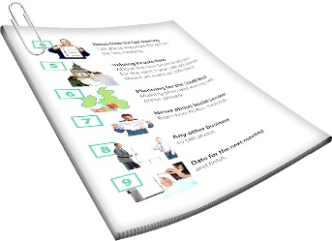
This is a long document.


It can be hard for some people to read a document this long.

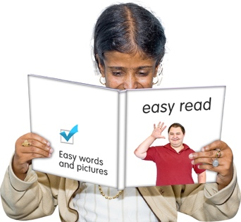
Some things you can do to make it easier are:
read it a few pages at a time
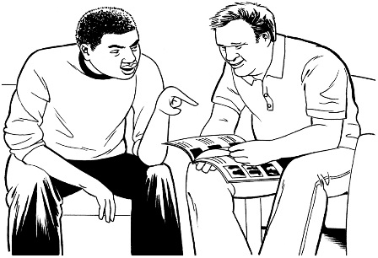
set aside some quiet time to look at it
have someone read it with you to support you to understand it.

What is in this document

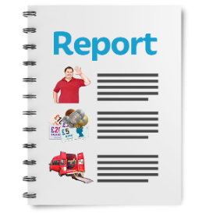
Page number:

About this report 4

What is the Disability Action Plan? 7

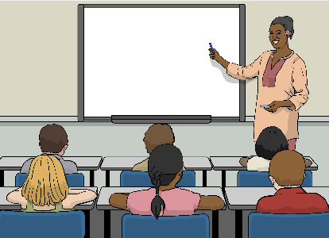
How things are going 14

Outcome 1: Education 17
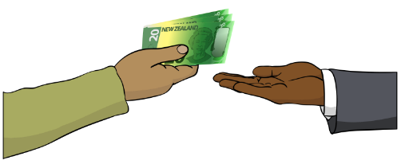

Outcome 2: Jobs and money 27
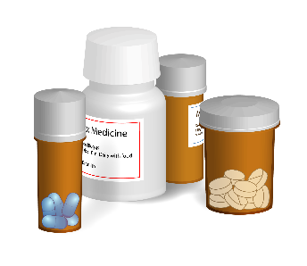

Outcome 3: Health and wellbeing 33


Page number:

Outcome 4: Protecting rights 40

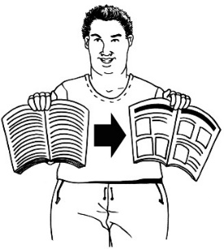
Outcome 5: Accessibility 47

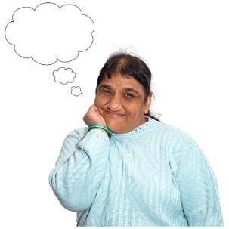
Outcome 6: Attitudes towards
disability 52

Outcome 7: Choice and control 53

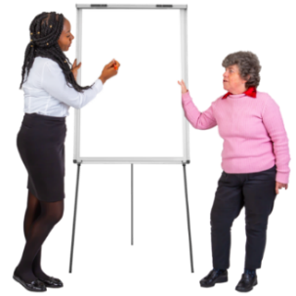
Outcome 8: Disabled people
as leaders 57

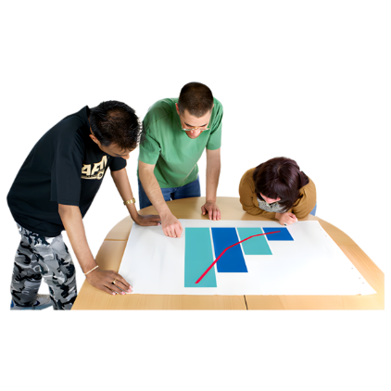
Cross Government Work
Programme: Disability Data and Evidence………………………………60

About this report

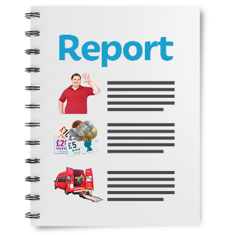
This Easy Read document is the last report about how well the
2019 – 2023 Disability Action Plan is working.

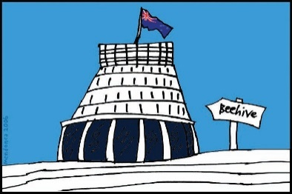
The Disability Action Plan is how the Government makes the
New Zealand Disability Strategy happen.

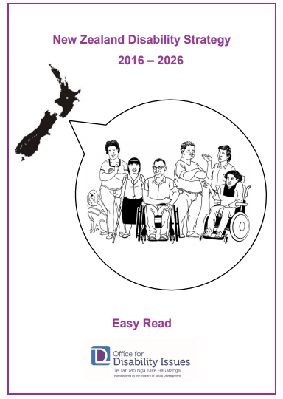
The New Zealand Disability Strategy works to make sure disabled people:
are treated fairly
are part of the community.

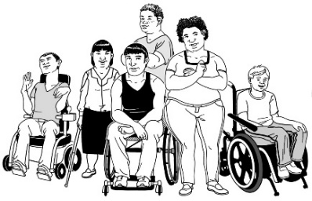
The New Zealand Disability Strategy also works to make sure disabled people:
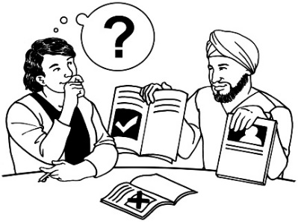
get what they need to have a good life
can make their own decisions.

In this document the:
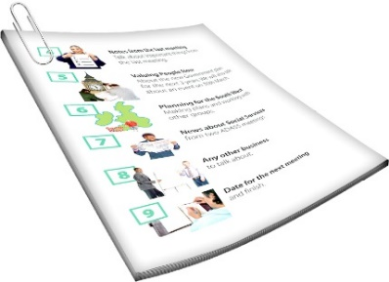
Ministry of Disabled People – Whaikaha is called Whaikaha
The Disability Action Plan is called the DAP.

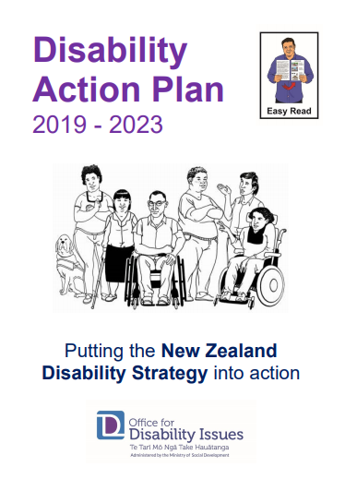
There are Easy Read documents about the:
New Zealand Disability Strategy
DAP.


You can find these Easy Reads on the Whaikaha website here:

tinyurl.com/nzds-dap

What is the Disability Action Plan?

The DAP works to improve the wellbeing of disabled people by working on 8 main outcomes.

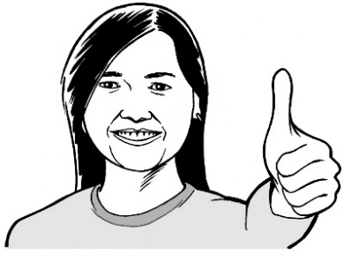
Wellbeing means how people feel about their lives.


Some of the things that are
important to wellbeing are:
- health
- money.


Here outcomes are the things we want to happen from the DAP.

These outcomes are:



education
jobs and money
health and wellbeing
protecting the rights of disabled people
accessibility
attitudes towards disability
disabled people having choice
and control over their own lives
disabled people as leaders.

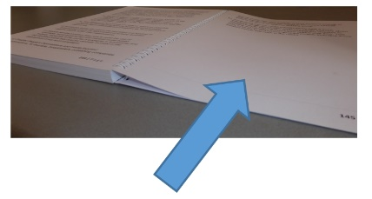
Pages 17 to 57 will go through these outcomes.

Every 6 months there is a report about what the different parts of Government are doing about the DAP.

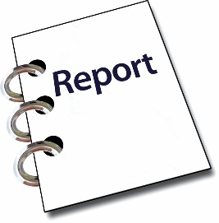
The reports are done by the agencies who look after the different outcomes.

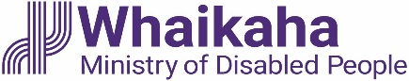
Whaikaha is responsible for writing some of the reports.

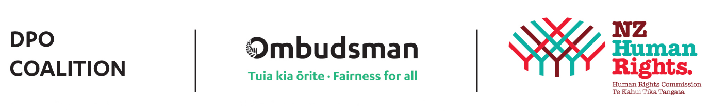
Whaikaha also works with the Disabled People’s Organisations Coalition.


The Disabled People’s Organisations Coalition is a group of people from different disability organisations.
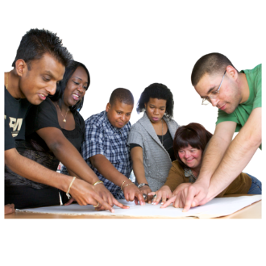

A coalition is a group of organisations that work together.

The Disabled People’s Organisations Coalition is also called the DPO Coalition.

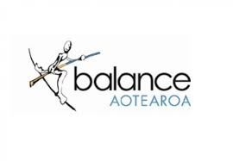
The DPO Coalition is made up of members from these 7 disability organisations:
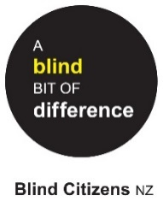
Balance Aotearoa
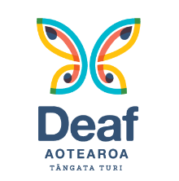
Blind Citizens New Zealand
Deaf Aotearoa
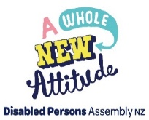
Disabled Persons Assembly New Zealand
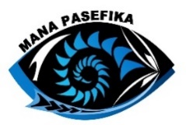
Mana Pasefika
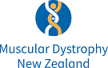
Muscular Dystrophy Association of New Zealand
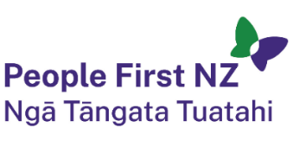
People First New Zealand – Ngā Tāngata Tuatahi.

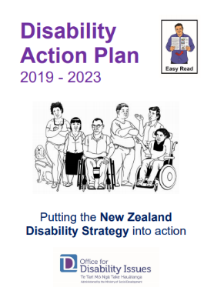
The reports are 1 of the ways to see how well the DAP is working.

This Easy Read is a summary of the report.

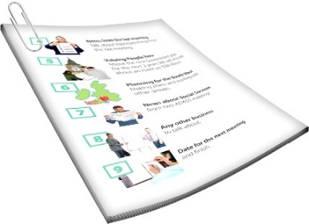
A summary is:
shorter than the full report
has the most important information from the full report.

You can find the full report here:

tinyurl.com/fulldapreports
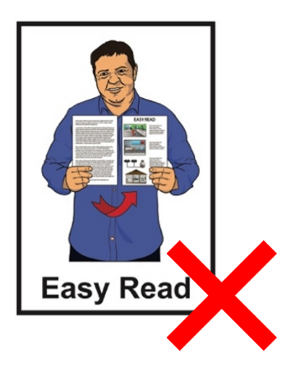

The full report is not in Easy Read.

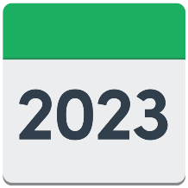
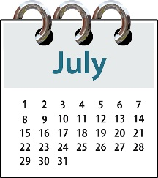
This report looks at what the different parts of Government did from:

July 2023

to
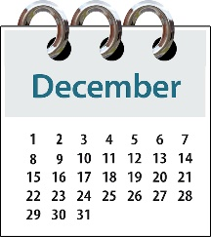
December 2023.

How things are going

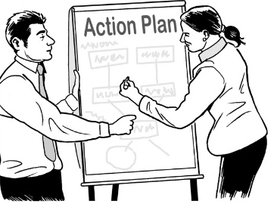
29
The DAP has 29 work programmes.

The people working on 2 of the programmes said they were
complete / finished.
2

The people working on 5 of the programmes said they were on track.
5

Being on track means:
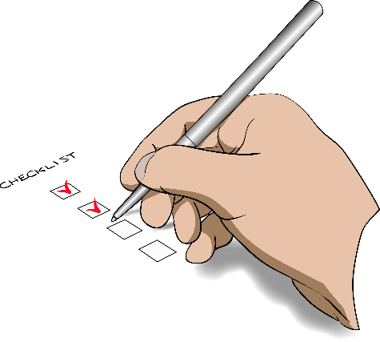
things are going well
they are meeting the goals set out in the DAP.

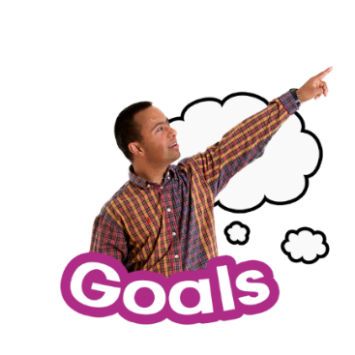
Goals are the things people planned to do by a certain time.

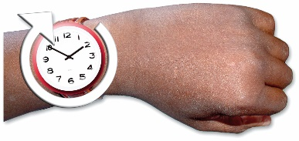
The people working on 19 of the programmes said they were on track with minimal risks.
19

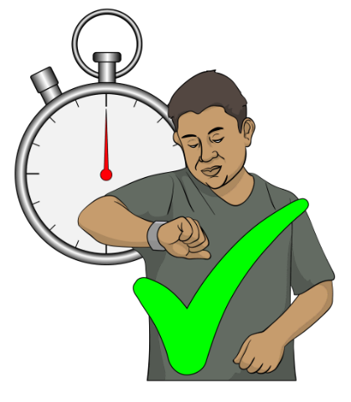
On track with minimal risks
means:
they think they will finish on time
it is not likely they will have big problems finishing.

The people working on 3 of the programmes said they were off track with minimal risks.
3

Off track with minimal risks means they:
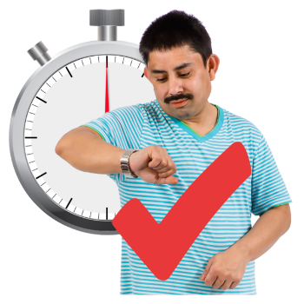
have not done as much as the DAP said
think they will still finish their
work on time.

Outcome 1: Education


Education is about learning things at:
- school
- university.

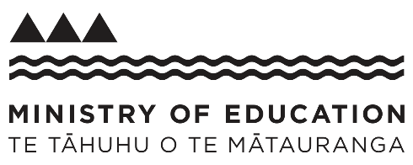
The Ministry of Education has 5 programmes in this outcome.

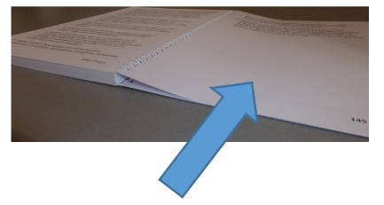
Pages 22 to 25 will go through these 5 programmes.


Some things that happened between July 2023 – December 2023 are:
schools can make changes to how students take their NCEA exams to better meet the needs of the students
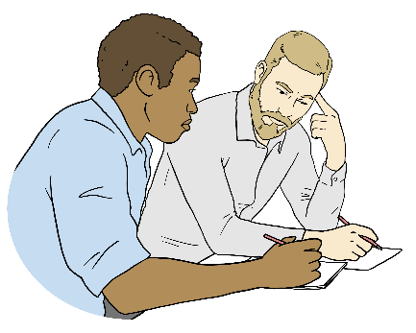
the Ministry of Education is still supporting Te Kōhanga Reo National Trust to make documents accessible to support the needs of disabled learners
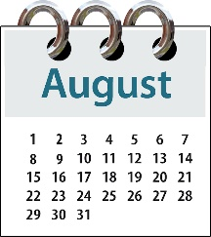
the Inclusive Design Modules were made available in August 2023.


NCEA shows what people have learned at high school / college.

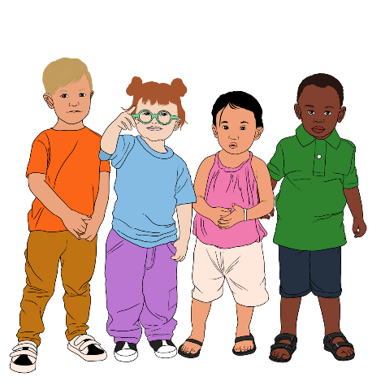
Kōhanga Reo is a place for young children to learn things like te reo Māori / Māori language.

Inclusive Design Modules are about training on universal design for people who work in schools.

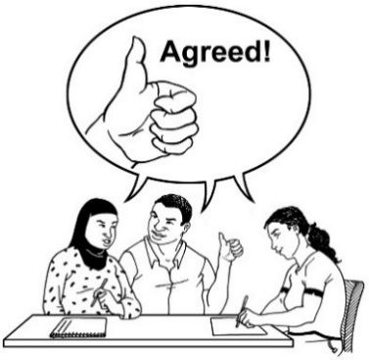
Universal design means designing things in a way that works well for everyone.

Another thing that happened between July 2023 – December 2023 is that the Early Learning Action Plan was paused.
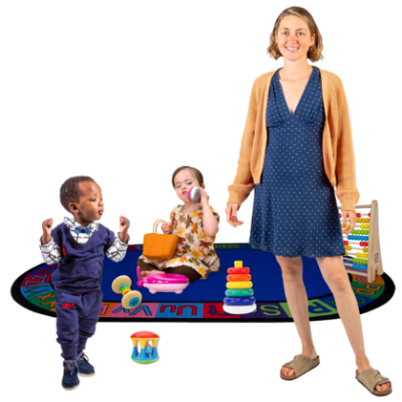

This plan says all children need to be able to:
be part of good early learning

have the support they need to:
- learn
- do well.

Early learning is for young children before they go to school.

Another thing that happened between July 2023 – December 2023 is that things are getting better for disabled people in tertiary education.

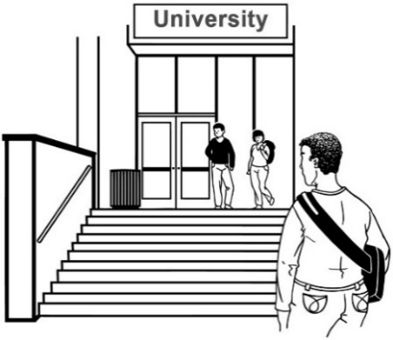
Tertiary education is education
you do after finishing high
school / college like:
university
polytechnic.

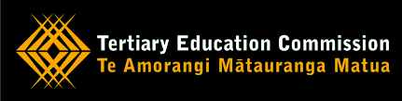
The Tertiary Education Commission also has a work programme under Outcome 1.

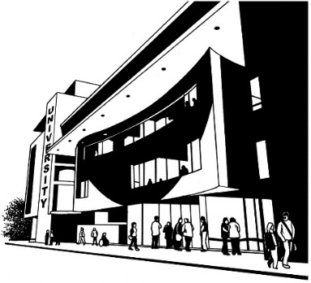
The Tertiary Education Commission is a part of
the Government that works on tertiary education.

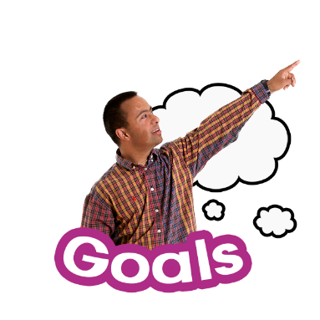
The goal of the work programme is to make tertiary education better for disabled people.

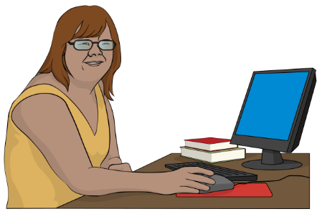
It should mean there are more disabled people:
being part of tertiary education
doing well in tertiary education.

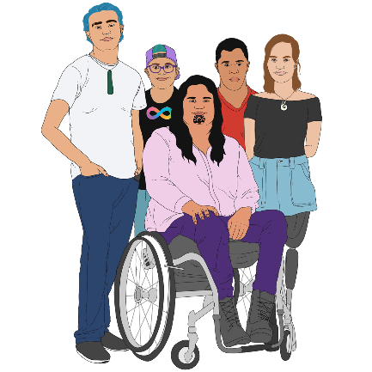
The Tertiary Education Commission will make new information available for tutors who support:
Māori disabled learners
Pacific disabled learners.

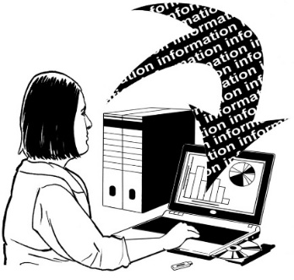
The information will be added to
the Kia Ōrite Toolkit.

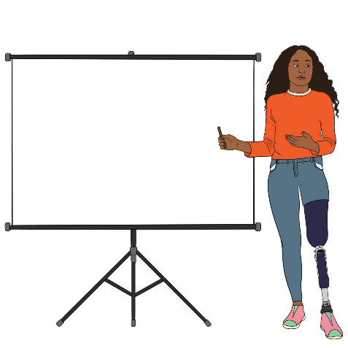
The Kia Ōrite Toolkit shows staff working in tertiary education how to make things inclusive for disabled learners.

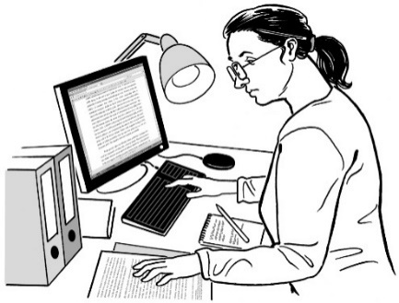
Programme 1: NCEA Review

The NCEA review is about making universal design part of everything to do with NCEA.

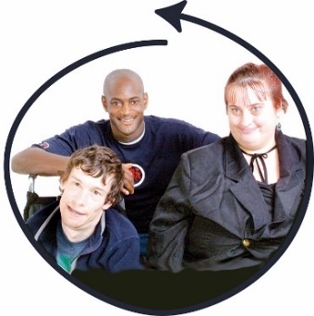
This means students will have more ways to show what they have learned.

This programme is on track with minimal risks.

Programme 2: Tomorrow’s Schools
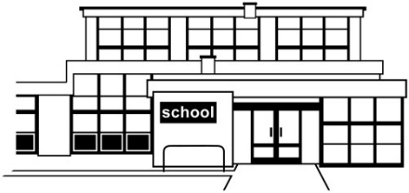
Tomorrow’s Schools is the way education / schools are set up in Aotearoa New Zealand.

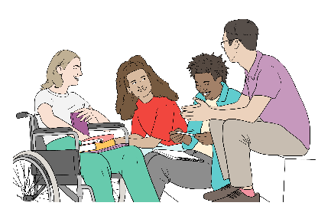
This is not just for disabled students.

It will change things for all students.

This programme is on track.

Programme 3: Learning Support Action Plan

This plan has different things in it including finding out which learners need support earlier.

This programme is on track with minimal risk.

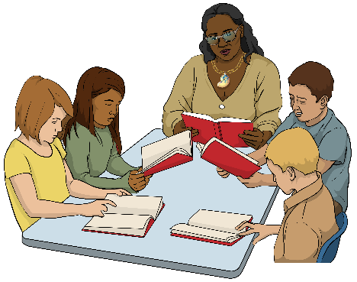
Programme 4: Curriculum Refresh Progress and Achievement

A curriculum says what people should learn.


This work programme is about making sure the New Zealand Curriculum is accessible to all learners.

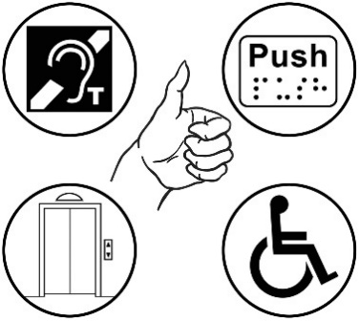
Accessible means everyone can
use it in a fair way.

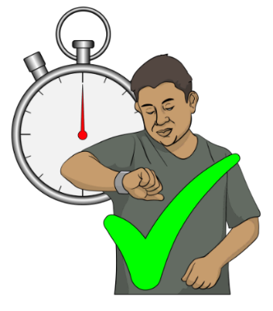
This programme is on track with minimal risk.

Programme 5: Reform of Vocational Education
Vocational education is being reformed so it meets the needs of all learners including disabled learners.

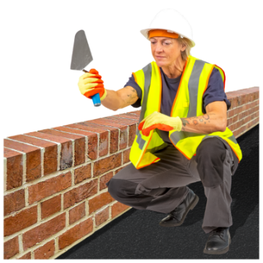
Vocational education is when you learn how to do a job like:
building
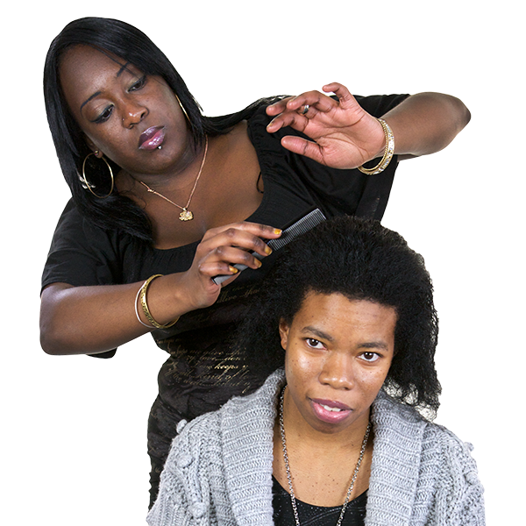
nursing
hairdressing.

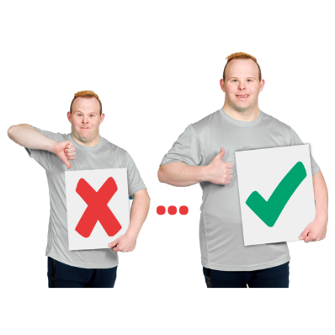
Reform means changing to make it better.

Outcome 2: Jobs and money


There are 4 work programmes in this outcome.

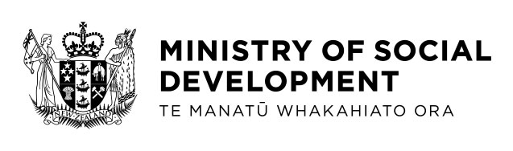
All 4 work programmes are led by the Ministry of Social Development.

Programme 1: Working Matters Disability Employment Action Plan
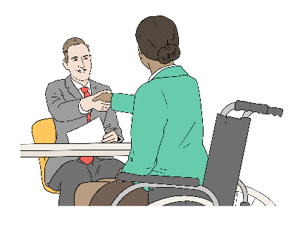
This is to make sure disabled people have a fair chance to get good work.


This programme is no longer being worked on.

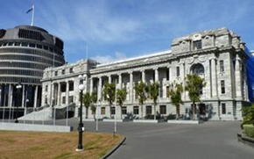
This is because the Government is:
now working on an Action Plan for everyone
not working on the Disability Employment Action Plan any more.

Programme 2: Stopping Minimum Wage Exemption Permits

Minimum wage is the least amount you can be paid for every hour of work.

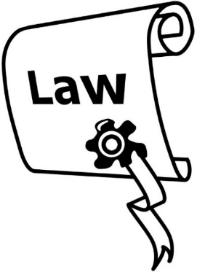
It is usually against the law to pay less than minimum wage.

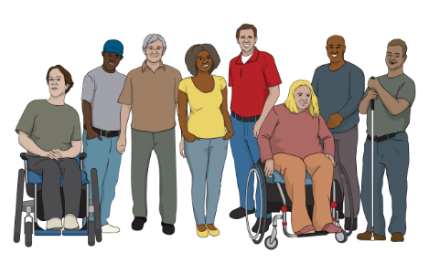
Some workplaces have exemption permits that mean they can pay disabled people less than minimum wage.

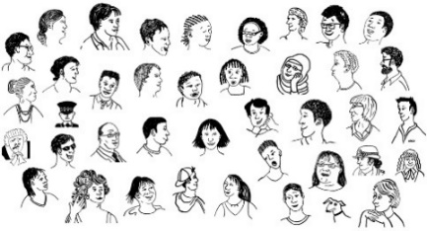
There are about 9 hundred people working for less than minimum wage because of these permits.

This programme is no longer being worked on.

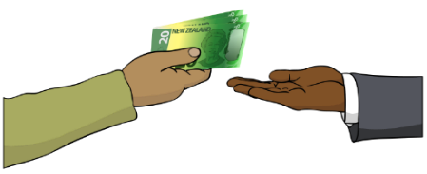
This is because the Government has said that workplaces can still use the exemption permits.

Programme 3: National Information Portal and Regional Hubs
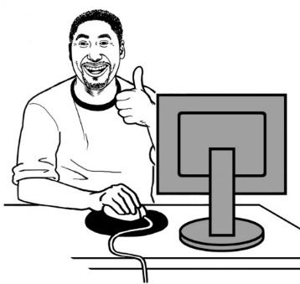
A portal is 1 place on the internet that shows you all the different
places to get information.

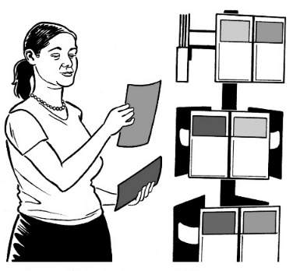
Hubs are places in your local area where you can:
find out information
connect with different services.

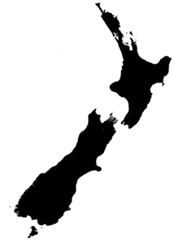
This programme looks at the idea of making hubs in different parts / regions of Aotearoa New Zealand to support disabled people having jobs.
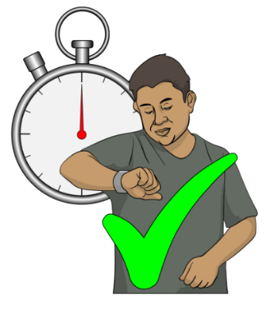

This programme is on track.

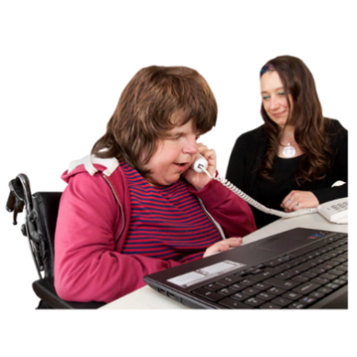
Programme 4: Accessible Employment

Accessible employment is about having more disabled people working in the public sector.

The public sector means places like government departments.

The Ministry of Social Development and the rest of the public sector are working to support this.
Some things that are being worked on for this programme are the:
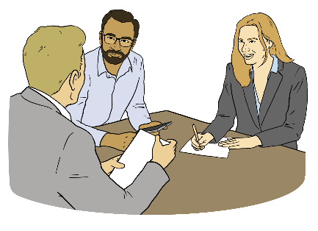
Lead Toolkit
Government internship programme.


The Lead Toolkit is information for employers about having disabled people work for them.

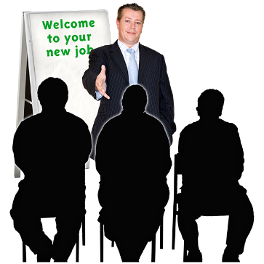
An internship is when you work somewhere for a short time to learn about a job.

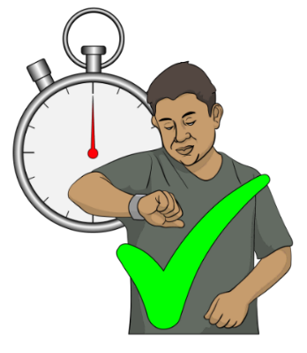
All the programmes under Accessible Employment are on track.

Outcome 3: Health and wellbeing

5
There are 5 work programmes in Outcome 3.

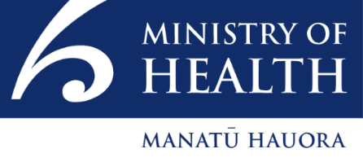
4 of the Outcome 3 work programmes are run by the Ministry of Health.


1 of the work programmes is run by Sport New Zealand.

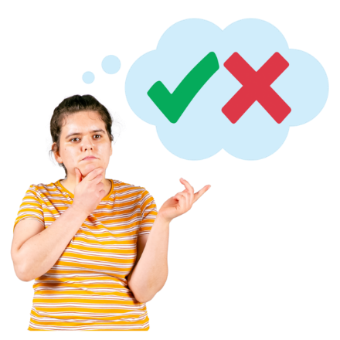
Programme 1: Safeguarding Bodily Integrity Rights

Bodily integrity means you get to decide what happens to your own body.

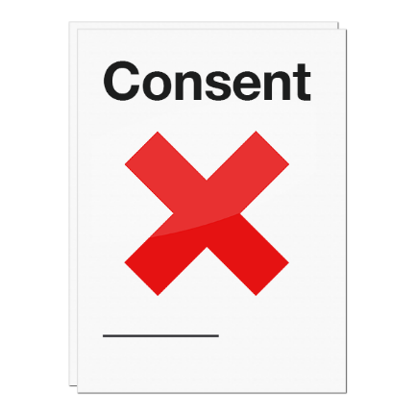
This work programme is about protecting disabled people from treatment they do not want like:
sterilisation
growth attenuation treatment.
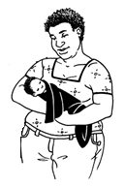

Sterilisation is making it so you can never have children.

Growth attenuation treatment is using medicine to stop people growing.
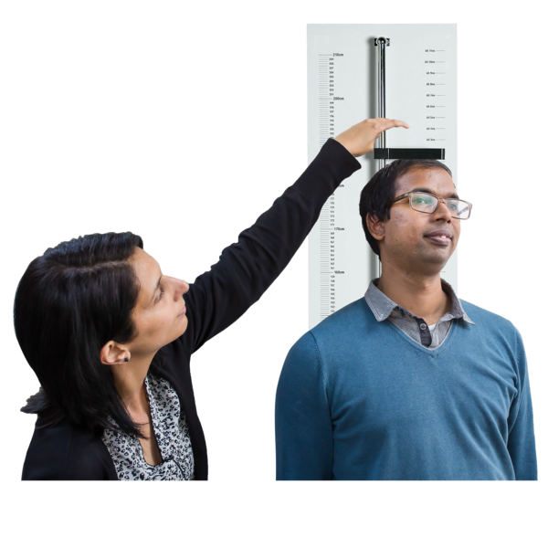

It is used to keep some disabled people the same size as when they were children.

The programme is off track with minimal risks.

The DPO Coalition is worried about how slowly this programme is being worked on.

Programme 2: Health Outcomes and Access to Services

This work programme is about:
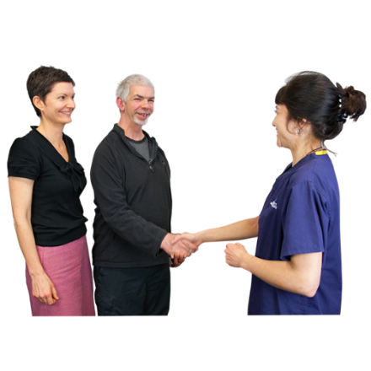
everyone being able to use health services
things going well for people after they have used health services.

The programme is on track with minimal risks.

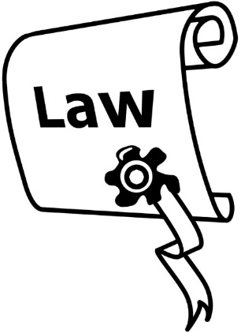
Programme 3: Repeal and Replace the Mental Health (Compulsory Assessment and Treatment) Act 1992

Repeal means to end a law.

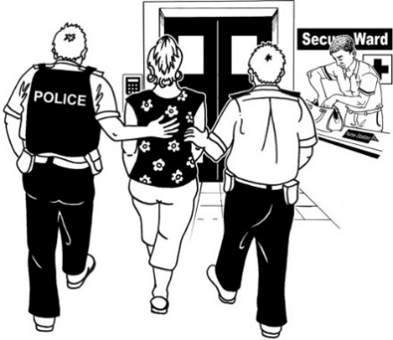
The Mental Health (Compulsory Assessment and Treatment) Act 1992 is a law that says sometimes people with mental distress can be made to have treatment even if they say no.

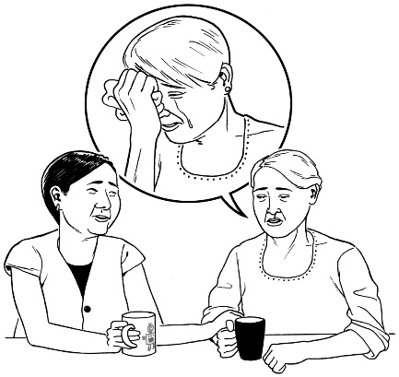
Mental health is health to do with:
how you feel
your mind.

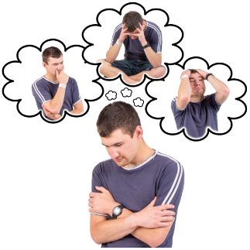
Mental distress is when your mental health is not doing well.

The programme is on track with minimal risks.

Programme 4: Seclusion and Restraint
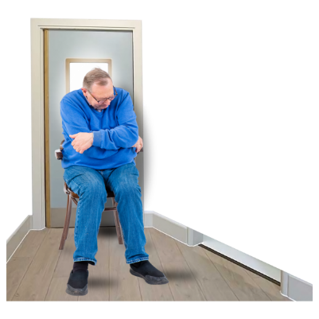
This work programme is about removing all seclusion and restraint from our health system.
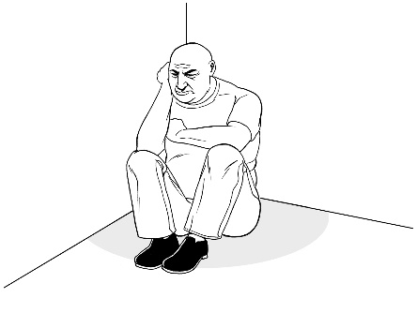

Seclusion is when someone is shut in a room on their own.

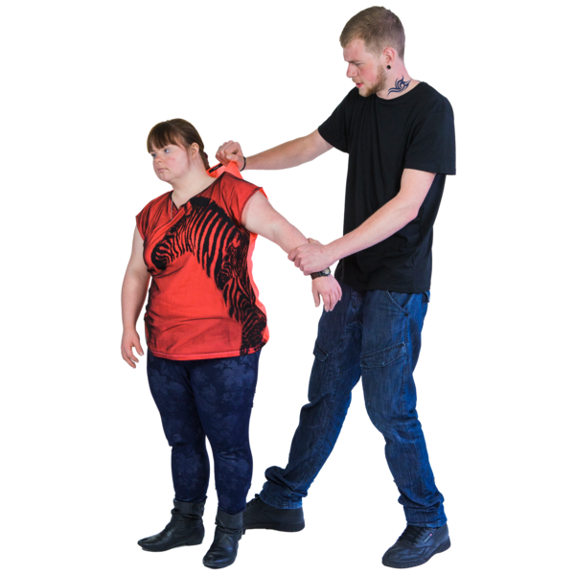
Restraint is when someone is stopped from moving in ways like:
- being tied down
- being given medicine that makes you sleepy
- someone holding onto you and stopping you from moving. .

The programme is on track with minimal risks.

The work programme which is run by Sport New Zealand is the:

Sport New Zealand Disability Plan

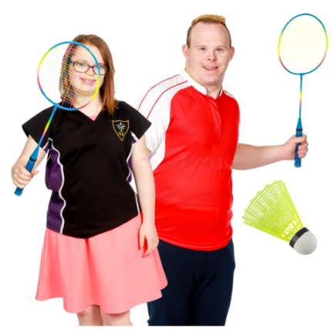
This is about making better chances for disabled children / young people to be part of sport.

This in on track with minimal risk.

Outcome 4: Protecting rights


This outcome is about protecting the rights of disabled people.

Rights are things that the
law says every person should:
have
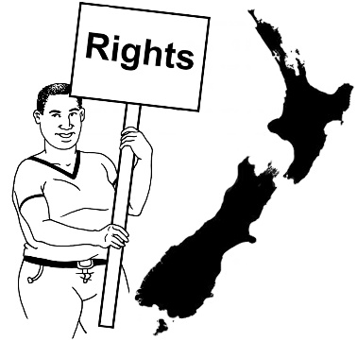
be able to do.

Rights are things like:
having a safe place to live
being able to get married.

There are 3 programmes for Outcome 4.
3

These programmes are run by:
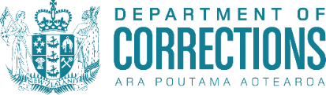
Whaikaha
the Department of Corrections
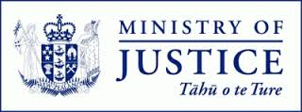
the Ministry of Justice.

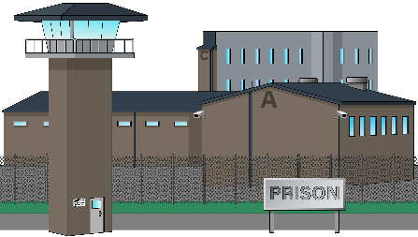
The Department of Corrections is the part of Government to do with things like prisons.

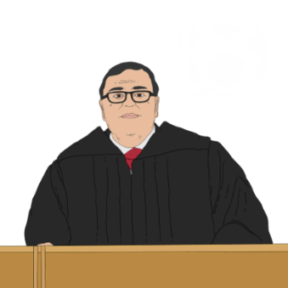
The Ministry of Justice is the part
of Government to do with things like courts.

Programme 1: Implementation of Safeguarding Responses for Disabled and Vulnerable Adults Te Aorerekura

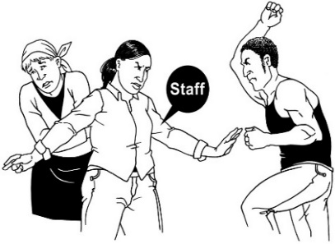
This is about keeping disabled people safe from:
violence
abuse / neglect – when someone is treated badly / hurt by someone.

This programme is run by Whaikaha.


In 2023 a group of government agencies got the money to set up DAPAR.

DAPAR:
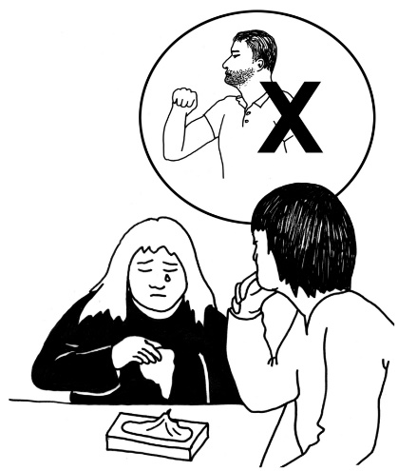
stands for Disability Abuse Prevention and Response
team
works with disabled adults who are at risk of:
- violence
- abuse.

This is on track.

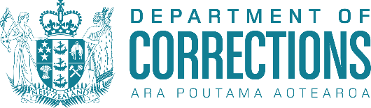
Programme 2: Department of Corrections Disability Action Plan Implementation
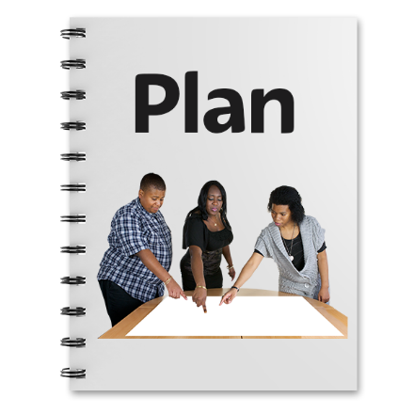
The Department of Corrections has published its first Disability Action Plan.

This work programme is on track with minimal risk.

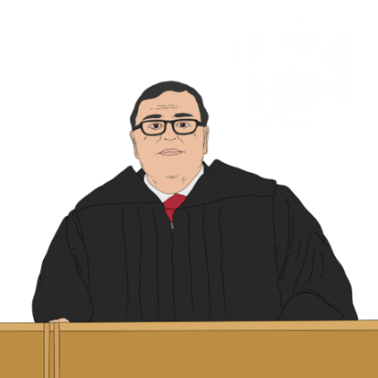
Programme 3: Ministry of Justice Work Programme

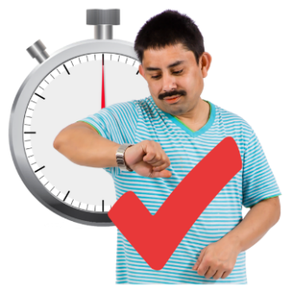
This programme is a group of smaller programmes to make the justice system easier to use for disabled people.

This is on track with minimal risk.


Information about what happens in the family court is available in alternate formats.

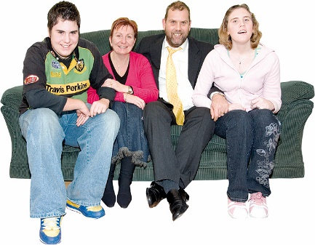
The family court is a court that assists New Zealanders with family issues.


Information in alternate formats is available here:

tinyurl.com/mr49w6w4

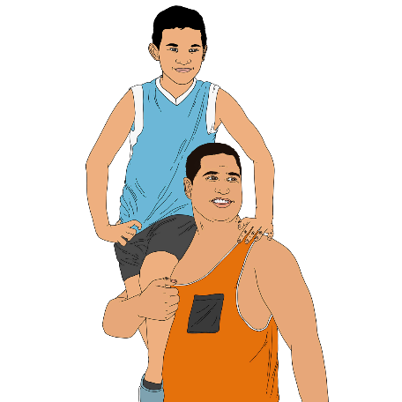
There is some work that is not on track like making information for parents on how to support children when the parents are separating.

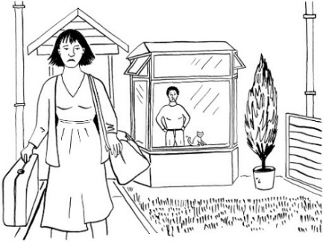
Separating is when a couple decide not to be in a relationship any more.

Usually this means they stop living together.

Outcome 5: Accessibility
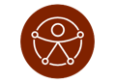

Outcome 5 is about accessibility.

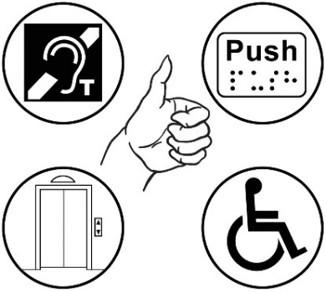
Accessibility means everyone can do / be part of things in a fair way.

The government agencies that are part of this work are:
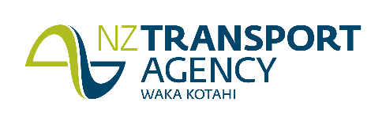
- New Zealand Transport Agency - Waka Kotahi

- Ministry of Transport
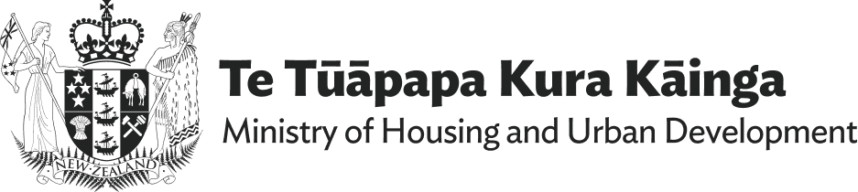
- Ministry of Housing and Urban Development
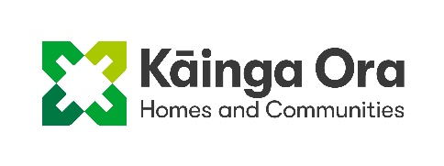
- Kainga Ora – Homes and Communities
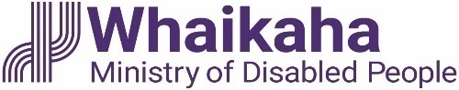
- Whaikaha – Ministry of Disabled People.
Some more government agencies that are part of the accessibility work are:
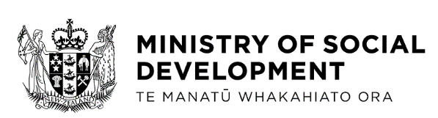
- Ministry of Social Development
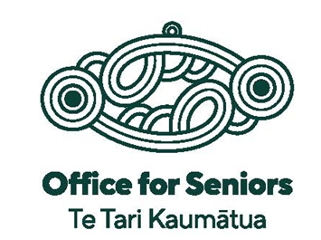
- The Office for Seniors

A big thing that happened in 2024 was that the Minister for Disability Issues withdrew the Accessibility for
New Zealanders Bill on 14 August.

Here withdrew means the Bill will
not be made into a law.

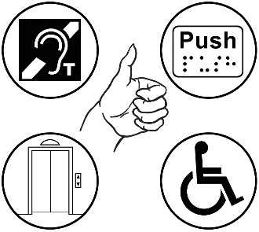
The Accessibility for New Zealanders Bill was made with the goal of making New Zealand fully accessible.

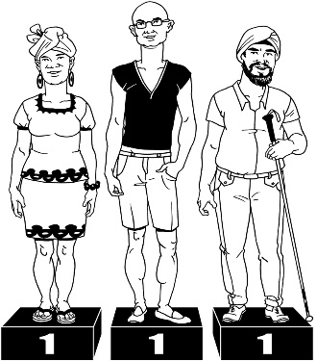
Here fully accessible means people from the disabled community have the same chance to reach their goals as everyone else.

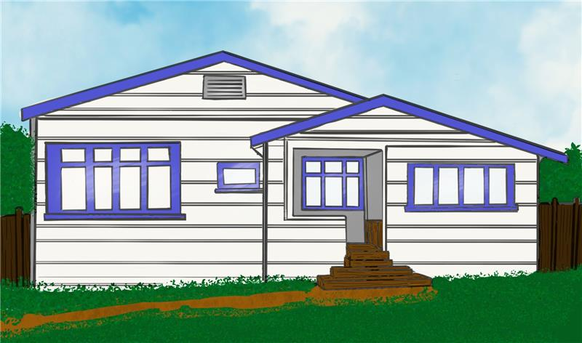
1 programme that is off track with minimal risk is Improve Accessibility Across the New Zealand Housing System.

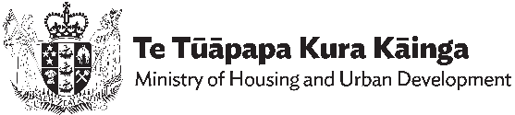
This work programme is done by the Ministry of Housing and Urban Development.

3
There are 3 work programmes in Outcome 5 that are on track:

Programme 1: Accessible Public Information
This work programme is being done by the Ministry of Social Development.

This work is on track.

Programme 2: Better Later
Life – He Oranga Kaumātua

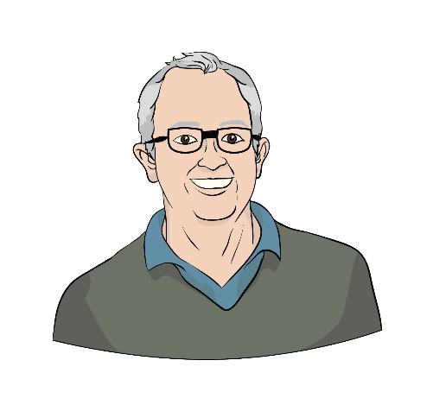
This work programme is being done by the Office for Seniors.

Seniors are people who are 65
years or older.

This work is on track with minimal risk.

Programme 3: Accessibility Work Programme
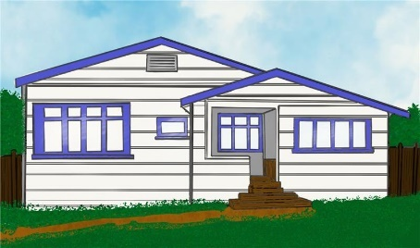
This is being done by Kāinga Ora which is the part of Government that looks after state / social housing.

This work is on track with minimal risk.

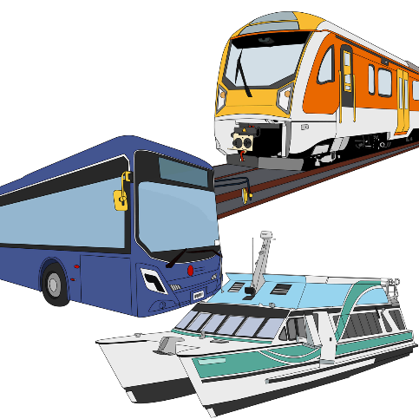
Joint Transport Disability Action Plan

This programme is shared between 2 different parts of the Government:
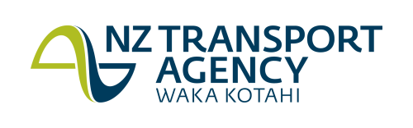
the New Zealand Transport Agency

the Ministry of Transport.

This work is on track with minimal risk.

Outcome 6: Attitudes towards disability


Outcome 6 is about attitudes towards disability.

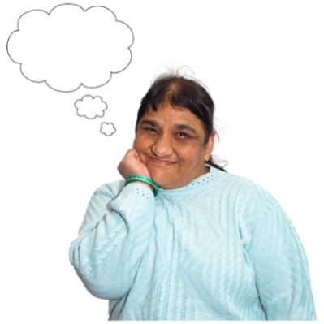
Attitudes are:
how people think
the ideas people have about disabled people.


Outcome 6 does not have a work programme of its own.

29
All the work programmes work on making the attitudes people have towards disabled people better.

Outcome 7: Choice and control

Outcome 7 is about disabled people having choice and control over their own lives.
2

Outcome 7 has 2 work programmes.

They are both managed by Whaikaha.

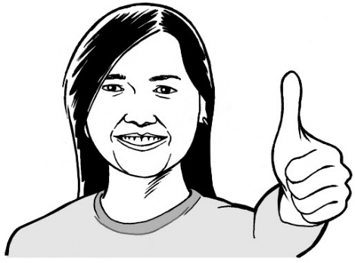
Both programmes are on track with minimal risk.

Programme 1: Supported Decision Making
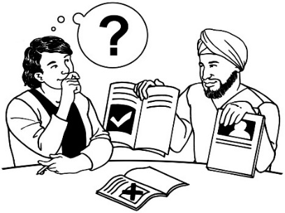
Supported Decision Making is making sure people have what they need to make their own decisions.

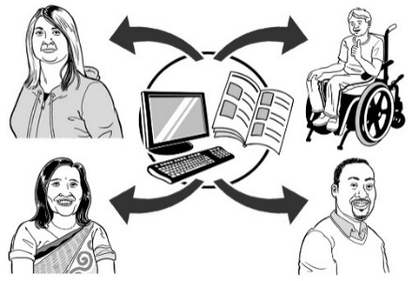
This work programme is to make information about supported decision making available for:
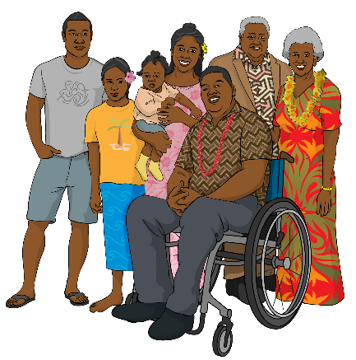
disabled people
their families / whānau.

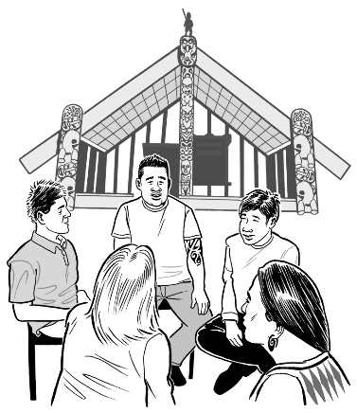
In 2024 a Māori rōpū / group was made to give a te ao Māori way of doing things in the Supported Decision Making programme.

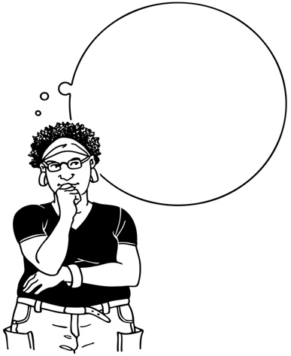

Te ao is about how Māori
view / think about:
- the world
their place in the world / how
they connect to it.

Programme 2: Disability Support System Transformation
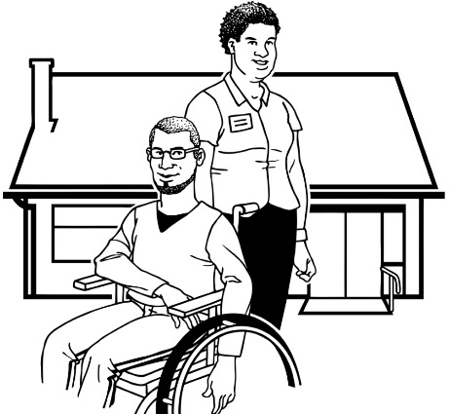
This is to change the disability support system to fit with the Enabling Good Lives ideas.

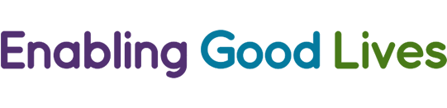
Enabling Good Lives is a different way of thinking about disability support.

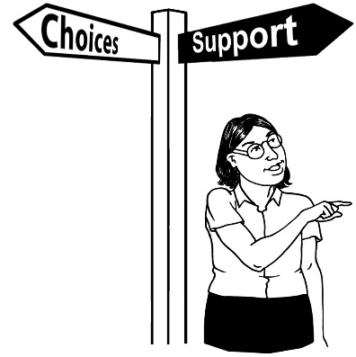
Enabling Good Lives is about
having:
- choice and control in your life
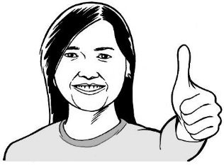
- the support you need and want
- a good life.

Outcome 8: Disabled people as leaders

Outcome 8 is about leadership.

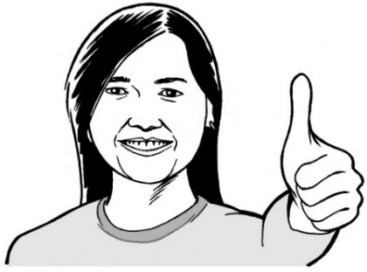
There is 1 work programmes in Outcome 8.

Nominations Database

A nomination is when you say someone would be a good fit for something like being on a board.

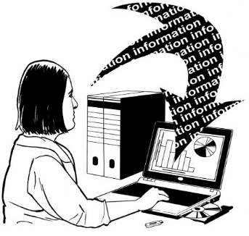
A database is a way of keeping information on a computer.

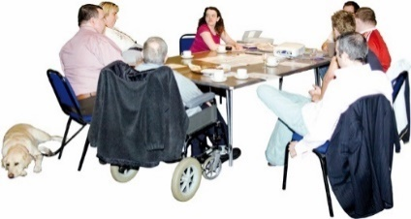
The nominations database is to make it so more disabled people are on public sector boards.
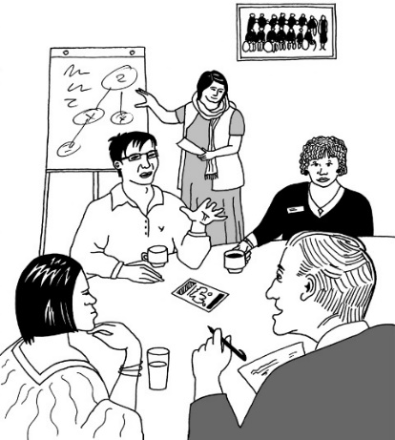
A board is a group of people who are:
in charge of an organisation
decide on the important things
an organisation does.

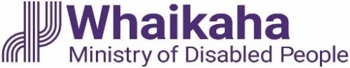
This work programme is run by Whaikaha.

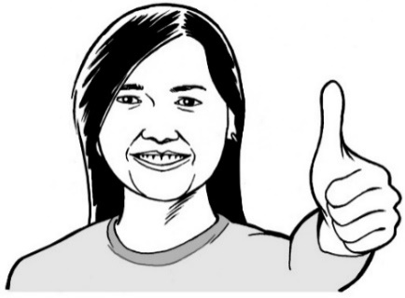
This work programme is on track.

Cross Government Work Programme: Disability Data and Evidence

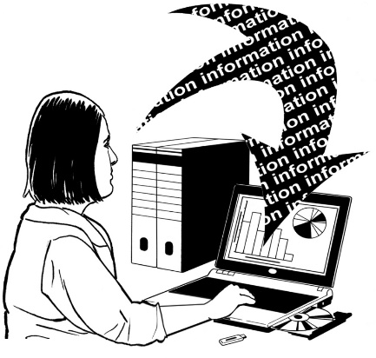
Cross Government Work Programme means government agencies working together to share data.


Data is information that government agencies collect as part of the work they do.

This programme is being led by Whaikaha along with Stats NZ.

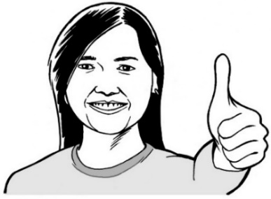
This programme is on track.

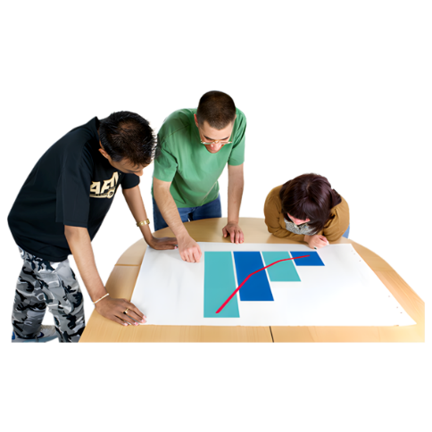
The programme is about using disability data available so that:
- policies meet the needs of disabled people better
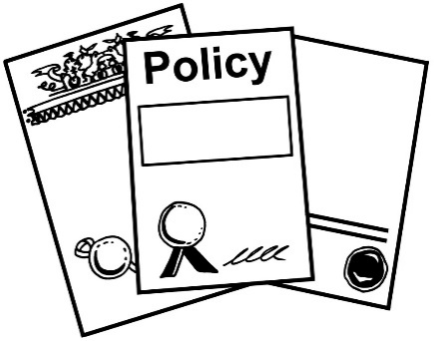
- services meet the needs of disabled people better.

Policies are like rules to be followed.

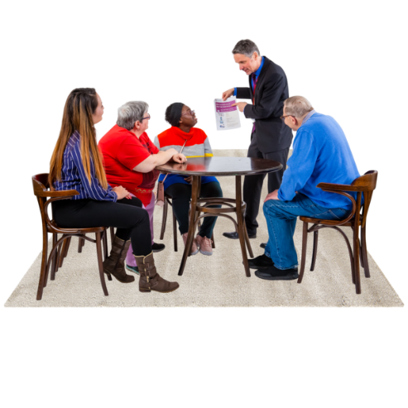
Some of the things that have been done are:
- setting up a Community of Practice who meet to learn about the data collected

- setting up a Data and Insights team at Whaikaha who collect / use data to provide advice.

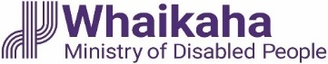
This information has been written by
Whaikaha – Ministry of Disabled People.

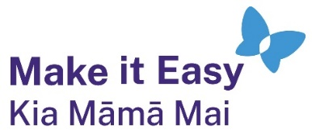
It has been translated into Easy Read by the Make it Easy Kia Māmā Mai service of People First New Zealand Ngā Tāngata Tuatahi.
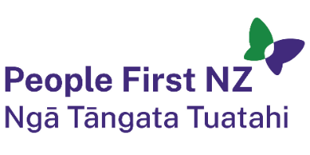
The ideas in this document are not the ideas of People First New Zealand Ngā Tāngata Tuatahi.

All images used in this Easy Read document are subject to copyright rules and cannot be used without permission.


Make it Easy uses images from:

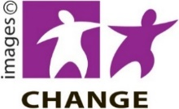
- Photosymbols

- Change Images


- Huriana Kopeke-Te Aho
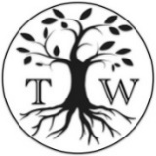
- SGC Image Works

- T Wood

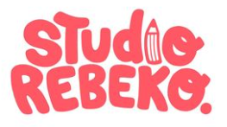
- Studio Rebeko

- Inga Kramer.

