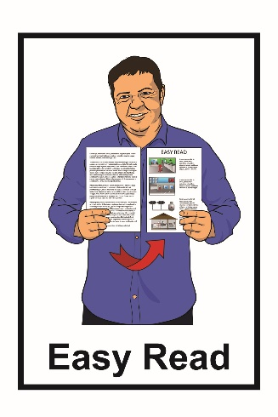

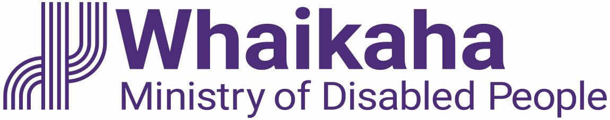

Message from Whaikaha – Ministry of Disabled People about the flooding
in Auckland

28 January 2023
This is a message from Whaikaha – Ministry of Disabled People.

The team at Whaikaha hope that everyone in Auckland is keeping safe from the flooding.

Whaikaha is working to make sure disabled people and whānau / family get the support during this time.

If you are in danger / unsafe please call 111.

If you are set up to do so you can text the 111 TXT line.

You can find more information about the 111 TEXT line on the New Zealand Police website:

https://tinyurl.com/bdekatxd
Where to get support if you are affected
by the flooding in Auckland

- Auckland Emergency Management

If you need help you should first contact Auckland Emergency Management:
Phone: 09 301 0101

Email:

aeminfo@aucklandcouncil.govt.nz
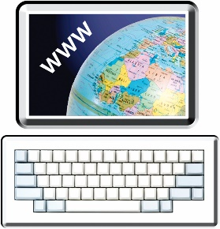

You can also find updates on their website:

www.aucklandemergencymanagement.org.nz/major-incident/flooding-2023
- Whakarongorau Aotearoa, New Zealand Telehealth Services

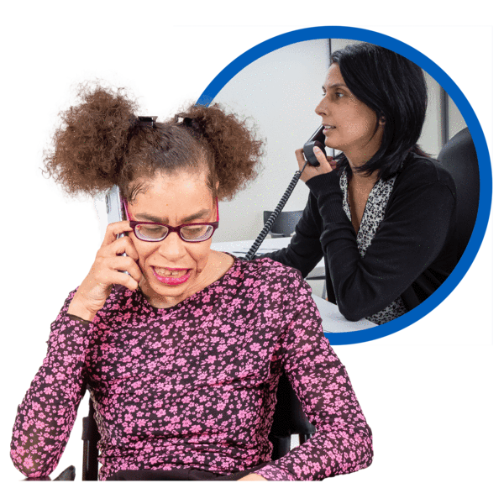
Deaf and disabled people and whānau / family can also talk to Whakarongorau Aotearoa, New Zealand Telehealth Services:
Phone: 0800 111 213

Text: 8988

It does not cost any money to call / text these numbers.
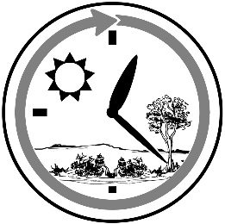
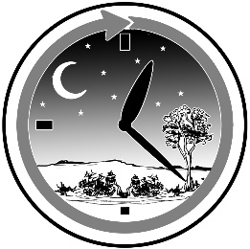
Whakarongorau is open all day / night.

- Your disability service provider
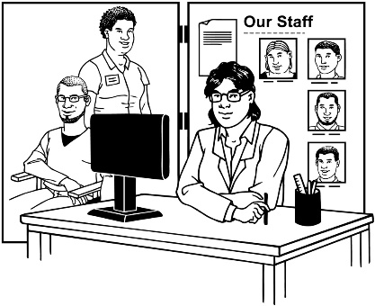

If you need extra support talk to your disability service provider.

You can also contact Whaikaha – Ministry of Disabled People:

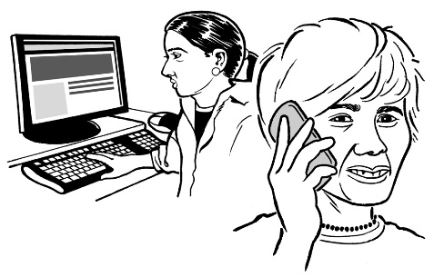
Phone: 0800 566 601

Email:

contact@whaikaha.govt.nz

- Work and Income

If you need help with money / costs because of the Auckland floods you can talk to Work and Income:

Phone: 0800 400 100

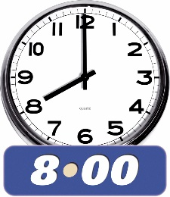
This phone line is open:

- 8 am in the morning to
5 pm in the evening on:
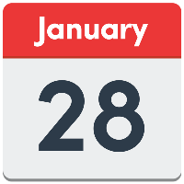
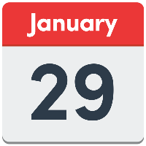
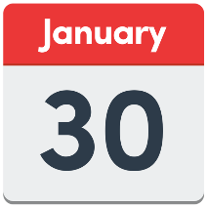
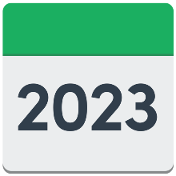
- Saturday 28 January 2023

- Sunday 29 January 2023

- Monday 30 January 2023.

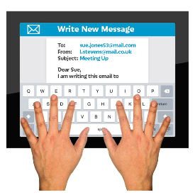
If you are Deaf / deaf you can email Work and Income on:

MSD_Deaf_Services@msd.govt.nz
Stay safe

If you live in Auckland please stay safe during this time.

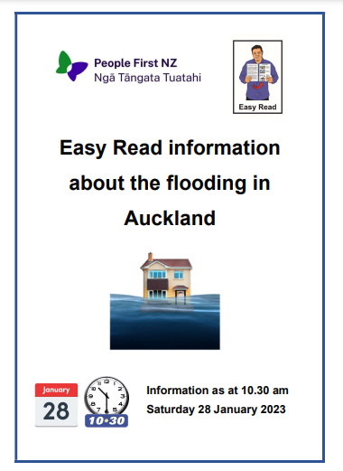
You can find more Easy Read information about staying safe in the Auckland floods on the People First New Zealand website:

www.peoplefirst.org.nz/auckland-floods-easy-read-information

Whaikaha will give updates so please check their website / Facebook page for more information:

Website: www.whaikaha.govt.nz

Facebook:

www.facebook.com/whaikaha.govt
This information has been written by Whaikaha – Ministry of Disabled People.

It has been translated into Easy Read by the Make it Easy Kia Māmā Mai service of People First New Zealand Ngā Tāngata Tuatahi.

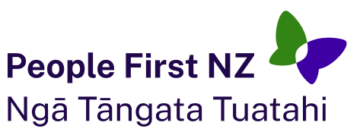
The ideas in this document are not the ideas of People First New Zealand Ngā Tāngata Tuatahi.
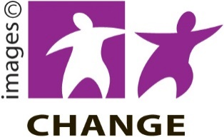
Make it Easy uses images from:

- Changepeople.org

- Photosymbols.com

- SGC Image Works.

All images used in this Easy Read document are subject to copyright rules and cannot be used without permission.

