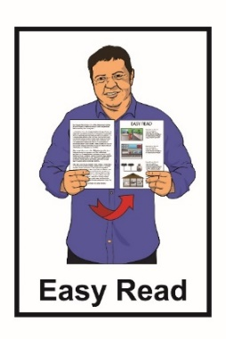
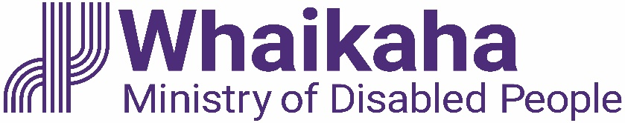

Flexible Disability Support study:

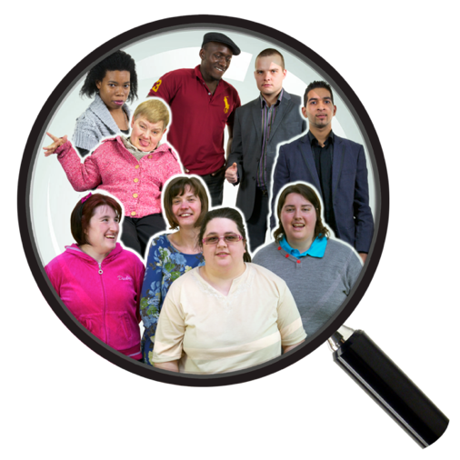
What we learned

Easy Read published: March 2023

What you will find in here

Page number:
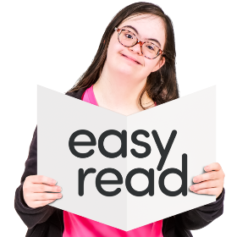

What this document is about? 3

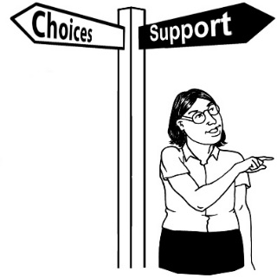
What is Flexible Disability
Support? 4

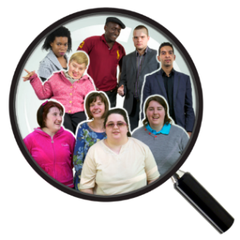
Who can get Flexible Disabilty Support? 6

Who took part in the study? 7

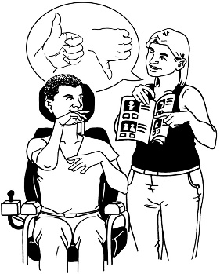
What things are going well? 10

What things could be better? 13
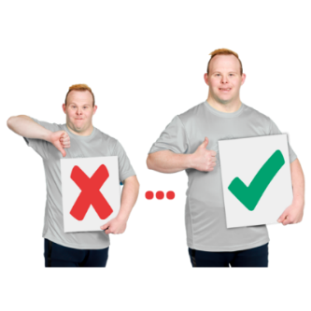
Page number:

What the study recommends? 14

Where to find more information 19

What this document is about

This Easy Read document is about a study that the Standards and Monitoring Service did in 2021.

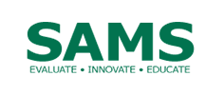
The Standards and Monitoring Service / SAMS is an organisation that:
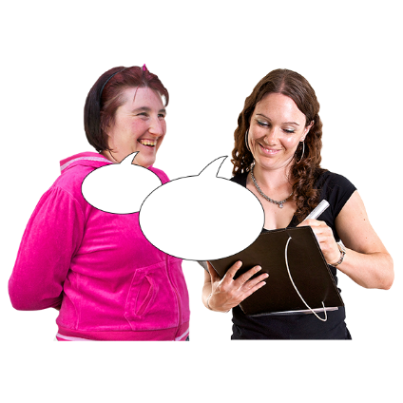
- does education about disability

- does research about disability

- is run by disabled people.

Research is:

- looking at what things have happened

- trying to find out how to do things better.

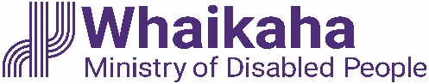
Whaikaha – Ministry of Disabled People will use the study to look at ways of making Flexible Disability Support better.

What is Flexible Disability Support?

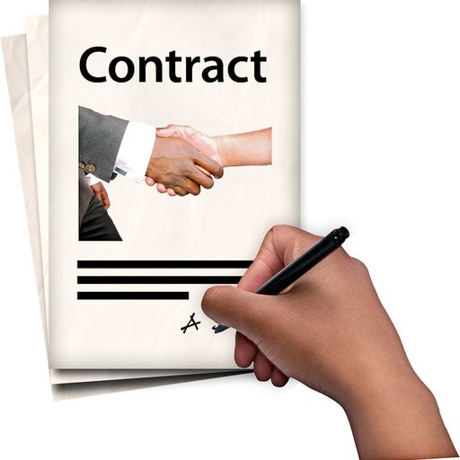
Flexible Disability Support is a contract between a disabled person and a service provider.

Flexible Disability Support is also sometimes called FDS.

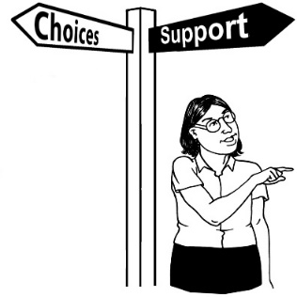
FDS lets disabled people spend their Enabling Good Lives budget with providers / support services they choose.

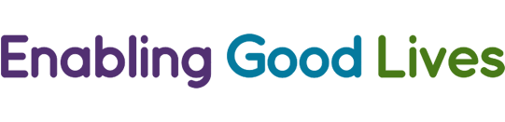
Enabling Good Lives is a different way of thinking about disability support.
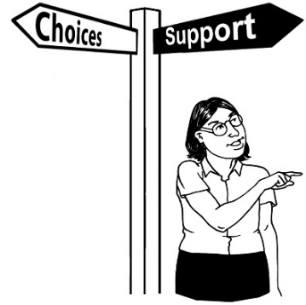

Enabling Good Lives is about having:
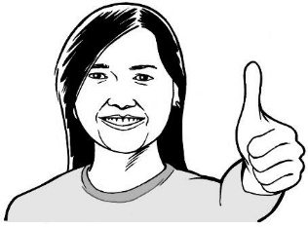
- choice and control in your life
- the support you need and want
- a good life.

Enabling Good Lives is called EGL for short.

Who can get Flexible Disability Support?

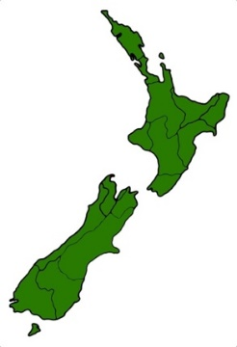
Some people who use EGL can get FDS if they live in:

- the Mid Central region

- Christchurch.

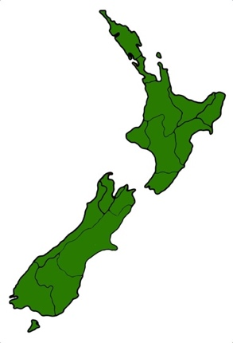
The Mid Central region includes:
- Palmerston North

- Horowhenua

- Manawatu

- Ōtaki

- Tararua.

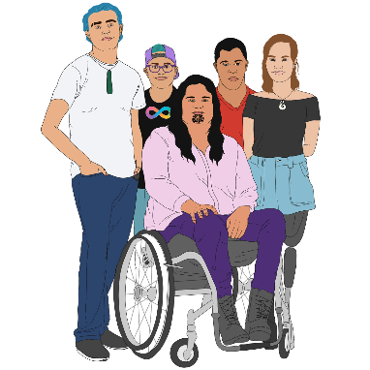
The people who use FDS may be:

- disabled

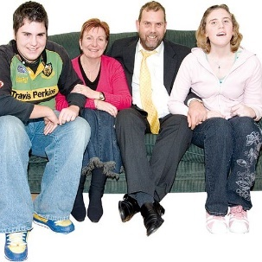
- tāngata whaikaha Māori / disabled Māori

- whānau / family of disabled people.

Who took part in the study?

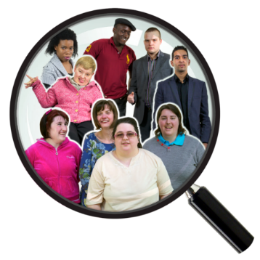
The people who took part in the study were:

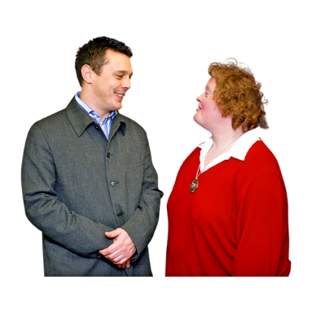
- 12 disabled people who use FDS

- whānau / family who use FDS.

The people who took part in the study all live in:

            - the Mid Central region

            - Christchurch.

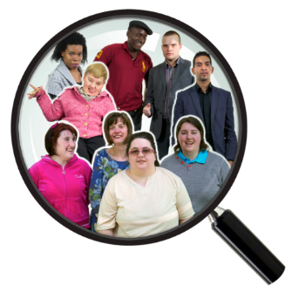
Other people who took part in the study were:
- Kaitūhono / Connectors from EGL
- a financial advisor
- an independent Kaitūhono/Connector.

Kaitūhono / Connectors work alongside disabled people to:

- build a plan of support

- connect with their community

- make plans for the years ahead.

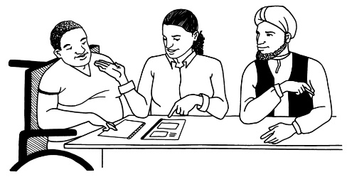
A financial advisor is someone who works alongside the disabled person to a budget / plan of how the EGL funding will be used.
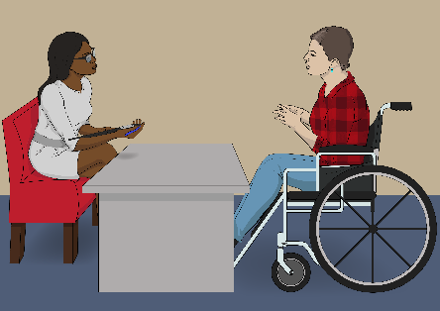
Independent means someone who works as a Kaitūhono / Connector but is not part of an EGL service.

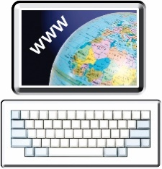
You can find more information about Kaitūhono / Connectors on the Enabling Good Lives website:

www.enablinggoodlives.co.nz/negl/national-leadership-group-position-statements/the-kaituhonoconnector-role/

What things are going well

The study showed that disabled people using FDS got lots of good outcomes.

The good outcomes fit with the Enabling Good Lives / EGL principles.
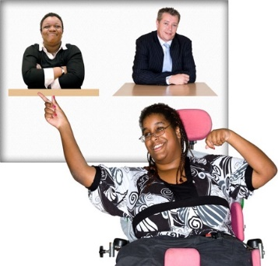

Most of the people in the study liked the way the FDS gave them:

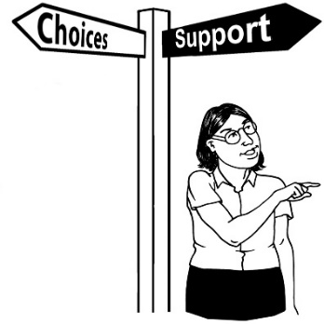
- the chance to say what they wanted

- more control over what they wanted to do.

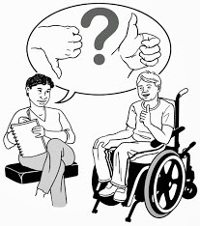
The disabled people who took part in the study said they:
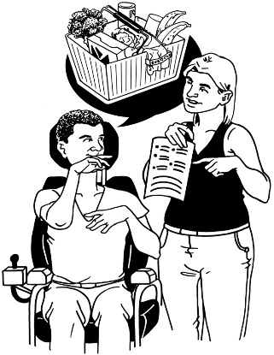
- had more chances to choose for themselves
- felt more in control of what was happening
- felt happier
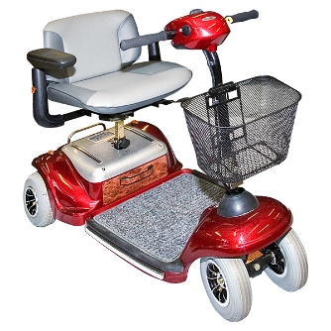
- liked being able to pick / buy things for themselves.

Some of the things they decided to buy were:
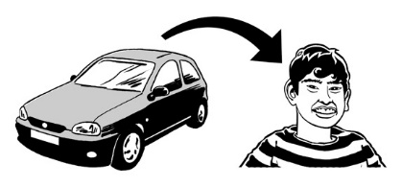
- a mobility scooter
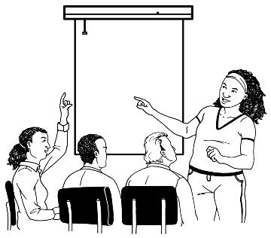
- driving lessons
- education / learning courses.

People also liked the way FDS supported them live more like people who do not have disabilites.

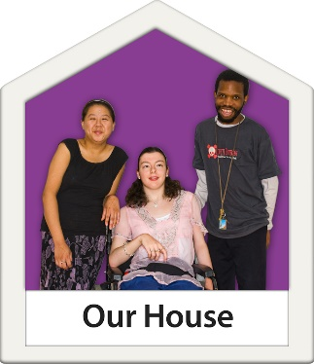
For example they liked being able to:
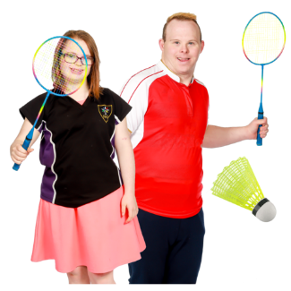
- decide for themselves about they how they live
- join exercise classes
- take part in education.

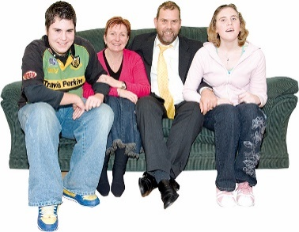
Another good thing was the way support from FDS made the lives of whānau / family better too.

What things could be better

The study showed that some people did not know:

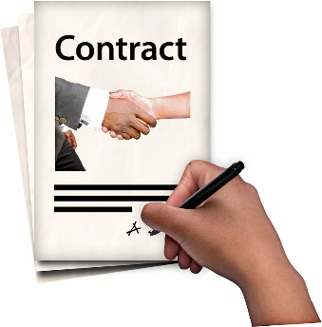
- about the different ways to use FDS
- what to do when they have an FDS contract
- who does what.

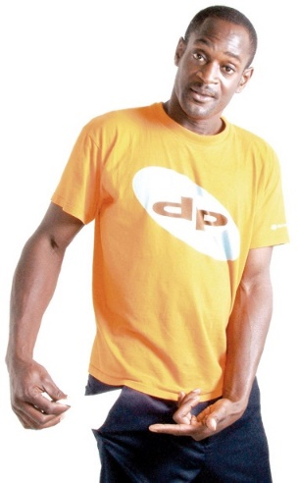
The study also showed that some people:
- did not know how to check how their EGL budget was going
- need help to understand how their EGL budget works.

What the study recommends

Recommends are the things that need to happen to make FDS work better for everyone.

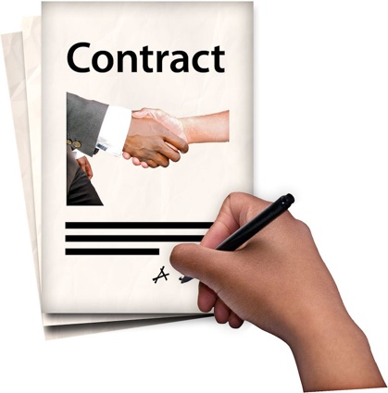
- Everything that is written about FDS must be easy for everyone to understand.

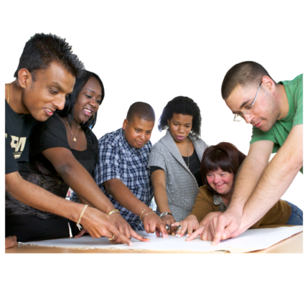
This means having clear information about:
- how an FDS contract works
- how to get started with FDS
- what everyone who is a part of the FDS contract must do.
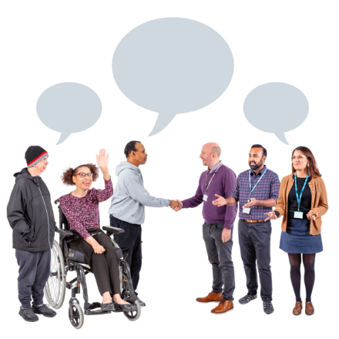
Alongside the disabled person the other partners in the FDS contract are:

- their whānau / family
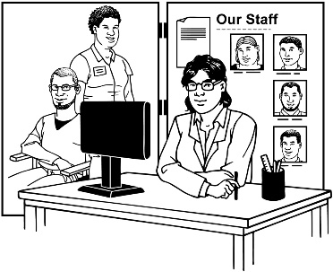
- the providers they choose
- Kaitūhono / Connectors.

The other things that must also be easy for everyone to understand are:
- what EGL looks like in real life
- the new disability support system.

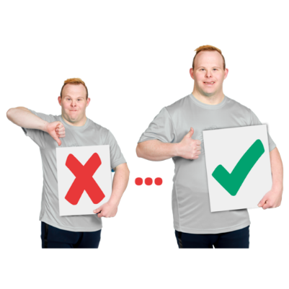
- Make it easier to look after your EGL budget

This means:

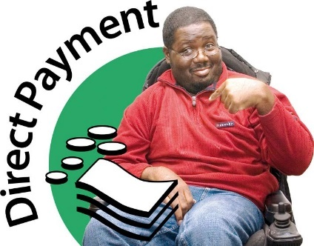
- making clear what you can buy with your EGL budget
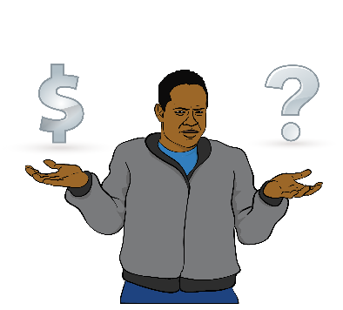
- making sure disabled people know how to check their EGL budget
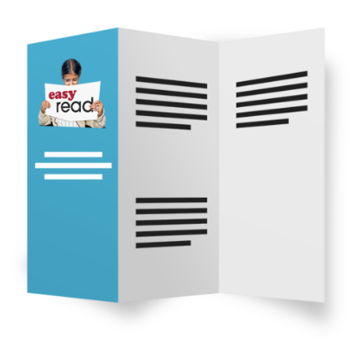
- supporting people understand how their EGL budget works
- making EGL budget information easier for everyone to understand.

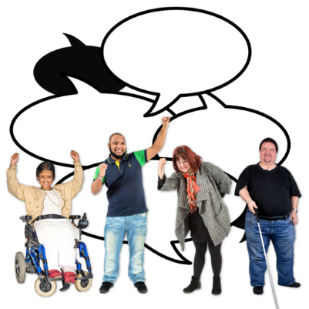
- Do more things to make FDS work better

This means:

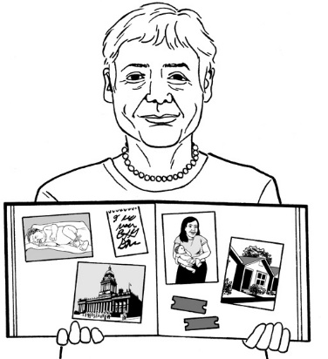
- doing more to make sure people know they can choose an FDS contract
For example people who are using an FDS contract could share their stories

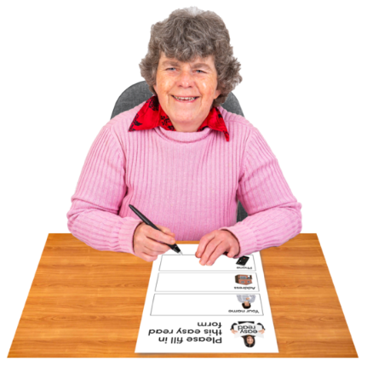
- making it easy for people who get FDS supports to give feedback about how things are working

- making sure the ways to give feedback is accessible for everyone.

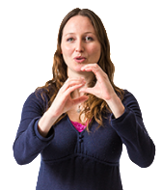
Accessible ways to give feedback are things like:

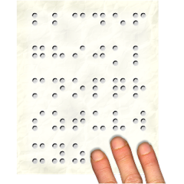
- New Zealand Sign Language

- Braille
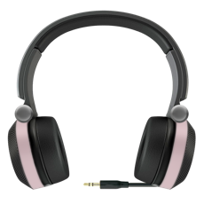
- audio.

Where to find more information

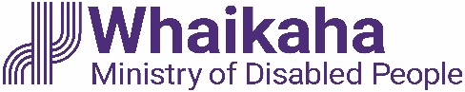
You can find more information about disability support services on the Whaikaha – Ministry of Disabled people website:

www.whaikaha.govt.nz

You can find more information about EGL on this website:

www.enablinggoodlives.co.nz

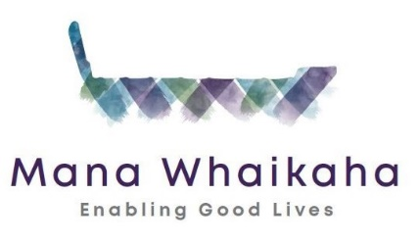
The Mana Whaikaha website also has Easy Read information about EGL principles:
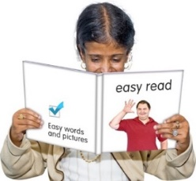
www.manawhaikaha.co.nz/assets/easy-read/EGL-vision-and-principles-Easy-Read.pdf
This information has been written by SAMS and Whaikaha – Ministry for Disabled People.

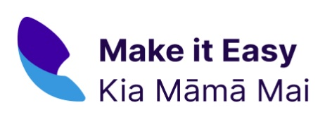
It has been translated into Easy Read by the Make it Easy Kia Māmā Mai service of People First New Zealand Ngā Tāngata Tuatahi.

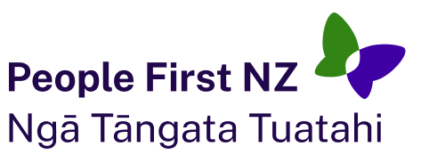
The ideas in this document are not the ideas of People First New Zealand Ngā Tāngata Tuatahi.
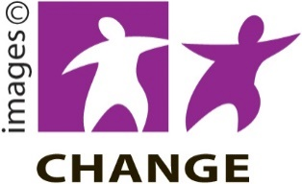
Make it Easy uses images from:

- Changepeople.org

- Photosymbols.com

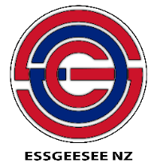
- SGC Image Works

- Huriana Kopeke-Te Aho.

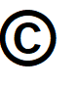
All images used in this Easy Read document are subject to copyright rules and cannot be used without permission.

