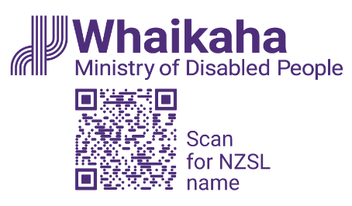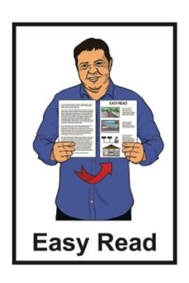

Cabinet paper – New Zealand Disability Strategy Refresh

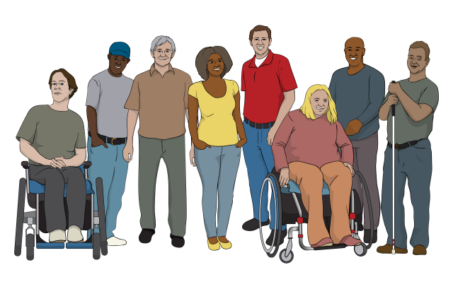

Published: June 2025

# What you will find in here

**Page number:**

About this Easy Read 2

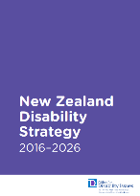

[About the New Zealand   
Disability Strategy](#_About_the_New) 7



[Writing the new   
Disability Strategy](#_Writing_the_new) 16

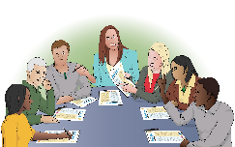

[Ministerial Disability   
Leadership Group](#_Ministerial_Disability_Leadership) 21

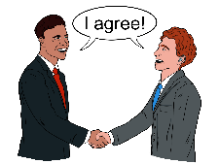

Decisions made by Cabinet 25

# About this Easy Read

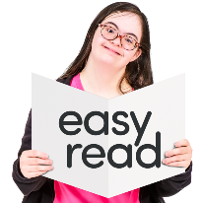

This Easy Read is a **summary** of a **Cabinet paper**.

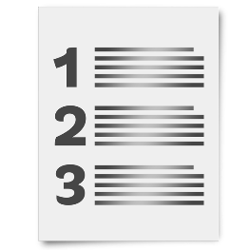

Here a **summary**:

is shorter than the Cabinet paper

tells you the main ideas.

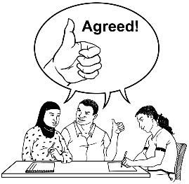A **Cabinet paper** is a document:

from a **Minister**

asking **Cabinet** to agree to something.

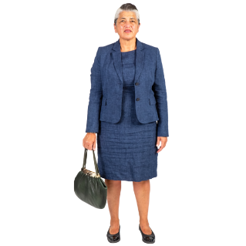A **Minister** is an important person who works in the Government.

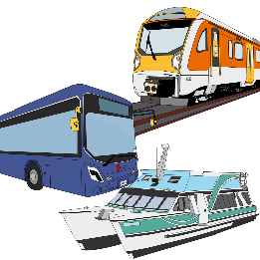They are in charge of what the Government does about things like:

education

transport.

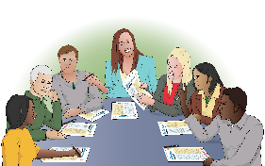

**Cabinet** is a group of the most important Ministers.

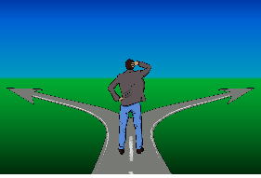

They make important decisions together.

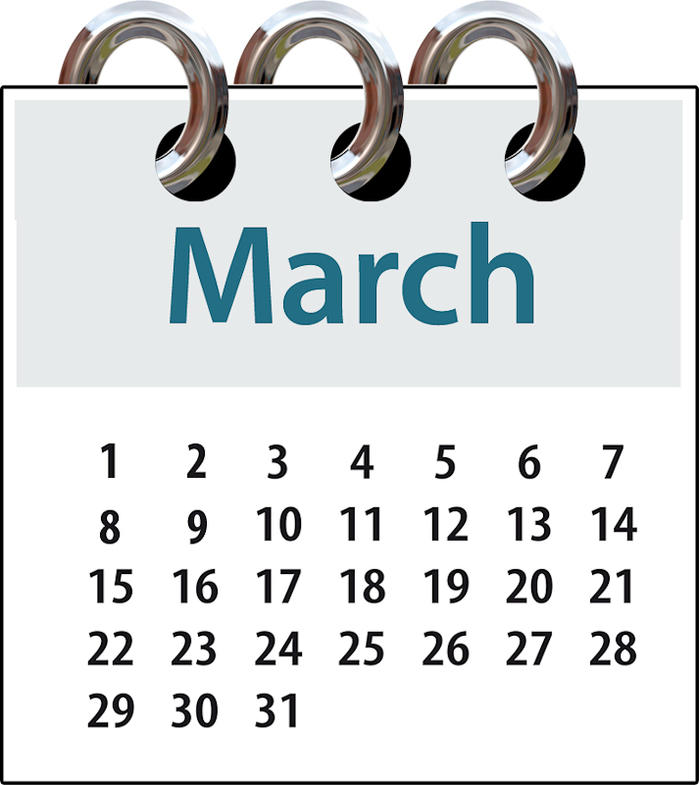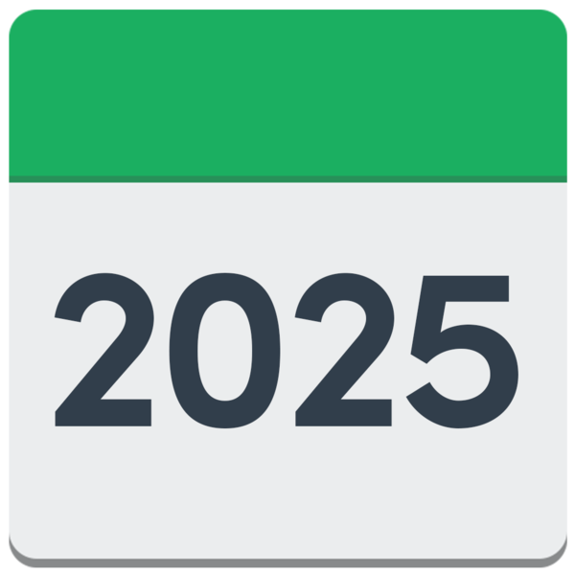

This summary is about decisions Cabinet made in March 2025.

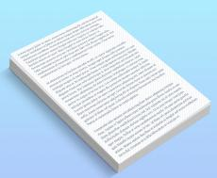These decisions were about how to:

**refresh** the **New Zealand Disability Strategy**

talk to disabled people about refreshing the New Zealand Disability Strategy.



**Refresh** means changing an old document so that it works better.

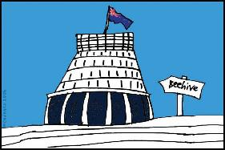The **New Zealand Disability Strategy** tells the Government how to make things better for disabled people in Aotearoa New Zealand.

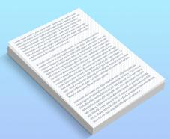

When you see the words **Disability Strategy** in this Easy Read they mean the New Zealand Disability Strategy.

**The **Ministry of Disabled   
People – Whaikaha** wrote this summary.

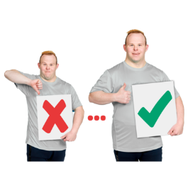

The **Ministry of Disabled People – Whaikaha** works to make change for disabled people so their lives are better.

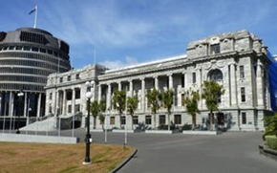The Ministry of Disabled People – Whaikaha makes things better for disabled people by working with:

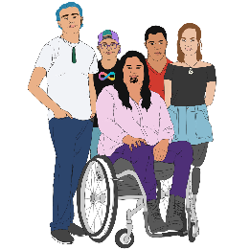the Government

the community which includes:

* disabled people
* tāngata whaikaha Māori / Māori disabled people

businesses.



In this Easy Read we call the Ministry of Disabled People – Whaikaha **Whaikaha** for short.

You can find the full Cabinet paper on this **website**:

[**https://tinyurl.com/3n8z5dc8**](https://tinyurl.com/3n8z5dc8)

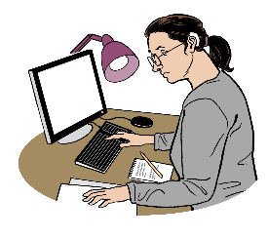

The full Cabinet paper is under the heading **New Zealand Disability Strategy refresh – approval for approach and consultation.**

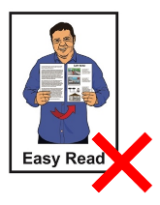

The full Cabinet paper is **not** in Easy Read.

# About the New Zealand Disability Strategy

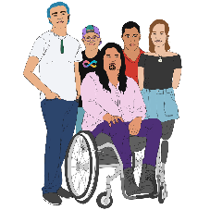

About 1 out of every 6 people in Aotearoa New Zealand is disabled.

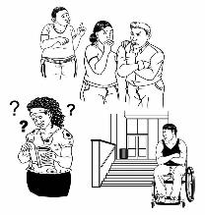

Life is often harder for disabled people than it is for non-disabled people.



The Disability Strategy we have now started in 2016.

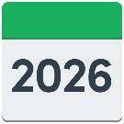

This Disability Strategy ends in 2026.

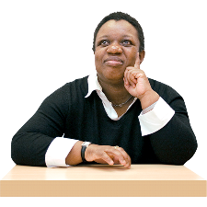

The **Minister for Disability Issues** is in charge of the Disability Strategy.

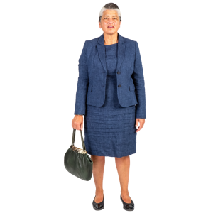The **Minister for Disability Issues**   
is the person in the Government in charge of making things better for disabled people.

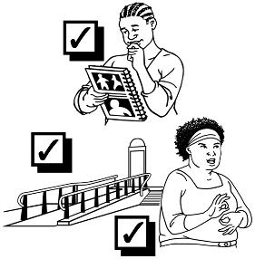The Minister for Disability Issues is Louise Upston.

She makes sure Aotearoa   
New Zealand is doing the things the Disability Strategy says we need to do.

She wants to write a new Disability Strategy.

She wants the new Disability Strategy to last 5 years.

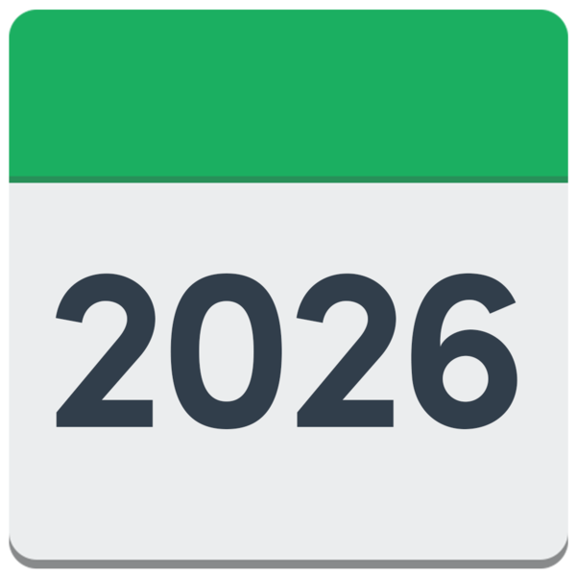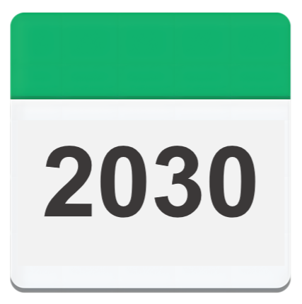

This means the new Disability Strategy will last from 2026 to 2030.

The new Disability Strategy will have:

a **vision**

**principles**

5 main **outcome areas**.

Here **vision** means ideas about   
what things should be like.

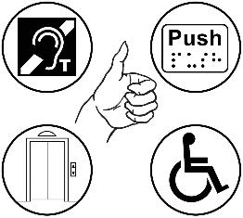

The vision in the Disability Strategy says what Aotearoa New Zealand will be like when it is a better place for disabled people.

****Here **principles** are ideas that guide the Government to reach its goals.

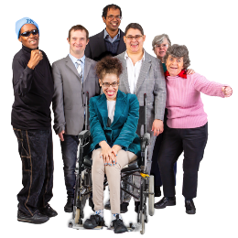

The principles in the Disability Strategy are the main ideas that will support the Government to make Aotearoa New Zealand a better place for disabled people.

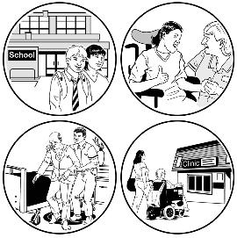**Outcomes** are how things end up   
for people.

**Outcome areas** are the different parts of life which the outcomes fit into.

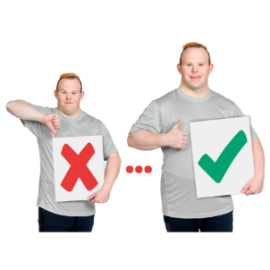

The Disability Strategy will say what needs to be done in each of the outcome areas to make things better for disabled people.

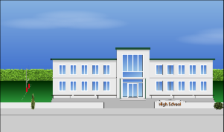The 5 outcome areas in the Disability Strategy are:

1. 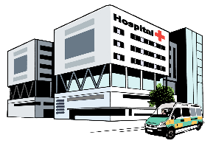Education
2. Employment
3. Health
4. 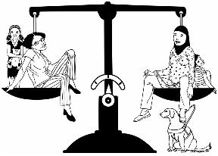Housing
5. Justice.

## Education

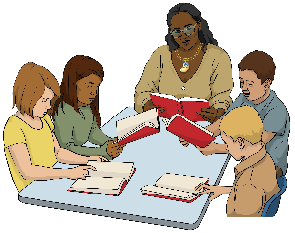The education outcome area is about:

learning

places that support people to learn like schools.

## Employment

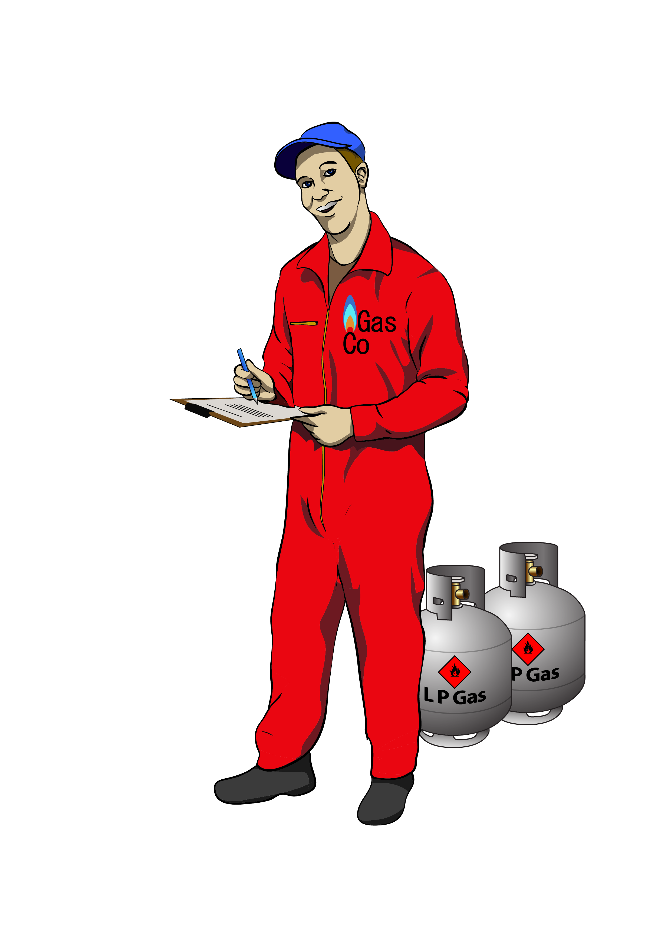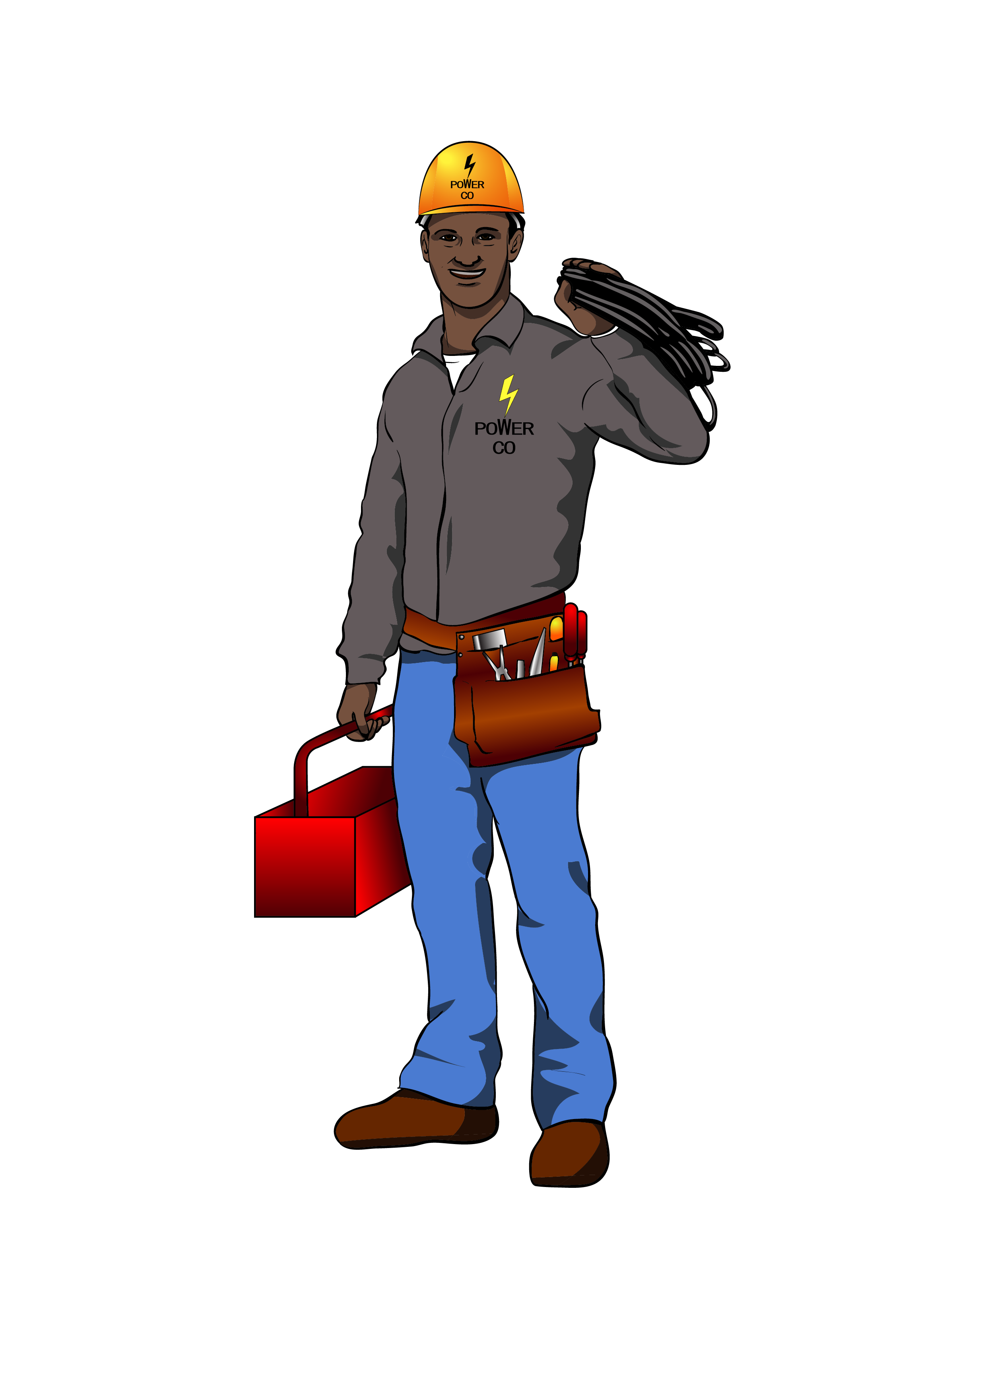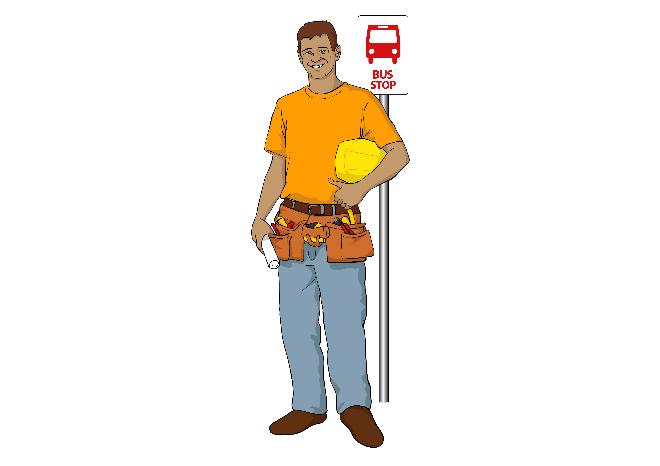

The employment outcome area is about jobs.

## Health

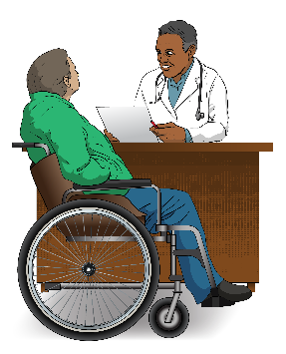The health outcome area is about things like:

doctors

hospitals

medicines.

## Housing

The housing outcome area is about where people live.

## Justice

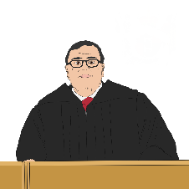The justiceoutcome area is about things like:

the Police

courts.

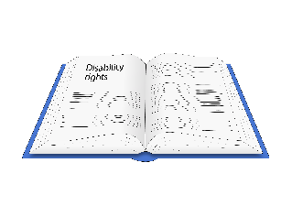

It is also about making sure laws protect the **rights** of disabled people.

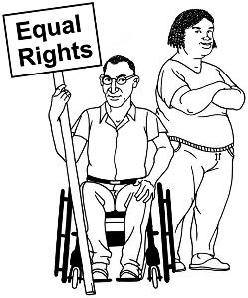**Rights** are important things that everyone should:

have

be able to do.

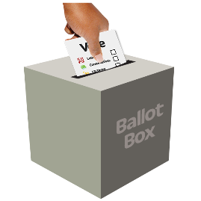Some examples of rights are the   
right to:

vote

go to school.

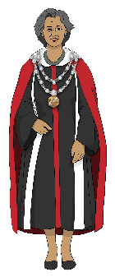

The Disability Strategy will also support **local government** to make things better for disabled people.

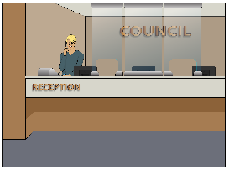**Local government** means the councils that run things in each part of Aotearoa New Zealand.

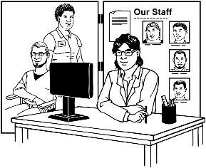

The Disability Strategy will also support **community organisations** to make things better for disabled people.

**Community organisations**:

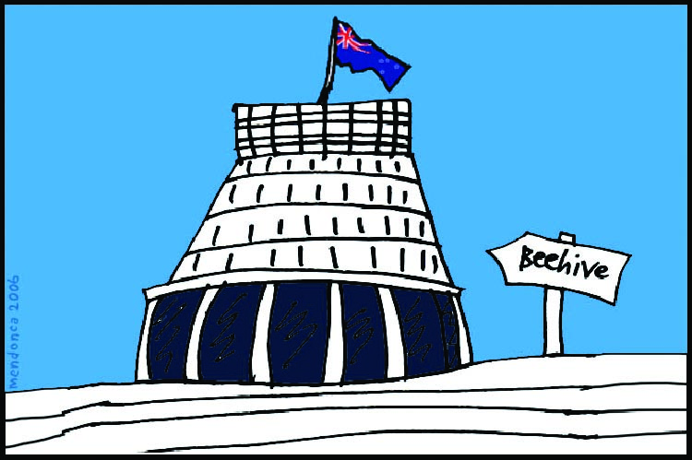

are not part of the Government

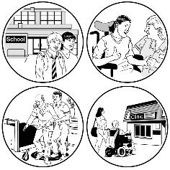work to make life better for people who need support.

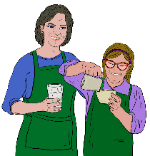Many community organisations support disabled people by doing things like:

supporting people to find jobs

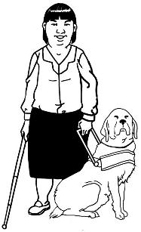training dogs to support disabled people

running homes for disabled people.

# Writing the new Disability Strategy

**Whaikaha will be in charge of writing the new Disability Strategy.

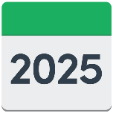

They will write the new Disability Strategy in 2025.

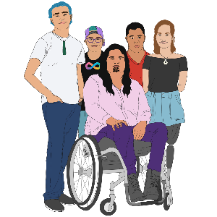

To write the new Disability Strategy Whaikaha will work with groups that **represent**:

disabled people

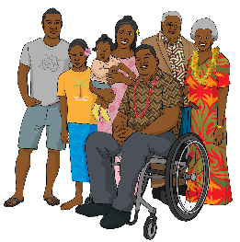tāngata whaikaha Māori / Māori disabled people

the whānau / families of disabled people.

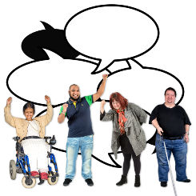To **represent** a group of people means to speak up for those people.

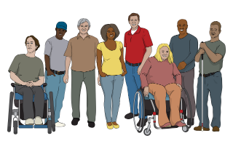

Whaikaha will also work with **Disabled People’s Organisations** to write the new Disability Strategy.

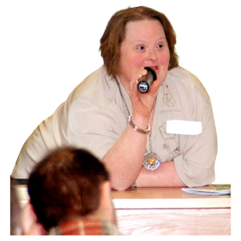**Disabled People’s Organisations** are groups that:

represent disabled people

are led by disabled people.

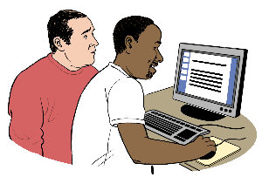Whaikaha will work with these groups to write the:

vision

principles.

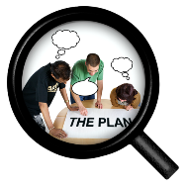Each outcome area will have **actions**.

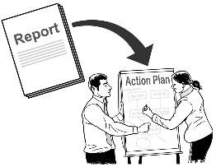

**Actions** are ideas the Government can do to make things better for disabled people.

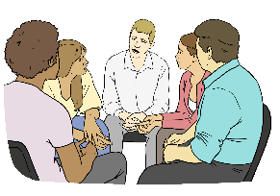

Whaikaha will set up **working groups** to write the actions for each outcome area.

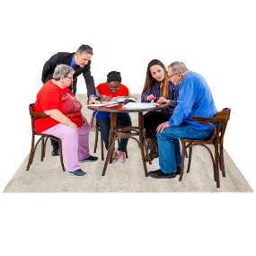

A **working group** is a group of people who work together to do a job.

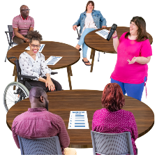

There will be a different working group for each outcome area.

Each working group will have:

disabled people

people who work for the government

people who have jobs to do with the outcome area.

From August 2025 everyone in Aotearoa New Zealand will be able to read a **draft** of the new Disability Strategy.

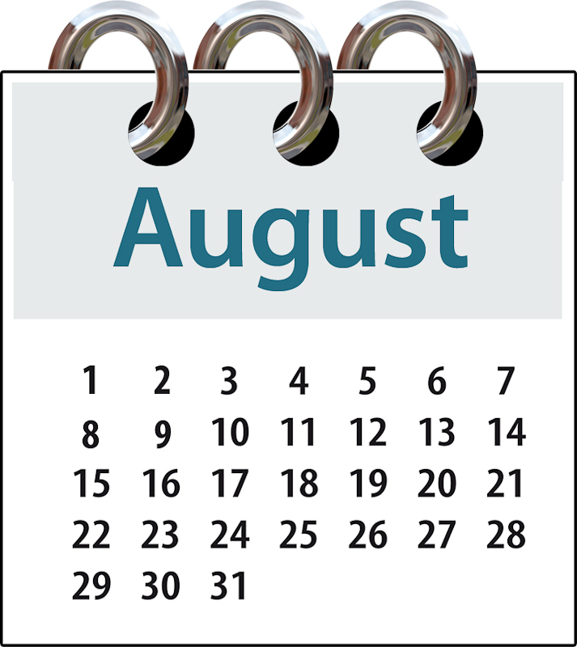

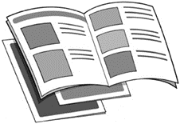

A **draft** is the first version of something like a document.

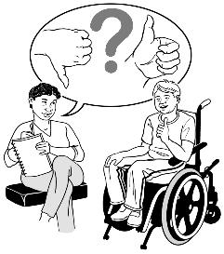

New Zealanders will be able to tell Whaikaha what they think about the draft.

Whaikaha will use the things people say about the draft to write the final version of the new Disability Strategy.

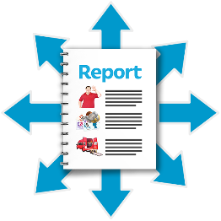

The Minister for Disability Issues wants to **release** the final version of the new Disability Strategy on   
3 December 2025.

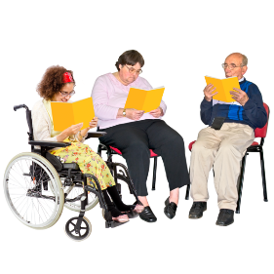

Here **release** means making the   
new Disability Strategy public so everyone can read it.



3 December is the International Day of Persons with Disabilities.

# Ministerial Disability Leadership Group



The Minister for Disability Issues has set up a **Ministerial Disability Leadership Group**.



The **Ministerial Disability Leadership Group**:

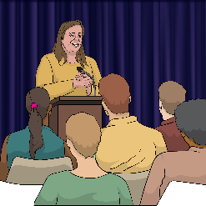is a group of Government Ministers

will lead the work the Government does for disabled people

will make decisions about the Disability Strategy.

The main Ministers in the Ministerial Disability Leadership Group will be the Ministers for:

disability issues

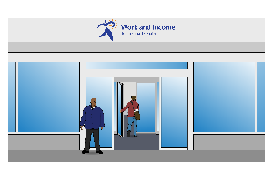**social development**

employment

housing

health

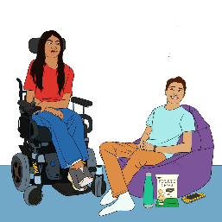education

local government

children.

**Social development** includes things like:

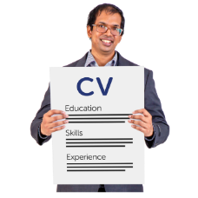benefits which are money you might get if you cannot work

supporting people to find work

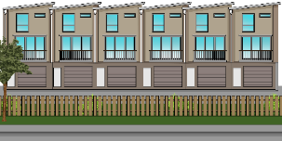working out who gets state housing.

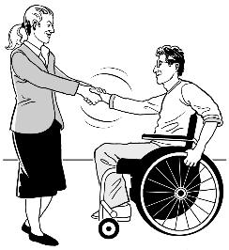Sometimes other Ministers will be asked to go to Ministerial Disability Leadership Group meetings.

# Decisions made by Cabinet



Cabinet had a meeting on 11 March 2025.

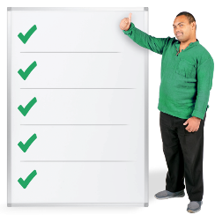

At this meeting the Minister for Disability Issues asked Cabinet to say yes to the plan for writing the new Disability Strategy.

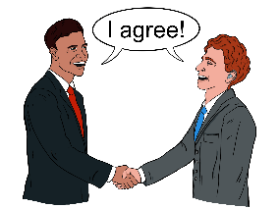

Cabinet said the Minister for Disability Issues could write a new Disability Strategy.

Cabinet said the new Disability Strategy could have:

a vision

principles.

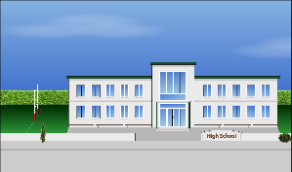Cabinet agreed that the 5 outcome areas in the new Disability Strategy would be:

****education

employment

health

****housing

justice.

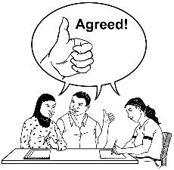

Cabinet said yes to how Whaikaha will write the new Disability Strategy.

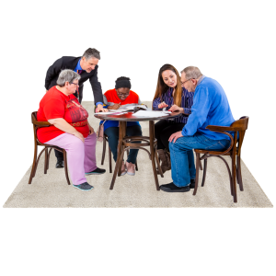

Cabinet said the working groups could write the actions for each outcome area.

Ministers will decide which actions will be in the final version of the new Disability Strategy.



Before New Zealanders can read the draft Disability Strategy it will be checked by:

the Ministerial Disability Leadership Group 

the Minister of Justice.

The Ministers will also check with the rest of Cabinet if they think they need to.

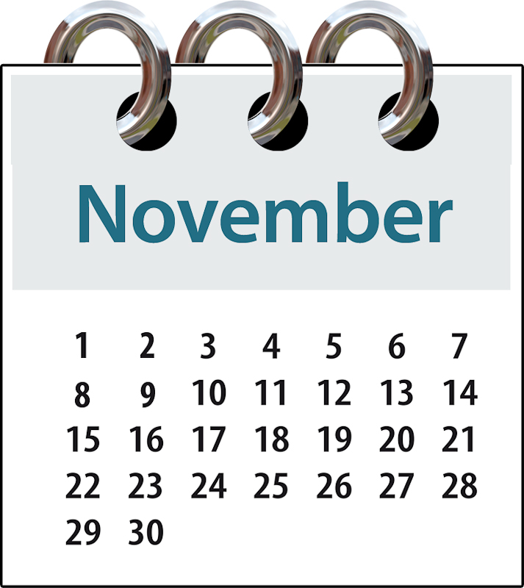

The Minister for Disability Issues will tell Cabinet about the final Disability Strategy in November 2025.

Hopefully Cabinet will say they agree to the new Disability Strategy.

*Whaikaha – Ministry of Disabled People logo with vines overlapping; Like the rātā vines growing together and flourishing to stand strong in the warmth of the sun. *This information has been written by the Ministry of Disabled People – Whaikaha.

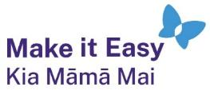It has been translated into Easy Read by the Make it Easy Kia Māmā Mai service of People First New Zealand Ngā Tāngata Tuatahi.



The ideas in this document are not the ideas of People First New Zealand Ngā Tāngata Tuatahi.

Copyright logo.

All images used in this Easy Read document are subject to copyright rules and cannot be used without permission.

Photo Symbols logo.Make it Easy uses images from:

* Photosymbols
* Change Images
* Huriana Kopeke-Te Aho

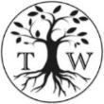

* SGC Image Works
* T Wood
* Studio Rebeko
* Inga Kramer.