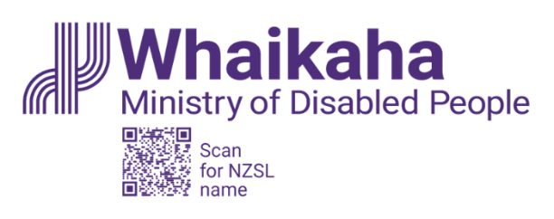
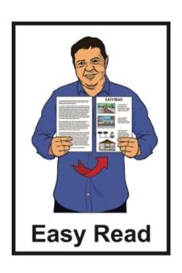

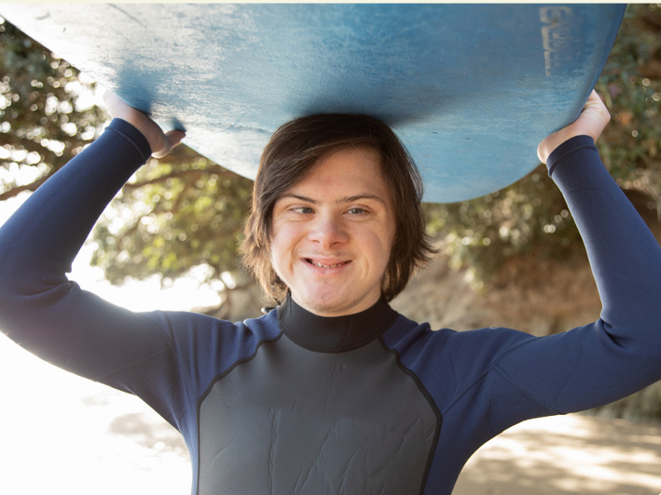
Ministry of Disabled People – Whaikaha:
Strategic Intentions
2025 – 2028 summary

Published: June 2025

Before you start

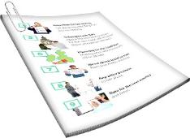
This is a long document.

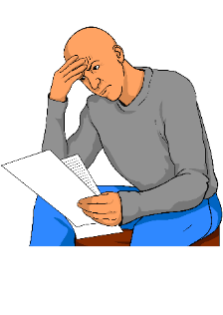
It can be hard for some people to read a document this long.

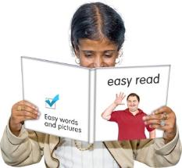
Some things you can do to make it easier are:
read it a few pages at a time
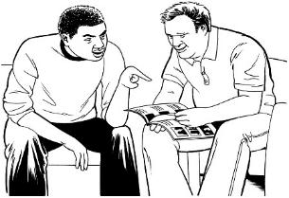
set aside some quiet time to look at it
have someone read it with you to support you to understand it.

What you will find in here

Page number:


About this Easy Read 4


About Whaikaha 7
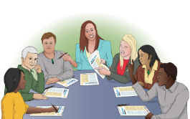

Our team 18

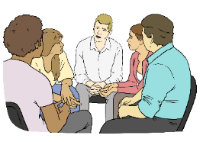
Why we need a Ministry of
Disabled People 21

Our 5 main functions 25
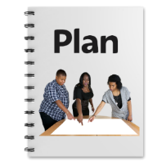

Our 6 strategic outcomes 32

Page number:
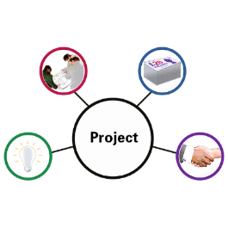

Our 7 main projects 46

How we will work with others 50


Contact us 52

About this Easy Read


This Easy Read is a summary of the document called Strategic Intentions Tauākī Whakamaunga Atu 1 July 2025 to 30 June 2028.

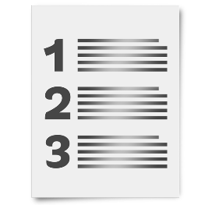
Here a summary:
is shorter than the Strategic Intentions document
tells you the main ideas.


The Ministry of Disabled
People – Whaikaha wrote the summary.

The Ministry of Disabled People – Whaikaha works to make change for disabled people so their lives are better.

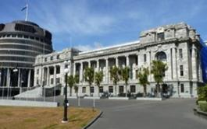
The Ministry of Disabled People – Whaikaha makes things better for disabled people by working with:

the Government
the community
businesses.


In this Easy Read we call the Ministry of Disabled People – Whaikaha Whaikaha for short.

Where it says our / we / us this means Whaikaha.

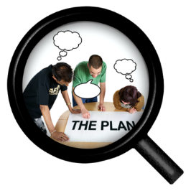
Here strategic intentions are the main things we plan to do like:
what work we need to do
how we want to do our work
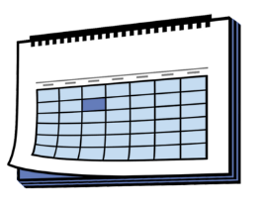
who should support us with our work
when we should do the work by.

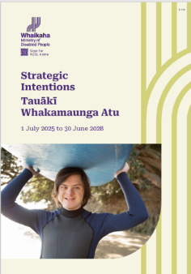
You can read the full Strategic Intentions document at this website:

https://tinyurl.com/SOI-2025to2028

This document is not in alternate formats like:
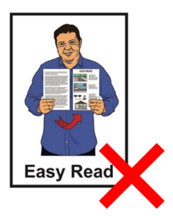
Easy Read
Braille
New Zealand Sign Language.

About Whaikaha

Our history
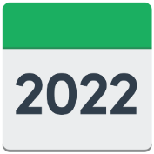
Whaikaha:
started on 1 July 2022
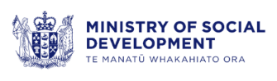
was part of the Ministry of Social Development.

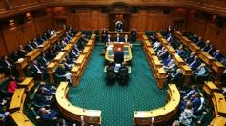
Cabinet decided near the end of 2024 that Whaikaha would become a standalone Ministry.


Cabinet is a group of ministers that meet to make decisions.

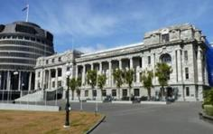
A minister is an important person who is part of the Government.
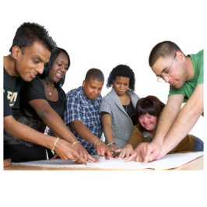
A standalone Ministry is a government agency that works mostly on 1 main thing.

The 1 main thing that Whaikaha works on is disability.

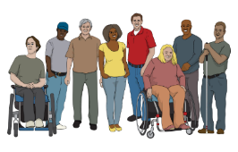
Whaikaha works with:
the disability community
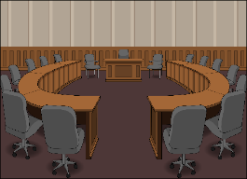
government agencies
local government like your city council

businesses
all communities.

Whaikaha is not part of another Ministry.

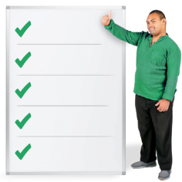
Our strategic framework

Our strategic framework says:
what work we will do to make lives better for disabled people in New Zealand
what things we will need to do our work
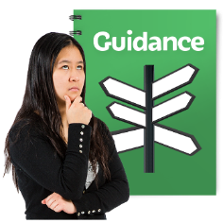
what things will guide us to do our work like our:
- vision
- purpose.


Here vision is what we hope something will look like in the
future / years ahead.

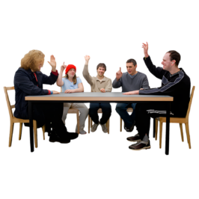
Here purpose is the reason why it is important to have a Ministry of Disabled People.


Our vision is:
Disabled people thriving in
New Zealand.


Here thriving means disabled people can:
- live a very good life
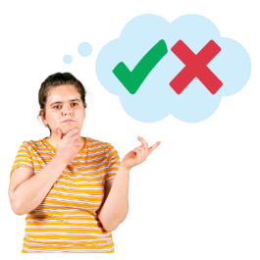
- do all the things they:
- need to do
- want to do.

Our purpose is:
To drive real and meaningful change with:
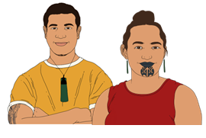
disabled people
tāngata whaikaha Māori / disabled Māori
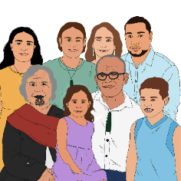
whānau / family of:
- disabled people
- tāngata whaikaha Māori / disabled Māori.

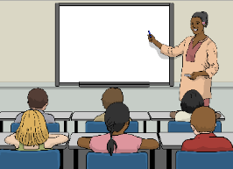
We work to make the lives of disabled people better in important areas like:
accessibility

education
employment / jobs
health
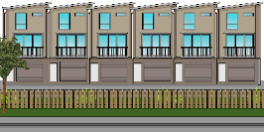
housing
the justice system.

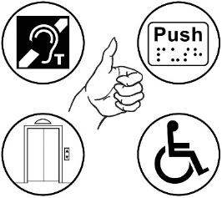
Accessibility is when things can be used by everyone like:
- disabled people
- non-disabled people.
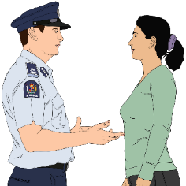
The justice system is about things like the:
law
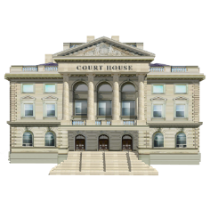
police
courts.

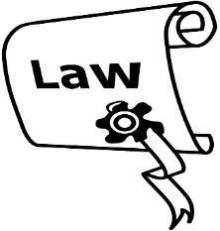
A law is a rule made by the Government that everybody must follow.

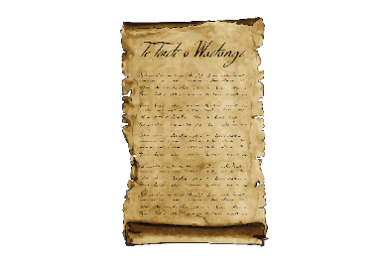
Our work is guided by:
te Tiriti o Waitangi / the Treaty of Waitangi
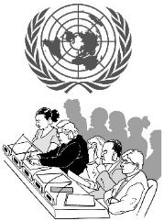
the United Nations Convention on the Rights of Persons with Disabilities.

Te Tiriti o Waitangi / the Treaty of Waitangi is an important agreement between:
Māori
and
the Crown.

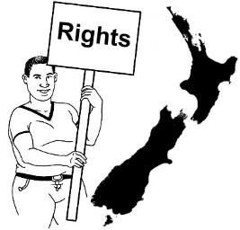
The purpose of Te Tiriti is to protect Māori:
rights
taonga.

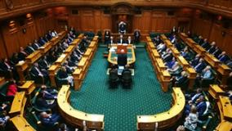
The purpose of Te Tiriti is also to:
keep peace and order
set up government.

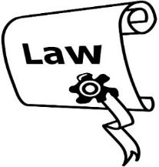
Peace and order means to follow laws / rules.

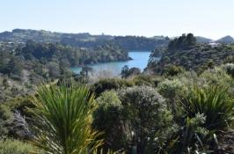
Taonga means treasures such as:
- land / rivers
te reo Māori / the Māori language
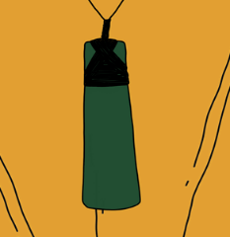
objects like
pounamu / greenstone
traditional food growing places
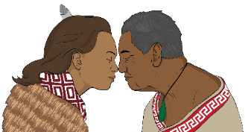
spiritual ideas
ways of life.

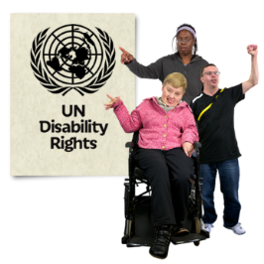
The United Nations Convention on the Rights of Persons with Disabilities is an agreement lots of countries have said yes to.

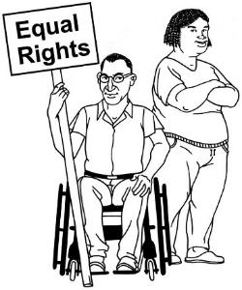
It is called the UNCRPD for short.

It says what governments must do to make sure disabled people get the same rights as everybody else.

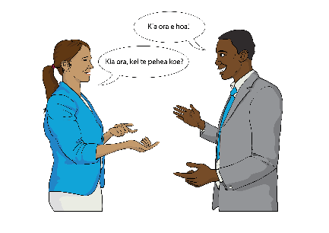
Important Māori values are part of our daily life at Whaikaha like:
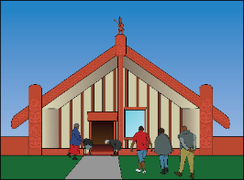
te reo Māori
tikanga / ways of doing things
whakataukī / sayings
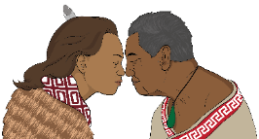
karakia / prayers.

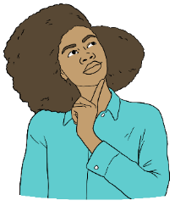
Here values are beliefs that guide our work.


We understand the importance of supporting Enabling Good Lives.

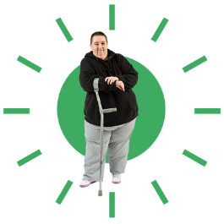
Enabling Good Lives is a way to support disabled people to have more control over their own lives.

We work with people who have lived experience of disability like:
disabled people
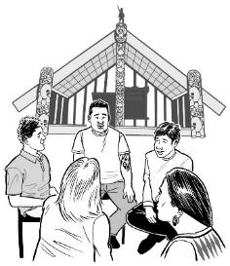
tāngata whaikaha Māori / disabled Māori
whānau / families of disabled people.

Our team

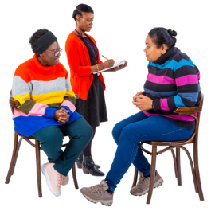
We have about 80 staff members.

About 6 out of every 10 of our staff are disabled.

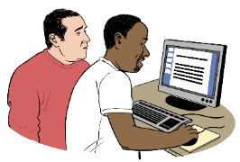
We provide reasonable accommodations for our staff.

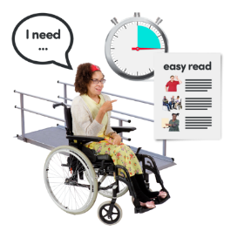
Here reasonable accommodations are where changes are made to something like a service so disabled people can use it.

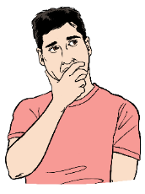
The work of our team is guided by our values.

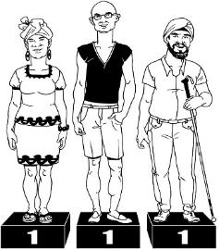
Our 3 main values are:
Mana taurite / Equity drives us
Mana kaha / We strengthen and support
Mana tīhura / We explore and learn.

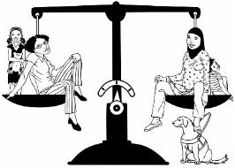
Here equity is where everyone is equal / treated the same way.

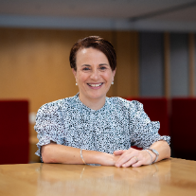
Our leaders are:
Paula Tesoriero who is
Chief Executive
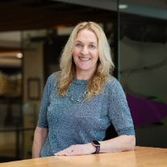
Ginny Baddeley who is
Deputy Chief Executive
Strategy and Enablement
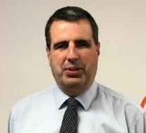
Ben O’Meara who is
Deputy Chief Executive
Policy and Insights
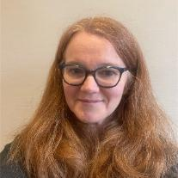
Rebecca Elvy who is
Deputy Chief Executive Outreach and Innovation
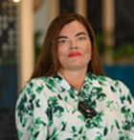
Ronelle Baker who is
Kauhautū – Chief Advisor Māori.

Why we need a
Ministry of Disabled People
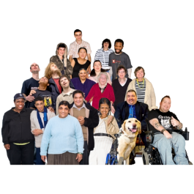

1 in every 6 New Zealanders are disabled.



There is no 1 word to say what disability is.

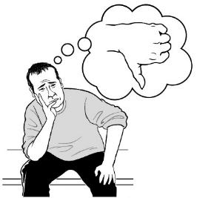
Some people do not like using some words to say who they are like:
disabled
have a disability.

Disabled people may use different words to say who they are.

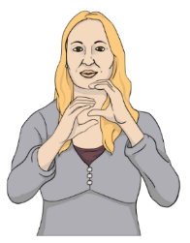
These words can be like:
Deaf
Turi Māori / Deaf Māori.
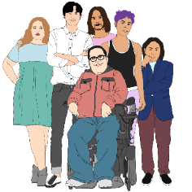

Everyone is different.

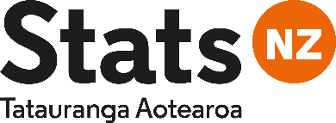
A survey in 2023 by Stats
New Zealand asked disabled people about their lives.
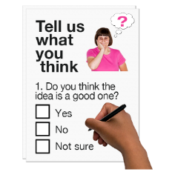

The survey found many disabled people face barriers every day.

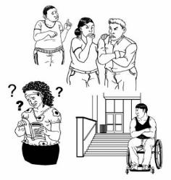
Barriers are things that stop people doing the things they need or want to do.

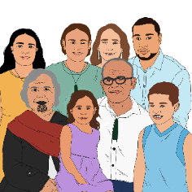
The survey found tāngata whaikaha Māori / disabled Māori face more barriers than non-Māori disabled people.
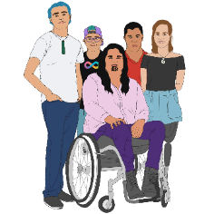

The survey also found disabled people do not do very well in things like:
- employment / getting jobs
- health.

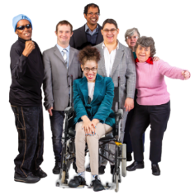
The survey found there are more disabled people in some communities like:
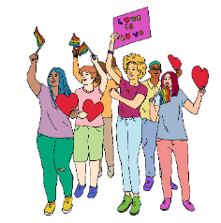
- Māori
- people living in Northland
- LGBTQIA+ people.

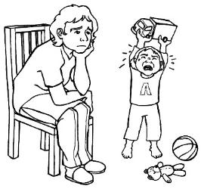
The survey also found carers of disabled children:
feel very stressed
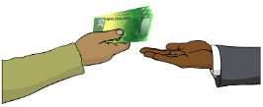
do not have jobs that pay them money
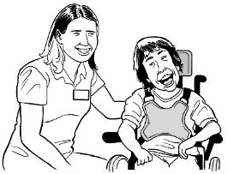
do not have much spare time
find it hard to get other people to support them with care.


Our job at Whaikaha is to make the lives of disabled New Zealanders better.

To do this we will need to:
follow what the UNCRPD says
support changes to make this happen
find out what disabled people need to make their lives better.

Our 5 main functions

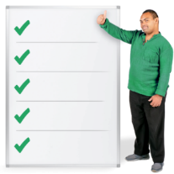
Here functions means the work we need to do as a Ministry to make lives for disabled people better.


We have 5 main functions:
leadership and making changes
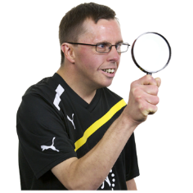
strategic policy
monitoring

disability information and advice
building strong relationships with disability communities.

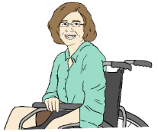
Leadership and making changes

Here at Whaikaha we are leaders in disability issues in Government.

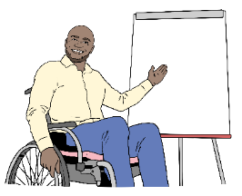
We support other government agencies to make sure their work supports disabled people.

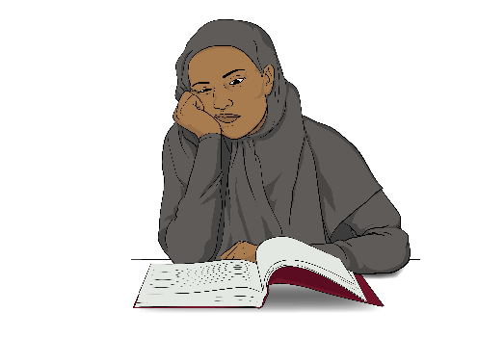
To support our work we follow 2 important strategies.

These strategies are the:
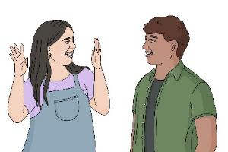
New Zealand Disability Strategy
New Zealand Sign Language Strategy.
The New Zealand Disability Strategy is the long term
plan to make lives better for all disabled New Zealanders.

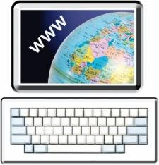
You can read more about the New Zealand Disability Strategy at this website:

https://bit.ly/3XmWUtx

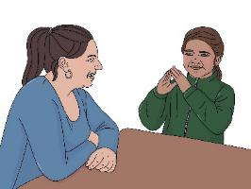

The New Zealand Sign Language Strategy is a plan to grow the use of New Zealand Sign Language here in New Zealand.

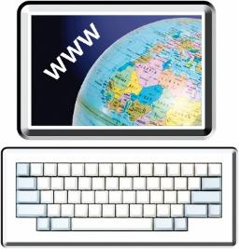
You can find out more information about the New Zealand Sign Language Strategy at this website:

www.nzsl.govt.nz/strategy

Strategic policy

Here a policy is a set of rules to guide us to do our work.

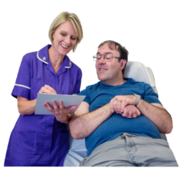
We work with government agencies to make sure they think about disabled people in areas like:
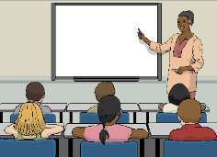
health
education.

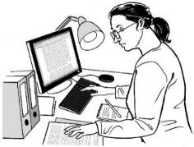
We need government agencies to find what is missing in their services for disabled people.

We will support government agencies to make sure they work for everyone including disabled people.

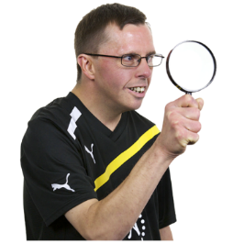
Monitoring

Monitoring is looking at something to find out if changes are needed to make it better.

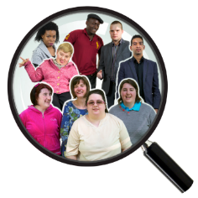
We look to see if the lives of disabled people are getting better.


We find out if the work the Government is doing is making life better for disabled people.


Disability information and advice

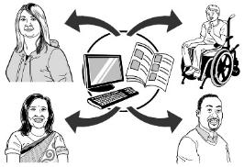
Whaikaha will be the place that brings all the information together about disability.

We will also run the
alternate formats service.


Alternate formats are ways people can get information they can understand.

The alternate formats include:
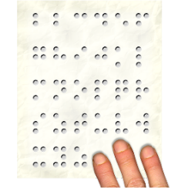
- Easy Read
- New Zealand Sign Language
- Braille.

Building strong relationships with disability communities

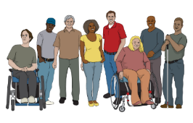
We will build strong relationships between:
disabled people
and
the Government.

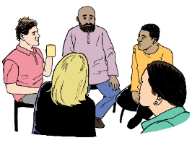
We want to see disabled people work with government agencies.

This will support government agencies to understand what:
disabled people need
changes need to be made to make the lives of disabled people better.

Our 6 strategic outcomes

Whaikaha has 6 strategic outcomes we think are important.

Here strategic outcomes are the:
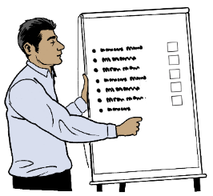
goals to make life better for disabled people
changes needed to reach these goals.

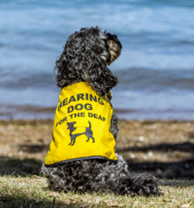
Accessibility – all disabled people can access the things they need to

Disabled people should be able to access:
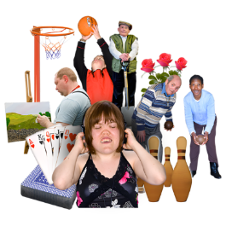
places like the:
- doctor
- supermarket
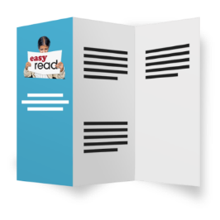
- park
government services like health
information.

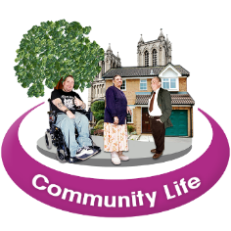
It is important all disabled people can take part in their community life.

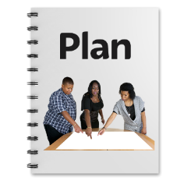
We have an accessibility work programme / plan to support government agencies to remove barriers for disabled people.


We also work with the Ministry of Transport to support disabled people to use public transport easily.

Education – disabled people should be able to get good education

Disabled people should be able to take part in all areas of education like:
school
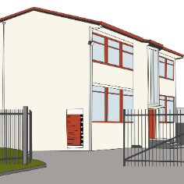
tertiary education like:
- training places
- universities
- wānanga.


A good education is important for disabled people to have good lives.

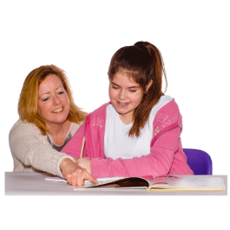
Disabled students should be supported to reach their education goals.

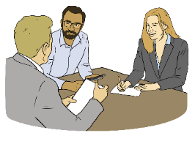
We will work with government education agencies to remove barriers:

in education
for students to enrol at an education place like a school
to go to school
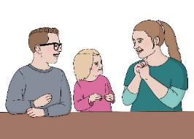
to getting the right learning support for disabled students.

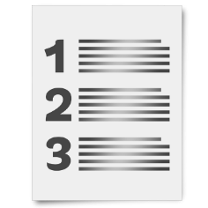
Here enrol means you put your name on a list so you can go to something like a school / university.

We will also work with government agencies to train teachers.

This is so teachers can learn more skills to support their disabled students.

It is also important we collect more information about disabled students.

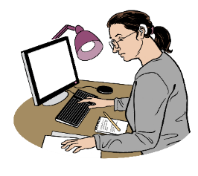
Having this information will support us to know where to make changes.


Employment – disabled people can have the same access to jobs as everybody else
Having a job is very important for disabled people.

Having a job supports disabled people to:
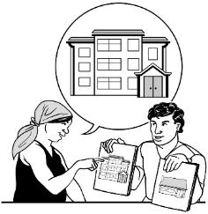
have money to buy the things they need to have a good life
make choices about their lives.

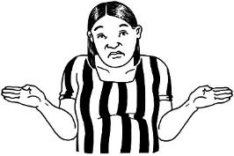
Disabled people:
- are less likely to have a job than
non-disabled people
- do not get as much money for jobs as non-disabled people.
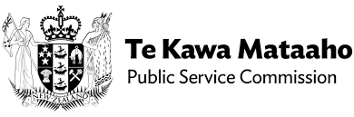
We are working with the Public Service Commission to make more job opportunities in the
Public Service.

Here opportunities are having more chances to do something like get a job.

The Public Service is made up of organisations that support the Government to do its work.

We will also work with government agencies to make getting jobs easier for disabled people in the Public Service.


Health – disabled people can get the best healthcare to support their wellbeing


Good health is one of the main things that support people to have good lives.

Non-disabled people have better health outcomes than disabled people.
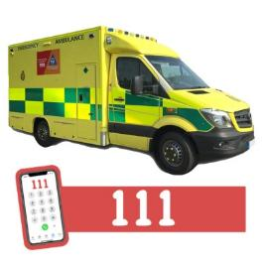

Disabled people:
make more emergency visits to the hospital
spend longer in hospital
find it hard to get their health problems sorted out.

To make health services better we will work with:
other government agencies
and
disabled people.

It is important disabled people get the health services they need to have a good life.

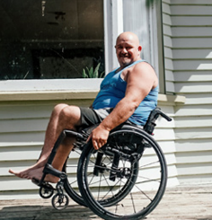
Housing – disabled people can choose where they want to live


Disabled people should be able to live in places:
that are healthy
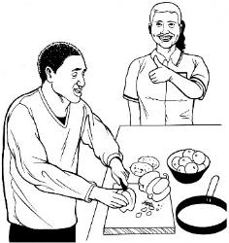
that are safe
where they choose to live
that support them to live independent lives.

Here independent means being able to:
make your own decisions
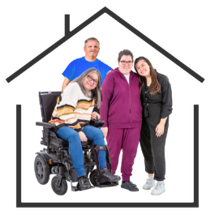
live where you want to live
live with who you want to live with.

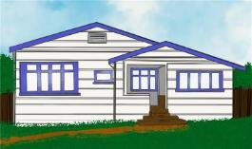
Good housing supports disabled people to have good health.

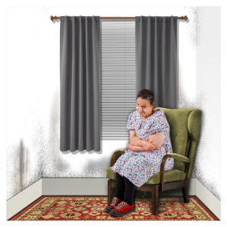
Disabled people are more likely than non-disabled people to live in:
damp houses
mouldy houses.

We work with housing agencies to:
support disabled people to get better housing
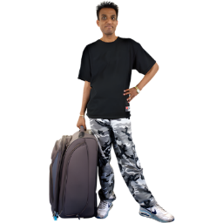
lower the number of disabled people living in emergency housing.

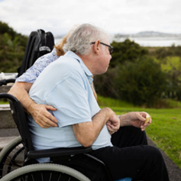
Justice – the justice system works for disabled people

Disabled people need to use the justice system in a way that works for them.
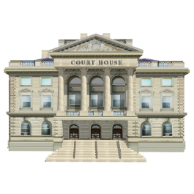

Dealing with the justice system can be very hard.

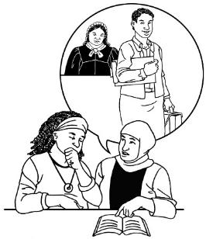
It is important for the wellbeing of disabled people that they:
have their rights protected
are treated fairly
can get the legal support they need.
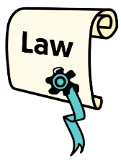

Legal is about things to do with the law.
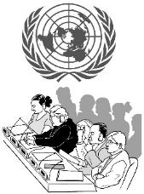
We support justice agencies to know what they need to do to follow the UNCRPD.

We work with justice agencies to make sure their services:
are accessible
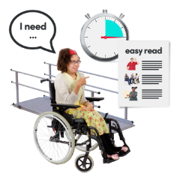
provide reasonable accommodation.

Our 7 main projects

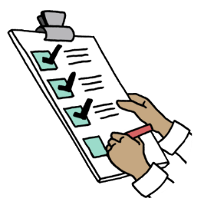
We have 7 main projects we will be working on.

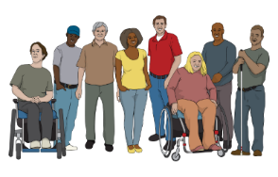
The first 4 projects include:
refreshing the New Zealand Disability Strategy which will be finished later in 2025
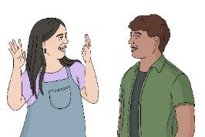
refreshing the New Zealand Sign Language Strategy which will be finished later in 2025
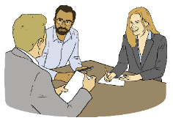
supporting government agencies to follow what the UNCRPD says
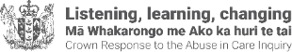
following the Royal Commission of Inquiry into Abuse in Care recommendations.

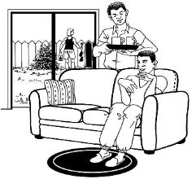
The Royal Commission of Inquiry into Abuse in Care made recommendations about making government care for disabled people better.

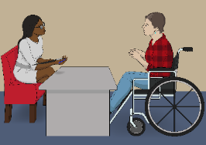
Recommendations are ideas about ways to make something like a service better.

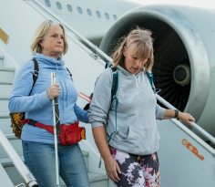
The fifth project is the accessibility work programme to support:
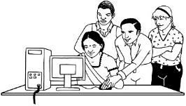
- making public spaces more accessible
- making digital spaces like websites more accessible
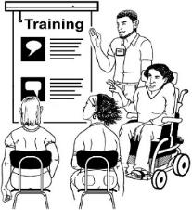
- teaching people about disability rights.

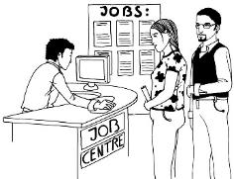
The sixth project is about making more jobs for disabled people in the
Public Service.


This project will support:
- disabled people to get jobs in the Public Service
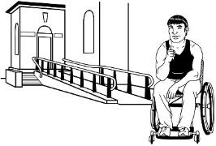
- the Public Service to be accessible for disabled people.


Our seventh project is to
reshape / change Whaikaha.

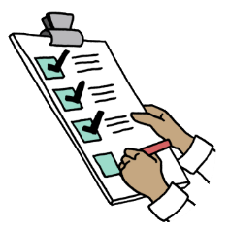
Work we will need to do are things like:
- getting the right people to do the jobs well
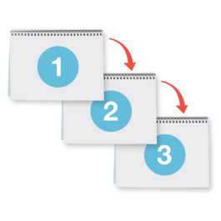
- having a structure that supports people to do their work well
- having good processes / ways to support people to do their work well.
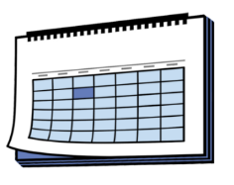

This project will take time to finish.

How we will work with others

We will:
work with others to do our work
work with disabled people
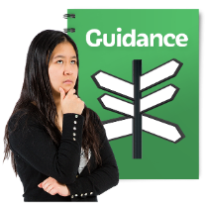
work with tangata whaikaha Māori / disabled Māori
be guided by our values in our work
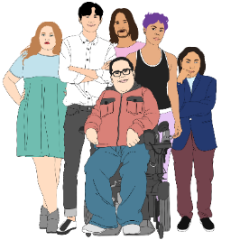
support the groups we work with to grow
build trust with the groups we work with.
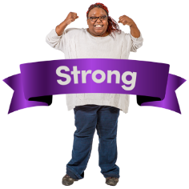
We will build strong relationships with:
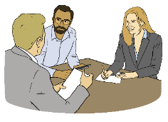
disability groups
Māori–Crown relationships
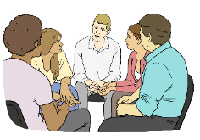
the Government
local government like councils
businesses
communities.

Contact us

For information on how to contact Whaikaha visit this website:

www.whaikaha.govt.nz/contact-us

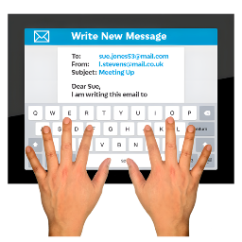
You can contact us:
by email at:
contact@whaikaha.govt.nz
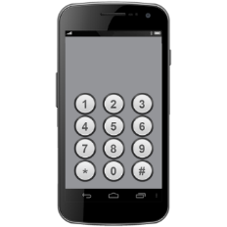
by phone on:
0800 566 601
This number does not cost money to call.

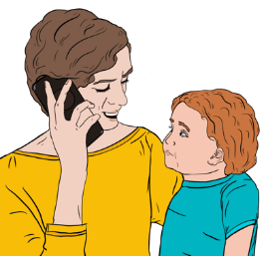
You can call us on the phone:
from 8 am to 5 pm on:
- Monday
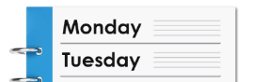
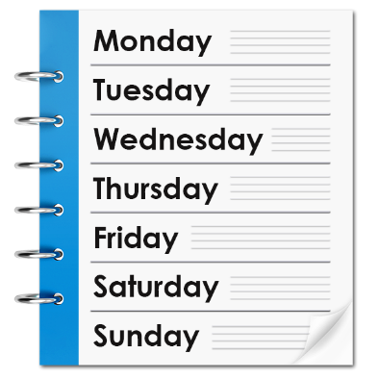
- Tuesday
- Thursday
- Friday
from 9.30 am to 5 pm on:

- Wednesday.


If you find it hard to use the phone the New Zealand Relay service is for people who are:
Deaf / hard of hearing
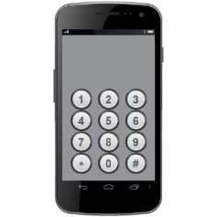
deafblind
speech impaired / find it hard to talk.

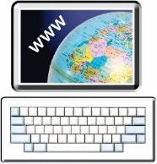
You can find out more about the New Zealand Relay service at:

www.nzrelay.co.nz


This information has been written by the
Ministry of Disabled People – Whaikaha.
Some of the images used have been provided by the Ministry of Disabled People – Whaikaha.
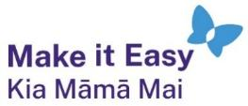
It has been translated into Easy Read by the Make it Easy Kia Māmā Mai service of People First New Zealand Ngā Tāngata Tuatahi.
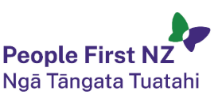
The ideas in this document are not the ideas of People First New Zealand Ngā Tāngata Tuatahi.

All images used in this Easy Read document are subject to copyright rules and cannot be used without permission.


Make it Easy uses images from:

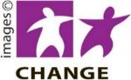
- Photosymbols

- Change Images


- Huriana Kopeke-Te Aho
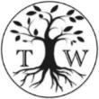
- SGC Image Works

- T Wood

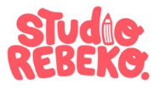
- Studio Rebeko

- Inga Kramer.

