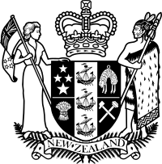
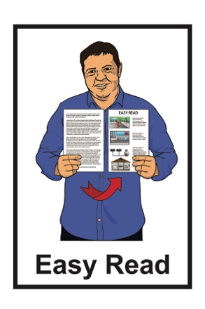

Press release:

Whaikaha –

Ministry of Disabled People

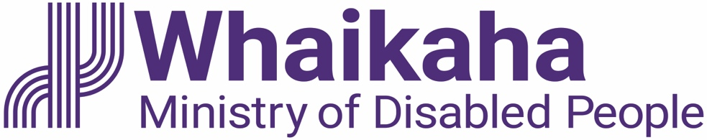

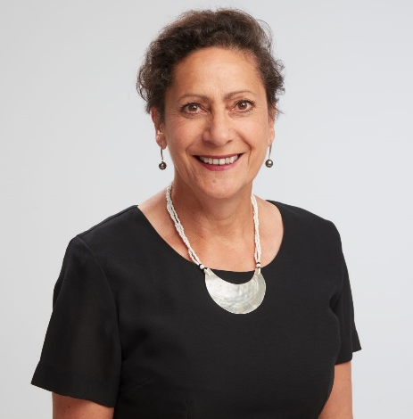

1 July 2022

About this document

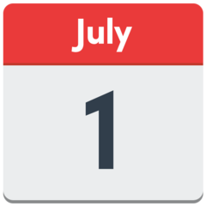
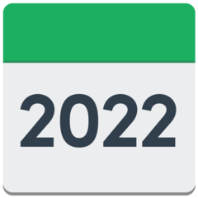
On 1 July 2022 a press release was put out by:
- Honourable Carmel Sepuloni

Minister for Social Development and Employment

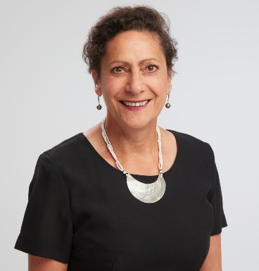
and

- Honourable Poto Williams

Minister for Disability Issues.

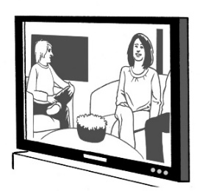
A press release is a document that is written for the media like TV / newspapers to use.

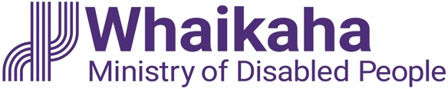
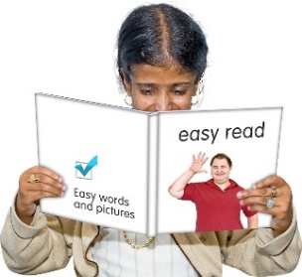
This Easy Read document is a summary of their press release about Whaikaha – Ministry of Disabled People.

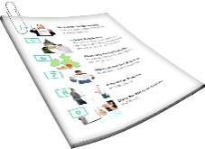
A summary:

- is shorter
- tells you the main ideas.

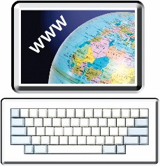
You can read the full press release about Whaikaha – Ministry of Disabled People online here:

www.whaikaha.govt.nz/about-us/welcome-from-our-new-minister

What the press release is about

The press release says that 1 July 2022 is the start of a new ministry that will be called:
Whaikaha – Ministry of Disabled People.

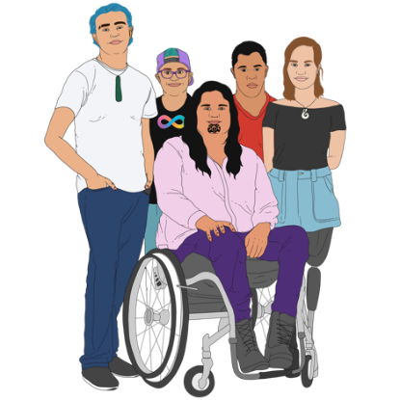
Whaikaha – Ministry of Disabled People is a new part of the New Zealand Government that will:

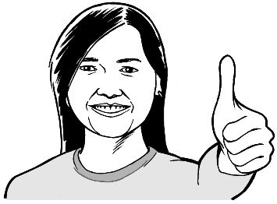
- make disability support services better for disabled people and their whānau / families

- use an Enabling Good Lives way of doing things.

Enabling Good Lives is a way of giving disability support so you have:
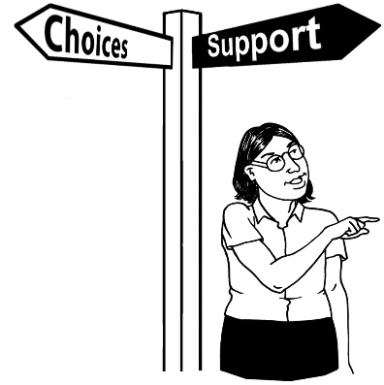
- choice and control in your life
- the support you need and want

- a good life.

The Ministry will also have a New Zealand Sign Language name which will be ready in about October 2022.

You can find more Easy Read information about Whaikaha – Ministry of Disabled People online at:

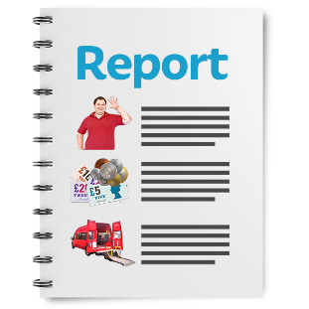
https://tinyurl.com/2wydfpbz

These documents are in Easy Read.

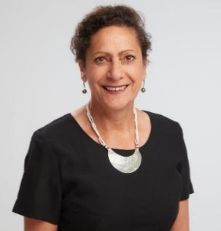
The Ministers said the start of the Whaikaha – Ministry of Disabled People is an important day for the 1.1 million disabled people in Aotearoa New Zealand.

The Ministers also said Whaikaha – Ministry of Disabled People is an important step to true working partnerships between:
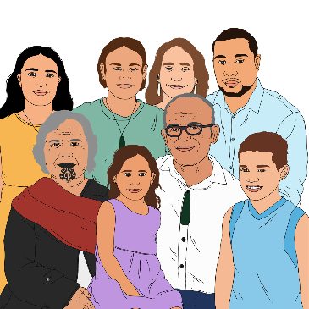
- disabled people

- tāngata whaikaha / disabled Māori
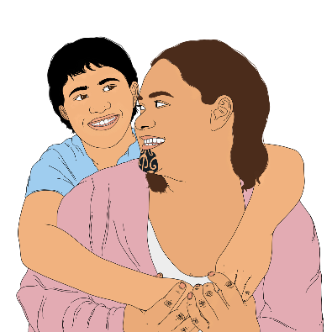
- whānau / family

- carers

- supporters

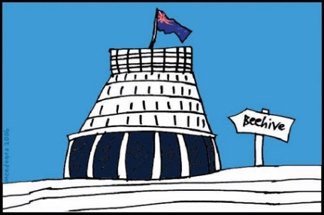
- government agencies.

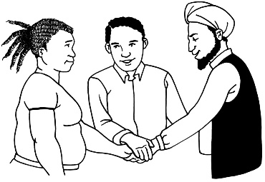
Working partnerships means to work together.

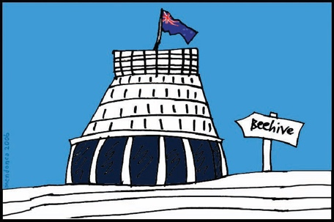
Whaikaha – Ministry of Disabled People will also work with other government agencies so that there are better services for disabled people such as in:
- employment / work

- education

- health / wellbeing.

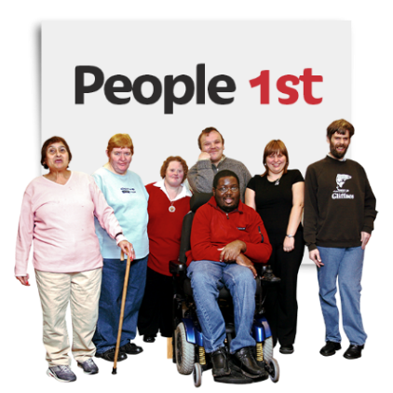
Whaikaha – Ministry of Disabled People will work in a way that is:

Nothing About Us, Without Us.

The Ministers said that disabled people have waited a long time for this new ministry.

There has been a lot of good work already by the:

- Establishment Unit for the new ministry
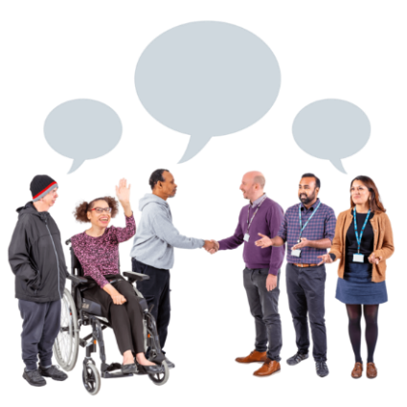
- Community Steering group that has given advice on the setting up of the new ministry.

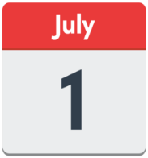
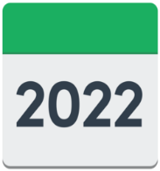
The 1 July 2022 is also the start of:

- Health New Zealand

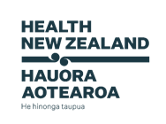
- The Māori Health Authority

Health New Zealand is now the health service for the whole of
New Zealand.
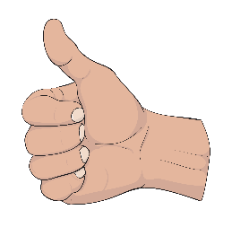
This means that everyone will get good care wherever they live.

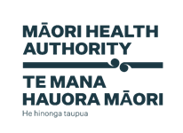
The Māori Health Authority will make sure:

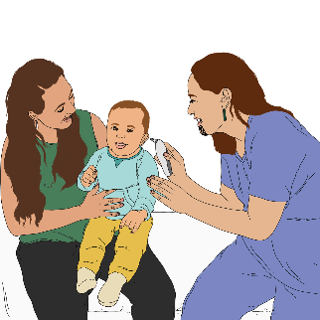
- Māori get better healthcare

- there are services that are a good fit for Māori.

You can find out more about these 2 new health organisations online here:

https://dpmc.govt.nz/sites/default/files/2021-05/health-reform-white-paper-summary-easy-may21.pdf

This document is in Easy Read.

Where to find more information

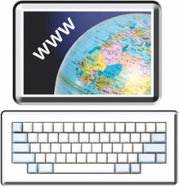
You can find more information about Whaikaha – Ministry of Disabled People at this website:

www.whaikaha.govt.nz

You can also:

Call: 0800 566 601

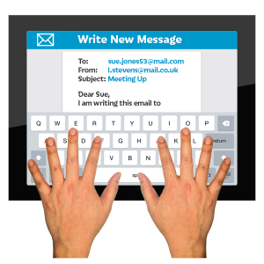
Email: contact@whaikaha.govt.nz

Freepost: Whaikaha – Ministry of Disabled People

Reply No. 262204

PO Box 1556

Wellington
This information has been written by the Office of Hon Poto Williams.

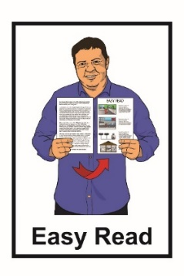
It has been translated into Easy Read by the Make It Easy service of People First New Zealand Inc. Ngā Tāngata Tuatahi.

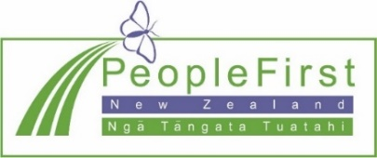
The ideas in this document are not the ideas of People First New Zealand Inc. Ngā Tāngata Tuatahi.
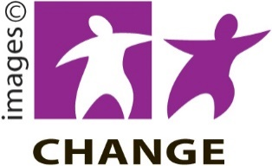
Make It Easy uses images from:

- Changepeople.org
- Photosymbols.com
- Sam Corliss
- Huriana Kopeke-Te Aho.

All images used in this Easy Read document are subject to copyright rules and cannot be used without permission.

