

**Your guide to**

**Choice in**

**Community Living**

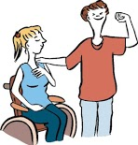

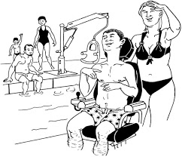

**Easy Read information**

The **Ministry of Health** is trying out a new way of supporting disabled people.

It is called the **New Model**.

The idea of the **New Model** is for you to have more choice and control about how you are supported to have a good life as part of your community.

One part of the **New Model** is **Choice in Community Living**.

**What is the New Model for supporting disabled people?**

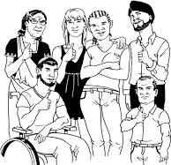

**Choice in Community Living** offers a new way for you to live in your community, instead of in a group home.

It gives you more choice about:

* how you live
* where you live
* who you live with.

**What is Choice in Community Living?**

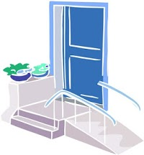



**Choice in Community Living** is for disabled people who:

* live in group homes

or

* have disability support needs similar to people in group homes.

**Choice in Community Living** is being tried out in **Auckland** and the **Waikato, Hutt and Otago/Southland regions**.

**Who can join Choice in Community Living?**

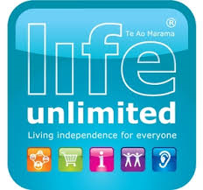http://www.waikatodhb.govt.nz/images/43754.jpg?w=250&h=58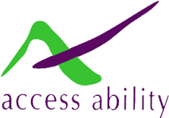

If you live in Auckland, talk to someone at: **Taikura Trust.**

If you live in the Waikato, talk to someone at: **Disability Support Link.**

If you live in the Hutt, talk to someone at: **Life Unlimited.**

Or if you live in Otago or Southland, talk to someone at **Access Ability.**

Then choose a disability support provider to help you plan for the upcoming changes in your life.

Write a plan with your family, friends and disability support provider.

**How do I join Choice in Community Living?**

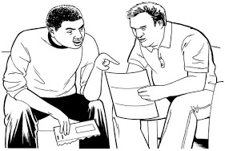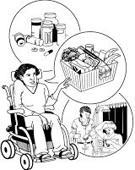

Your plan will include:

* what is important to you
* the support you need to help you live your life.

Once your plan is finished your disability support provider can help you find a home and reach your goals.

Then, when you move into your own home, your disability support provider will check to make sure your plan is working well for you.

**Where can I get more information?**

**Auckland**: **Taikura Trust**

Phone: 0800 824 5872

Email: info@taikura.org.nz

**Waikato: Disability Support Link**

Phone: 0800 55 33 99

Email: dsloffice@waikatodhb.health.nz







http://www.waikatodhb.govt.nz/images/43754.jpg?w=250&h=58







**Hutt**: **Life Unlimited**

Phone: 0800 008 011

Email: info@lifeunlimited.net.nz

**Otago/Southland: Access Ability**

Phone: 0800 758 700

Email: otago@accessability.org.nz











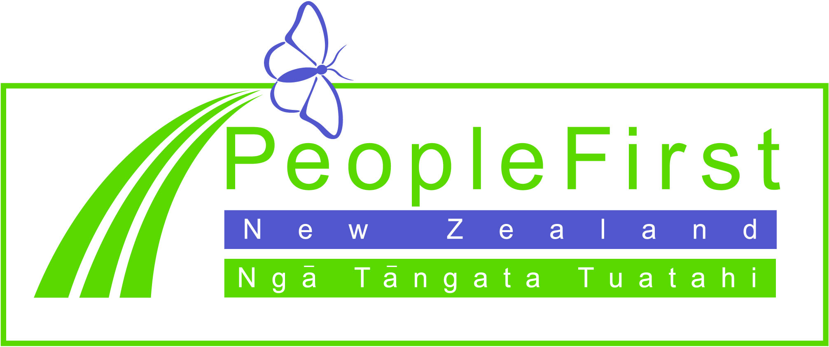

**This information has been translated into Easy Read by People First New Zealand Inc.**