The Equipment and Modification Services (EMS) Portal
(formerly the Prioritisation Tool)
Changes February 2019

Contents
Contents 2
Introduction 3
Audience 3
An Overview of the Changes 3
Change in Name 3
Online Training 3
Removal of the Impact on Life Questionnaire 3
Changes to the Assessor Section Form 4
Standard Questions Across All Services 5
Equipment Related Questions 6
Housing Modification Related Questions 7
Vehicle Purchase and Modification Related Questions 8

Introduction
This document provides an overview of the changes to the EMS Prioritisation Tool available from February 2019. A complete ‘Getting Started Guide’ is available which provides a more detailed description of these changes.

Audience
This document is intended for EMS Assessors who have used the Prioritisation Tool prior to these changes being made in February 2019.

An Overview of the Changes

Change in Name
The EMS Prioritisation Tool is now known as the EMS Portal.
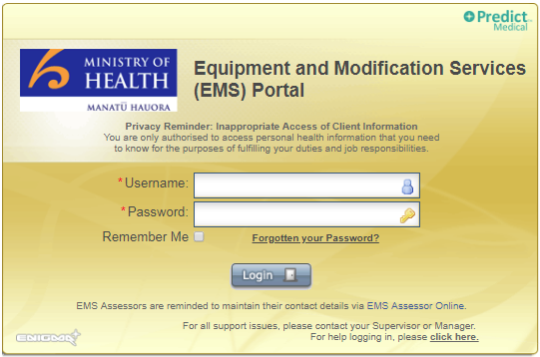

Online Training
It is no longer a requirement to complete the Learn Online on-line training before accessing the EMS Portal.

Removal of the Impact on Life Questionnaire
The Impact on Life Questionnaire is no longer required and has therefore been removed. Once your Client has been added into the Portal you will have immediate access to the Assessor Section part of the record.
Any previously completed Impact on Life Questionnaires with their associated Assessor Sections will be available to view via the Previous Records area of the record.
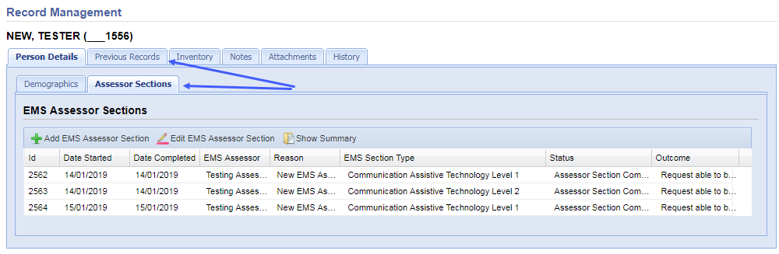

Changes to the Assessor Section Form
The Portal will no longer determine whether a request can be funded or not; it is the provision of the rationale for your request that the EMS Providers (accessable and Enable NZ) will use to determine which requests can be funded. The Assessor Section has therefore been updated to allow you to enter the rationale supporting your request and the questions have been updated to reflect this.
The questions regarding the Client’s ability to benefit have been removed. In their place are questions on the rationale supporting your decision. The questions differ slightly depending on the type of request you are making, determined automatically based on the Section Type you choose.
There are three options:
- Equipment
- Housing Modifications
- Vehicle Purchase and Modifications
Submission of these forms will automatically provide the links to the EMS Providers with the message: “Funding able to be considered (subject to all requirements having been met)” – there is no longer a ‘Funding Not Available’ response.
Only one rationale form can be completed per Section Type.

Standard Questions Across All Services
These questions will appear for all service types.
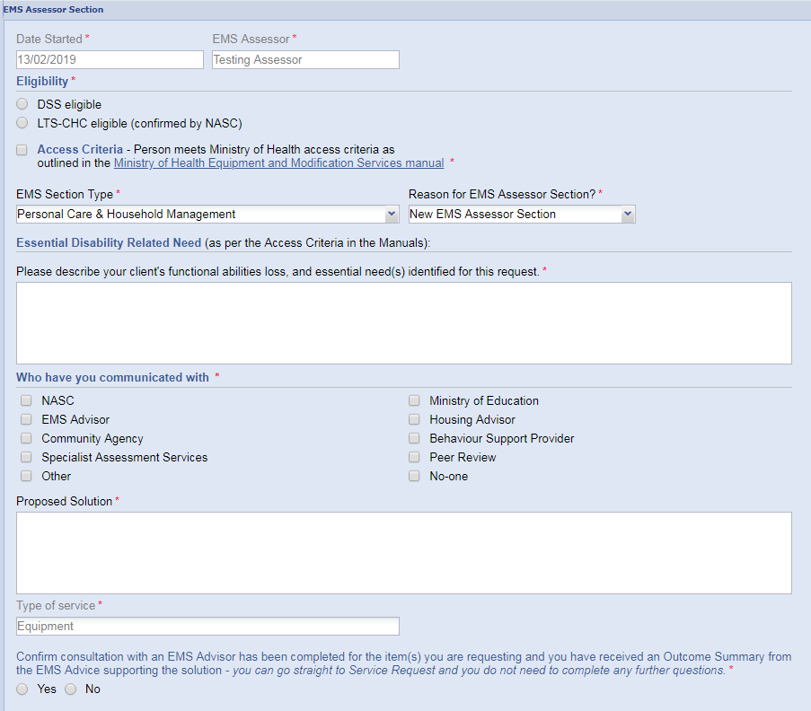

Equipment Related Questions
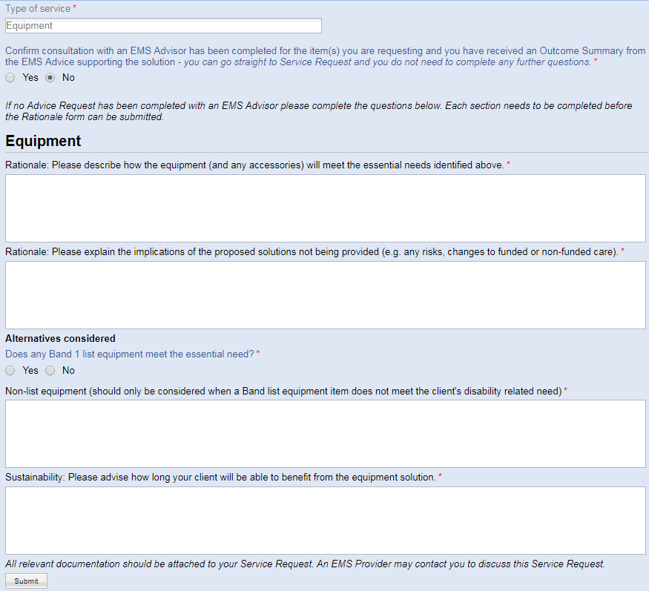
If no Band 1 list equipment meets the essential need the option for Band 2 appears; the same applies for Band 3.

Housing Modification Related Questions
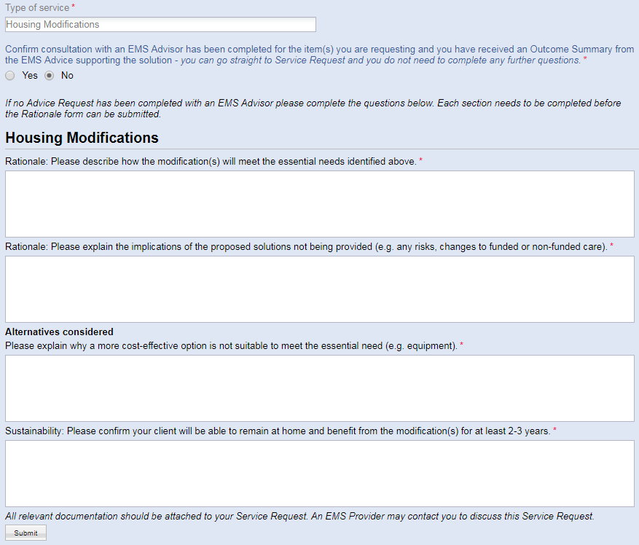

Vehicle Purchase and Modification Related Questions
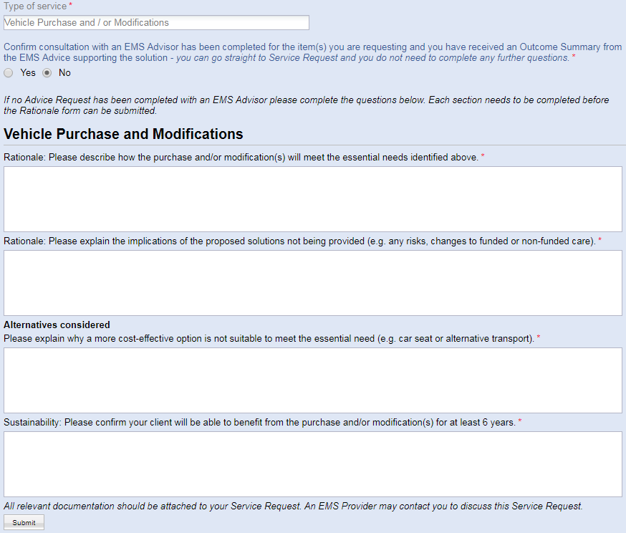
As the Impact on Life Questionnaire is no longer used, the limitation on one Assessor Section per Impact on Life Questionnaire no longer applies. All Assessor Sections will be added in the single Assessor Section view and it is now possible to add more than one Assessor Section of the same type.
