The Equipment and Modification Services Portal

Getting Started Guide
Version 2.0
(February 2019)

Contents
Getting Started 3
Logging in 3
Logging out 3
The Dashboard 4
Default View 4
Searching for a Person 5
Displaying the Person Details 6
The Person Record 7
Adding a New Person Record 7
Searching for a Person 8
Recording Discrepancies 10
Automatic Checking of Details 11
The Person Details Form 14
The Assessor Section 16
For Assessors in the Enable NZ Region 20
For Assessors in the accessable Region 21
EMS Assessors in Training 22
Authorising Supervisors/EMS Assessors 23
Saving as a PDF 24
Previous Records 24
Inventory 25
Resources 25
Support 25

Getting Started

Logging in
In your internet browser, enter one of the following web addresses:
If you have a Connected Health connection please use: https://ch.ems.health.nz/
If you do not have a Connected Health connection please use: https://secure.ems.health.nz
The Connected Health address should always be used when a Connected Health connection is available.
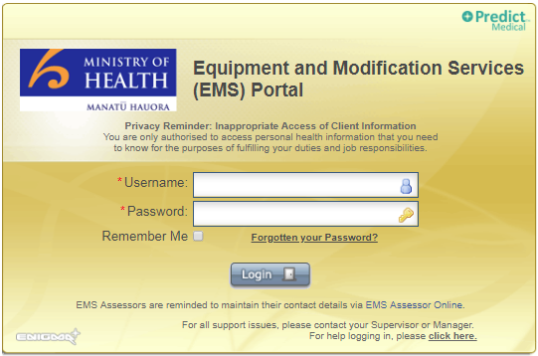

Enter your username and password and click <Login>.¹
If you are the only person using your computer, you can click the ‘Remember Me’ checkbox to remember your details.
If you need help logging into the Portal please click the link for help on the login screen.

Logging out
You can log out at any time by selecting the Options menu followed by <Logout>.

¹ If you are an EMS Assessor your username will be created automatically based on the data from the Enable NZ EMS Assessor Online database. It is therefore extremely important that you keep your details updated within the Enable NZ EMS Assessor database. If your accreditation details expire, your access to the Portal will be suspended. Updating your details will re-establish your access to the Portal although this may take up to 48 hours to process.

The Dashboard

Default View
The default view after logging into the Portal is always the Dashboard.
The Dashboard view will always default to show only Person Records where something is in a ‘Pending’ state.
The menu options at the top will change depending on the user role you have.
The ‘EMS Assessor To-Do List’ automatically displays only the Person Records which need attention – these are records that are in a ‘Pending’ state for one of the following reasons:
Enrolment Pending | The Person Details form has been started and saved but has not been completed and submitted.
Pending Assessor Section | A Person Record is present but no Assessor Section has been started. If no Assessor Section is started within one month, the Person Record will no longer display on the dashboard by default, but will still appear if searched for.
Pending Approval | Assessor Section has been submitted by an EMS Assessor-in-training and requires review by a Supervisor.

Entering any search criteria, eg NHI, will automatically override the default display.
All records that you have worked on, dated chronologically, can be displayed by selecting <Clear All> followed by <Search>.
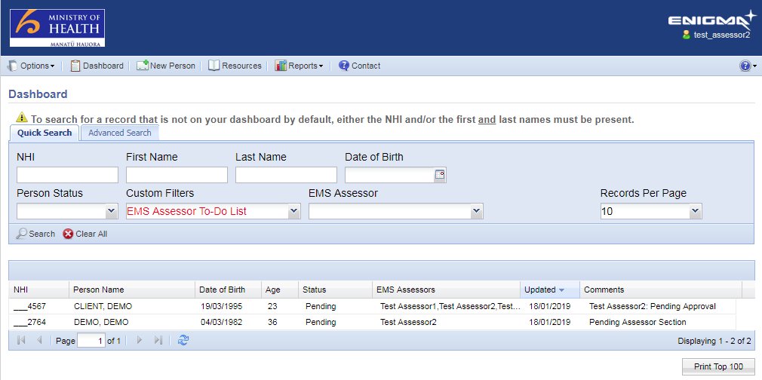

Searching for a Person
You can search for all your records by clicking on <Clear All> followed by <Search>:
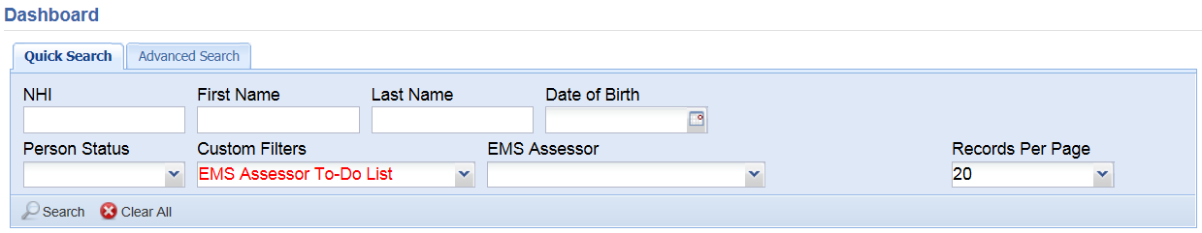
This search will show you all records where you submitted any of the forms UNLESS the NHI and/or First Name and Last Name of a Person are entered.
The only way you can find a record that you have not started or submitted any forms for is to specify the Person’s NHI and/or their First Name and Last Name.
Unless you have specified the NHI and/or First and Last Names, all search results, irrespective of the search criteria selected, will include only the records you have previously submitted data for.
There are two pages of search criteria, both are independent from each other - any search criteria entered on one page will not be considered if the other page is visible when clicking on <Search>.
Any search criteria selected will appear in red.
Quick Search:
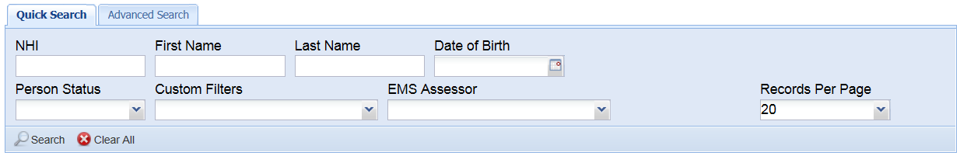
Advanced Search:
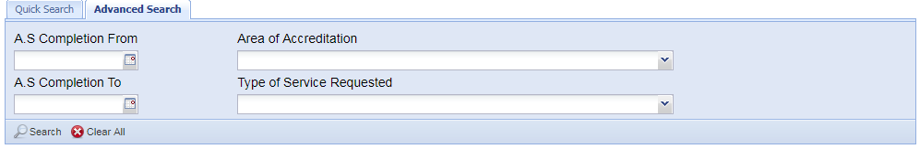
A S (Assessor Section) Completion search is based on the date on which the Assessor Section was completed. If the Assessor Section requires approval, the completion date would be the date on which the review was completed.

Displaying the Person Details
If a Person Record appears in the search results, the record can be opened by:
- Double clicking on the Person Record
- Clicking on the Person Record and clicking on the <View Details> button which will appear
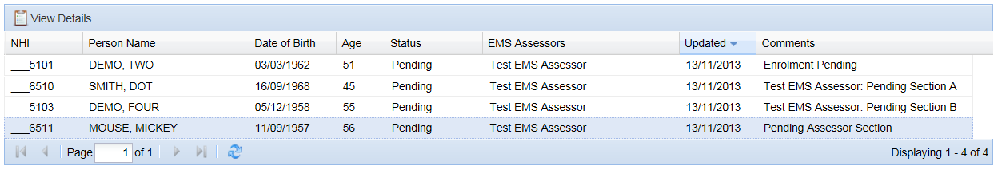

The Person Record
A Person Record consists of:
- The Person Details (demographics)
- Assessor Section(s)
- Previous Records (shown only if any are present)
- Inventory
- Notes
- Attachments
- History

Adding a New Person Record
A new Person Record is added into the Portal by clicking on the <New Person> menu option at the top of the screen:
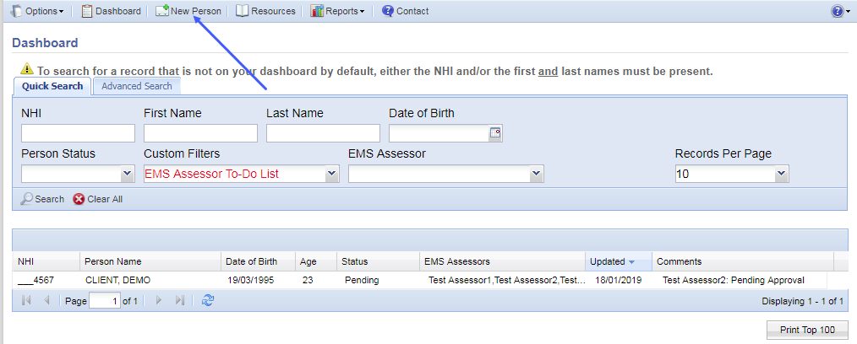
Before you can add a new person into the Portal you have to first search to see if they already have a record present.

Searching for a Person
Select <New Person> from the Dashboard and you will see that you have the option to search for a client by name or by NHI:
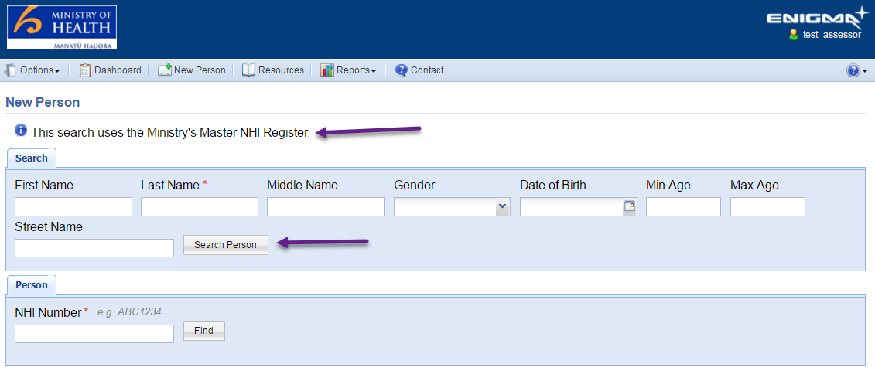
The red asterisk (*) indicates a mandatory field; you must always include your client’s last name in the search. You can then add as much or as little information as you choose. If too many names are found, you will be asked to narrow the search criteria further.
When specifying the age range, this must be within a 10-year span.
If there is already a record in the Tool for your client you will see a message advising you:
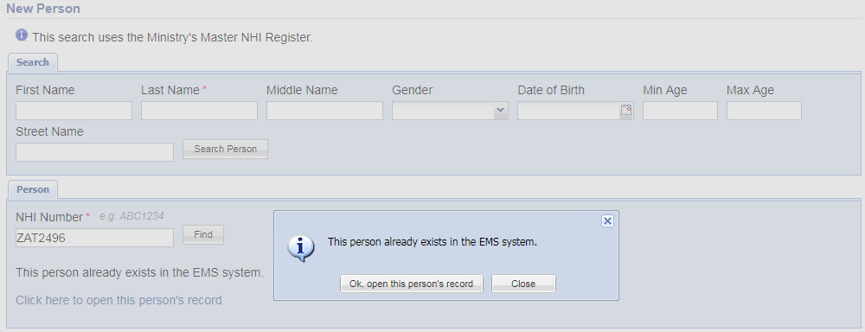
Click <Ok, open this person’s record> and you will be taken to their record.
If there is no record in the Tool for your client you will see the results of the search from the Ministry’s Master NHI Register. The search results will give you all possible results with a score, indicating how close a match to the search criteria the person sits:
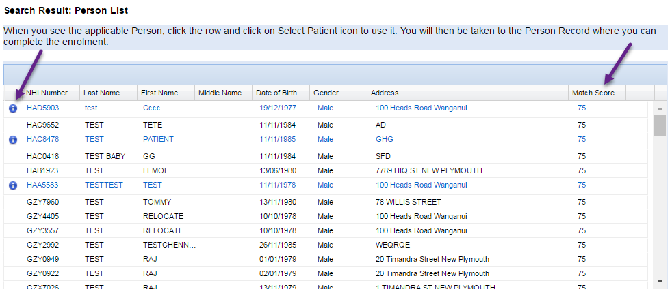
If a client has multiple names, this is shown by the blue ‘i’ indicator. Clicking on the ‘i’ brings up the list of names for the client so you can make sure you have the correct name:
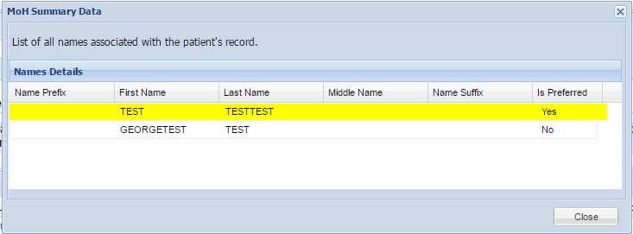
You can continue to search by NHI if you know the NHI for your client.
To open a client from the list, click the row you want to select and then click <Select Patient> from the header row above:
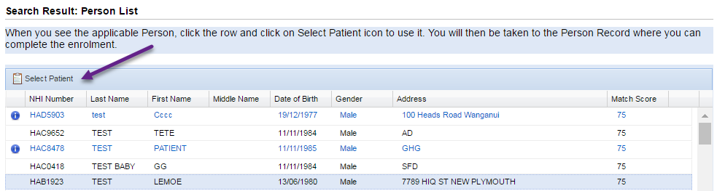
This will open the client’s record and automatically complete the data in the form where it exists.

Recording Discrepancies
When the enrolment form opens, you will see a message at the top in red:
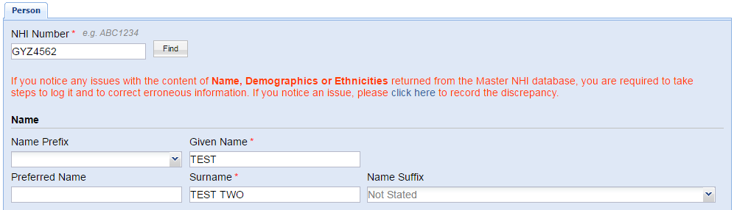
As the message states, if you know from talking with your client that any of these details are incorrect, it is your responsibility to report this through your normal channels. Within the Portal, the pre-populated data will always update from the Master NHI; if you have not recorded a discrepancy, the next time anyone opens this client record, the previous data from the Master NHI will overwrite what you have entered.
To prevent this from happening, you need to log the discrepancy within the Portal, described below.
Click the <click here> link shown in the above image to record the discrepancy:
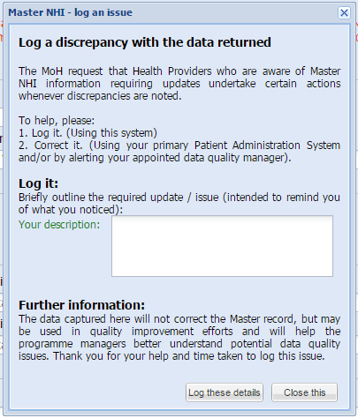
Important – completing this form will NOT update the data in the Master NHI Register. As above, you are still required to report the data discrepancy through your normal channels. Logging the discrepancy will stop your updates from being overwritten each time you open the client record.
Once the data has been updated in the Master NHI Register the Portal will recognise that new information is present.

Automatic Checking of Details
When you open a client record, the Portal will perform a behind-the-scenes check against the Master NHI to ensure the correct NHI is being used.
For client records created in the Portal before 20th September 2017, if the primary NHI (the NHI that should be used) was not known, the next time the record is opened, the Master NHI will automatically find the primary NHI for that client and update it and a prompt will appear for you to acknowledge.
In the example below, the Client record was stored as ZAT2518 but the primary NHI is ZAT2496. You can see that the NHI has been updated automatically:
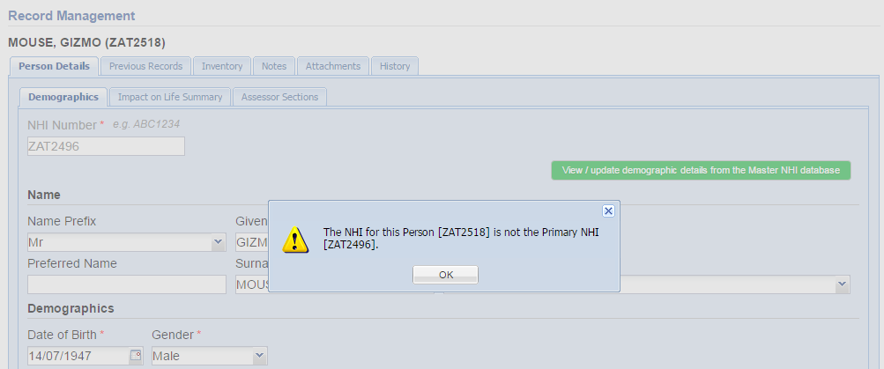
If the Portal recognises that there is more up-to-date information stored for the client than is in the Portal form, you will see a message:
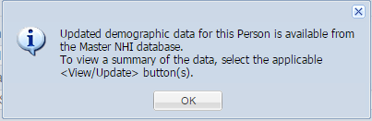
Click on either of the <View / update…> buttons to see what new data is available.
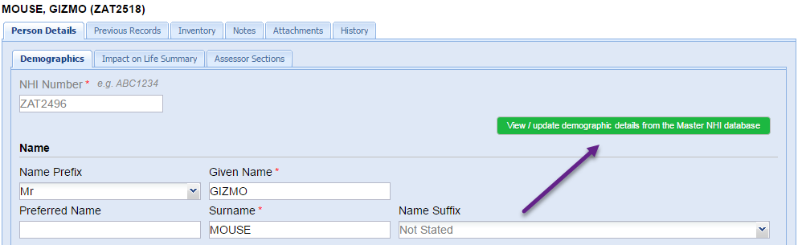
Clicking <View / update demographic details…> will show you the following form:
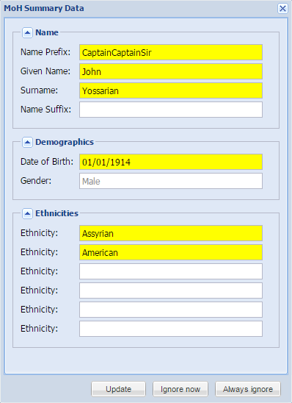
All items in yellow are different from the data stored on the form. You can choose to update it, ignore it for now or always ignore it.
A similar process is present for address details:
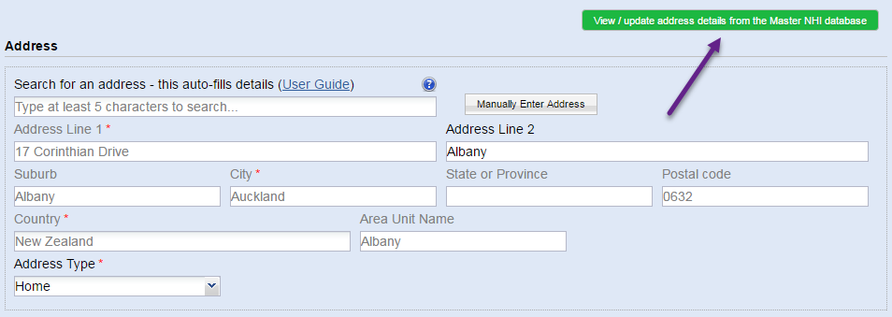
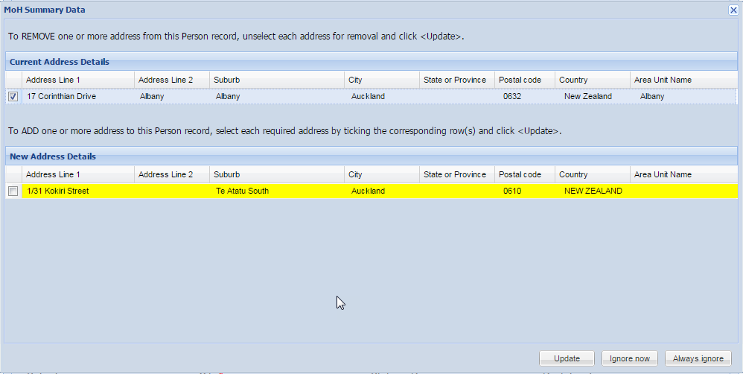

The Person Details Form
The form is split into a number of sections. Any question which has a red asterisk (*) beside it is mandatory and must be completed before the form can be submitted. If some of the data is not available the form can be saved with partial data for completion later.
A large number of the questions have drop-down lists which the answer is selected from; this is indicated by an arrow at the side of the question:
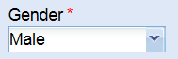
Some of the questions with a larger number of options to choose from will allow you to start typing the option you want, and once at least three characters have been entered, a search will trigger which will display all options on the list matching the letters you have entered. The list will get shorter until you find the option you are looking for. These questions are:
- Name Suffix
- Ethnic Group
- Iwi
- Language Spoken
- Primary Disability and/or Diagnosis
Entering Addresses
If you work for an organisation which has a Ministry recognised Organisation Identifier, you will have the option to search for an address:
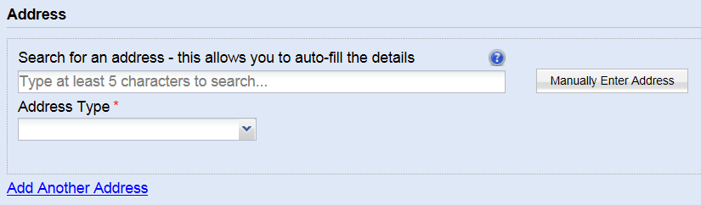
Some hints on how to find addresses can be found by clicking on the question mark icon.
Start typing the address and after you have entered at least 5 characters, the system will start providing you with address options to choose from. The more details you enter, the more the system will restrict the results presented:
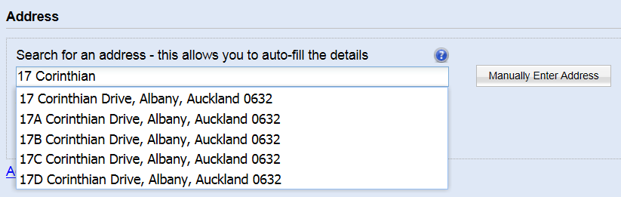
Click on the correct address and the address will automatically update the address fields:
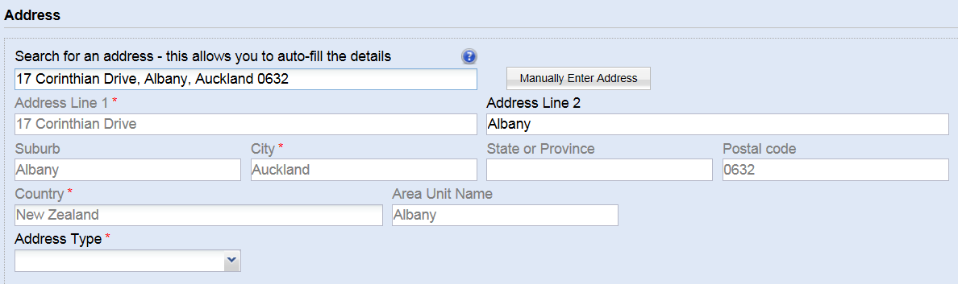
Note that all address fields apart from Address Line 2 are greyed out and cannot be edited. Additional comments can be entered into Address Line 2 if required, eg ‘access at the back’.
If you cannot find the address you are looking for, click <Manually Enter Address>. This will clear the address fields and allow you to enter them in manually.
Note: When an address is found using the search method, a number of hidden address fields are also populated which are used for reporting, therefore it is important to try to find the address using the search option first, before resorting to the manual entry method.
Adding Multiple Options
There are three parts of the form where you can add multiple entries:
- Secondary Disability
- Address
- Communication Method
It is mandatory to add at least one of each of these sections of data, however additional data can be added by clicking on the <Add Another …> buttons:
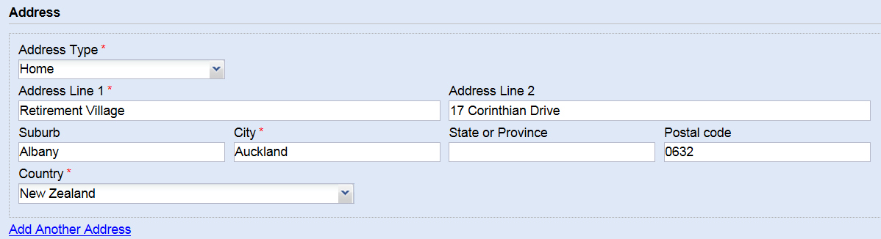
The added items can be removed again if required by clicking the <Remove> button which will appear as soon as <Add Another …> has been clicked:
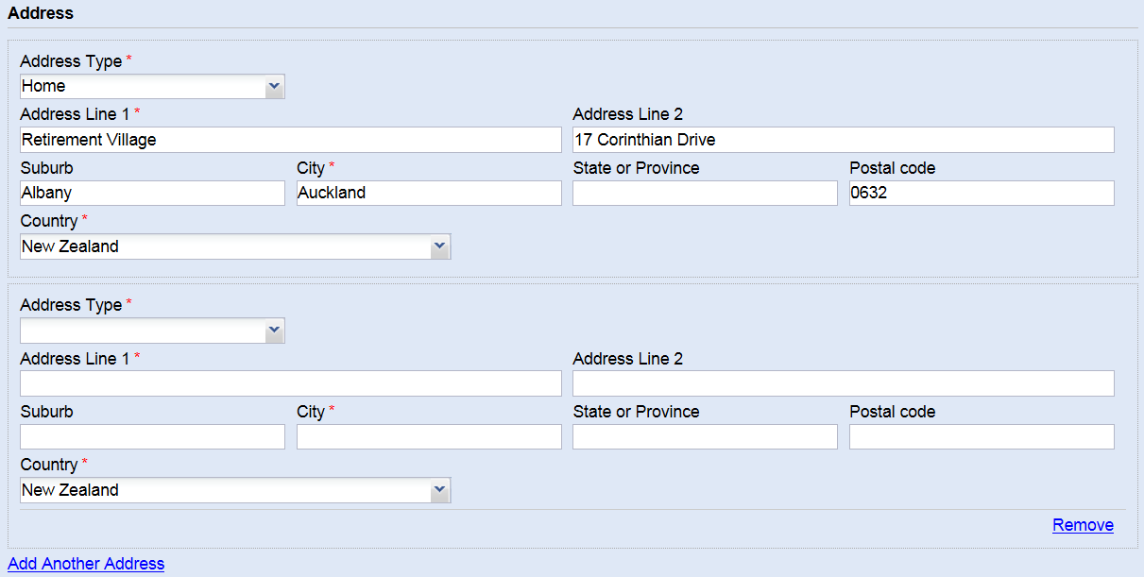
Once all of the details have been entered into the form, add the Person Record by clicking <Submit>, at the bottom of the form. You will then be given the option to remain with this Person Record, or to return to the Dashboard. The Person Record details can be updated at any time.

The Assessor Section
Once the person has been added into the Portal you have access to the Assessor Sections area of the Tool. This is where you complete the details on the type of equipment or service that you are requesting for your client.
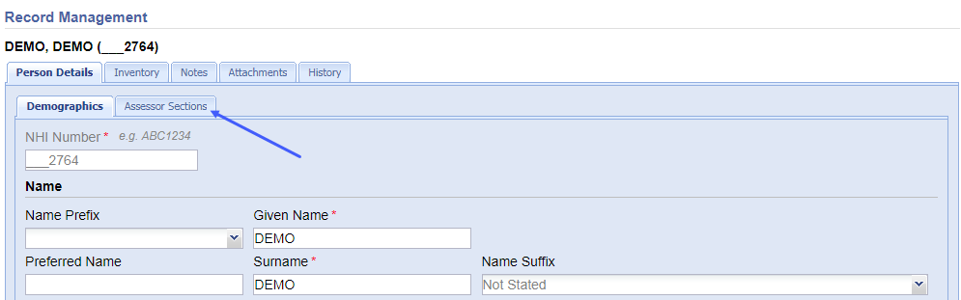
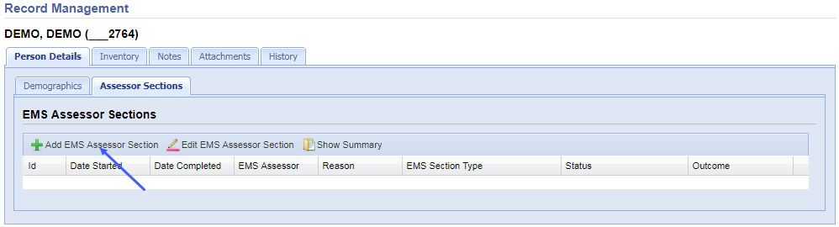
Click <Add EMS Assessor Section> to add a new EMS Assessor Section. This is the top section of the form:
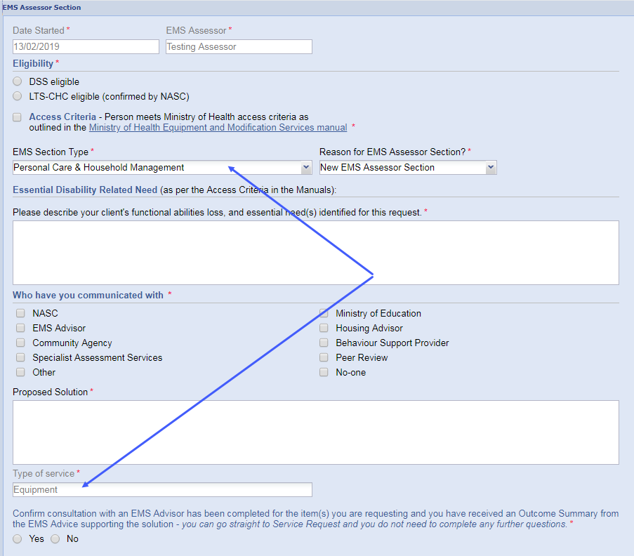
The EMS Section Type will include all services which you have the credentials to deliver and will default if only one section type is available. You cannot complete an EMS Assessor Section for a Section Type that is outside of your area of accreditation. If your accreditation covers more than one Section Type, all applicable options will be available for selection and there will be no default selection. If you are in training for a specific area, please refer to the section headed EMS Assessors in Training.
You can create only one Assessor Section for your solution based on accreditation area.
The Reason for EMS Assessor Section will always default to ‘New EMS Assessor Section’ but there are other options available if needed:
- Change In Need – the Person’s needs have changed since the original Assessor Section was completed
- Data Entry Error Fix – you made a mistake when entering the Assessor Section and you need to redo it
- Additional Equipment or Modification – since entering the Assessor Section, you have realised that the Person needs more services, related to the original Assessor Section
The Assessor Section form covers:
- The type of request ie your area of accreditation
- Eligibility
- Access Criteria
- Essential Disability Related Need
- Proposed solution
- Rationale supporting your choice of solution
The ‘Type of Service’ will be answered automatically depending on the Section Type chosen above; it cannot be changed manually and will be one of three possible service types:
- Equipment
- Housing Modifications
- Vehicle Modifications
The type of service determines the questions that appear in the next part of the form and allows you to enter the rationale behind your choice of solution.
If you have consulted with an EMS Advisor and received an Outcome Summary supporting the solution you do not have to complete the remaining rationale questions:
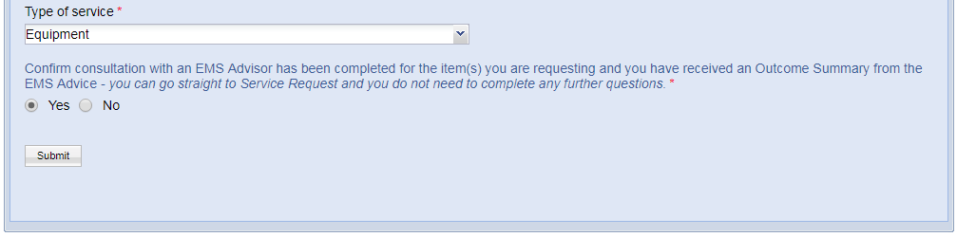
If you answer ‘No’ to having confirmed receipt of an Outcome Summary supporting the solution after consultation with an EMS Advisor, you are presented with the rationale questions.
From this point in the form the rationale changes depending on the type of service you are delivering. For Equipment, if Band 1 List equipment is suitable you will not see the question regarding Band 2 List equipment. You will only see the Band 2 question if Band 1 List does not have suitable equipment and similarly you will only see the Band 3 question if Band 2 List does not have suitable equipment.
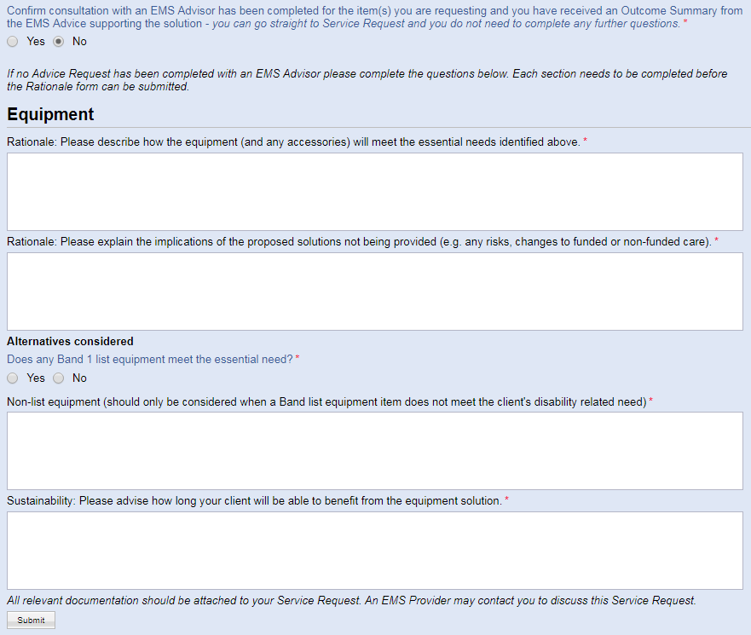
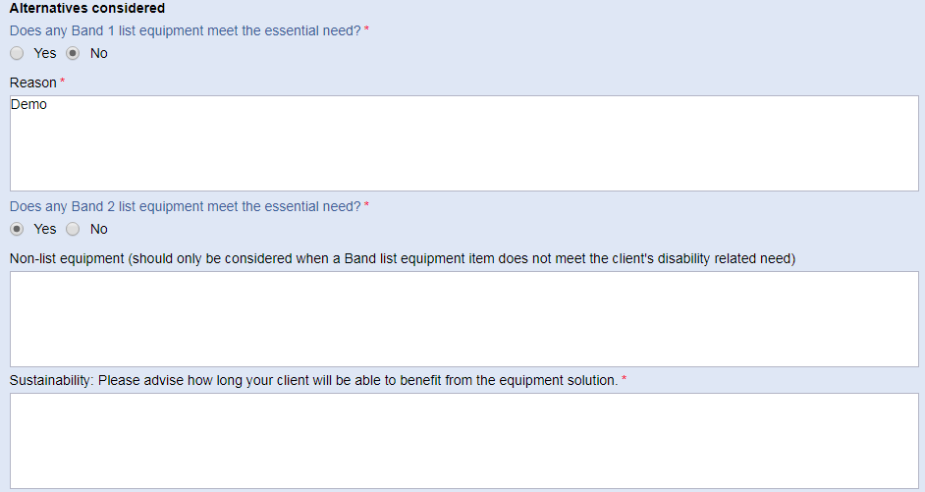
When you have answered all the applicable mandatory questions click <Submit >. You will be presented with a summary of the answers you entered with the option to confirm the answers, or to cancel and return to the form where you can change any of your answers.
Once submitted you will be advised: “Request able to be considered for Funding (subject to all requirements having been met).”
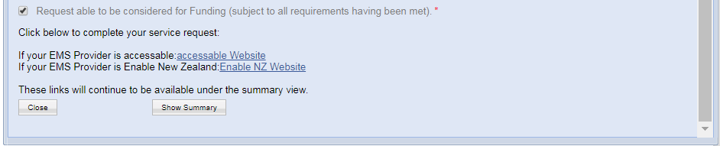
The links to the EMS Providers to create your service request will be presented as shown above.
If you have requested a solution for a service that you are not credentialled for, before the links to the EMS Providers are displayed you will be asked to enter details of a credentialled Assessor to review and approve your application. See [EMS Assessors in Training]. Once the review has been completed, the Assessor Section will then be deemed to be complete and you will be able to submit your application.
For Assessors in the Enable NZ Region:
Although the Assessor Section will be complete within the Portal, before you can successfully complete a Service Request within Enable NZ you are required to attach a pdf version of the Assessor Section, showing the rationale for the solution. To do this, click the <Show Summary> button at the bottom of the submitted form. This will display the summary of the Assessor Section. Using the pdf link at the top of the summary, export the summary as a pdf and save the document to your computer.
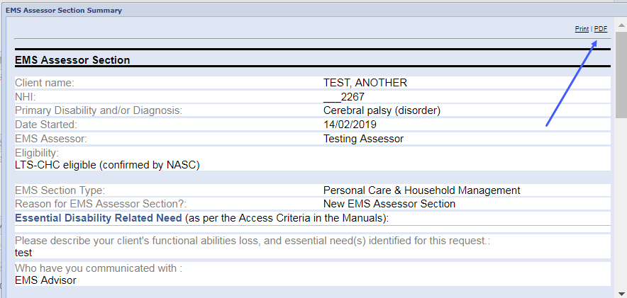
After you click the link through to Enable NZ as part of this process you will be asked to upload the pdf that you have just saved.
For Assessors in the accessable Region:
Within the accessable region, clicking on the link will take you directly into accessable’s system; the relevant details including the rationale will be passed through in the Service Request automatically.
If you want to keep a copy of the completed Assessor Section for your files click the <Show Summary> button at the bottom of the submitted form. This will display the summary of the Assessor Section. Using the pdf link at the top of the summary, export the summary as a pdf and save the document to your computer.

EMS Assessors in Training
EMS Assessors that are in training for an Area of Accreditation, are able to complete Assessor Sections for this area, however these require review by a suitably accredited Assessor.
If you are in training, when you complete the Assessor Section, you will be presented with a list of all EMS Section Types that you are already credentialed in, followed by any EMS Section Types that you are in training for, appended with (Provisional):
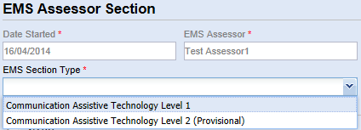
Any area in which you are fully credentialed, will be available without the Provisional option.
Select the applicable EMS Section Type and complete the Assessor Section as described earlier in this guide. When the form has been submitted you will be required to specify the Assessor Code of either your Supervisor or another suitably credentialed EMS Assessor who can review this Assessor Section.
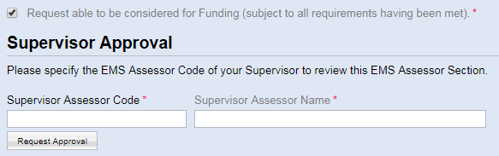
Enter their Assessor Code and tab out of the field to trigger a search. The name of the EMS Assessor will appear so that you can confirm you have entered the correct Assessor Code. Click <Request Approval>. Once the Assessor Section has been reviewed, you will receive an automated email advising you of the outcome. Complete the process in the normal way.

Authorising Supervisors/EMS Assessors
If you are responsible for the supervision of an EMS Assessor in training, you will be required to review and either approve or reject the Assessor Section(s) that they have entered. The Assessor Section will be entered by the EMS Assessor in the normal way, but before it can be submitted to the EMS Provider, you will receive an email asking you to review and approve the Assessor Section.
Log into the Portal (a link will be provided in an email that will be sent to you), and open the Assessor Section that you are to review:
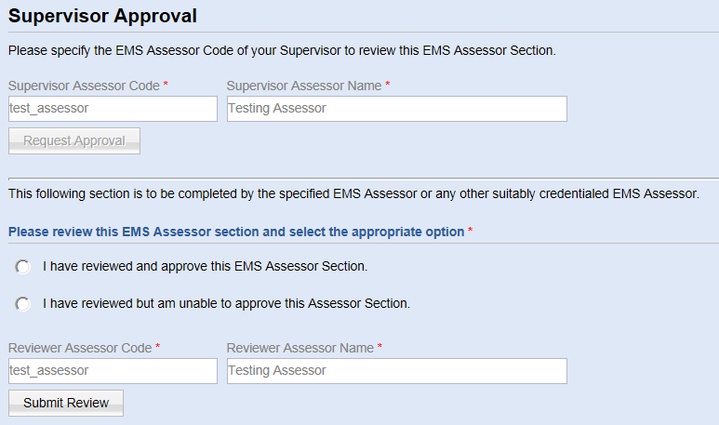
Review the complete record and then respond as appropriate, by selecting one of the two options available. Click <Submit Review>. This will send an automated email to the originating EMS Assessor so that they can complete the process.

Saving as a PDF
If you need to save your Assessor Section as a pdf, here are the steps to take:
- Open the Assessor Section Summary
- At the top of the Assessor Section Summary, look for the Print and PDF options:
- Click PDF. A pdf view of the Assessor Section will be presented. Hover your mouse towards the bottom of the screen and you should see the options to print or save the pdf. Click the save option and save it to your computer

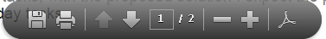

Previous Records
Any records created prior to the removal of the Impact on Life Questionnaire and workflow in February 2019 will be visible through the ‘Previous Records’ tab. If there are no previous records for your client there will be no ‘Previous Records’ button displayed.
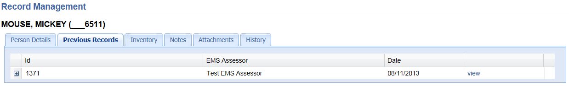
Clicking on the ‘+’ symbol expands the display to show the associated Assessor Sections. The Impact on Life questionnaire and the Assessor Section summaries can be opened by selecting <view>.
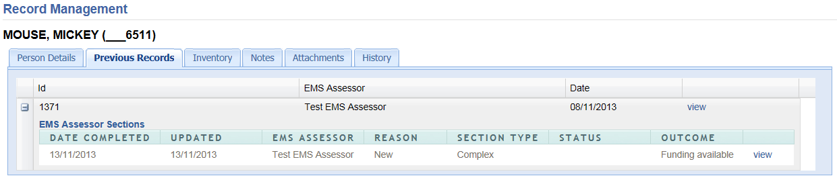
Links to the EMS Providers are not present when viewing records via Previous Records.

Inventory
Data covering equipment and services that have been provided are fed into the Portal on a quarterly basis once received from the EMS Providers. Before visiting your Client it is recommended that you take a look at the Person Record to see whether any or what equipment and services have been provided for this Person.
The inventory tab will automatically appear on the Person Record (next to the Person Details tab or the Previous Records tab if present):
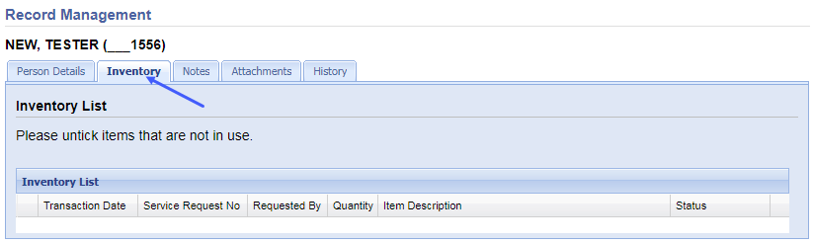
Select the Inventory tab to view the Inventory List. Each item that has been provided for that Person will appear on the list, with a tick box automatically selected (left hand-side), indicating that the item is in use. If you know that the Person is not using the inventory item, remove the tick from the box and the status will automatically update to “Not in use”. This will assist EMS Assessors and Providers to be kept up to date with Inventory utilisation.
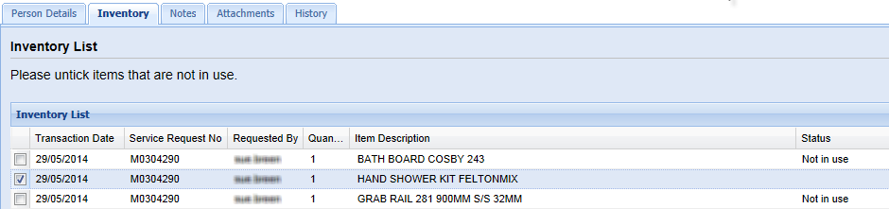

Resources
The Resources area stores useful reference information and is opened by selecting <Resources> from the menu options:

Support
For help using the Portal contact your Supervisor or Manager in the first instance and if they cannot help, contact helpdesk@enigma.co.nz

If you do not see this search criteria you will not have access to the Ministry’s Master NHI Register. Contact helpdesk@enigma.co.nz for advice

