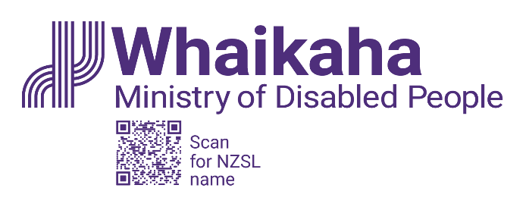
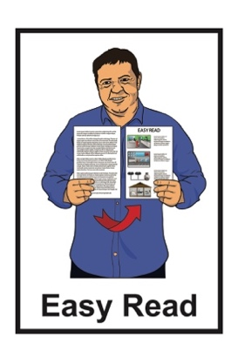

New Zealand Disability Strategy 2026 to 2030:

Public Consultation


Published: August 2025

What you will find in here

Page number:
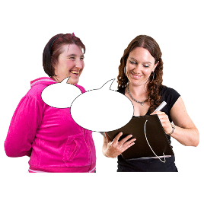

About this Easy Read 3

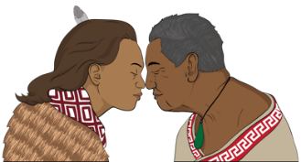
Whakataukī 6

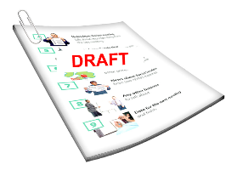
Where to read the draft strategy 8

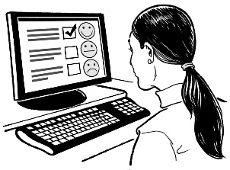
How to tell us what you think 11

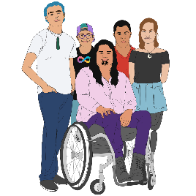
Why do we need a disability
strategy? 15

Page number:

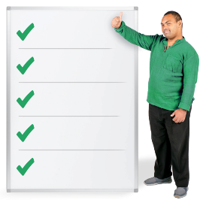
What have we done about the draft strategy so far? 18


What will happen next? 23

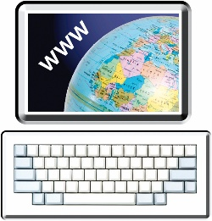
More information 24

About this Easy Read

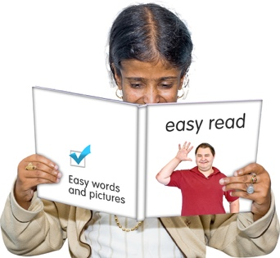
This Easy Read is about the public consultation for the New Zealand Disability Strategy refresh.

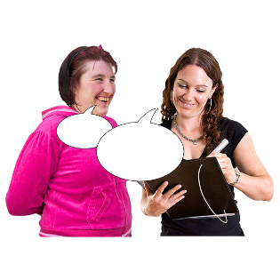
A public consultation means asking everyone what they think about something.


The New Zealand Disability Strategy is a group of plans
that tell the Government how to make things better for disabled people in Aotearoa New Zealand.

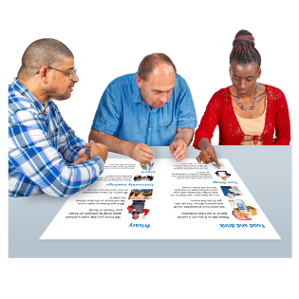
The New Zealand Disability Strategy refresh is about:

looking at the New Zealand Disability Strategy
thinking about what needs to change
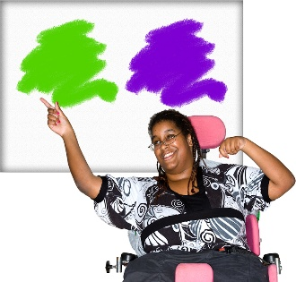
choosing what the New Zealand Disability Strategy will do over the next 5 years.


This Easy Read is by Ministry of Disabled People – Whaikaha.

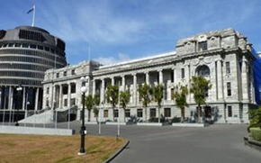
Ministry of Disabled
People – Whaikaha works to make things better for disabled people by working with:
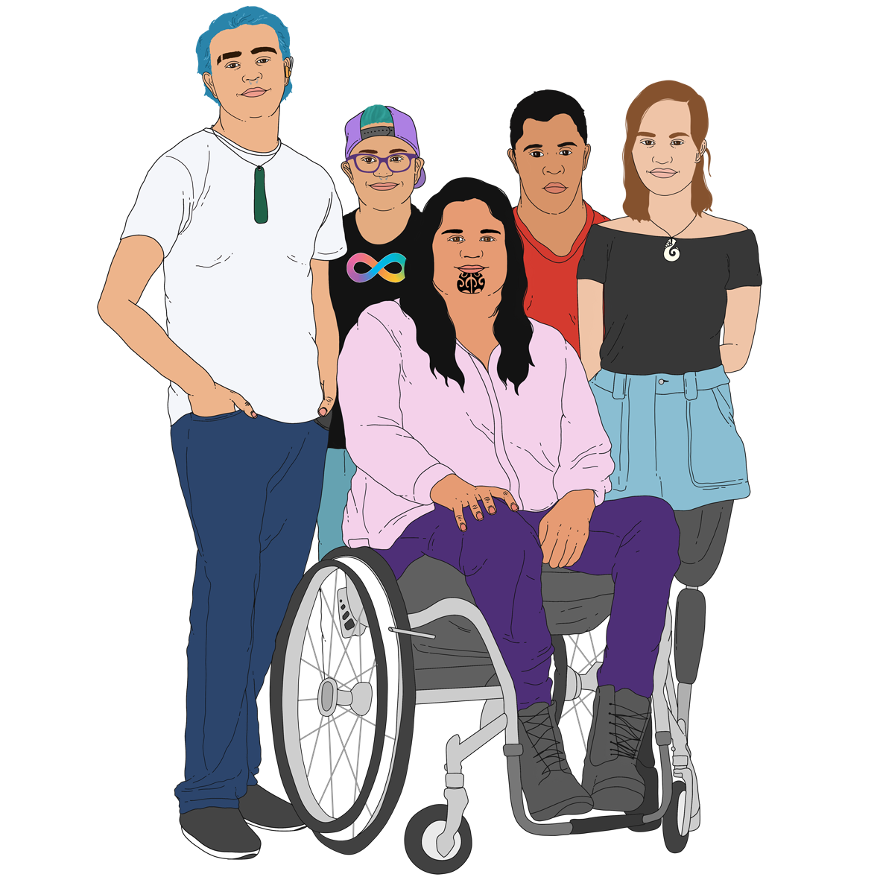
the Government
the community which includes:
- disabled people

- tāngata whaikaha Māori / Māori disabled people
businesses.

In this Easy Read when we say Whaikaha this means Ministry of Disabled People – Whaikaha.

Where it says we / our this means Whaikaha.

Whakataukī

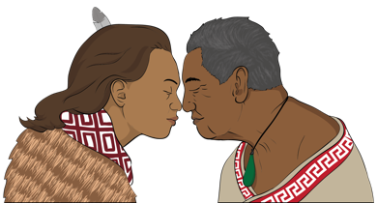
A whakataukī is a Māori saying that shares an important message.

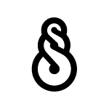
Kia hiwa rā kia hiwa rā.

Kia kōkiri ake, kia mataara.

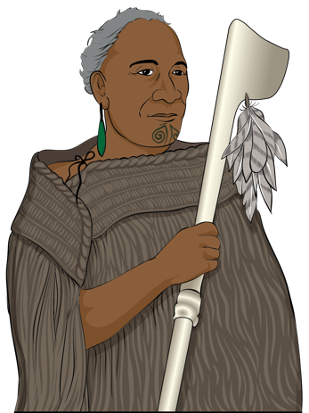
He karanga atu ki te ao whānui, ki te ao whaikaha.

Haere mai ōu whakaaro rangatira ki tēnei kaupapa whakahirahira nau mai e te iwi e.

Here are the English words of the whakataukī:


Be watchful, be alert.

Rise up, come forward, be counted, be alert.
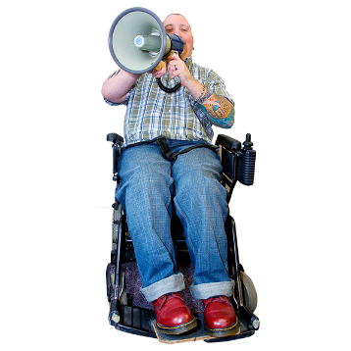

A call going out to the world, to the disabled world.

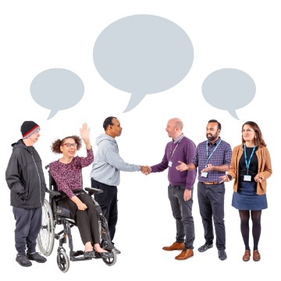
We welcome your chiefly thoughts to this important discussion.

We welcome all.

Where to read the draft strategy

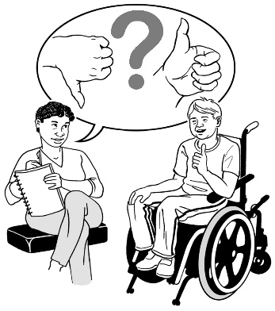
We want you to tell us what you think about the draft New Zealand Disability Strategy 2026 – 2030.

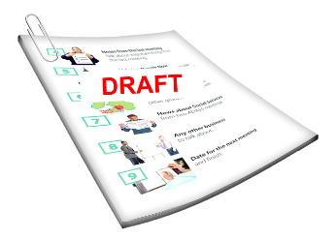
A draft is the first version of a document.

In this Easy Read the draft New Zealand Disability Strategy
2026 – 2030 will be called the draft strategy.


The draft strategy is available in:
Easy Read
Braille
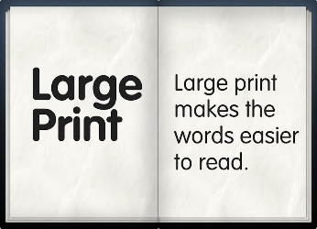
audio
large print.

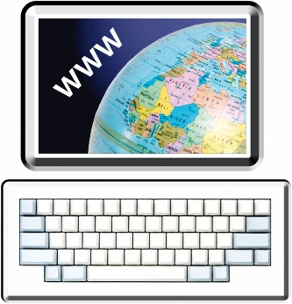
Find the format you want at this webpage:

https://shorturl.at/18ALN


Click on the heading Read the draft strategy 2026 – 2030.


The draft New Zealand Disability Strategy 2026 – 2030 is in New Zealand Sign Language / NZSL at this webpage:

https://shorturl.at/v7RsK

How to tell us what you think

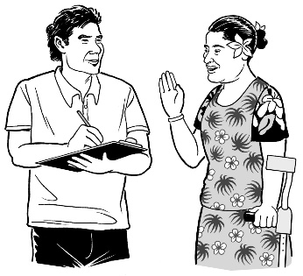
There are lots of ways you can tell us what you think about the draft strategy.

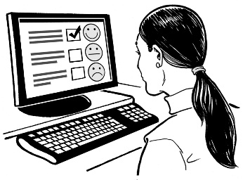
You can fill out a feedback form online.

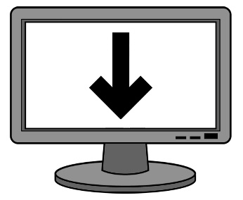
You can also:
download the feedback form to your computer
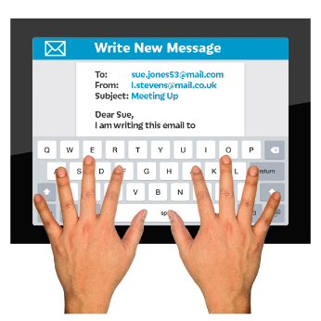
and
email the filled in feedback form to us.

The feedback form is at this webpage:

https://shorturl.at/18ALN

Click on the heading How to have your say.

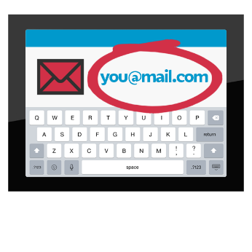
You can tell us what you think by email at:

disabilitystrategy@whaikaha.govt.nz

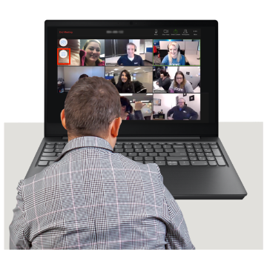
You can tell us what you think by going to a meeting:
online
in person.

You can tell us you want to go to a meeting at this webpage:

https://shorturl.at/zuF06

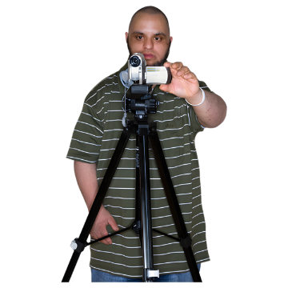
You can also send us a 3 minute video by recording it at:

www.videomail.io

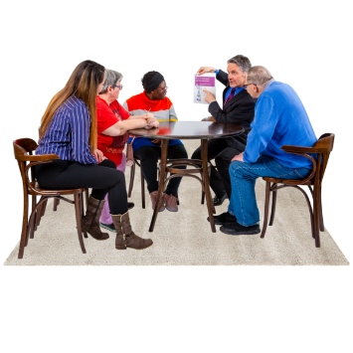
You can give your feedback as part of an organisation / group using our consultation toolkit.

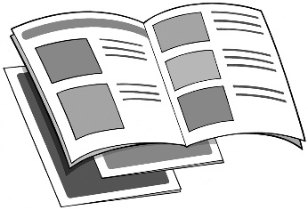
Here a consultation toolkit is information that tells you how to give feedback from your group.

To get a consultation toolkit email us at:

disabilitystrategy@whaikaha.govt.nz

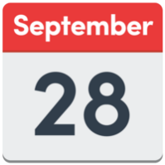
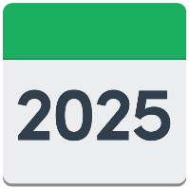
The date to give your feedback by is Sunday 28 September 2025.

Why do we need a disability strategy?

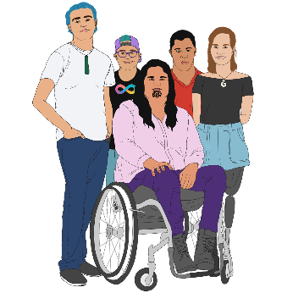
The New Zealand Disability Strategy tells government agencies what is important to:
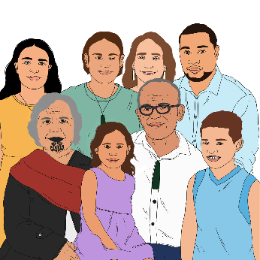
disabled people
tāngata whaikaha Māori
whānau / families.
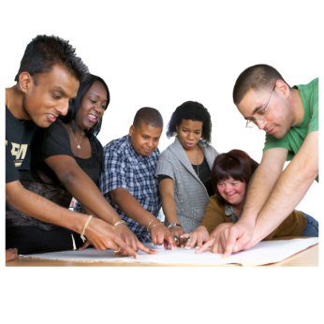

The New Zealand Disability Strategy shows where change is needed.
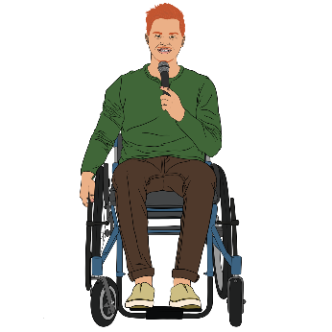

This is so disabled people can:
be leaders
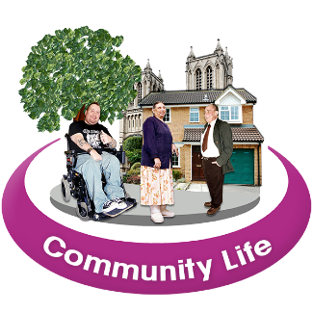
have good lives
take part in their community.
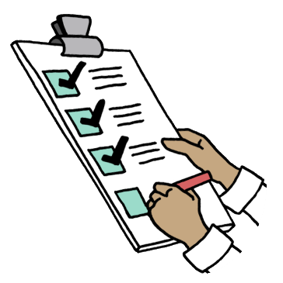
The strategy will also be part of how New Zealand works towards what we need to do for the United Nations Convention on the Rights of Persons with Disabilities.

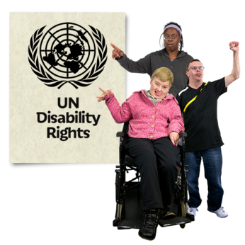
The United Nations Convention on the Rights of Persons with Disabilities is a law lots of countries have agreed to.

The United Nations Convention on the Rights of Persons with Disabilities is also called the UNCRPD.
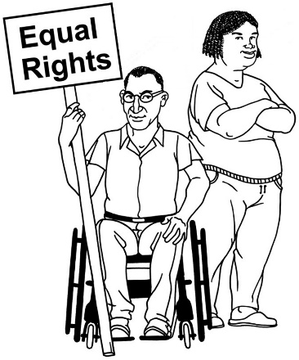

It says what governments must do to make sure disabled people get the same rights as everybody else.

Find out more about the UNCRPD at this webpage:

https://shorturl.at/7bkgj

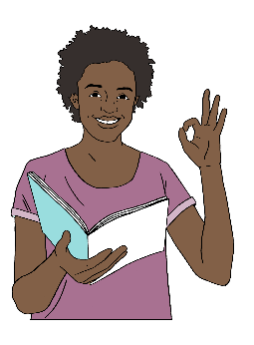
This webpage has an Easy Read version of the UNCRPD.


Whaikaha will also use the New Zealand Disability Strategy to:
check how the lives of disabled people are being made better
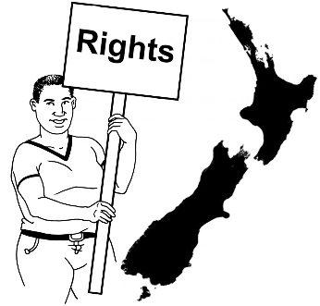
support the rights of:
- disabled people
- tāngata whaikaha Māori.

What have we done about the draft strategy so far?

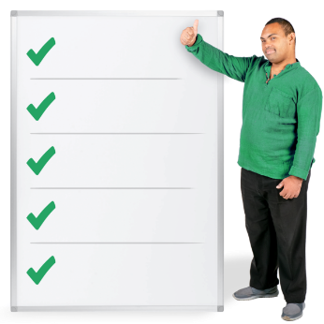
In 2025 we have worked on refreshing the:
visions of the strategy
principles of the strategy.
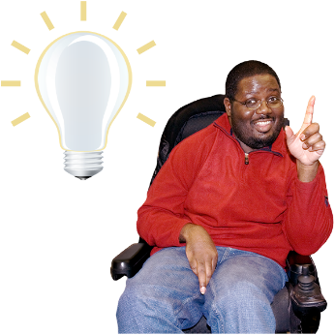

Here vision means ideas about
what things should be like.


Here principles are ideas / beliefs that tell us:
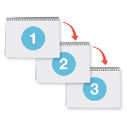
what we should do
how we should do things.

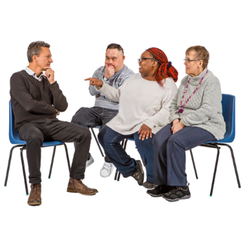
We did this by talking to:
disabled people’s organisations
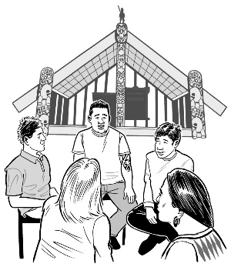
tāngata whaikaha Māori:
- groups
- whānau / families.

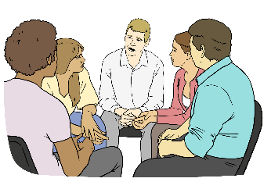
We have also made working groups.

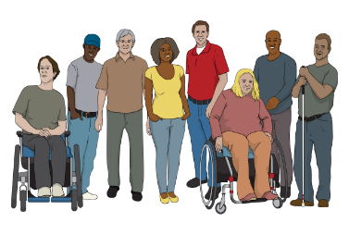
Here a working group:
is a group of people who know lots of things about disability
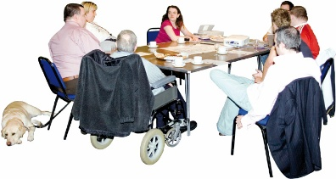
meets to talk about important things to do with the New Zealand Disability Strategy refresh.


For our priority outcome areas the working groups came up with:
goals
why things need to change
actions.

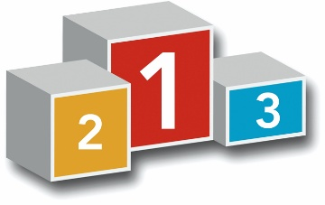
Here priority outcome areas are
the things that are most important to work on in the New Zealand Disability Strategy refresh.
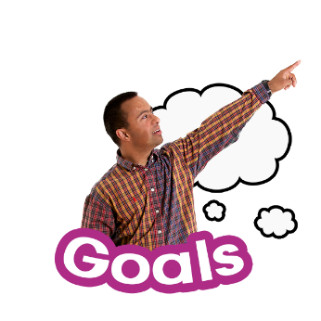

Here goals are how we want things to be.


Actions are things we will do to work towards meeting a goal.

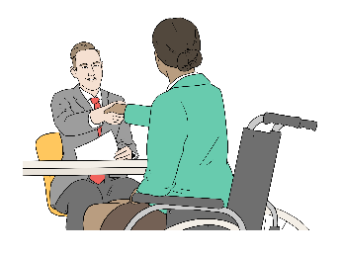
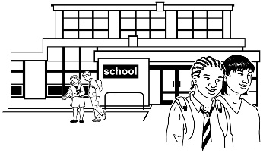
The priority outcome areas of the New Zealand Disability Strategy refresh are:
education / school

employment / jobs
health
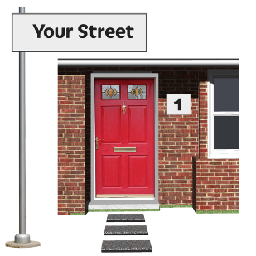
housing
justice.

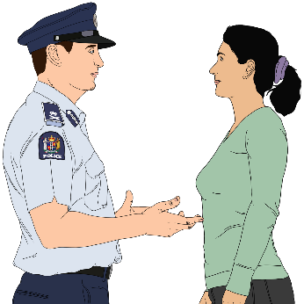
Here justice means things to do with New Zealand law like:
police
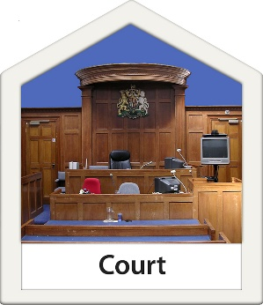
courts
prisons.

Find out more about the working groups at this webpage:

https://shorturl.at/bWJDf

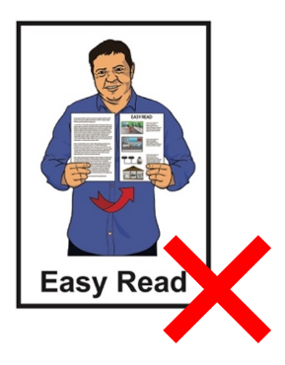
This webpage is not in Easy Read.

What will happen next?


We will look at all the feedback when the consultation is done.

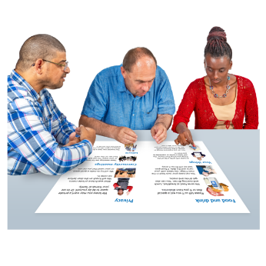
The feedback will be used to update the draft strategy.

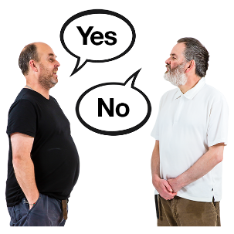
The draft strategy will then go to Cabinet for them to decide on.

Here Cabinet is a group of senior government ministers who make important decisions.

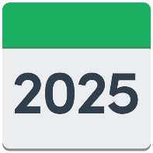
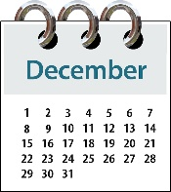
The aim is to put out the finished New Zealand Disability Strategy
2026 – 2030 in December 2025.

More information


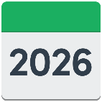
The disability strategy we are using now is the New Zealand Disability Strategy 2016 – 2026.

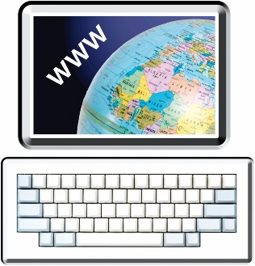
The New Zealand Disability Strategy 2016 – 2026 is at this webpage:

https://shorturl.at/oEB9X

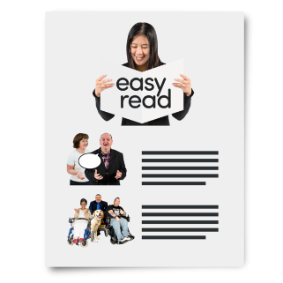
There is an Easy Read version of the New Zealand Disability Strategy
2016 – 2026 at that webpage.

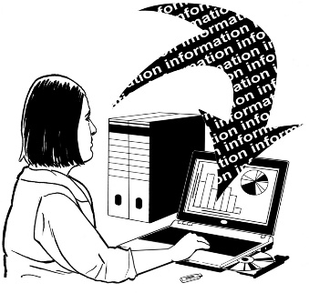
Data insights were used as part of the New Zealand Disability Strategy refresh.


Data insights are sets of information that show what groups of people:
are doing
need.

The data insights used in the New Zealand Disability Strategy refresh are at this webpage:

https://shorturl.at/dfqoK
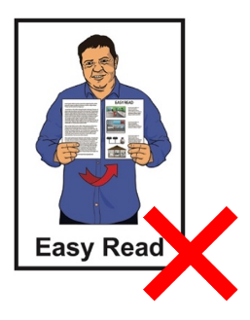

This webpage is not in Easy Read.

Cabinet papers on the New Zealand Disability Strategy are at this webpage:

https://shorturl.at/ulCM0

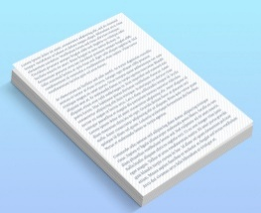
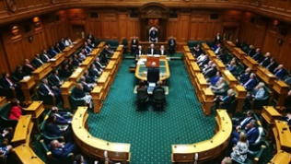
A Cabinet paper has information in it that Cabinet needs to:
know about
make a decision about.

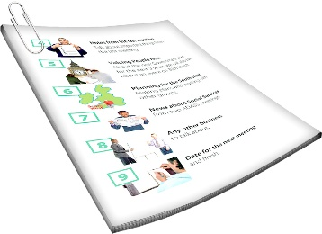
Some of the Cabinet papers are in Easy Read.


This information has been written by Whaikaha – Ministry of Disabled People.

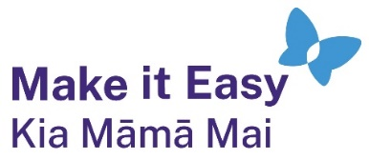
It has been translated into Easy Read by the Make it Easy Kia Māmā Mai service of People First New Zealand Ngā Tāngata Tuatahi.

The ideas in this document are not the ideas of People First New Zealand Ngā Tāngata Tuatahi.

All images used in this Easy Read document are subject to copyright rules and cannot be used without permission.


Make it Easy uses images from:

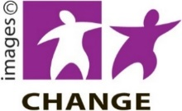
- Photosymbols

- Change Images


- Huriana Kopeke-Te Aho
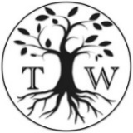
- SGC Image Works

- T Wood


- Studio Rebeko

- Inga Kramer.

