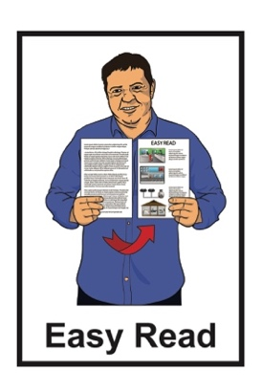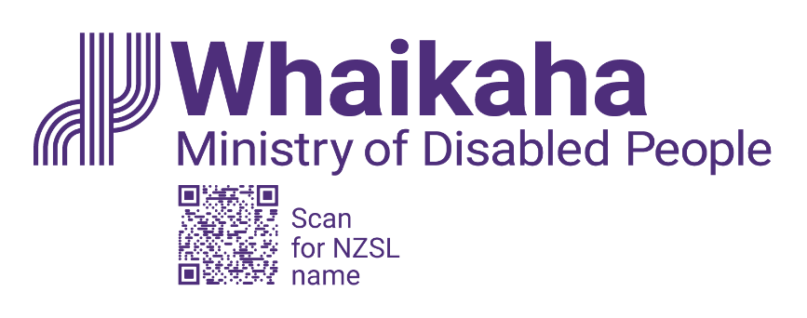

New Zealand Disability Strategy

2026 to 2030:

Public consultation has started

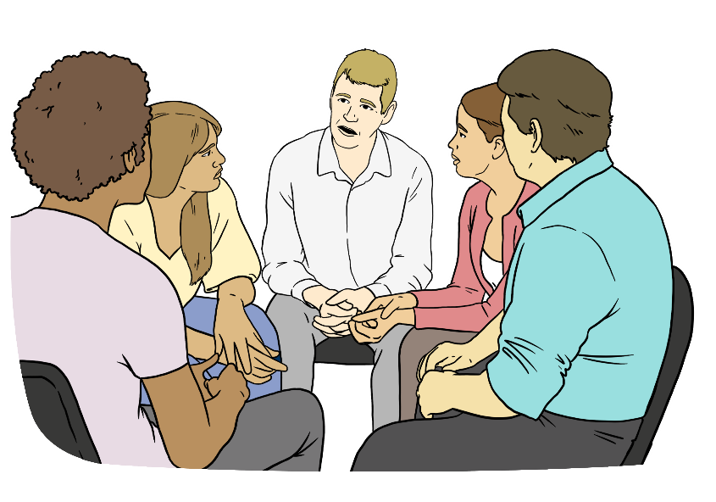

Published: August 2025

# About this Easy Read

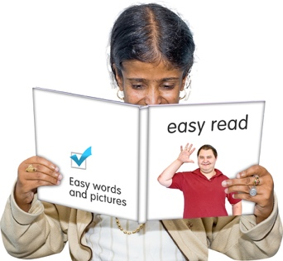

This Easy Read has some news about the **public consultation** for the **New Zealand Disability Strategy refresh**.

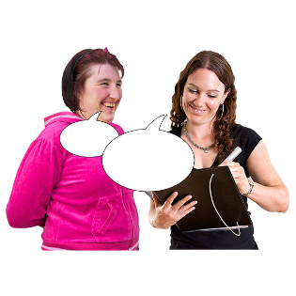

A **public consultation** means asking everyone what they think about something.

The **New Zealand Disability Strategy** is a group of plans that tells the Government how to make things better for disabled people in Aotearoa New Zealand.

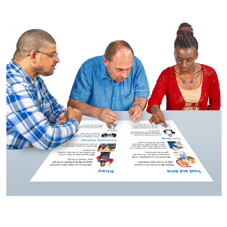The **New Zealand Disability Strategy refresh** is about:

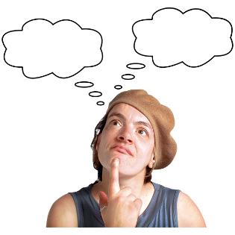looking at the New Zealand Disability Strategy

thinking about what needs to change

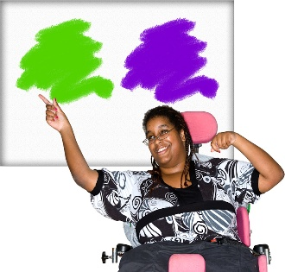choosing what the New Zealand Disability Strategy will do over the next 5 years.

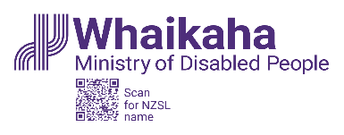This Easy Read is by the **Ministry of Disabled People – Whaikaha.**

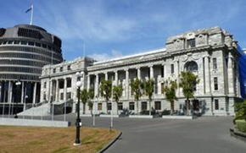The **Ministry of Disabled**

**People – Whaikaha** works to make things better for disabled people by working with:

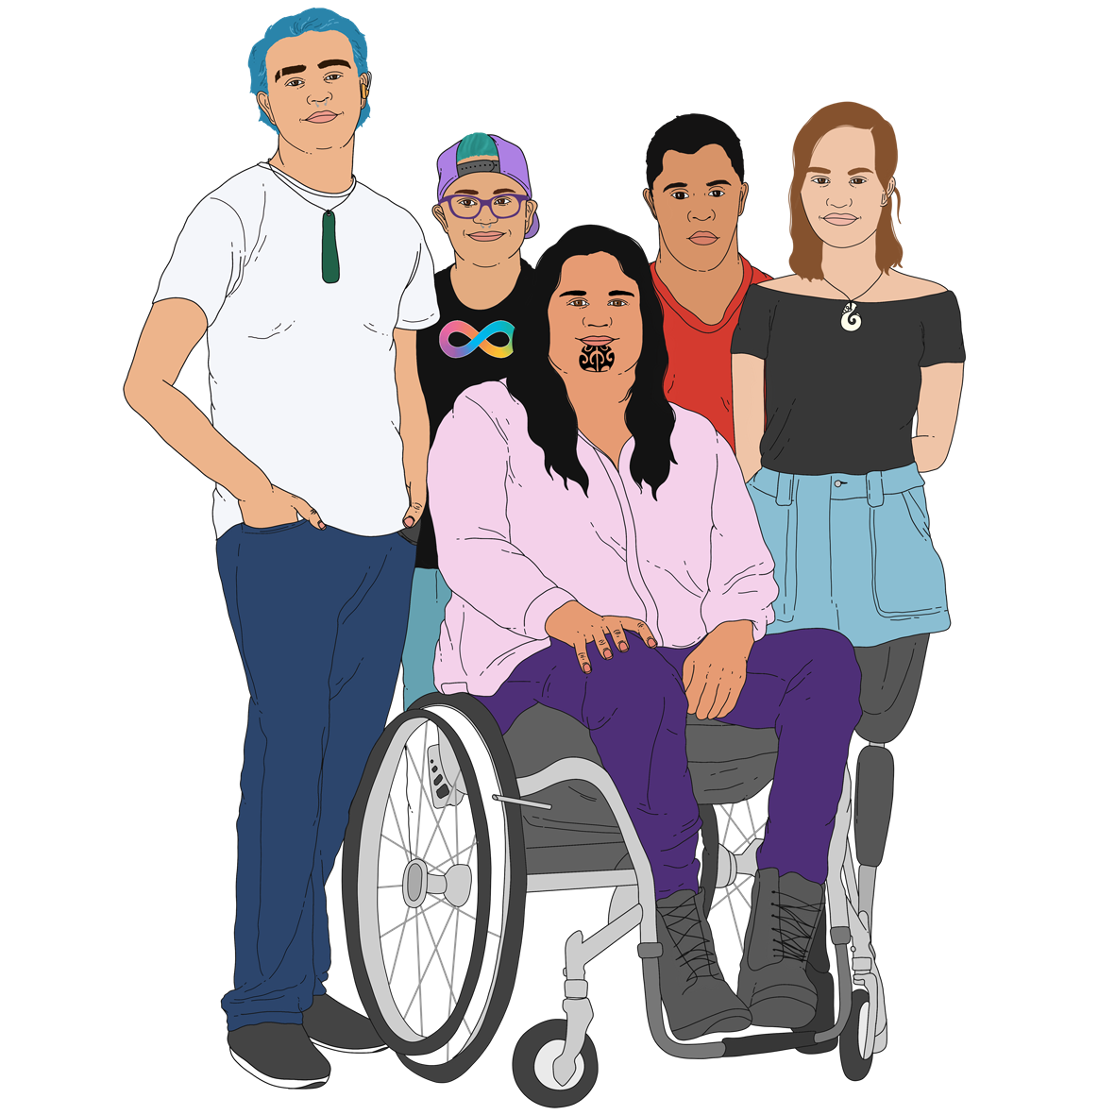the Government

the community which includes:

* disabled people
* tāngata whaikaha Māori / Māori disabled people

businesses.

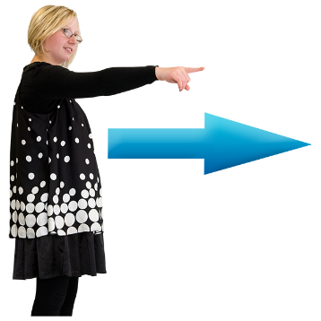In this Easy Read when we say **Whaikaha** we mean the Ministry of Disabled People – Whaikaha.

Where it says **we / our** this means Whaikaha.

# The public consultation is now open

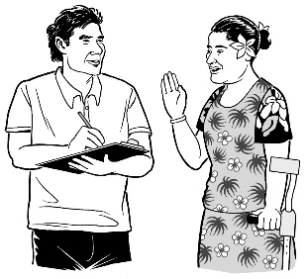

**Feedback** is now open for the **draft** New Zealand Disability Strategy

2026 – 2030.

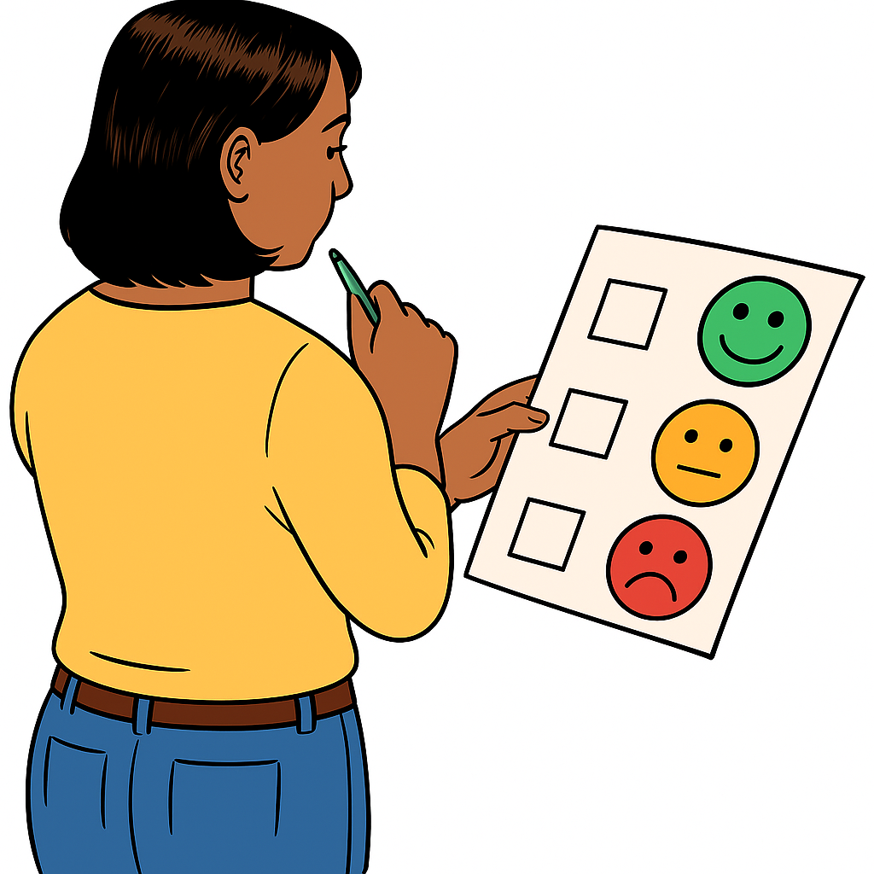

**Feedback** means saying what you think about something.

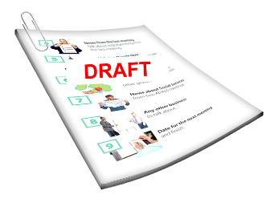

A **draft** is the first version of a document.

In this Easy Read the draft New Zealand Disability Strategy   
2026 – 2030 will be called the **draft strategy**.

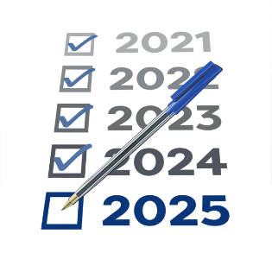The disability strategy being used right now:

is 10 years old

needs to be refreshed.

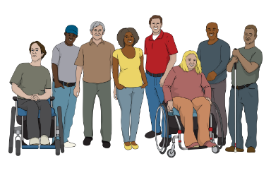The new draft strategy:

talks about things that matter to the disability community

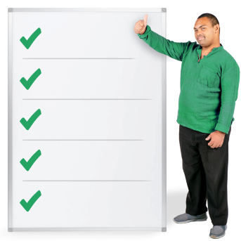has a list of:

* things that need to be done to make change
* where changes are needed most.

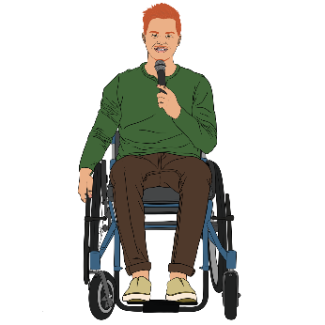This is so disabled people can:

be leaders

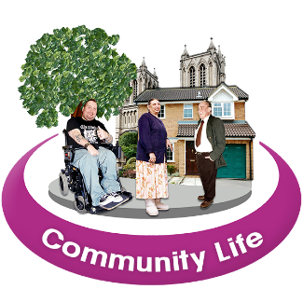have good lives

take part in their community.

The draft strategy is available in these alternative formats:

Easy Read

New Zealand Sign Language / NZSL

Braille

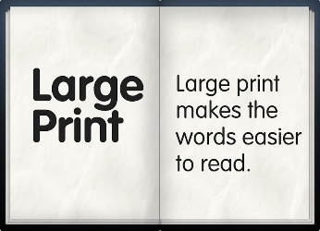audio

large print.

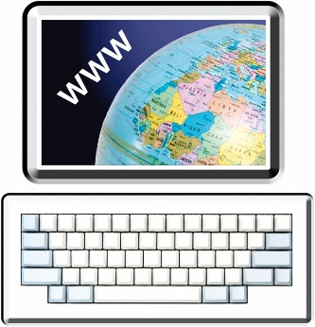You can find the alternative formats of the draft strategy on this **webpage**:

[**https://shorturl.at/18ALN**](https://shorturl.at/18ALN)

To find the alternative formats at that webpage click on the heading:

**Read the draft strategy   
2026 – 2030**.

The draft strategy is also in New Zealand Sign Language / NZSL at this **webpage**:

[**https://shorturl.at/v7RsK**](https://shorturl.at/v7RsK)

# How to tell us what you think

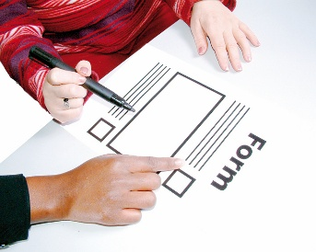There are lots of ways you can tell us what you think about the draft strategy including:

feedback forms

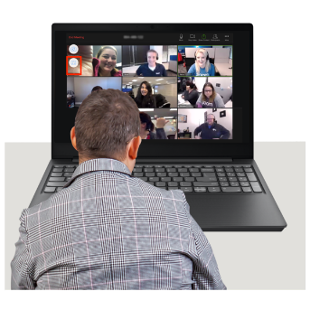meetings that will be:

* online
* in person.

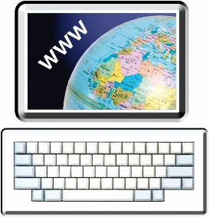The feedback forms are at this **website**:

[**https://shorturl.at/18ALN**](https://shorturl.at/18ALN)

To find the feedback forms at that website click on the heading:

**How to have your say**.

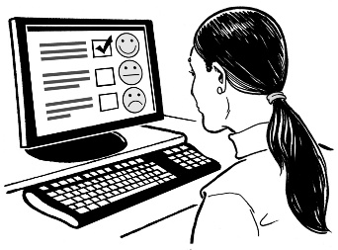You can fill in the feedback form online.

You can also:

download the feedback form

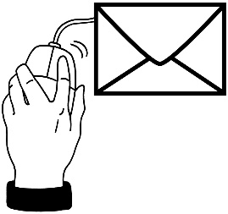and

email it back to us.

Information about our meetings is at this **website**:

[**https://shorturl.at/zuF06**](https://shorturl.at/zuF06)

You can give feedback about:

the whole draft strategy

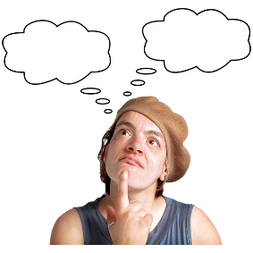or

parts of the draft strategy that are interesting to you.

The date to give us your feedback by is **Sunday 28 September 2025**.

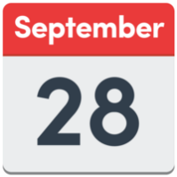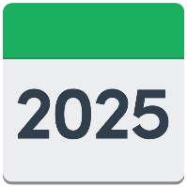

# What is in the draft strategy?

The draft strategy has 4 main parts:

the background

the vision and principles

**priority outcome areas** with **actions**

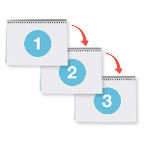

how we will measure success.

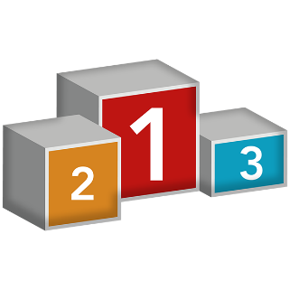

**Priority outcome areas** are the   
most important things we need to work on.

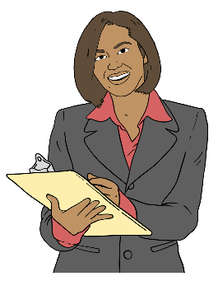

**Actions** are things we will as part of meeting a **goal**.

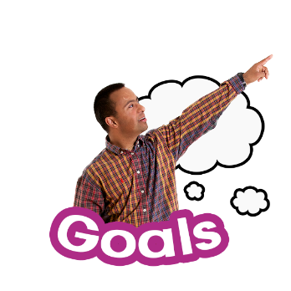

A **goal** is something we want to   
make happen.

## The background

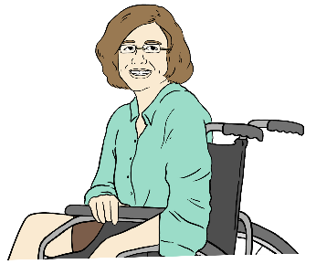

The background of the draft strategy talks about:

how things are now for:

* 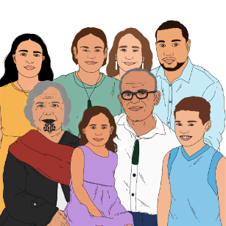disabled people
* tāngata whaikaha Māori
* 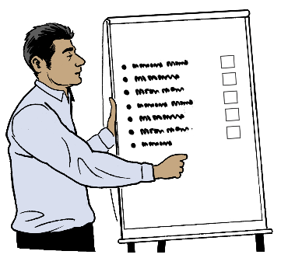whānau / families.

what is getting better

what still needs to change.

## The vision and principles

Here **vision** means ideas about   
what things should be like.

Here **principles** are ideas / beliefs that tell us:



what we should do

how we should do things.

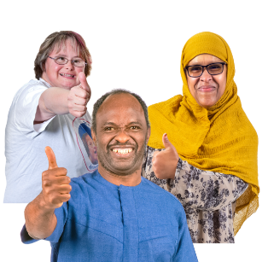

The vision sets out the **future** disabled people want.



The **future** is a time that is still to happen.

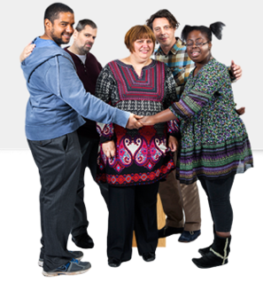The principles are important things in the draft strategy like:

**values**

ideas

commitments / things we say we will do.

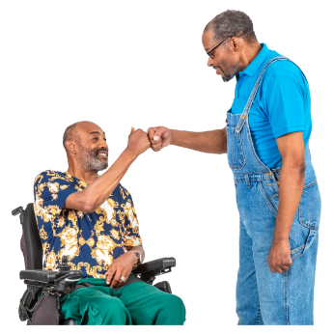**Values** are beliefs that are used to decide how to:

behave

work.

## Priority outcome areas with actions

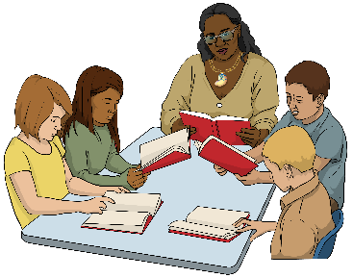

The priority outcome areas are:

education like schools

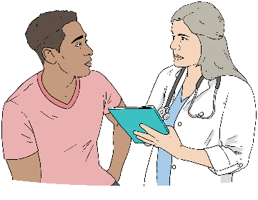employment which is about jobs

health

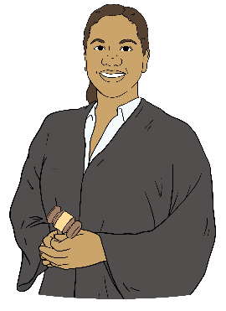housing

**justice**.

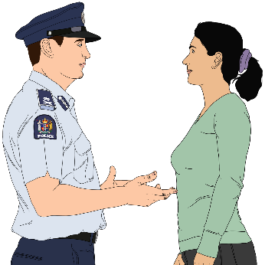Here **justice** means things to do with New Zealand law like:

police

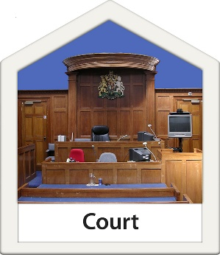courts

prisons.

## How we will measure success

We will check the strategy is working to make a difference for disabled people in Aotearoa New Zealand.

# What has happened so far?

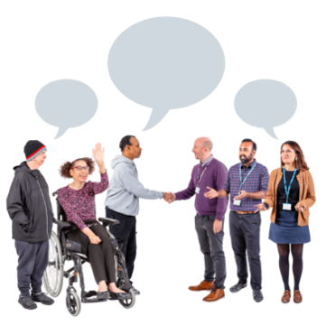We got the draft strategy ready for consultation by:

getting information from the disability community

looking at **data** on how things are for disabled people

talking to:

* 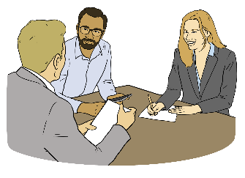**sector** leaders
* government agencies.

**Data** is information that shows what groups of people:

are doing

need.

A **sector** is a group of lots of   
different **industries** that do similar kinds of work.



An **industry** is a group of businesses that do the same kind of work.

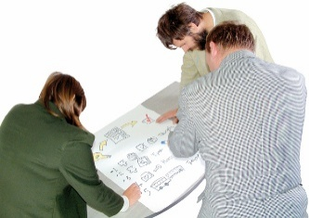Whaikaha worked with disability groups to refresh the vision and principles of the draft strategy.

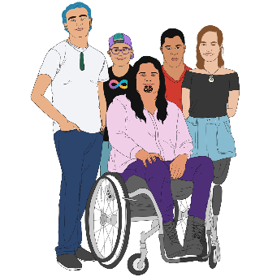**Working groups** were set up that included:

tāngata whaikaha Māori

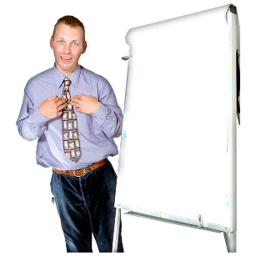**representatives** from the disability:

* sector
* 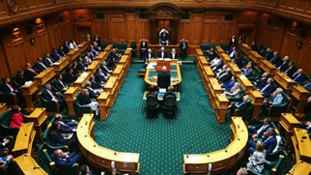industry

Government officials.

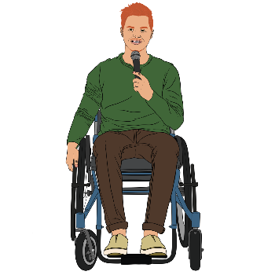A **representative** is someone who speaks for a group.

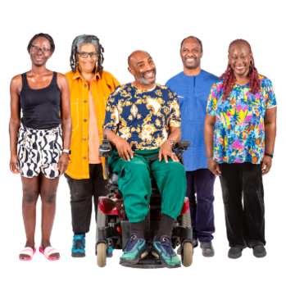Here a **working group:**

is a group of people who know lots of things about disability

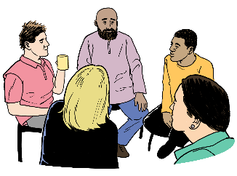meets to talk about important things to do with the New Zealand Disability Strategy refresh.

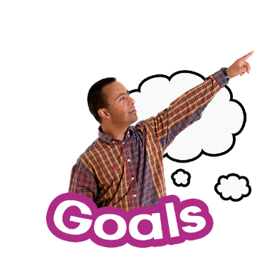For each of the priority outcome areas the working groups came up with:

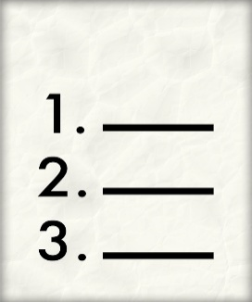goals

actions to reach the goals.

**This information has been written by the Ministry of Disabled People – Whaikaha.

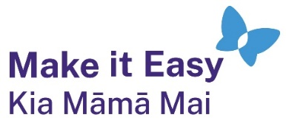It has been translated into Easy Read by the Make it Easy Kia Māmā Mai service of People First New Zealand Ngā Tāngata Tuatahi.

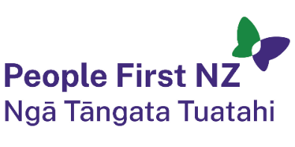

The ideas in this document are not the ideas of People First New Zealand Ngā Tāngata Tuatahi.



All images used in this Easy Read document are subject to copyright rules and cannot be used without permission.

Make it Easy uses images from:

* 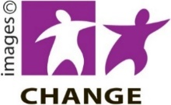Photosymbols
* Change Images
* 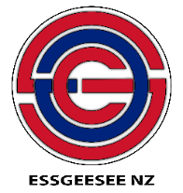Huriana Kopeke-Te Aho

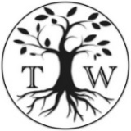

* SGC Image Works
* T Wood
* 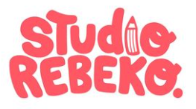Studio Rebeko
* Inga Kramer.