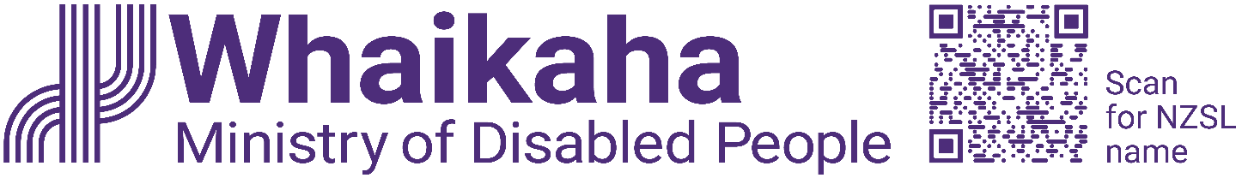

Summary of work to action health priority area
New Zealand Disability Strategy 2026-2030
Adapted in 2026 by Accessible Formats Service,
Blind Low Vision NZ, Auckland

Transcriber's Note: The logo at the top of the page is: Whaikaha—Ministry of Disabled People.

Summary of work to action health priority area

Introduction
The New Zealand Disability Strategy 2026-2030 (the strategy) has 34 actions across five priority areas of education, employment, health, housing and justice. During 2026:
- 13 actions will be delivered or started
- 6 actions will be developed
- 12 actions will be scoped (planned)
This document is a 'change story' to explain:
- the goal for the health priority area and the supporting actions
- when the actions will be done and by which government agencies
- the order for actions and the links between the actions
- the risks and challenges to doing the actions.
A change story for each priority area is on the Whaikaha—Ministry of Disabled People website.
Education: https://www.whaikaha.govt.nz/about-us/our-work/new-zealand-disability-strategy-2026-2030/delivering-the-actions#scroll-to-1Short url: https://shorturl.at/wKTw5
Employment: https://www.whaikaha.govt.nz/about-us/our-work/new-zealand-disability-strategy-2026-2030/delivering-the-actions#scroll-to-2. Short url: https://shorturl.at/FJghF
Housing: https://www.whaikaha.govt.nz/about-us/our-work/new-zealand-disability-strategy-2026-2030/delivering-the-actions#scroll-to-4. Short url: https://shorturl.at/fiijr
Justice: https://www.whaikaha.govt.nz/about-us/our-work/new-zealand-disability-strategy-2026-2030/delivering-the-actions#scroll-to-5. Short url: https://shorturl.at/2v9jr

Health change story
In the health priority area, there is a goal and 5 supporting actions. In 2026, 1 action will be delivered, 3 will be developed, and 1 will be scoped (planned).
The health actions cover a range of issues. They will be led by either the Ministry of Health (MoH) or Health New Zealand (HNZ).

Goal for health
Disabled people will achieve the highest possible standard of health and wellbeing.

Actions for health
To make progress towards the strategy's goal for health, Government will do the following.
- Review and improve policies and practices, so the health journey is equitable, accessible and inclusive. This review will cover all interactions with the health system: communication, information, technology, decision-making, service design and delivery, and the built environment. Self-determination will be key, including making sure tools for self-determination and supported decision-making are standard practice in healthcare—especially for people with different communication, cognitive or psychosocial needs.
- Train the health workforce to deliver services that are inclusive, culturally safe and easy to navigate. This includes:
- increasing disabled people throughout the health and disability workforce. This can be done through recruitment and workplace policies, inclusive and accessible work environments, and career development
- embedding disability responsiveness and lived experience in workforce training and ongoing professional development.
- Build disabled people's skills and knowledge to take up health system roles. Government agencies will find ways to build disabled people's capability for health system design, consultation, monitoring, leadership, and advisory and governance roles.
- Identify disabled people in national health data. This will make disabled people more visible in the health system, so population health outcomes and patient experiences can be monitored better, while ensuring information security, privacy and protection.
- Put a system in place so disabled people can record their accessibility needs against their National Health Index (NHI) number. Recording people's accessibility needs will mean those needs can be easily shared with health providers. Disabled people will not have to repeat their needs to providers, and providers will be better able to meet those needs. This work will be guided by disability community expectations and data sovereignty.

When and how are the health actions being carried out
Most actions in the health priority area have policy and delivery parts. There will need to be contributions from both the MoH and HNZ in either a lead or support role.
Work relevant to the health actions has already started. This includes actions under HNZ's "Te Pae Waenga—New Zealand Health Plan 2023–2027", and the Ministry of Health's "Health of Disabled People Strategy 2023".
Based on their roles and responsibilities, the MoH and HNZ are working in the first six months of 2026 to scope the work needed. This will include:
- being clear about what work has started
- who will contribute
- what will be delivered
- the order of work
- what actions depend on each other.
For example:
- action 1 will build on HNZ work to improve practices and delivery, and HNZ and MoH will develop and apply an approach to prioritise the policies for review
- action 2 and action 3 cover work on strategy, policy, operations and delivery.
- action 4 needs a policy and system level approach. Population level data is needed for monitoring and reporting and to identify where there are ways to improve the health system for disabled people
- action 5 is part of the broader Patient Profile and National Health Index (PPNHI) programme being implemented by HNZ.

Risks and challenges for the health actions
There are many links between the health actions and many of the actions depend on one another. As a result, slow progress in one action may also slow the progress of other actions. Progress on some projects, such as the PPNHI programme, may also depend on securing funding in future Budget rounds.
End of Summary of work to action health priority area

