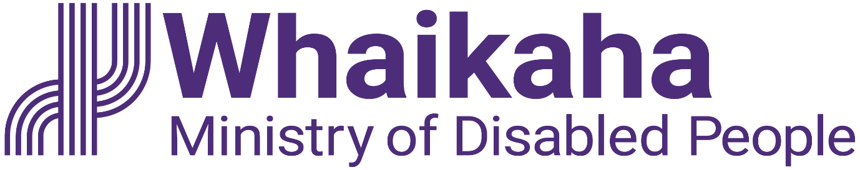
Whaikaha Community Update
Adapted in 2023 by Accessible Formats Service, Blind Low Vision NZ, Auckland

TN: Logo on the top of the page is: Whaikaha Ministry of Disabled People.

Whaikaha Community Update
Tēnā koutou katoa,
Welcome to the latest Whaikaha community update.
In this update, we will share information about what we have been working on Whaikaha as well as an important update about access to COVID-19 antiviral treatments.

Office for Disability Issues now part of Whaikaha
The Office for Disability Issues (ODI) was integrated into Whaikaha on 1 August 2023. The people from the ODI team are continuing their important work as part of the Policy, Strategy and Partnerships Group within Whaikaha, including partnering on the New Zealand Disability Strategy and Action Plan, interagency advice based on the UNCRPD, and advice for the Minister for Disability Issues. The New Zealand Sign Language Board and the team supporting them remains the same.

UNCRPD update
Whaikaha has been leading the coordination of the Government response to the recommendations from the United Nations Committee on the Rights of Persons with Disabilities (UNCRPD). The Committee examined New Zealand in September 2022 and provided 60 recommendations. Since then, Whaikaha has been working with relevant government agencies to respond to the recommendations, and the Government has now agreed to implement 51 out of the 60 recommendations.
The next step is for the Minister for Disability Issues to report back to Cabinet on agencies' implementation progress, and to seek Cabinet agreement to a monitoring process. This will also include the ways recommendations which have not been agreed to can be monitored.
The Government has also agreed to hold a public forum with the disability community by December 2027. This will provide an opportunity, halfway through implementation, to ensure that progress is being made and that agencies have an opportunity to improve implementation should they need to.
For more information on the Government response visit the Cabinet agrees on a response to recommendations from UNCRPD examination article. You can find this here: https://odi.cwp.govt.nz/united-nations-convention-on-the-rights-of-persons-with-disabilities/cabinet-response-uncrpd-examination or here https://tinyurl.com/b5s3etmb
The full Cabinet paper is available in three alternate formats. The summary Cabinet paper is available in all alternate formats.

Nōku te kainga noho, nōku te whakatau, My Home, My Choice
My Home My Choice launched this year as part of the Whaikaha System Transformation. It focuses on the work needed to transform the way people in residential services are assisted so they have more choice and control in their lives. This includes developing options and alternatives for people who are considering entry into or exit out of residential services and supporting disabled people and tāngata whaikaha Māori to have opportunities for learning, working, having somewhere to call home and fully participating in their community.
The programme has now appointed its steering group and they have held their first meeting. The group is made up of seven representatives from the community and Sir Robert Martin KNZM and Gary Williams MNZM will provide leadership as the patrons.
The programme is still in its very early stages but there will be opportunities for the wider community to provide feedback throughout the programme soon.
For more information (including alternate formats) visit our website at: https://www.whaikaha.govt.nz/about-us/policy-strategies-and-action-plans/my-home-my-choice/ or here https://whaikaha.govt.nz/mhmc.

Funding secured to extend the Enabling Good Lives approach
In September 2023, the Government announced that Whaikaha had secured funding of $73.7 million over the next four years and $40.5 million in the following years to continue to transform the disability system in line with the Enabling Good Lives approach.
A Transformation Management Office is being established in Whaikaha to oversee the detailed development and implementation of the system transformation initiatives. It will report to a tripartite Transformation Management Board which will provide governance on the transformation initiatives with disabled people and tāngata whaikaha Māori working alongside leadership from within the executive of Whaikaha.
More information: https://www.whaikaha.govt.nz/about-us/enabling-good-lives/#scroll-to-5 or here https://whaikaha.govt.nz/sept-fund.

Transformation Management Board—call for interest
To ensure disabled people and tāngata whaikaha Māori are at the decision-making table, we are establishing the Transformation Management Board. Our video newsletter let people know that applications were open from 11-25 October 2023.
The Transformation Management Board is one of the partnership arrangements being established to transform the disability support system, so it improves the lives of disabled people and tāngata whaikaha Māori throughout Aotearoa New Zealand.
Once appointed, Management Board members will primarily provide advice to support the implementation of transformation initiatives funded through the Budget 2022 contingency. Members will be paid, and travel may be needed.

Work with us
Over the coming months, we will be looking for the right people to join our team and help shape the future of disability services in New Zealand. There are opportunities across all teams in Whaikaha working to deliver better outcomes for disabled people, tāngata whaikaha Māori, families and whānau in line with the Enabling Good Lives approach. All our kaimahi (staff) must be able to establish credibility and trust and have empathy for the unique and diverse experiences of disabled people. We welcome applications from disabled people, or those who have a lived experience of disability through whānau or community involvement.
All vacancies will be listed on our website here: www.whaikaha.govt.nz/comms.
We encourage disabled people and their whānau to apply.
If you want to learn more about working at Whaikaha, check out our YouTube video with our Chief Executive, Paula Tesoriero, and Ben O'Meara, Deputy Chief Executive Policy, Strategy and Partnerships. You can find the video here: https://www.youtube.com/watch?v=GXDI_-jDgkY

Access expanded for COVID-19 antiviral
From 1 October 2023, Pharmac has expanded access to COVID-19 antiviral treatments for people who are vulnerable to severe illness following COVID-19 infection, including disabled people and people with one or more severe health conditions that have resulted in severe frailty or vulnerability. The changes reflect feedback received from patients and carers, health practitioners, and Whaikaha in response to a Pharmac consultation ending 21 August 2023.
More information is available on the Pharmac website here: https://pharmac.govt.nz/news-and-resources/news/2023-09-20-media-release-access-to-covid-19-antiviral-treatments-widened-for-more-people-at-risk/ or here https://tinyurl.com/yc2kr8cy.

Want to get in touch?
We will share another update soon but if there is something specific you would like to hear about in future updates, other general feedback or you want to get in touch, please visit our Contact us webpage here: https://www.whaikaha.govt.nz/contact-us/

You can also contact us on:
Phone: 0800 566 601
Mon, Tue, Thur, Fri: 8am-5pm
Wed: 9:30am-5pm
Text: 4206
New Zealand Relay is a telecommunications service for people who are Deaf, Deaf-blind, experiencing hearing loss or have a speech condition. For more information go here: www.nzrelay.co.nz
They can contact us on your behalf during these times:
Monday to Friday 7am to 6pm
Ngā manaakitanga ki a koutou katoa | Best wishes to you all
End of Whaikaha Community Update

