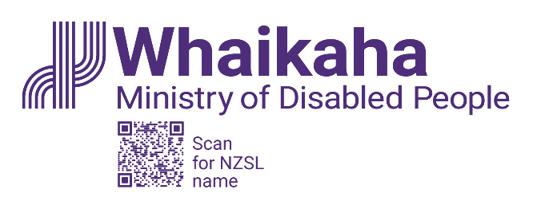
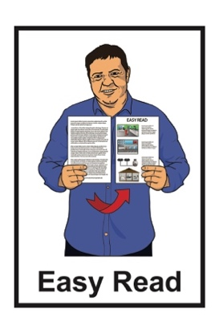

Response to a decision made about family carers

Published: April 2024

About this response

This Easy Read document is a Whaikaha – Ministry of Disabled People statement about the Court of Appeal decision on family carers.

In this Easy Read document Whaikaha – Ministry of Disabled People will be called Whaikaha.
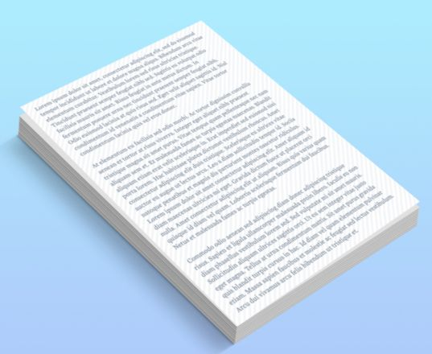

A statement is a short message with information in it.

A decision is when someone makes up their mind about something.

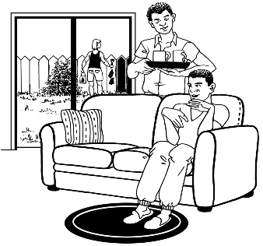
Family carers are whānau / family who are caring for their disabled adult family member.

Whaikaha was started on 1 July 2022.

On this date the agency looking after things for this case changed:
from the Ministry of Health
to Whaikaha.

What the appeal is about

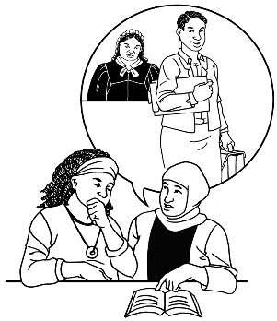
2 family carers took the Government to the Employment Court.

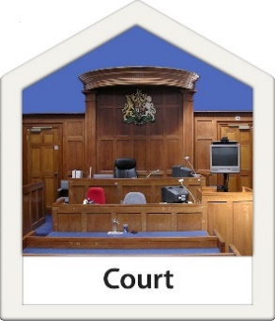
The Employment Court is where employment disputes are:
listened to
decided on.

Employment means getting paid for the work you do.

Disputes means to not agree about something important.

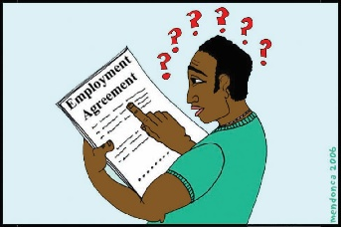
The 2 family carers said that the people they look after could not be their employers.

In this case employer means that the person must hire their carers.

The 2 family carers wanted to know if the Government is their employer.

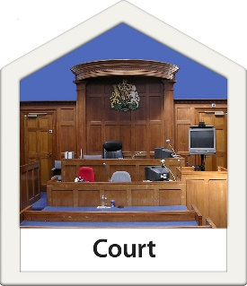
The Employment Court listened to what the family carers were asking.

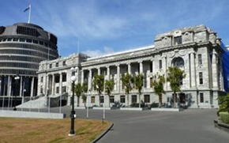
In 2021 the Employment Court decided that the Government is the employer of those 2 family carers.

Why the Government appealed

the decision

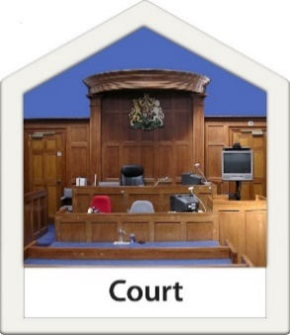
The Government did not agree with the Employment Court decision.

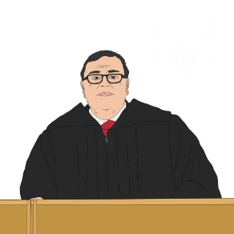
The Government went to the Court of Appeal.

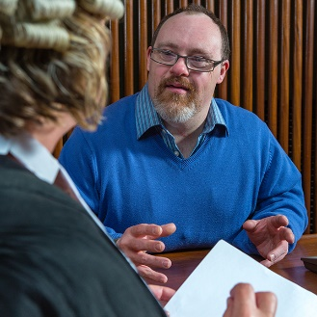
They made an appeal about the case.

An appeal is when someone asks the court to change a decision made in the past.

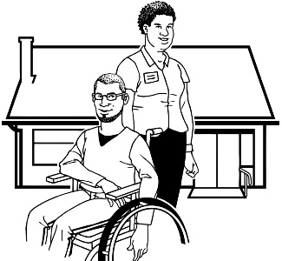
Being an employer means you have obligations towards the people that work for you.

Obligation means a thing that a person must do.

The Government thinks the Employment Court was wrong to decide that they should be the employer of family carers.

This is because the Government:
is not part of what family carers do day to day
does not have any say in hiring the family carers.

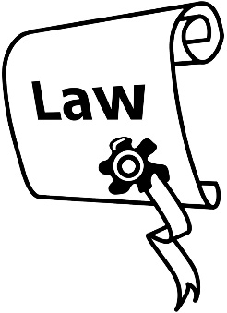
The Government has been waiting for the Court of Appeal to make a decision on the appeal.

This is so they can understand if the Employment Court was:
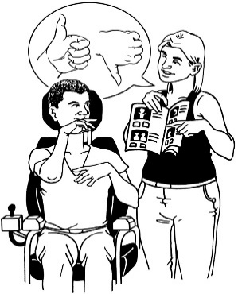
right
or
wrong.

What happens next?

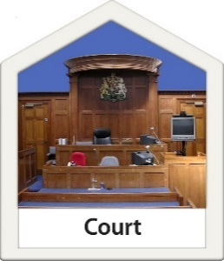
The Court of Appeal made a decision on the appeal.

The Government / Whaikaha needs to think about:
what the decision means
who will be affected by the decision.

When Whaikaha knows more they will tell people what they know.

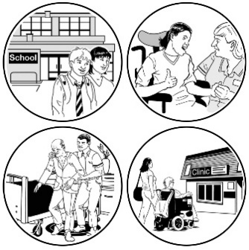
Whaikaha wants to make sure that the people they support get the things they need.

Where to find more information

You can read more about this appeal on this website:

www.whaikaha.govt.nz/pfc

If you have any more questions you can contact Whaikaha by:
phone on:

0800 566 601
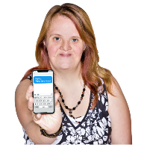
text message on:

4206
email at:

contact@whaikaha.govt.nz

This information has been written by Whaikaha – Ministry of Disabled People.

It has been translated into Easy Read by the Make it Easy Kia Māmā Mai service of People First New Zealand Ngā Tāngata Tuatahi.

The ideas in this document are not the ideas of People First New Zealand Ngā Tāngata Tuatahi.
Make it Easy uses images from:

- Changepeople.org
            - Photosymbols.com

- SGC Image Works
- Huriana Kopeke-Te Aho
- T. Wood.
All images used in this Easy Read document are subject to copyright rules and cannot be used without permission.

