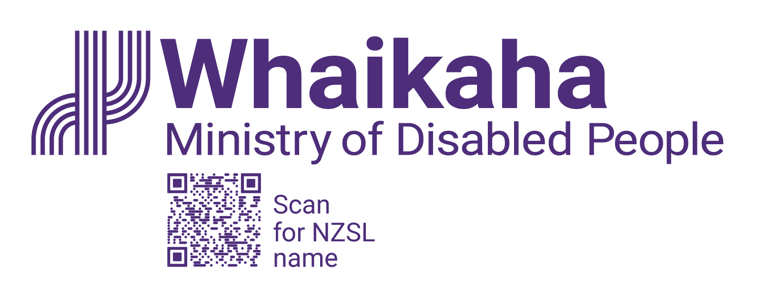

Whaikaha response to Court of Appeal decision on family carers

What this appeal relates to
Two family carers who are looking after their disabled family members previously took the government to the Employment Court.
The two family carers said that the people they look after couldn’t be their employers and they wanted to know whether the government, through Whaikaha, is their employer.
The Employment Court listened to what the family carers were asking, and in 2021 decided that the Government is the employer of those two family carers.
Whaikaha – the Ministry of Disabled People was established 1 July 2022. On establishment, responsibility for these legal proceedings transferred from the Ministry of Health to Whaikaha.

Why Whaikaha appealed the Employment Court’s decision
Whaikaha appealed the Employment Court’s decision to the Court of Appeal because it didn’t agree with the Employment Court’s decision.
Being an employer means you have obligations towards the people that work for you.
Whaikaha thinks the Employment Court was wrong to decide that Whaikaha should be the employer of family carers because we don’t have any involvement in what the family carers do day to day. We didn’t make any decisions about whether to hire them too.
We have been waiting for the Court of Appeal to make a decision on the appeal so we can understand whether the Employment Court was right or not.

Next steps
The Court of Appeal has now made a decision on the appeal.
We need to think about what the decision means, including who is affected by the decision, before we can say anything else.
Once we know more, we will let you know.
Our priority will always be to make sure that people supported through Whaikaha receive the disability support they need.
You can find more information here: www.whaikaha.govt.nz/pfc

End of: Whaikaha response to Court of Appeal decision on family carers

