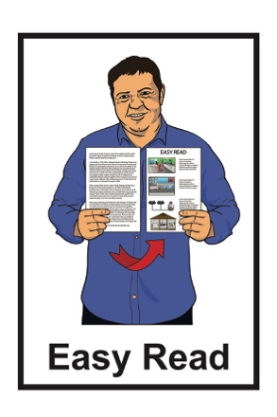

An update from Whaikaha –
Ministry of Disabled People

Newsletter

December 2022
What you will find in here

Page number:
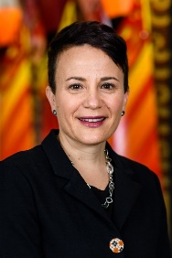

Message from Paula Tesoriero 2
[Grab your reader’s attention with a great quote from the document or use this space to emphasize a key point. To place this text box anywhere on the page, just drag it.]

Our website 10

Online hui / meetings 12
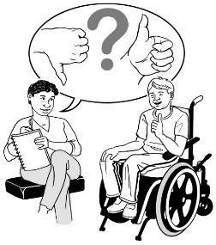

Have your say 15

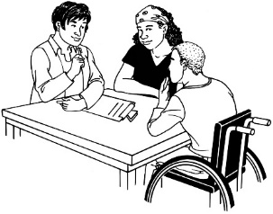
Jobs at Whaikaha 20

Message from Paula Tesoriero

Kia ora / Welcome to the first newsletter from Whaikaha – Ministry of Disabled People.
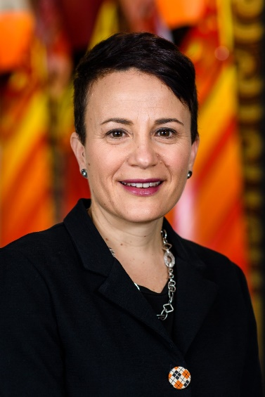

My name is Paula Tesoriero.

I am the Chief Executive for Whaikaha – Ministry of Disabled People.

A Chief Executive is someone who is in charge of an organisation.

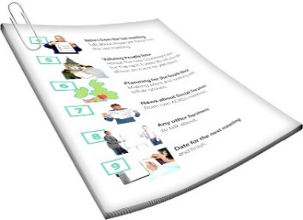
This newsletter gives you an update about what work has been happening at Whaikaha – Ministry of Disabled People.
In this newsletter we will call Whaikaha – Ministry of Disabled People – Whaikaha for short.
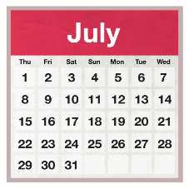
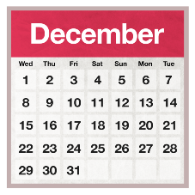

Whaikaha is almost 6 months old.

I have been in my job for 3 months.

A lot of things have happened in that time.

I have met a lot of people who do really important work.

We are working on being able to do a lot more things.
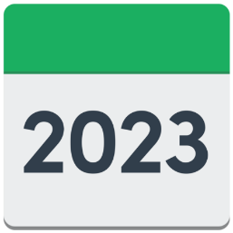

2023 is going to be very busy for us.

What people at Whaikaha have been working on so far

Some of the things we have been working on are:
[Grab your reader’s attention with a great quote from the document or use this space to emphasize a key point. To place this text box anywhere on the page, just drag it.]
- our website – www.whaikaha.govt.nz
- social media like Facebook
- online hui / meetings where people can ask questions
- finding more people to work for us.
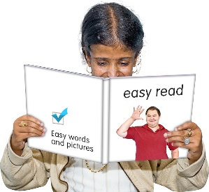

There is more information about all of these later in this newsletter.

Changes to Disability Support

From 2023 we will be working to change disability support services in all of New Zealand to work in an Enabling Good Lives way.

Enabling Good Lives is a different way of thinking about disability support.
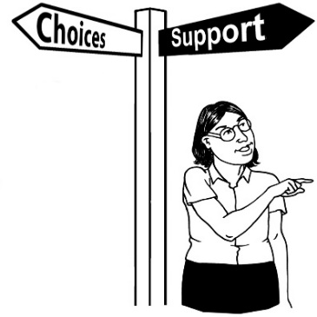

Enabling Good Lives is about having:
- choice and control in your life
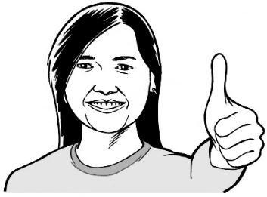
- the support you need and want
- a good life.

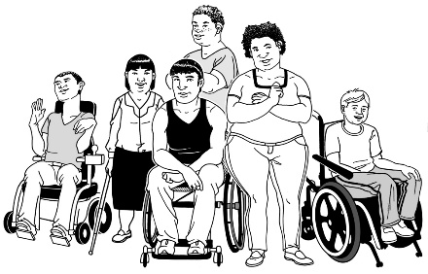
We will do this by working together with:
- the disability community
- Māori.
It is important to us that we get it right.
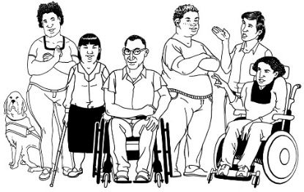

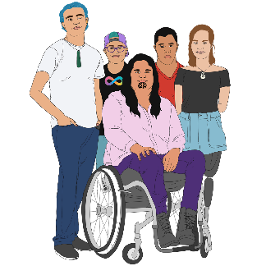
Enabling Good Lives will make a better future for:
- disabled people
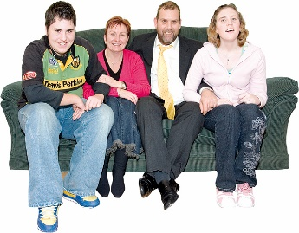
- tāngata whaikaha Māori / Māori disabled people
- their whānau / family.

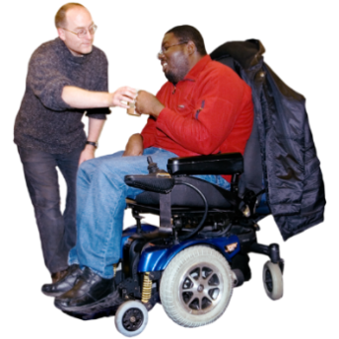
We have also been working hard to make sure moving disability support services from Manatū Hauora Ministry of Health goes well.

Feedback from the United Nations

In August some people from Whaikaha went to a meeting at the United Nations office in Geneva in Switzerland.

The United Nations office brings together people from a lot of different countries to work together on important things.

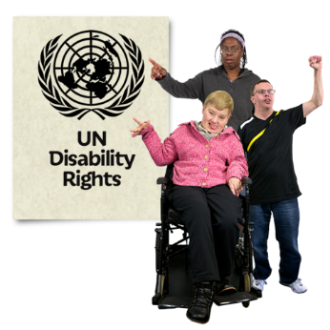
The United Nations gave us some feedback about how well New Zealand is doing at making the things in the United Nations Convention on the Rights of Persons with Disabilities happen.

Feedback is saying what they think about how things are going.
The United Nations Convention on the Rights of Persons with Disabilities is a document lots of countries have agreed to.
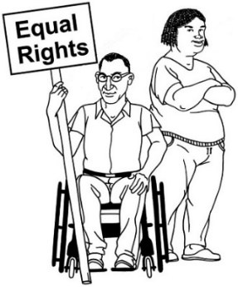

It says what governments must do to make sure disabled people get the same rights as everybody else.

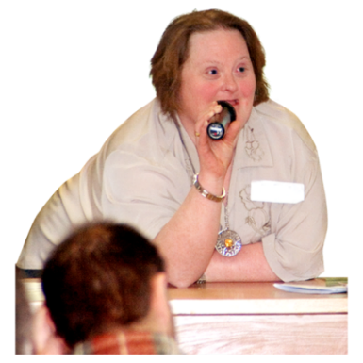
We are now working on what we will say to the United Nations about the feedback.

Wishing you the best for 2023

2022 has been:
- busy
- another hard year with the COVID-19 pandemic.

I am looking forward to spending some time with my whānau / family this summer.

I hope you:
- enjoy your summer celebrations like Christmas
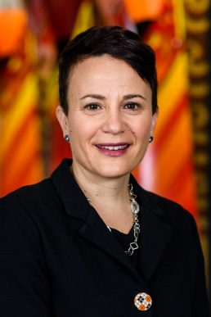
- have a calm start to 2023.

Ngā mihi nui / Many thanks

Paula Tesoriero

Our website

You can find more information about Whaikaha on our website at:
[Grab your reader’s attention with a great quote from the document or use this space to emphasize a key point. To place this text box anywhere on the page, just drag it.]

www.whaikaha.govt.nz

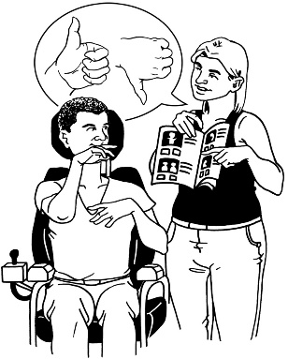
Since we started our website we have added a lot of information about:
- what we are doing
- how to get support
- news
- who we are.

We keep working on our website together with people in the disabled community.
[Grab your reader’s attention with a great quote from the document or use this space to emphasize a key point. To place this text box anywhere on the page, just drag it.]

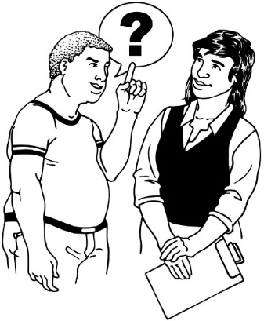
We will keep asking how we can make:
- our website better
- it easier for you to access what you need.

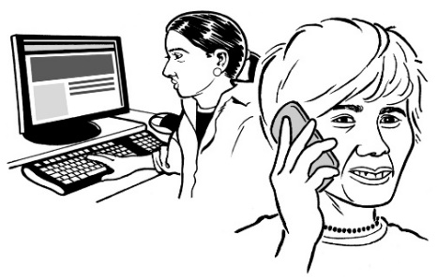
We would like to hear from you if you:
- cannot find the information you need
- have ideas about how to make our website better.

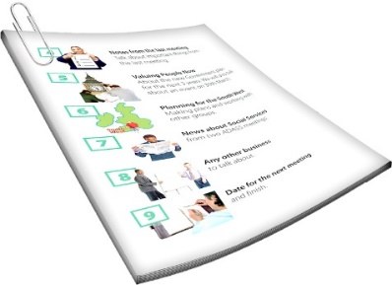
There is information on how to get in touch in the next part of this document.

Online hui / meetings

In November we started our Question and Answer meetings on Zoom.

Zoom is a way of talking with people on the internet using video.

We plan to have these meetings every month.

These meetings are a chance for you to ask questions.

We plan to invite:
- people who work at Whaikaha
- speakers from the community.
We will post information about when each meeting with be:
[Grab your reader’s attention with a great quote from the document or use this space to emphasize a key point. To place this text box anywhere on the page, just drag it.]
- on our website at:
whaikaha.govt.nz
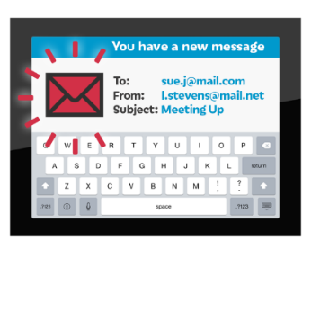
- on Facebook
- in our email newsletter.

If you are not signed up to our newsletter you can email us at

contact@whaikaha.govt.nz

We will put recordings of the meetings on our website at:
[Grab your reader’s attention with a great quote from the document or use this space to emphasize a key point. To place this text box anywhere on the page, just drag it.]

whaikaha.govt.nz/about-us/news/

You can find some Easy Read guides about how to use Zoom on the People First New Zealand website:

www.peoplefirst.org.nz

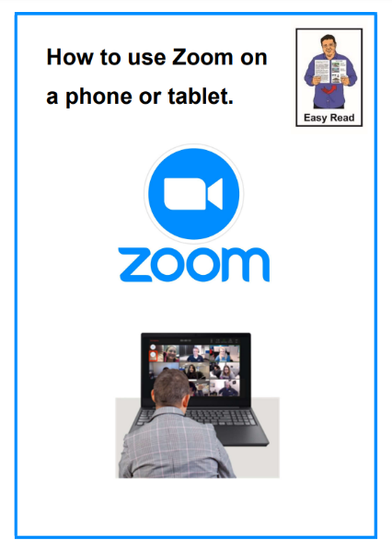
The Easy Read guides are called:

- How to use Zoom using a computer or laptop

- How to use Zoom using a phone or tablet.

Have your say

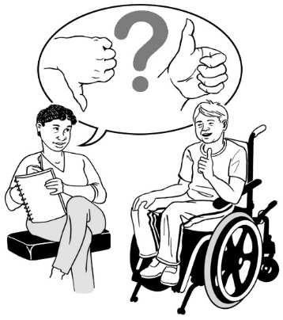
There are lots of different ways you can tell us what you think.

What you tell us is important to how the government supports the disabled community.

You can phone us on:

0800 566 601

The phone call will not cost you any money.

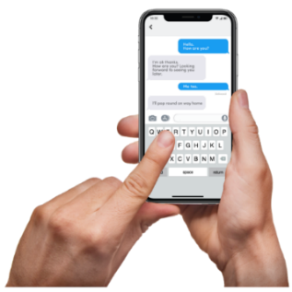
You can send us a text at:

4206

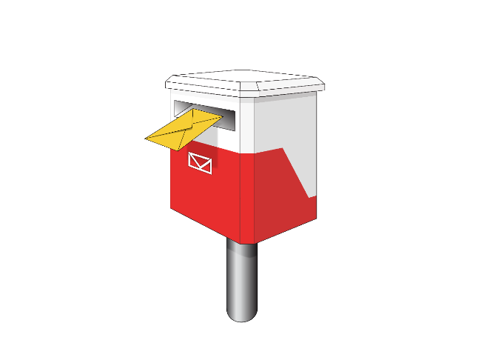
You can post us a letter to:
Reply Paid 26224

PO Box 1556

Wellington
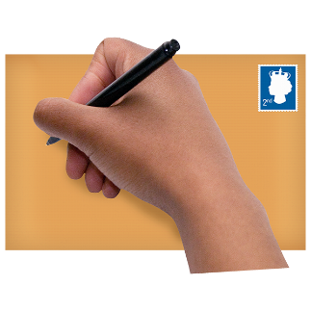
You do not need a stamp for this letter.

You can also contact us by email at:
contact@whaikaha.govt.nz

If you use New Zealand Sign Language / NZSL you can also send a video to this email address.

You can also contact us on social media.

Our Facebook page is at:

www.facebook.com/whaikaha.govt

Our LinkedIn page is at:

www.linkedin.com/company/whaikaha-ministry-of-disabled-people/

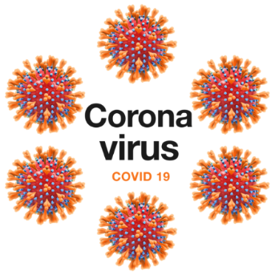
There is a COVID-19 Disability helpline if you need support for anything to do with COVID-19 like:
- vaccines
- testing
- looking after yourself at home when you have COVID-19.

You can contact the COVID-19 Disability helpline:
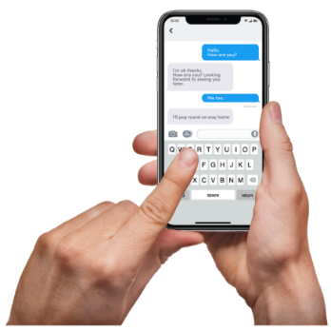
- by phone on:
0800 11 12 13
- by text at:
8988.

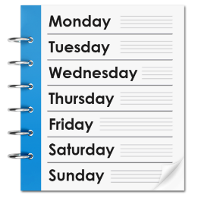
You can contact the COVID-19 Disability helpline at any time.

You do not need to pay for the phone call.

Jobs at Whaikaha

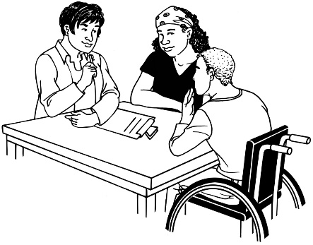
As Whaikaha gets set up we will be sharing information about jobs.

We expect there will be different jobs in different parts of Whaikaha.

Jobs will be listed on this website:

https://jobs.msd.govt.nz/go/Whaikaha/9001500/

We are working on making sure everyone can use the website.

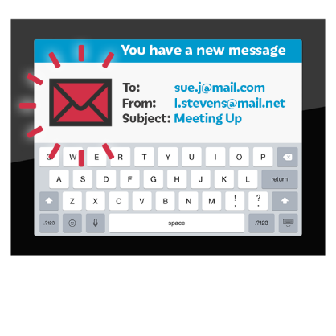
If you have any problems using the website please contact us at:
contact@whaikaha.govt.nz.
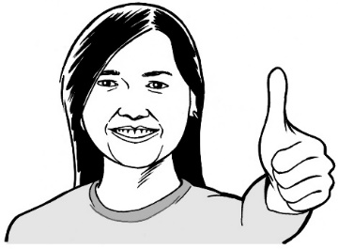

We will be happy to assist you.

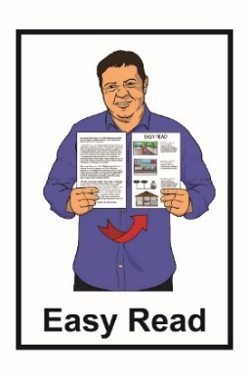
This information has been written by Whaikaha – Ministry of Disabled People.

It has been translated into Easy Read by the Make It Easy service of People First New Zealand Inc. Ngā Tāngata Tuatahi.

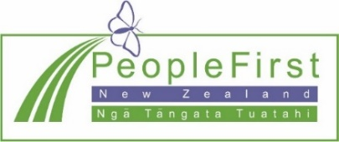
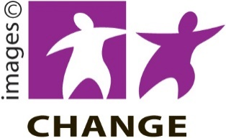
The ideas in this document are not the ideas of People First New Zealand Inc. Ngā Tāngata Tuatahi.

Make It Easy uses images from:
- Changepeople.org
- Photosymbols.com
- Sam Corliss
- Huriana Kopeke-Te Aho.

Some images were provided by Whaikaha.

All images used in this Easy Read document are subject to copyright rules and cannot be used without permission.

