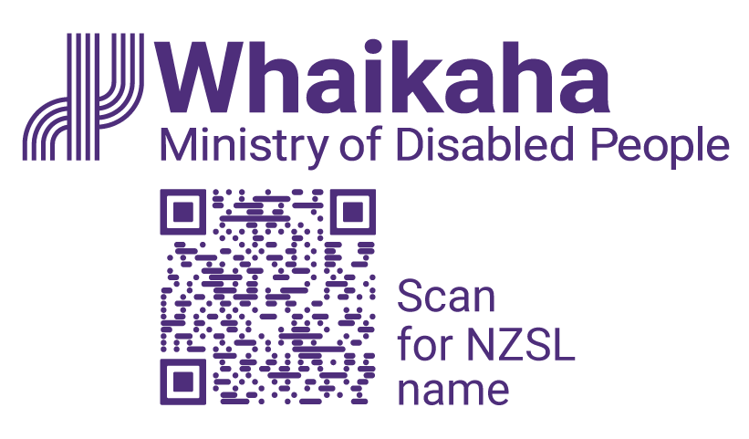

Clarifications on Purchasing Rules for Flexible Funding

Adapted in 2024 by Accessible Formats Service,
Blind Low Vision NZ, Auckland

TN: The logo on the top of the page is Whaikaha Ministry of Disabled People.

Clarifications on Purchasing Rules for Flexible Funding
Whaikaha – Ministry of Disabled People is providing clarifications to support disabled people, tāngata whaikaha Māori and whānau to apply the Purchasing Rules for flexible funding supports.
The clarifications have been informed by the feedback received from our community and providers.
Whaikaha recognises we have a lot to learn from the way we made our announcement on March 18, 2024.
We acknowledge the changes have been distressing and caused confusion for the community, and for the service providers who support disabled people.
We are committed to our partnership approach and the transformation of the disability support system.
The clarifications are:
- Ride and driver services can be used to support a disabled person to access services or engage with the community, where this is a reasonable and cost-effective option
- The following items can be purchased for a disabled person to assist self-management, on a one-off basis within a flexible funding allocation period:
- Electronic tablet devices
- Noise-cancelling headphones
- Sensory toys, fidget spinners, etc
- Weighted blankets
- Household support arrangements in place through Choice in Community Living or a personal budget can continue, where these arrangements are an alternative to residential care that enables people to live in the community
- Existing support arrangements can continue where:
- the disabled person has committed to employment, a course of study, therapy, or a timebound programme; and
- they have relied on the availability of flexibility under the previous Purchase Rules to support them to participate in those commitments; and
- that commitment was made before 18 March 2024.
Whaikaha recognises that every person and every situation is different. If you have specific questions about how these changes relate to you, please contact your Needs Assessment and Service Co-ordination service (NASC)/Host or Enabling Good Lives site in the first instance. This information has been shared with them.
Whaikaha is committed to working with disabled people, tāngata whaikaha Māori and whānau to develop longer-term settings aligned with the Enabling Good Lives vision and principles, UNCRPD and Te Tiriti o Waitangi.

Key links for more information:
- Purchasing Rules at www.whaikaha.govt.nz/rules
- We have produced guidance for the Sector, more information on the clarifications can be found at www.whaikaha.govt.nz/clar-info

How to contact Whaikaha
If you want to get in touch, you can:
Email: contact@whaikaha.govt.nz
Visit our website at: www.whaikaha.govt.nz/contact-us/
Phone: 0800 566 601
Text: 4206
Monday, Tuesday, Thursday, Friday: 8am - 5pm.
Wed: 9:30am - 5pm

New Zealand Relay is a telecommunications service for people who are Deaf, Deaf-blind, experiencing hearing loss or have a speech condition: www.nzrelay.co.nz
End of Clarifications on Purchasing Rules for Flexible Funding

