


Support for families as

fuel prices rise



Published: April 2026

About this Easy Read


This Easy Read is from Inland Revenue – Te Tari Taake.


Inland Revenue – Te Tari Taake is the government agency that looks after things to do with tax.


In this document Inland
Revenue – Te Tari Taake will be called Inland Revenue.



Tax is money that goes to the Government.

When you are paid some of it goes to the government as tax.


This Easy Read is about an increase to the in-work tax credit

Here an in-work tax credit is money:
paid by Inland Revenue

to people who get Working for Families.

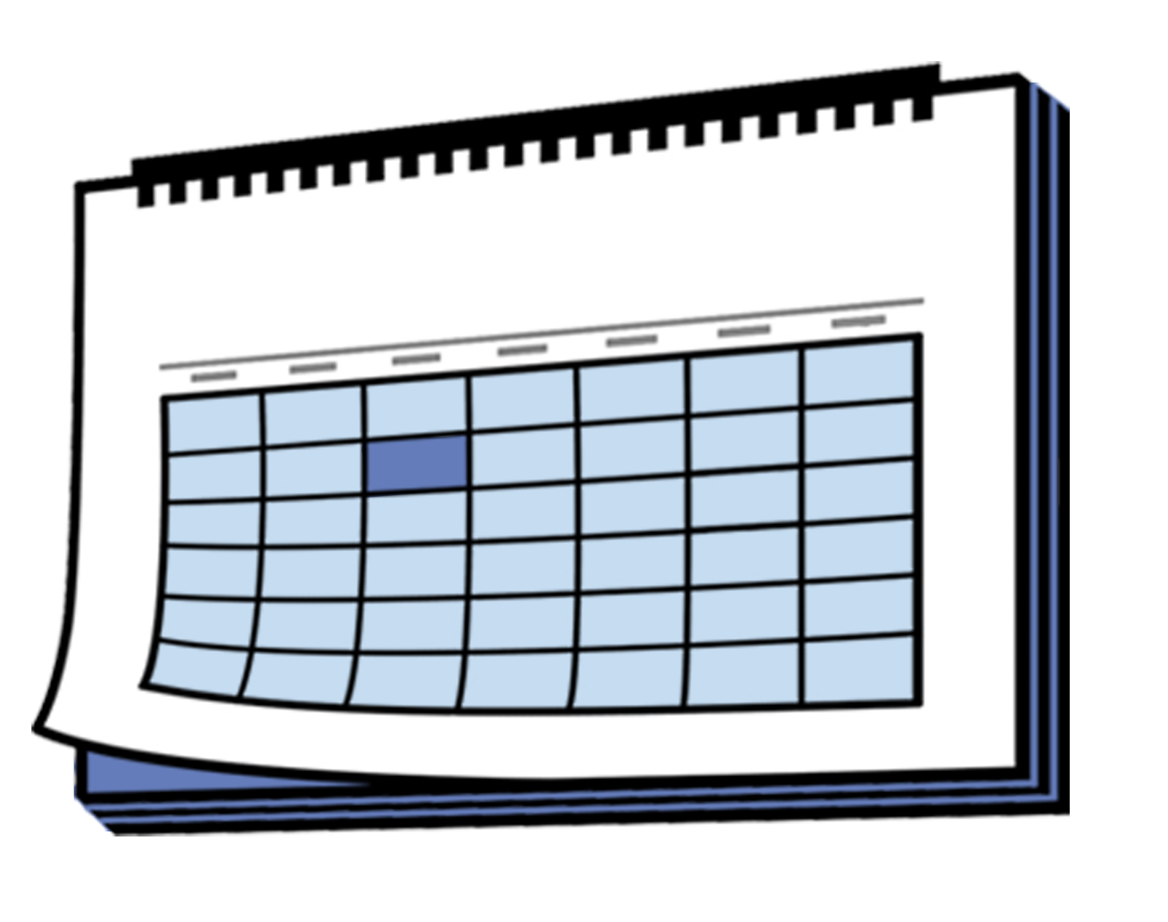
Families can choose to get an
in-work tax credit paid:
every week

every 2 weeks
at the end of the tax year as a lump sum / paid all at once.



The tax year goes:
from 1 April of 1 year
to 31 March of the next year.


Working for Families is payment given to people who:
have children

earn under an income
level / amount of money.


The increase to the in-work tax credit will be for families:
with children
who have at least 1 parent working
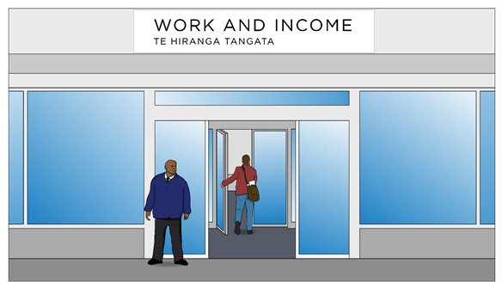

who are not getting:
- a main benefit
- student allowance.


Here a main benefit means:
Jobseeker Support
Sole Parent Support

or
Supported Living Payment.

Why is the increase happening?


The cost of fuel has gone up.

Fuel means things we use for energy like:

petrol
diesel


This is because of the war / fighting in the Middle East.


The Middle East is part of the world where a lot of fuel comes from.


The change in cost makes it hard for people who need a car to:

get to work
take children to school
travel to important places.


Families will need more money because higher fuel prices make everyday life cost more.

Families will get more money for fuel through increasing the in-work tax credit.

How much money will families get?


Some families will get
50 dollars each week
less than 50 dollars each week.

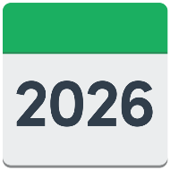
The increase to in-work tax credit will start on 1 April 2026.

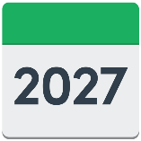
It will stop:
on 31 March 2027
or
when the cost of petrol is lower.



Here the cost of petrol being lower means 91 octane petrol is:
less than 3 dollars for every litre
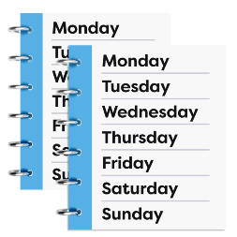
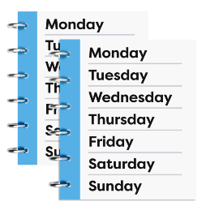
and
stays that way for 4 weeks in a row.


91 octane petrol is the kind of petrol most people use in their cars.

What families need to do


Most families do not need to do anything.


If a family already gets the in-work tax credit:

Inland Revenue will send families a letter telling them what money they will get
the extra amount will happen without families doing anything

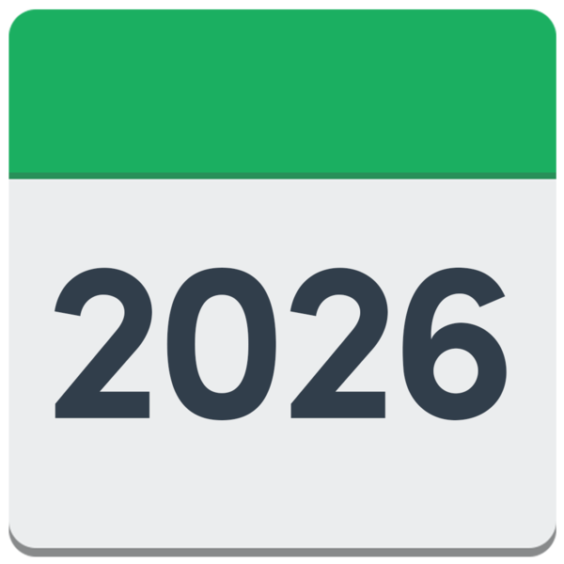
weekly payments will go up from 7 April 2026

payments that happen every
2 weeks will go up from
14 April 2026.

Payments that happen at the end of the tax year will still have the increase made as a lump sum / paid all at once.


If families are not getting the increase to the in-work tax credit

You can figure out if you can get Working for Families by using this website:

https://tinyurl.com/vjr2y2et


This website is not in Easy Read.


You can contact Inland Revenue if you think you might be able to get the increase to the in-work tax credit.


You can contact Inland Revenue using MyIR online at:

https://myir.ird.govt.nz

This website is not in Easy Read.


You can phone Inland Revenue on:

0800 227 773

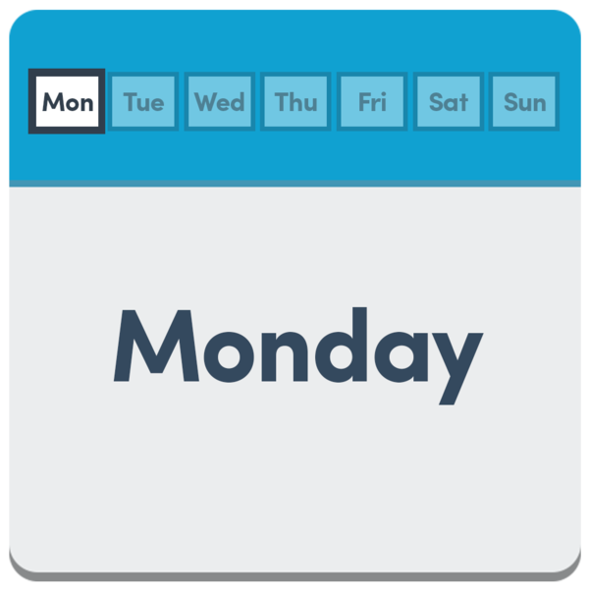
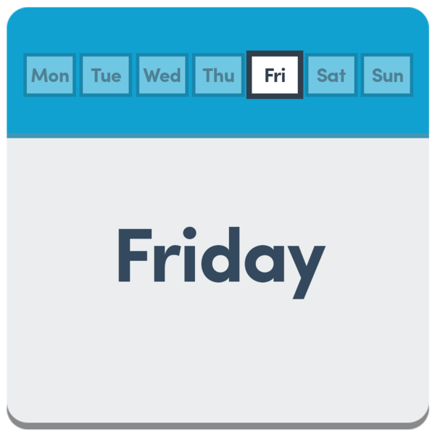
You can call this number from:
Monday to Friday


8 am to 6pm.

There is information about how to contact us if you are Deaf or hard of hearing at this website:

www.ird.govt.nz/contactus/hearing-loss-services

This website is not in Easy Read.


You can send us a letter by post to:

Inland Revenue

PO Box 39019

Wellington Mail Centre

Lower Hutt 5045

This information has been written by Inland Revenue – Te Tari Taake.


It has been translated into Easy Read by the Make it Easy Kia Māmā Mai service of People First New Zealand Ngā Tāngata Tuatahi.

The ideas in this document are not the ideas of People First New Zealand Ngā Tāngata Tuatahi.

All images used in this Easy Read document are subject to copyright rules and cannot be used without permission.


Make it Easy uses images from:


- Photosymbols

- Change Images


- Huriana Kopeke-Te Aho

- SGC Image Works

- T Wood


- Studio Rebeko

- Inga Kramer.

