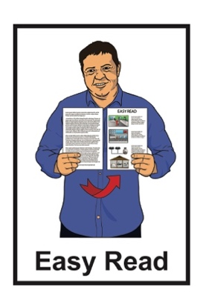

National Pacific Disability

Action Plan Survey
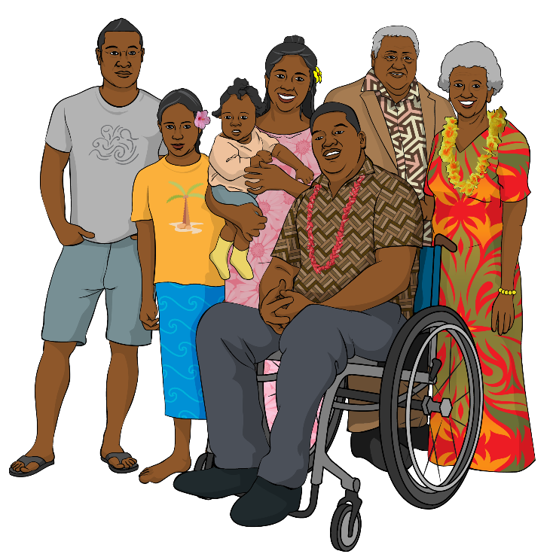

Published: March 2024

Before you start

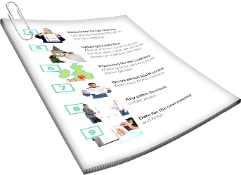
This is a long document.

It can be hard for some people to read a document this long.

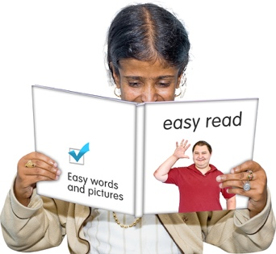
Some things you can do to make it easier are:
read it a few pages at a time
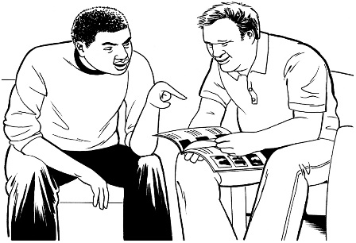
set aside some quiet time to look at it
have someone read it with you to support you to understand it.

What is in this document?

Page number:

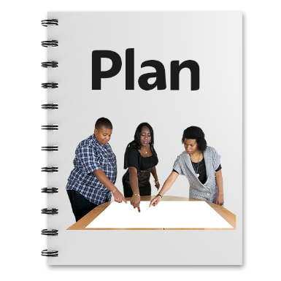
What is this document is about? 4

What is the Action Plan? 6
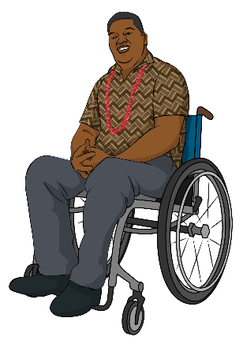

Who can do this survey? 8

Information about the survey 11
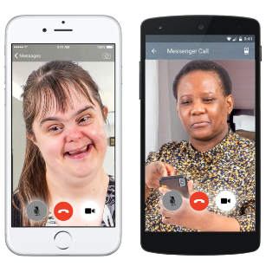

Other ways to take the survey 13

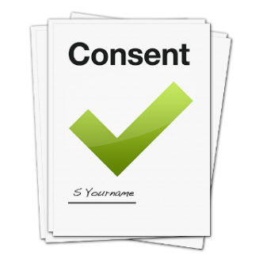
Consent form 15

Page number:
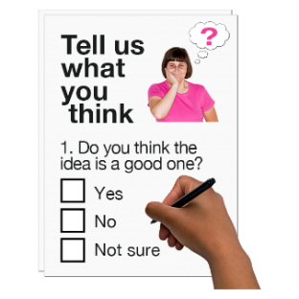

Survey questions 20

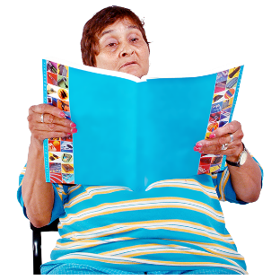
Where to find more information 57

What is this document is about?

This Easy Read document is the National Pacific Disability Action Plan Survey.

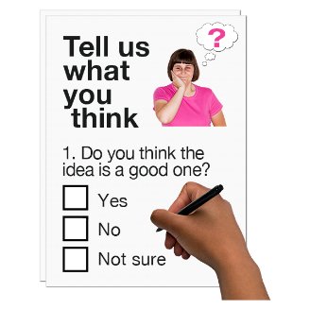
A survey is a way to get information by asking people questions.

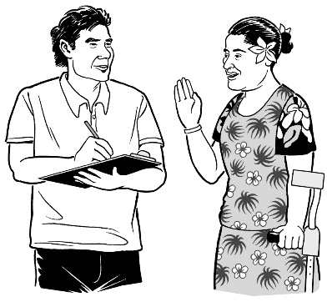
This survey will ask you questions about what it is like to be a Pacific disabled person.

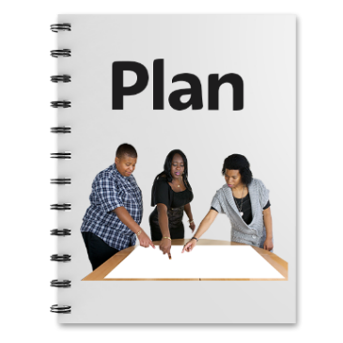
In this document the National Pacific Disability Action Plan will be called the Action Plan.

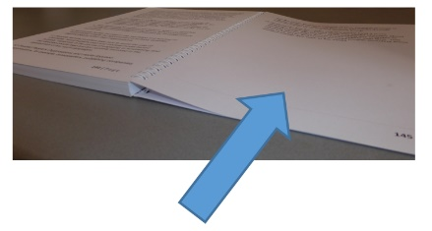
You can find out more about the Action Plan on pages 6 to 7.
The Action Plan is being made by Whaikaha – Ministry of Disabled People.

In this document Whaikaha – Ministry of Disabled People will be called Whaikaha.

In this document we / our refers to Whaikaha.

What is the Action Plan?

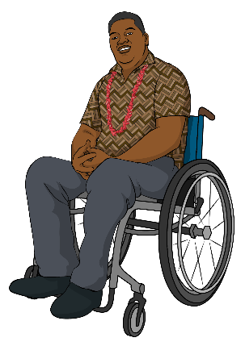
The National Pacific Disability Action Plan will guide changes being made to the disability support system for Pacific people.

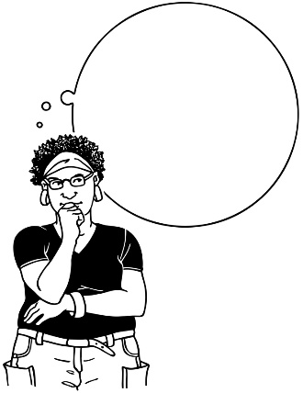
We will learn what people think from:
- talanoa
- this survey.

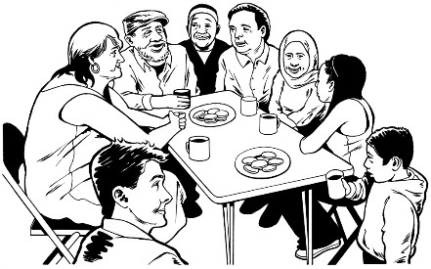
Here talanoa means meeting to:
- talk
- tell a story.

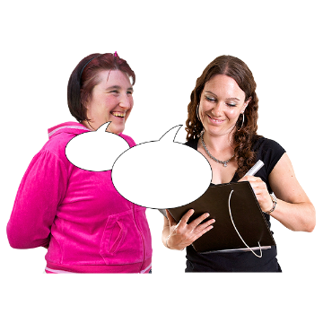
The more you tell us the better the Action Plan will be.

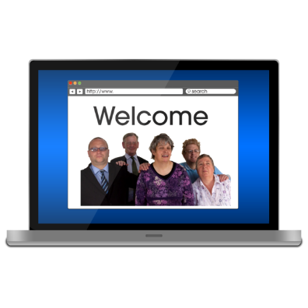
The Action Plan will be put up on our website when it is finished.

Who can do this survey?

You can do this survey if:
- you are a Pacific disabled person
- you are the:
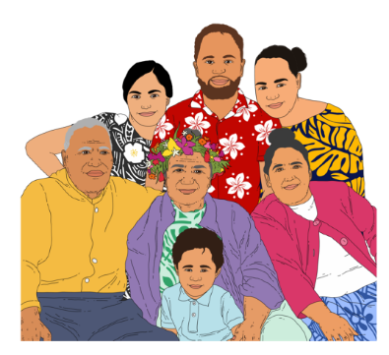
- whānau / family of a Pacific disabled person
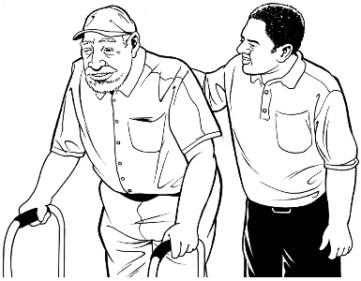
- aiga / family of a Pacific disabled person
- carer of a Pacific disabled person.

You can do this survey if you are:
16
- at least 16 years old
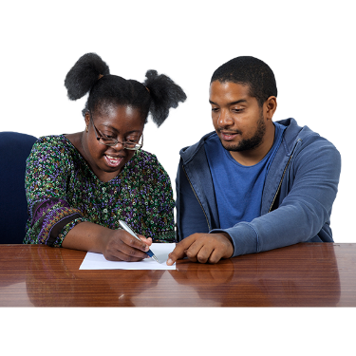
or
- a caregiver supports you to do the survey if you are under 16 years old.

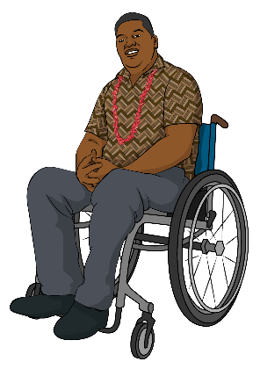
In this document we use the words Pacific disabled person.

You might use different words to talk about yourself like:
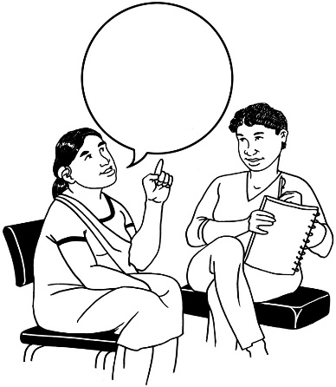
- person living with a disability
- tāngata whaikaha Māori
- whānau hauā.

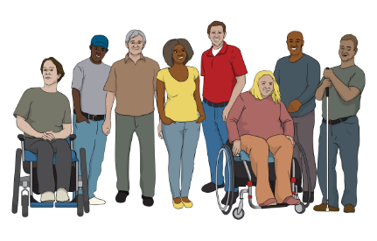
You might use different words to talk about yourself like saying you:
- have an impairment
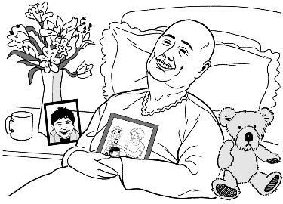
- live with an injury
- live with an illness.

Information about the survey

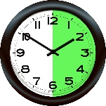
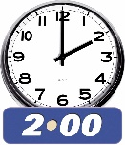
The survey will take about
30 minutes to 2 hours to do.

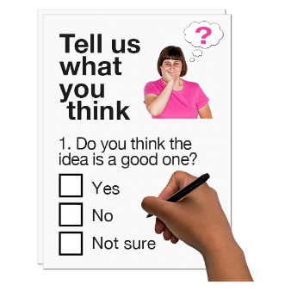
You can answer as many questions as you would like to.

If you need more space for your answers you can put in more pages.

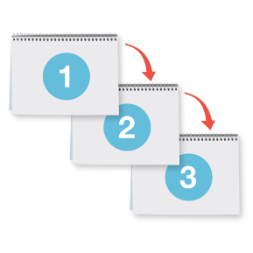
If you are adding more pages write the numbers of the questions you are answering on them.

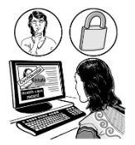
The information you give us will be kept private.

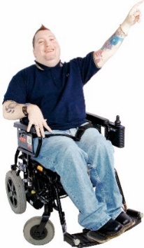
If we want to put something that you said in the Action Plan we will ask if it is ok.

The closing date of the survey can be found at this website:

www.whaikaha.govt.nz/NPDAP

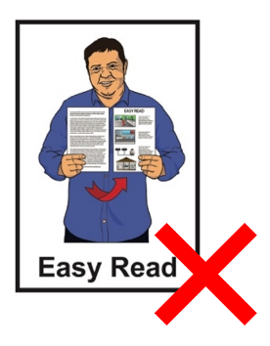
This website is not in Easy Read.

Other ways to take the survey

Some ways you can do this survey are by:
- video
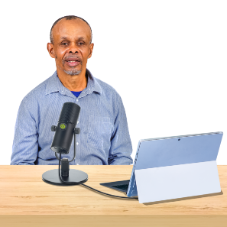
- audio message / sound
- email.

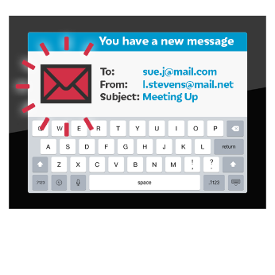
When you have finished your survey this way email it to:

pacificpeoples@whaikaha.govt.nz

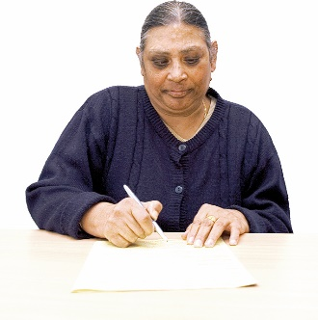
You can print out this document to do the survey.

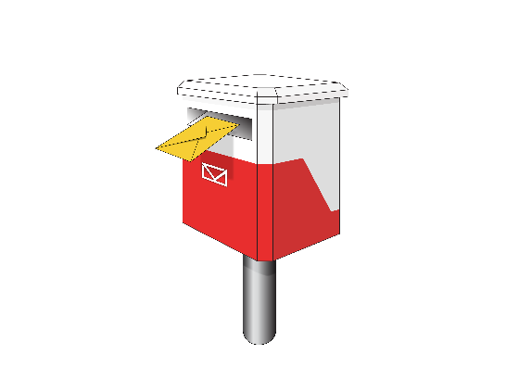
When you have finished your survey this way post it to:

Tofa Suafole Gush

Whaikaha - Ministry of Disabled People

Reply Paid: 262204

PO Box 1556

Wellington 6140

Consent form

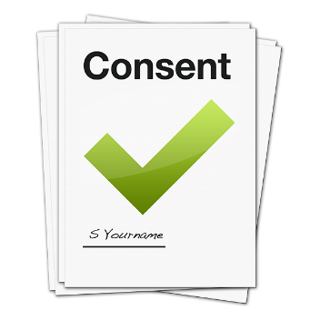
A consent form is something you fill in to say you agree to something.

It is your choice if you want to do this survey.

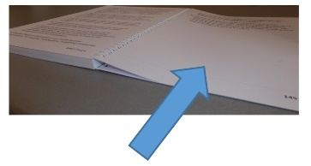
The consent form starts on the next page.

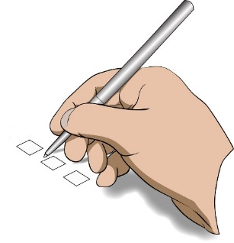
Are you doing this survey for someone else?

Put a tick in the box beside your answer.

Yes

No

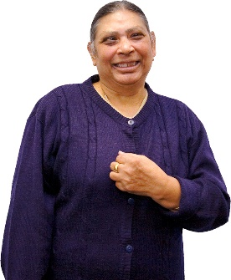
Answer the next questions for:
- yourself
or
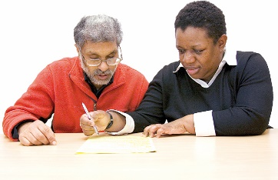
- the person you are doing the survey for.

Do you agree to share the information you put in the survey with us?

Put a tick in the box beside your answer.
Yes

No

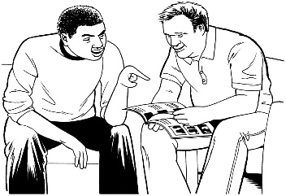
Do you understand this information is being given to Whaikaha?

Put a tick in the box beside your answer.

Yes

No
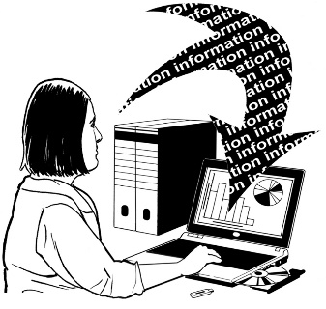
Do you understand the information is being used to make the Action Plan?

Put a tick in the box beside your answer.

Yes

No

Do you understand the information will be kept private?

Put a tick in the box beside your answer.

Yes

No

Do you agree to have the information you give in this survey stored at Whaikaha?

Put a tick in the box beside your answer.

Yes

No

Survey questions

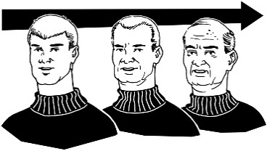
- How old are you?

Put a tick in the box beside your answer.

0 – 18

18 – 24

25 – 34

35 – 44

45 – 54

55 – 64

older than 65.
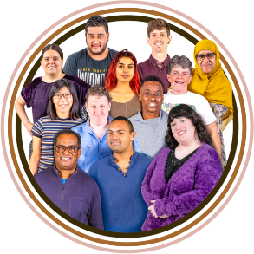
- What is your ethnicity?

Put a tick in the box beside your answer.

You can choose more than 1 answer.

Samoan

Tongan

Cook Island

Fijian

Kiribati

Niuean.

There are more answers on the next page.
More Question 3 answers:

Tokelauen

Tuvaluan

Māori

Rotuman

Other.

If you chose other put your answer in the box below.

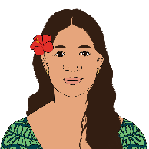
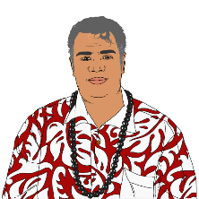
- What is your gender?

Put a tick in the box beside your answer.

I do not want to say my gender
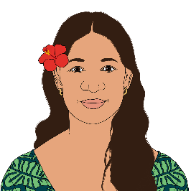
female / woman

male / man

another gender

If you chose another gender put
your answer in the box below.

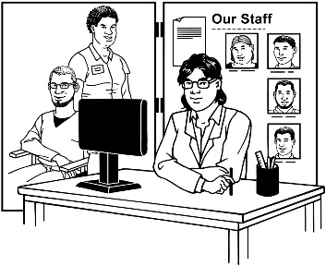
- What types of services do you use?

Put a tick in the box beside your answer.

Disability services

Health services

Ministry of Social
Development / MSD

Accident Compensation
Corporation / ACC

Supports that are not paid like whānau / family

Other services

If you chose other services tell us about them in the box below.

- What are some of the things that make you feel good about being a Pacific disabled person?

Put your answer in the box below.

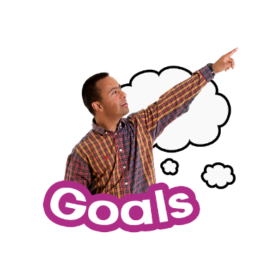
- What are your goals for the future?

A goal is something important you want to make happen.

The future is a time that is yet to happen.

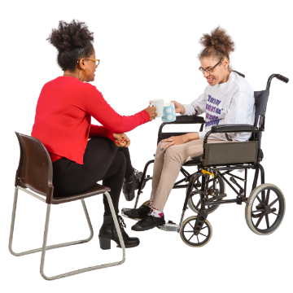
This question is about the support you get from:
- communities
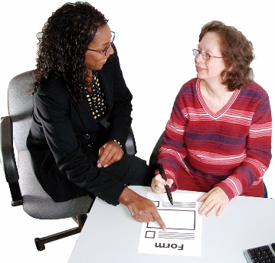
and
- organisations.

Put your answer in the box on the next page.

Put your answer in the box below.

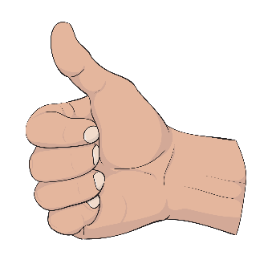
- How can these groups support you better to reach your goals?

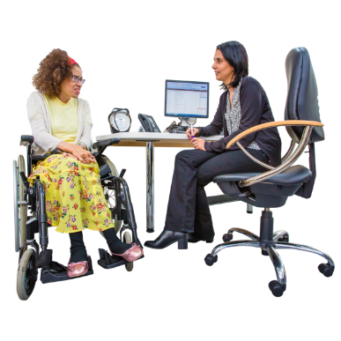
This question is about:
- disability services
- health services
- social services like:
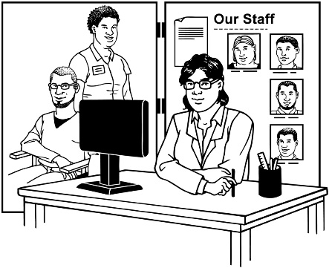
- housing
- getting a job
- getting money to live on.

Put your answer in the box on the next page.

Put your answer in the box below.

- What are some of the problems you have getting these services?

This question is about:
- disability services
- health services.

Put your answer in the box below.

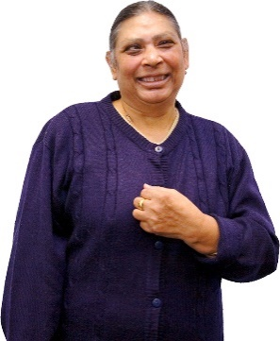
- How can these services be made better to support:
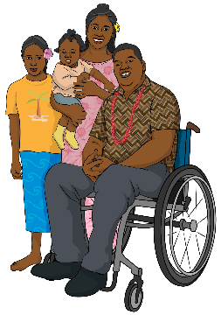
- your wellbeing?
- the wellbeing of your family?

Wellbeing means things like:
- how we feel about ourselves
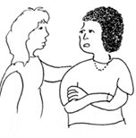
- looking after our bodies with good food and exercise
- getting support when we are feeling sad or worried.

Put your answer in the box on the next page

Put your answer in the box below.

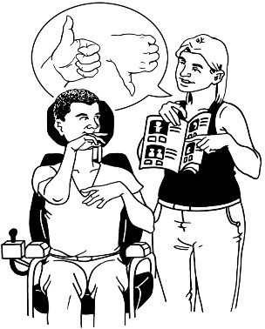
- What other support would
make your life better?

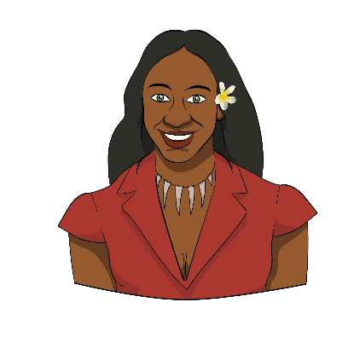
This question is about Pacific:
- cultural values
- traditions.

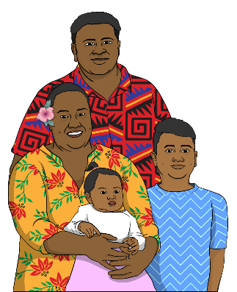
Cultural values are things that are important to a group of people.

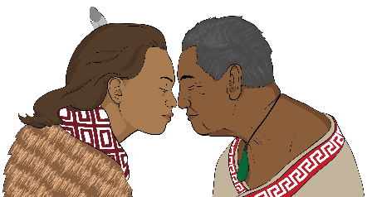
Traditions are important things that:
- have been done for a long time
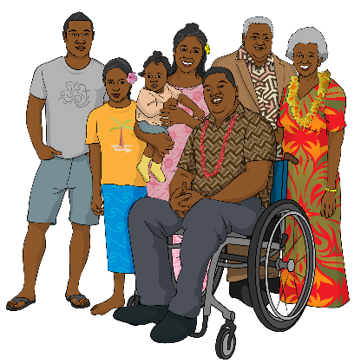
- are used by:
- families
- groups of people.

Put your answer in the box below.

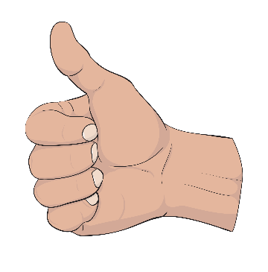
- How can disability services for
Pacific disabled people get
better at using:

- cultural values?

- traditions?

Put your answer in the box below.

- How can disability services for
Pacific disabled people have less bias?

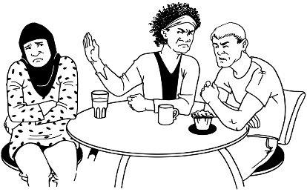
Bias means treating someone unfairly because of things like their race.

Put your answer in the box below.

- How can support services better meet the needs of communities like:
MVPFAFF+
rainbow / LGBTQIA+
takatāpui.

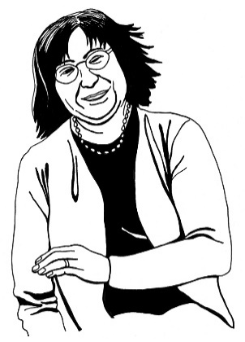
MVPFAFF+ stands for:
- Mahu
- Vakasalewalewa
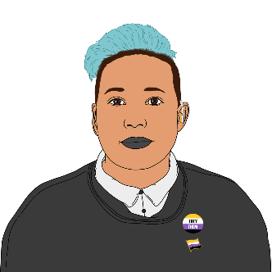
- Palopa
- Fa’afafine
- Akava’ine
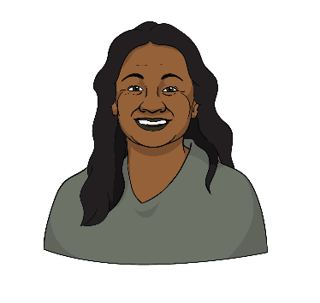
- Fakaleiti
- Fakafifine.

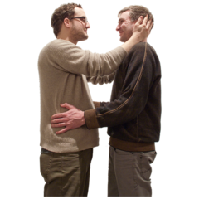
Rainbow / LGBTQIA+ stands for people who are:
- Lesbian
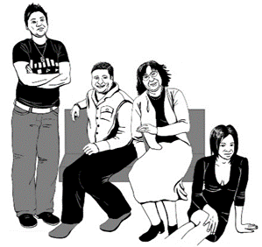
- Gay
- Bisexual
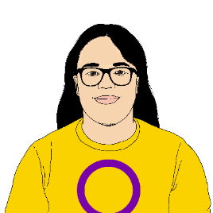
- Transgender
- Queer
- Intersex
- Asexual
- + is for other people who fit in similar groups.

Put your answer to question 13 in the box below.

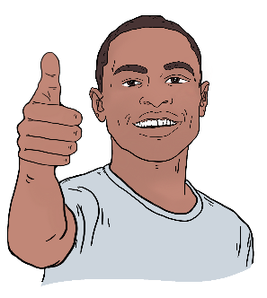
- How can disability services
get better at doing what these
people need?

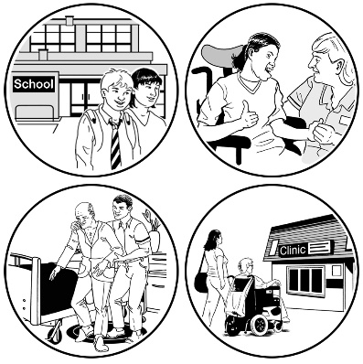
This question is about the things you do:
- every day
- in your community.

Put your answer in the box below.

- What are:
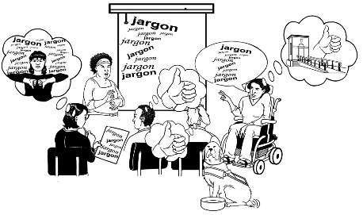
- the problems you have doing the things written on the next
4 pages
and
- the things you would like done to change them?

Put a tick in the box beside any you want to answer.

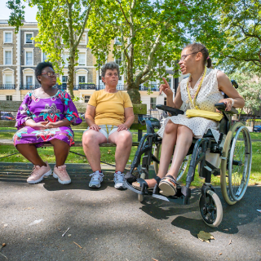
After you have ticked the box put the changes you want in the box below it.

Public spaces like parks or libraries

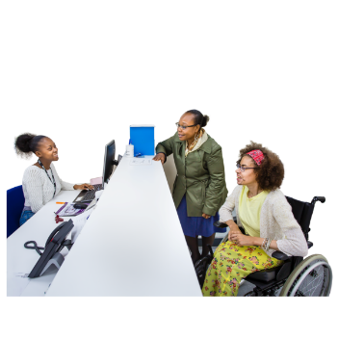
Next part of Question 15:

Healthcare

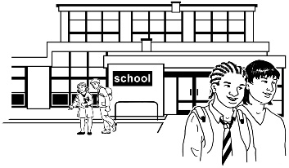

Education / learning

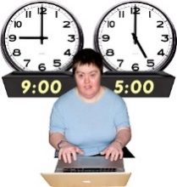

Employment / working

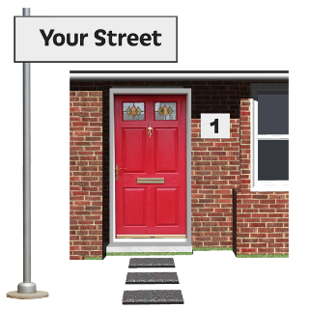
Next part of Question 15:

Housing

Sports

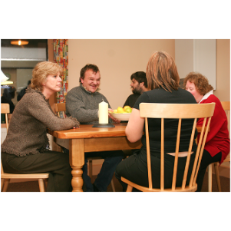

Social events like meeting with friends

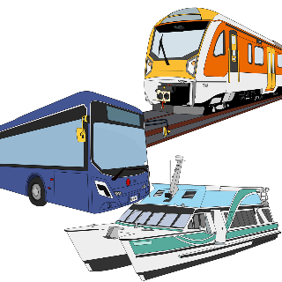
Next part of Question 15:

Transport

Other

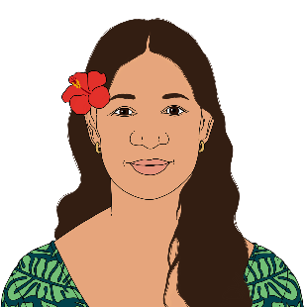
- How can we get more leaders
who are Pacific disabled
people in communities?

Put your answer in the box below.

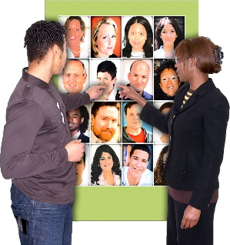
- Do you think the people who
make decisions about Pacific
disabled people think properly
about what you need?

Put a tick in the box beside your answer.

Yes

No
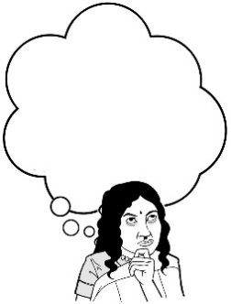

Why do you think this?

Put your answer in the box below.

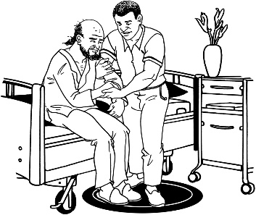
Answer this question if you are a carer doing this survey.

- Write about the things:
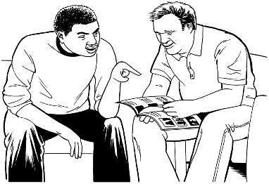
- you do to support the person you care for
and
- that would make your work easier.

Put your answer in the box below.

Answer this question if you are a carer doing this survey.

- What is your relationship to
the person you care for?

A relationship can be something like:
- parent
- brother / sister
- friend
- paid carer.

Put your answer in the box below.

Answer this question if you are a carer doing this survey.

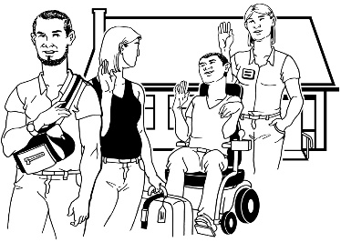
- Do you have someone else
who can look after the person
you care for if you cannot?

Put a tick in the box beside your answer.

Yes

No

If you would like to give more information about this put your answer in the box below.

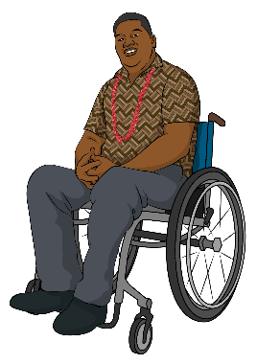
- Is there anything else you
would like to tell us about your
life as a Pacific disabled
person?

Put your answer in the box below.

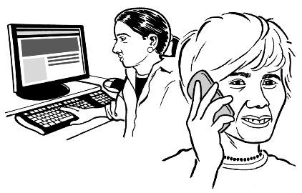
- Are you ok with us contacting you to ask if we can put something you have said in our action plan?

We might need to contact you if we want to use something you have said in our action plan.

Put a tick in the box beside your answer.

Yes

No

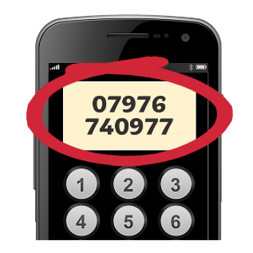
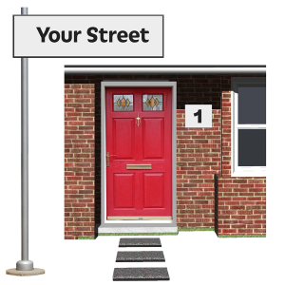
Please fill out this box with the best way to contact you if you ticked YES on the last page.

or

Go to the next question if you ticked NO on the last page.

Put your answer in the box below.

- Do you have any disabilities?

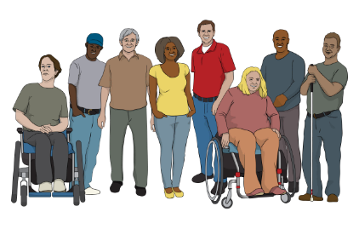
This question is about your:
- disability / disabilities
- impairment / impairments
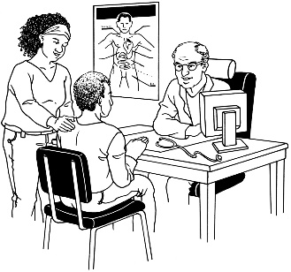
- health condition / health conditions
- injury / injuries.

Put your answer in the box below.

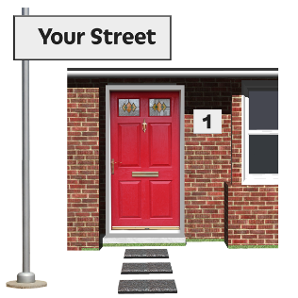
- Where do you live?

You can put your:
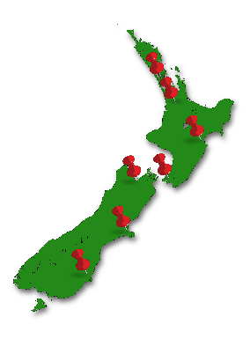
- region
- town
- city.

Put your answer in the box below.

Where to find more information

You can get in touch Whaikaha with on this website:

www.whaikaha.govt.nz/contact-us/

You can also contact Whaikaha by:
- phone on:
0800 566 601
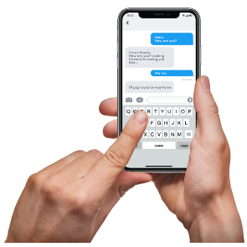
- text message on:

4206

If you find it hard to use the phone the New Zealand Relay service is for people who are:

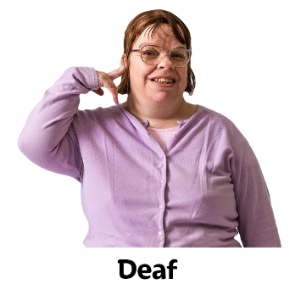
- Deaf / hard of hearing

- deafblind

- speech impaired / find it hard to talk.

You can find out more about the New Zealand Relay service at:

www.nzrelay.co.nz

This information has been written by Whaikaha – Ministry of Disabled People.

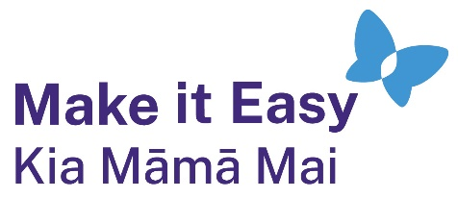
It has been translated into Easy Read by the Make it Easy Kia Māmā Mai service of People First New Zealand Ngā Tāngata Tuatahi.
The ideas in this document are not the ideas of People First New Zealand Ngā Tāngata Tuatahi.

Make it Easy uses images from:

- Changepeople.org

            - Photosymbols.com

- SGC Image Works
- Huriana Kopeke-Te Aho
- T. Wood.
All images used in this Easy Read document are subject to copyright rules and cannot be used without permission.

