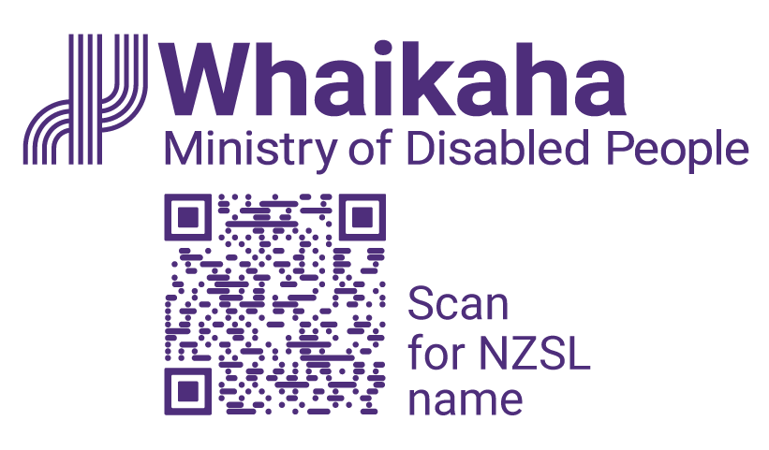
Advisor NZSL
Adapted in 2025 by Accessible Formats Service,
Blind Low Vision NZ, Auckland
TN: The logo on the top of the page is Whaikaha Ministry of Disabled People and a QR code to scan for NZSL name.

Advisor NZSL
- Permanent Wellington based opportunity
- Join a collaborative and engaging team
- Career development opportunities
Work closely with the NZSL Board and the Deaf community and NZSL users to maintain and promote NZSL through the New Zealand Sign Language Strategy and associated actions.

Mō te tūnga | About the role:
As an Advisor NZSL you will work together with the NZSL Board, and the Deaf community and community of NZSL users, to maintain and promote NZSL through the New Zealand Sign Language Strategy and associated actions.
Key responsibilities include:
- Providing high quality advice and services to the NZSL Board, to the Manager NZSL Office, and to other government agencies
- Project delivery and co-ordination
- Commitment to tāngata turi, Te Tiriti and the UNCRPD
- Providing peer review for others
- Assisting in the design and delivery of projects
- Contributing to and co-ordinating the development of cross-government actions to achieve the NZSL Strategy
- Maintaining an up-to-date understanding of the issues affecting the Deaf sector and Deaf people

Mōu | About you:
You will have an understanding/knowledge and/or interest in the following:
- New Zealand Sign Language
- Deaf organisations and the Deaf world
- Issues impacting on the lives of disabled people and their families
- Relevant sector organisations, including disabled people's organisations, Māori, Pacific and ethnic organisations, and relevant international groups
You will have strong analytical skills and a demonstrated commitment to developing and maintaining specialist skills and knowledge in this area.
Your ability to develop and maintain effective relationships will see you working with others in the Outreach and Innovation Group and Whaikaha, and with the government and community sectors.
Your written communication will be strong with the ability to write clearly and concisely, including for memos, public query responses, and Official Information Requests.
You will be comfortable working independently and in teams to deliver on initiatives in a complex environment.
To undertake this role successfully you will either be a disabled person or you will be able to establish credibility and trust with the disability community.

He Whakaahuatanga Tūnga | Position Description:
The job description, closing date, salary, application process and alternate formats of this advertisement can be found here: https://www.whaikaha.govt.nz/AdvisorNZSL

Mō mātou | About us:
At Whaikaha, we want an Aotearoa New Zealand where Deaf and disabled people and tāngata whaikaha Māori are thriving.
As a Ministry we are dedicated to this goal, working with government, businesses, and communities to drive real change.
We do this by investing in disability communities, providing strategic and policy advice across government, monitoring how well services are working, and identifying new, exciting opportunities to make a difference.
We care about the wellbeing and success of our people and provide a supportive and inclusive environment.

Me pēhea te tuku tono | How to apply:
Click the 'Apply' button to complete the online form, or let's kōrero about what you need to feel supported in your application. For example, you may prefer to use video instead of a traditional CV and cover letter, or you might want whānau or a friend to tell us about you.
Contact us about the best way for you to apply by emailing:
PeopleandCulture@whaikaha.govt.nz.
If you work for Whaikaha please apply through the myHR portal so that your employee profile is visible as an internal candidate.
End of Advisor NZSL

