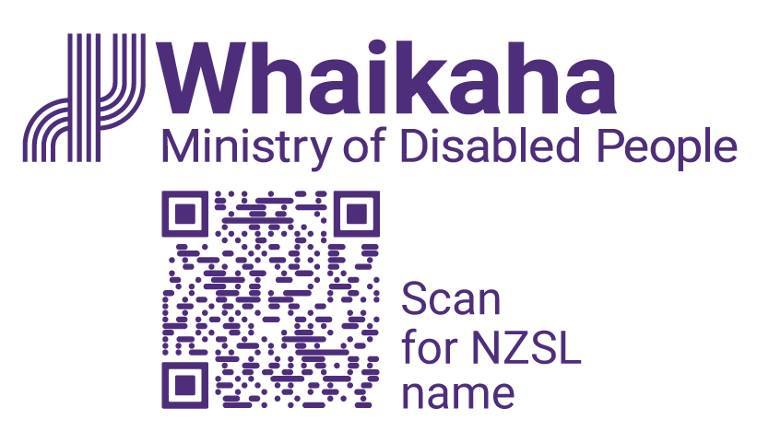
Data Analyst

Adapted in 2025 by Accessible Formats Service,
Blind Low Vision NZ, Auckland
TN: The logo on the top of the page is Whaikaha Ministry of Disabled People and a QR code to scan for NZSL name.

Data Analyst

Mō te tūnga | About the role:
This exciting opportunity will see you contributing to the development of key data and insights that support decision-making to improve outcomes for disabled people, tāngata whaikaha Māori, and their families and communities. You will be responsible for sourcing, analysing, and presenting both quantitative and qualitative data to strengthen the evidence base around disability in Aotearoa.
Key responsibilities:
- Source, analyse, and transform data using tools such as Microsoft Power BI, Microsoft Excel, SQL, and R.
- Use data and evidence from a variety of sources to develop data products and insights for diverse audiences.
- Present complex information in a clear, accessible, and concise format for non-technical users.
- Work proactively with stakeholders to define and source data that meets user needs and supports evidence-informed decision-making.
- Contribute to work to build and grow the disability data system and improve access to high-quality data and evidence.

Mōu | About you:
- Strong technical and analytical skills, with experience in both quantitative and qualitative data analysis and data visualisation.
- Familiarity with tools such as Power BI, Excel, SQL, or R, and the ability to present complex information in accessible ways.
- Knowledge and experience of working with disability data and evidence, and an understanding of the diverse experiences of disabled people and tāngata whaikaha Māori.
- Proven ability to tell stories with data and deliver high-quality insights for a range of audiences.
- A collaborative mindset and commitment to equity, accessibility, and Te Tiriti o Waitangi.
To undertake this role successfully, you will either be a disabled person, tāngata whaikaha Māori, or have lived experience as whānau, or be able to establish credibility and trust with the disability community.

He Whakaahuatanga Tūnga | Position Description:
The job description, closing date, salary, application process and alternate formats of this advertisement can be found here: Work with us | Whaikaha - Ministry of Disabled People (http://bit.ly/3Vz8jFi)

Mō mātou | About us:
At Whaikaha, we want an Aotearoa New Zealand where Deaf and disabled people and tāngata whaikaha Māori are thriving.
As a Ministry we are dedicated to this goal, working with government, businesses, and communities to drive real change.
We do this by investing in disability communities, providing strategic and policy advice across government, monitoring how well services are working, and identifying new, exciting opportunities to make a difference.
We care about the wellbeing and success of our people and provide a supportive and inclusive environment.

Me pēhea te tuku tono | How to apply:
Click the 'Apply' button to complete the online form, or let's kōrero about what you need to feel supported in your application. For example, you may prefer to use video instead of a traditional CV and cover letter, or you might want whānau or a friend to tell us about you.
Contact us about the best way for you to apply by emailing:
PeopleandCulture@whaikaha.govt.nz.
If you work for Whaikaha please apply through the myHR portal so that your employee profile is visible as an internal candidate.
End of Data Analyst

