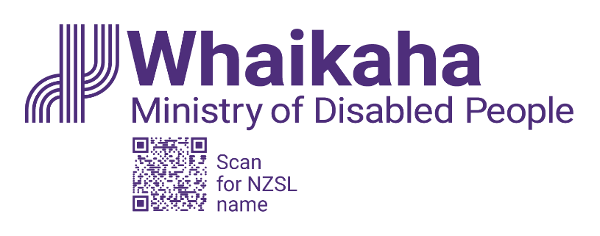
Principal Advisor Outreach
Adapted in 2025 by Accessible Formats Service,
Blind Low Vision NZ, Auckland

Transcriber's Note: The logo at the top of the page is, Whaikaha: Ministry of Disabled People.

Principal Advisor Outreach

Mō te tūnga About the role:
As Principal Advisor Outreach, you'll work closely with the Director-Outreach to influence government programmes and service delivery to drive meaningful change for Deaf and disabled people.
You'll lead strategic projects, provide high quality advice to the Minister's office, and support cross-agency and disability community engagement.
You'll also contribute insights to the Whaikaha Policy team and may represent the Director in key forums.
Key responsibilities:

Key responsibilities
- Support strategic engagement direction and business planning for the Outreach team
- Provide expert engagement advice to improve outcomes for disabled people
- Represent Whaikaha in external forums and meetings
- Lead and support cross-agency work programme delivery
- Brief senior leaders and the Minister on key issues
- Advise on Ministerial correspondence and issues management
- Coach and mentor team members to build capabilit

Mōu | About you:
- Senior level expertise in engagement, strategy, and government processes
- A deep commitment to improving outcomes for disabled people
- Proven leadership in complex programmes
- Strong understanding of engagement frameworks (IAP2 accreditation a plus)
- Experience influencing and aligning cross-government initiatives
- Knowledge of NZ government structures and decision-making
- Proven project delivery and planning capability with an outcomes focus
- Strong written skills with proven experience writing briefings for Ministers
- Proven experience engaging with senior leaders and Ministers and the disability community
To undertake this role successfully you will either be a disabled person, or you will be able to establish credibility and trust with the disability community.

He Whakaahuatanga Tūnga | Position Description:
The job description, closing date, salary, application process and alternate formats of this advertisement can be found here: Work with us | Whaikaha - Ministry of Disabled People (http://bit.ly/3Vz8jFi)

Mō mātou | About us:
At Whaikaha, we want an Aotearoa New Zealand where Deaf and disabled people and tāngata whaikaha Māori are thriving.
As a Ministry we are dedicated to this goal, working with government, businesses, and communities to drive real change.
We do this by investing in disability communities, providing strategic and policy advice across government, monitoring how well services are working, and identifying new, exciting opportunities to make a difference.
We care about the wellbeing and success of our people and provide a supportive and inclusive environment.

Me pēhea te tuku tono | How to apply:
Click the 'Apply' button to complete the online form, or let's kōrero about what you need to feel supported in your application. For example, you may prefer to use video instead of a traditional CV and cover letter, or you might want whānau or a friend to tell us about you.
Contact us about the best way for you to apply by emailing: PeopleandCulture@whaikaha.govt.nz.
If you work for Whaikaha please apply through the myHR portal so that your employee profile is visible as an internal candidate.
End of Principal Advisor Outreach

