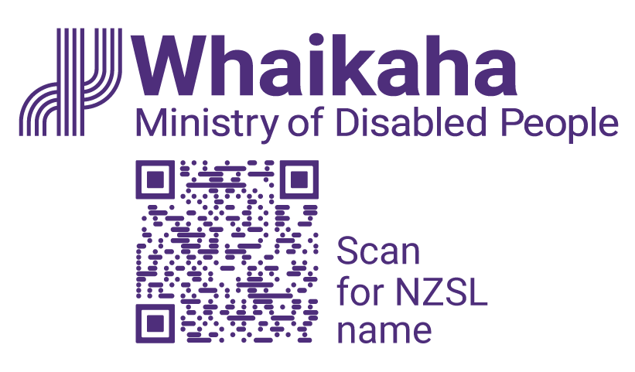
Summer Intern
Adapted in 2025 by Ministry of Disabled People – Whaikaha
TN: The logo on the top of the page is Whaikaha Ministry of Disabled People and a QR code to scan for NZSL name.

Summer Intern
- Join an internship that supports inclusion, accessibility and opportunities for disabled people, tāngata whaikaha Māori and Deaf people
- Use your degree and lived experience to make a positive impact on government agencies and the communities we serve
- Paid internship opportunity, based in Wellington
Join the first All-of-Government Ministry of Disabled People – Whaikaha summer internship cohort!

All-of-Government Summer Internship Programme:
The Ministry of Disabled People – Whaikaha is leading a summer internship programme for current tertiary students or recent graduates to gain public service work experience.
There are placement opportunities across the public sector. While we’re still confirming the agencies for this year’s pilot programme, there are lots of possibilities. Government agencies cover business, culture, education, emergency, environment, health, housing, international and trade, justice, national security, populations and communities, social services and transport sectors.
Should you be successful, you will be matched to a role that aligns with your skills, experiences, and interests.
You’ll have regular opportunities to connect and share your experiences with other interns, even if you are working at different agencies. You will also have an assigned mentor and buddy to support you during your internship.
Interns will get to take part in formal learning and development sessions, meet senior public service leaders, and the Minister for Disability Issues. At the end of the programme, you’ll present on your experiences and get career support.
The programme will run from 19 November 2025 to 13 February 2026.

Mōu te tūnga | About the role:
As a Summer Intern you will gain knowledge and experience working in a professional environment within a public sector organisation. Whaikaha is committed to supporting host agencies to meet the accessibility needs of interns.
This role is full-time and fixed term for approximately 12 weeks. Flexible or part-time arrangements can be explored.

Mōu | About you:
We are seeking interns who are keen to bring lived experience, disability perspectives and a passion for equity to their work.
Ideally, you will be:
- In your final year of tertiary studies or have completed your tertiary studies in the last two years
- Eligible to live, study, and work in New Zealand
- Able to manage tasks and meet deadlines with support or strategies that work best for you
- Open to collaboration and building positive relationships
- Curious, self-aware, and open to feedback
- Familiar with Microsoft Office products such as Excel, Word, PowerPoint and Outlook

He Whakaahuatanga Tūnga | Position Description:
The job description, closing date, salary, application process and alternate formats of this advertisement can be found here: https://www.whaikaha.govt.nz/SummerIntern

Me pēhea te tuku tono | How to apply:
In your application, we are keen to know about:
- Your motivations – why are you interested in this internship? What do you hope to get out of it?
- What are you passionate about - areas of skill, experience, or interest? What are you keen to work on? We want to be able to align your preferences with the roles available as much as possible
After applications close, we will begin the shortlisting process. Shortlisted candidates will go through to the next phases which involve:
- A chance for us to learn more about your skills, experience and interests
- An in person or online interview
Click the 'Apply' button to complete the online form, or let’s kōrero about what you need to feel supported in your application. For example, you may prefer to use video instead of a traditional CV and cover letter, or you might want whānau or a friend to tell us about you.
Contact us about the best way for you to apply by emailing: peopleandculture@whaikaha.govt.nz

If you work for Whaikaha please apply through the myHR portal so that your employee profile is visible as an internal candidate.
End of Summer Intern

