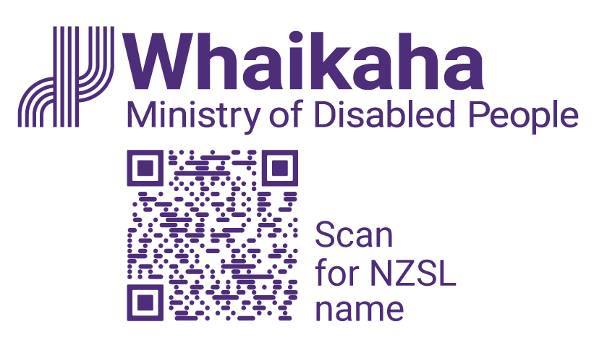
Advisor, Communications
Adapted in 2026 by Accessible Formats Service,
Blind Low Vision NZ, Auckland
TN: The logo on the top of the page is Whaikaha Ministry of Disabled People and a QR code to Scan for NZSL name.

Advisor, Communications

Mō te tūnga | About the role:
As an Advisor, Communications, you’ll play a key part in delivering advice and practical support across our communications function. This role focuses on graphic design and digital content and would suit someone who enjoys creating social media content and working with tools like Canva.
You’ll help shape internal communications that keep our kaimahi informed and connected, contribute to digital channels including our intranet, website and social media platforms, and work on media and stakeholder engagement activities.
Key responsibilities:
- Contribute to team planning, strategy, and work programme development.
- Develop engaging graphic design and digital content for a variety of audiences and platforms.
- Support delivery of key projects and initiatives across Whaikaha.
- Develop internal communications to keep staff engaged and connected.
- Support and update our digital channels including the internal and external websites.
- Ensure all content meets accessibility and quality standards and uses plain, inclusive language.
- Champion storytelling and effective communication that builds trust and inspires action.
- Support media management and issue response, ensuring risks and opportunities are identified early.

Mōu | About you:
- Proven experience in internal and/or external communications.
- A genuine interest in graphic design and visual storytelling, with confidence using Canva or similar design tools.
- Well‑developed writing and editing skills, with an ability to craft clear, engaging content for diverse audiences.
- Familiarity with content management systems and digital publishing best practices.
- Understanding of social media platforms and how to tailor content for different channels.
- A team player who’s proactive, curious, and thrives in a flexible, collaborative environment.
- Experience creating or editing video content is an advantage, but not essential.

We encourage applications from Deaf and disabled people, Turi Māori, tāngata whaikaha Māori, and those with lived experience. If you're passionate about inclusion and ready to learn, we'd love to hear from you.

He Whakaahuatanga Tūnga | Position Description:
The job description, closing date, salary, application process and alternate formats of this advertisement can be found here: Work with us | Whaikaha - Ministry of Disabled People (http://bit.ly/3Vz8jFi)

Mō mātou | About us:
At Whaikaha, we want an Aotearoa New Zealand where Deaf and disabled people, Turi Māori and tāngata whaikaha Māori are thriving.
As a Ministry we are dedicated to this goal, working with government, businesses, and communities to drive real change.
We do this by investing in disability communities, providing strategic and policy advice across government, monitoring how well services are working, and identifying new, exciting opportunities to make a difference.
We care about the wellbeing and success of our people and provide a supportive and inclusive environment.

Me pēhea te tuku tono | How to apply:
Click the 'Apply' button to complete the online form, or let's kōrero about what you need to feel supported in your application. For example, you may prefer to use video instead of a traditional CV and cover letter, or you might want whānau or a friend to tell us about you.
Contact us about the best way for you to apply by emailing:
PeopleandCulture@whaikaha.govt.nz.
If you work for Whaikaha please apply through the myHR portal so that your employee profile is visible as an internal candidate.
End of Advisor, Communications

