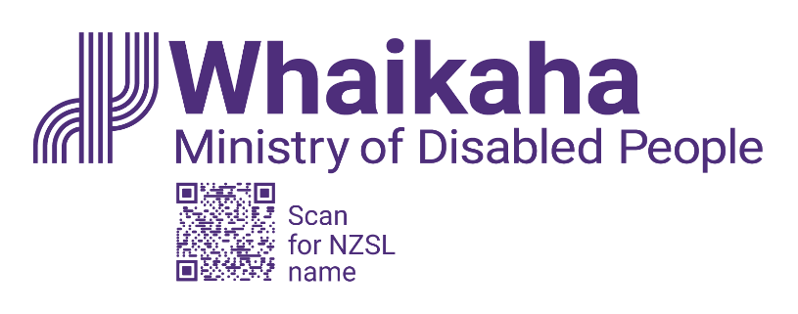
Advisor, Innovation
Adapted in 2026 by Accessible Formats Service,
Blind Low Vision NZ, Auckland

Transcriber's Note: The logo at the top of the page is Whaikaha—Ministry of Disabled People, with a QR code that directs to the Whaikaha New Zealand Sign Language name.

Advisor, Innovation

Mō te tūnga | About the Role:
As Advisor, Innovation, you will support the development of initiatives grounded in community-led and human‑centred design, helping to deliver meaningful outcomes and solutions.
Key responsibilities:
- Support the design and facilitation of workshops, engagement, and learning processes.
- Provide innovative and purposeful analysis and advice across a range of contexts.
- Help turn design and innovation ideas into practical, impactful solutions.
- Collaborate with others, building strong relationships with the disability community, government agencies, iwi/hapū partners, NGOs, and other stakeholders.

Mōu | About You:
- Curious and motivated to contribute to meaningful system change.
- Knowledge of human-centred design, community-led design, or innovation frameworks.
- Understanding of the issues and priorities impacting disabled people.
- Ability to build relationships and work collaboratively across diverse groups.
- Ability to communicate clearly and assemble information in accessible ways.
If this role feels like a good fit but you don’t meet every point in the criteria, we still encourage you to apply. We value a wide range of experience and skills.
We encourage applications from Deaf and disabled people, Turi Māori, tāngata whaikaha Māori, and those with lived experience. If you’re passionate about inclusion and ready to learn, we’d love to hear from you.

He Whakaahuatanga Tūnga | Position Description:
The job description, closing date, salary, application process and alternate formats of this advertisement can be found here: Work with us | Whaikaha - Ministry of Disabled People (http://bit.ly/3Vz8jFi)

Mō mātou | About us:
At Whaikaha, we want an Aotearoa New Zealand where Deaf and disabled people and tāngata whaikaha Māori are thriving.
As a Ministry we are dedicated to this goal, working with government, businesses, and communities to drive real change.
We do this by investing in disability communities, providing strategic and policy advice across government, monitoring how well services are working, and identifying new, exciting opportunities to make a difference.
We care about the wellbeing and success of our people and provide a supportive and inclusive environment.

Me pēhea te tuku tono | How to apply:
Click the "Apply" button to complete the online form, or let’s kōrero about what you need to feel supported in your application. For example, you may prefer to use video instead of a traditional CV and cover letter, or you might want whānau or a friend to tell us about you.
Contact us about the best way for you to apply by emailing: PeopleandCulture@whaikaha.govt.nz.
If you work for Whaikaha please apply through the myHR portal so that your employee profile is visible as an internal candidate.
End of Advisor, Innovation

